桃園市立大有國民中學111學年度第一學期第三次評量試卷
年 級 | 8 | 考 試  科 目 | 英語 |  |  | 命 題  範 圍 | L 5 ~ Review 3 | 作 答  時 間 | 45分
班 級 |  | 姓 名 |  | 座 號 |  | 分 數
- 聽力測驗 每題2分 共30 %

一 辨識句意：根據聽到的內容，選出符合描述的圖片或符合圖片的描述。

- ( ）
(Ａ) 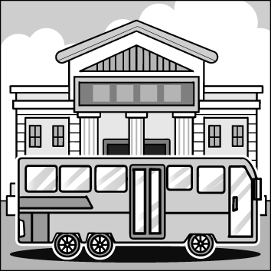 (Ｂ) 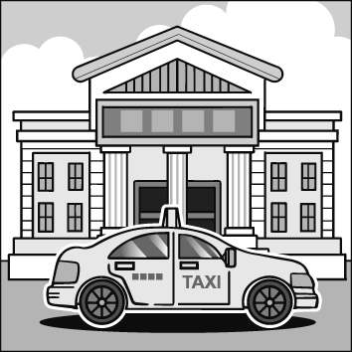 (Ｃ) 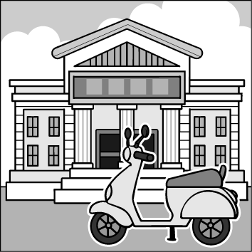

- ( ）
(Ａ) 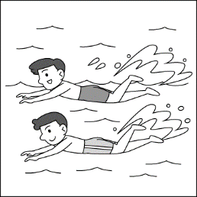 (Ｂ) 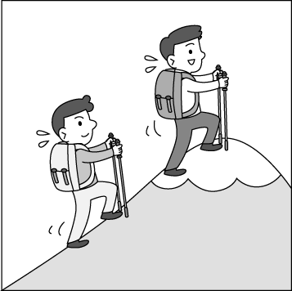 (Ｃ) 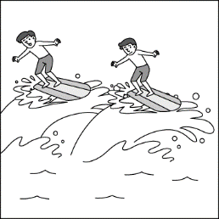

- ( ）
(Ａ) 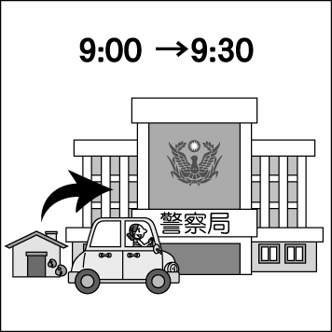 (Ｂ) 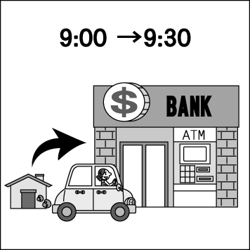 (Ｃ) 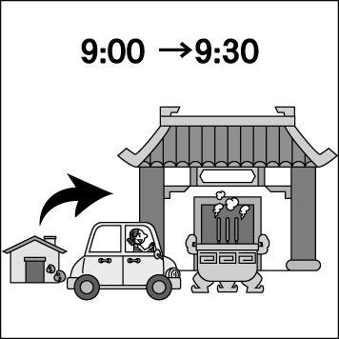

- ( ）
(Ａ) 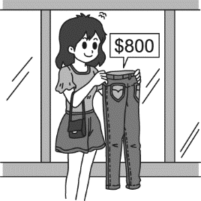 (Ｂ) 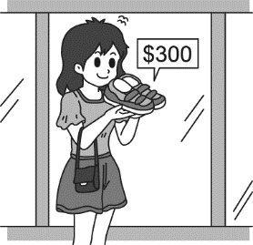 (Ｃ) 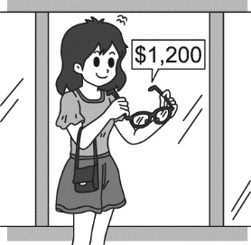

- ( ）
(Ａ) (Ｂ) 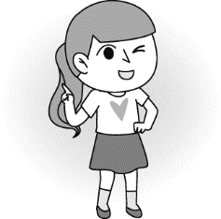 (Ｃ) 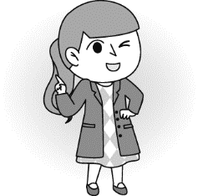

二 基本問答：根據聽到的內容，選出一個最適合的回應或最適合的問句。
- ( ）
(Ａ) Go straight and turn right. Walk about 5 minutes and you can see it.
(Ｂ) You can ask for help.
(Ｃ) There are many people in the hospital today.

- ( ）
(Ａ) She enjoyed the movie last night.
(Ｂ) She enjoys going surfing.
(Ｃ) She doesn’t have much time this afternoon.
- ( ）
(Ａ) Well, only half an hour.
(Ｂ) There isn’t much homework today.
(Ｃ) It is so difficult to finish the work on time.
- ( ）
(Ａ) I am going to Tokyo.
(Ｂ) In two days.
(Ｃ) I was in Japan last week, too.
- ( ）
(Ａ) I am going to have afternoon tea in the coffee shop.
(Ｂ) I was in the bathroom.
(Ｃ) No, I don’t have time tomorrow afternoon.

三 言談理解：根據聽到的內容，選出一個最適合的答案。
- ( ）
(Ａ) The man and the woman are on the bus.
(Ｂ) The woman is going to the hospital.
(Ｃ) The man and the woman are at a bus stop.
- ( ）
(Ａ) Go shopping.
(Ｂ) Wash the clothes.
(Ｃ) Go biking at the park.
- ( ）
(Ａ) Go mountain climbing.
(Ｂ) Go fishing.
(Ｃ) Go swimming.
- ( ）
(Ａ) A new T-shirt.
(Ｂ) A new pair of shoes.
(Ｃ) A new bag.
- ( )

(Ａ) They are going to buy some food in the supermarket.
(Ｂ) They are going to work together in the office.
(Ｃ) They are going to have dinner in a Japanese restaurant.

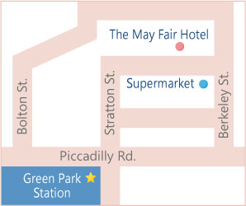
- 綜合測驗 每題2分 共70
- There is a hotel ________ the supermarket.
- next to (B) near

(C) across from (D) in the front of

- John: How was your Christmas party last night?

Mary: Great. Everyone had a _______ night.
- lost (B) wonderful (C) cheap (D) sadly
- Dylan: The new smartphone cost me NT$25600.

Sarah: Wow! That’s ________. I won’t spend that much money buying it.
- fast (B) most (C) cheap (D) expensive
- Clerk: Everything in our shop is going to be ________ next Saturday.

Gina: I see. I will come again then.
- sale (B) on sale (C) having a sale (D) for sale
- Joyce is busy ________ playing basketball every day because there will be a basketball game next month.
- to practice (B) practice (C) practicing (D) practiced
- The Kato family ________ at Mitsui Outlet Park三井購物城 last Sunday.
- went surfing (B) went hiking (C) went swimming (D) went shopping
- Vivian ________ thirty minutes ________to Taipei, but looking for a parking space ________her almost an hour.
- spend; driving; takes (B) spent; driving; took (C) spends; to drive; take (D) spent; drive; to take
- Walk ________ Minguang E. Rd. 民光東路 ________ four blocks, and turn right ________ Daye Rd. 大業路.

You will get to my home.
- along; for; on (B) down; to; at (C) straight; for; to (D) across; on; along
- We can ________ a bus to Taipei, and we can also go home ________ train.
- take; in (B) took; on (C) take; by (D) took; by a
- The Wang family live on ________ floor in Japan.
- twenty-one (B) twenty-first (C) the twenty-one (D) the twenty-first
- There is going to ________an important exam next Friday, so I have to study hard now.
- have (B) being (C) be (D) having
- The company will keep the prices ________ by using ________ workers.
- expensive; high (B) high; expensive (C) cheap; low (D) low; cheap
- Dayou Junior High School is ________ the corner ________ Dayou Rd. 大有路and Minguang E. Rd. 民光東路.
- in; of (B) at; on (C) on; of (D) on; between
- Shin Kong Mitsukoshi 新光三越Department Store is near my house, so we can go shopping there ________.
- walk (B) on foot (C) by plane (D) on bus
- Because of COVID-19, many old people are now in the ________.
- bank (B) museum (C) pool (D) hospital
- It is very convenient for people to ________ to work in a big city, like New York in the USA.
- by metro (B) take the metro (C) in the metro (D) drive the metro
- After riding a bike around the lake, I want to stop ________ some water and take a rest.
- to drinking (B) drank (C) drinking (D) to drink
- The Katos ________ to take a trip to Taiwan with their American friends next month because the Chinese New Year is

coming soon.
- is going (B) are going (C) were going (D) will be
- Clerk: How would you like to pay?

James: ________
- It’s $NT1000. (B) I spent $NT1000 on it. (C) In cash. (D) I paid by cash.

閱讀題組一
(At a shopping mall)
Meg：Hi, Tim. What are you doing here?
Tim：I’m shopping for a birthday gift for my dad. Tomorrow is his 45th birthday, so I want to get something special
for him.
Meg：You’re so sweet. What are you going to buy for your dad?
Tim：I have no idea.
Meg：What about this smartphone? It looks nice.
Tim：It’s nice, but it’s too expensive. I can’t afford it.
Meg：Then what about those cameras?
Tim：He seldom takes pictures.
Meg：Look! There is a big sale on the watches there. The watches are cool, and they are 50% off only today!
Tim：Let’s go take a look!
Meg：Hey, do you like this brown one?
Tim：That’s great. Brown is my dad’s favorite color, and it is his style, too.
Meg：It 39 only one thousand dollars.
Tim：OK. I’ll take this one!
style 風格 off 折扣

35. What does “I can’t afford it.” mean?
(A) Tim doesn’t like it at all.
(B) Tim has lots of money to buy it.
(C) Tim wants Meg to buy it for him.
(D) Tim doesn’t have enough money to buy it.
36. What is Tim going to buy for his dad?
(A) 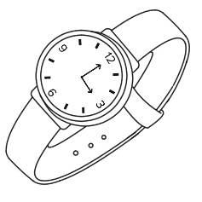 (B) 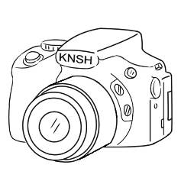 (C) (D)
37. How much will Tim have to pay for the brown watch if he buys it tomorrow?
(A) NT$1,100. (B) NT$500. (C) NT$1,000. (D) NT$2,000.

38. Which is true of the following?

(A) Tim is going to buy a gift for Meg. (B) Tim and Meg are brother and sister.

(C) Tim’s father will be forty-five years old soon. (D) The cameras in the store are on sale today.

39. (A) costs (B) pays (C) takes (D) spends

閱讀題組二
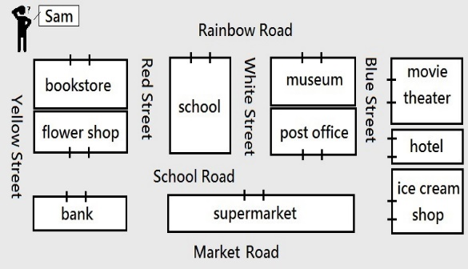

40. If Sam walks down Rainbow Road, what will he first see on his right? if 如果
(A) A bookstore. (B) A hotel. (C) A museum. (D) A supermarket.
41. What is true from the map?
(A) The movie theater is next to the school.
(B) The bank is across from the flower shop.
(C) Both the bookstore and the flower shop are on White Street.
(D) Sam will see the movie theater after he goes past School Road.

閱讀題組三

What will be your career in the future? How are you going to make a successful career plan? The following
ways may be able to help you.
1. You are 100% responsible for your life.
No one can decide for you. You must take full responsibility for your career plan.
2. Give yourself time to think.
Ask yourself: What do I really want? What do I care about most? What do I want my life to look like in the
future? Think carefully. You may want to make your career decision based on these points above.
3. Set your goals.
Dream big but start small. To reach your final big goal, you need to break it down into short, medium, and
long-term goals. And take a small step each time.
4. Know your abilities.
Know your strengths and weaknesses. Utilize your strengths and minimize your weaknesses.
5. Find a career mentor.
Find one or some mentors. They can give you useful advice.
6. Try new things.
Learning can bring you new ideas. If you don’t want to stay in your current career, learning is the best way to
get out of it and find your true interests.
   responsible有責任的 responsibility 責任decision 決定based on 根據goal 目標
abilities 能力strength 優點weakness 弱點minimize 減少mentor 導師advice 建議 current目前的

42. What is the reading about?
- Ways to know one’s abilities. (B) People to care about.

(C) Ways to plan one’s career. (D) New things to learn.

43. Which word has a same meaning to utilize?

(A) Use. (B) Lost. (C) Dream. (D) Play.

44. Which is true?
- You shouldn’t know yourself. (B) It is better to ask mentors for any career advice.

(C) It is not important to set short, medium, and long-term goals.

(D) Learning new things can’t help you to find your real interests.

45. What do these points refer to in the reading?
- Your teachers. (B) Your abilities. (C) Your weaknesses. (D) Your answers.

克漏字測驗

Welcome to the future world, everyone. Now I would like to tell you about our new product產品, the Virtual Tours. We are really happy that it is finally online now after years of hard work. Virtual Tours give people a different chance to experience the fun of going on a trip to very far places without 46 a plane. That is to say, people can stay at their comfortable homes and then visit many famous places around the world, like Louvre羅浮宮, Iceland aurora冰島極光 or Pyramids古埃及大金字塔. With it, you don’t have to worry about how much a trip will 47 or how long it will 48 . Also these famous places are always filled with people, but that won’t trouble you anymore. In fact, they 49 to only you, so you can 50 as much time as you want there. We use digital photos and videos for our Virtual Tours, and they give people a true 3D feel. Hope you enjoy your Virtual Tours!

46. (A) fly (B) taking (C) to take (D) drive

47. (A) pay (B) spend (C) save (D) cost

48. (A) spend (B) take (C) save (D) drive

49. (A) aren’t belong (B) won’t belong (C) will belong (D) are belong

50. (A) take (B) took (C) spend (D) spent

~END~

~May you all have a wonderful winter vacation!~

