桃園市立大有國民中學110學年度第一學期第一次評量試卷
年 級 | 8 | 考 試  科 目 | 英語 |  |  | 命 題  範 圍 | U 1 ~ U1 2 | 作 答  時 間 | 45分
班 級 |  | 姓 名 |  | 座 號 |  | 分 數

聽力測驗

一 辨識句意：根據聽到的內容，選出符合描述的圖片或符合圖片的描述。（每題1分）
- (Ａ) 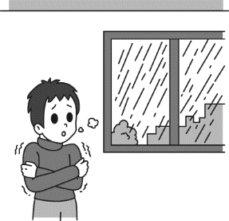 (Ｂ) 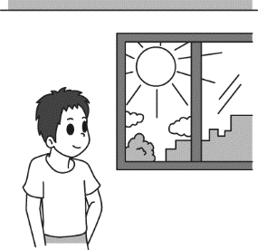 (Ｃ) 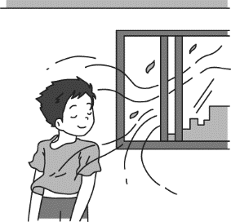
- (Ａ) 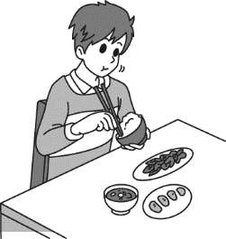 (Ｂ) 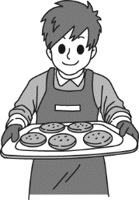 (Ｃ) 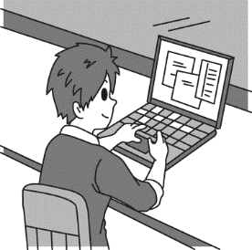
- (Ａ) 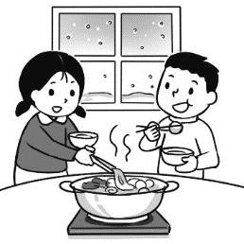 (Ｂ) 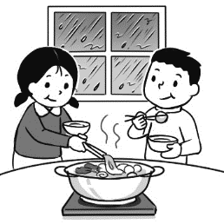 (Ｃ) 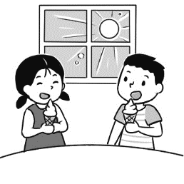
- (Ａ) 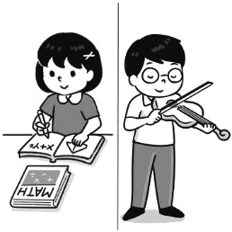 (Ｂ) 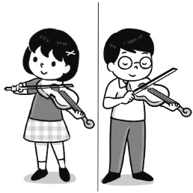 (Ｃ) 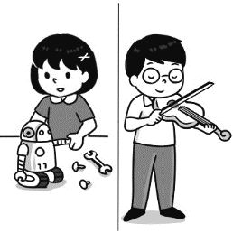

二 基本問答：根據聽到的內容，選出一個最適合的回應或最適合的問句。（每題2分）
- (Ａ) Yes, I made some new friends.
(Ｂ) I didn’t wake up this morning.
(Ｃ) I made a card for my little boy.

- (Ａ) We will make some snowmen together.
(Ｂ) Yes, but most of time we have snow on the mountains.
(Ｃ) Yes, it rains a lot in Taiwan.

- (Ａ) Will you join me next time?
(Ｂ) It is very cold outside. Come on in.
(Ｃ) It is mine. My dad bought it for me as my birthday gift.

- (Ａ) I cooked dinner for my family.
(Ｂ) I was not really good at making cakes.
(Ｃ) I do not want to go home early.

- (Ａ) There were so many people in the airport.
(Ｂ) I went there by car.
(Ｃ) I called my parents first.

三 言談理解：根據聽到的內容，選出一個最適合的答案。（每題2分）
- (Ａ) He likes to stay at home.
(Ｂ) He likes to go to the pool.
(Ｃ) He likes to go to the beach.
- (Ａ) Spring.
(Ｂ) Winter.
(Ｃ) Summer.
- (Ａ) Their math teacher.
(Ｂ) Their favorite subjects.
(Ｃ) Their favorite sports.
- (Ａ) He likes to go swimming.
(Ｂ) He likes to stay at home.
(Ｃ) He likes to have some ice cream.
- (Ａ) Talk to Mr. Wang.
(Ｂ) Have lunch with Cindy.
(Ｃ) Do the report.
四 文法測驗。（每題2分）
- ________ a lot of snow there in winter.
- It is (B) There are (C) They have (D) We has
- ________ rain a lot in Kaohsiung in spring.
- You have (B) It doesn’t (C) There isn’t (D) We have
- It was my birthday yesterday. My aunt ________ a big robot to me ________ the USA.
(A) sent; from (B) bought; in (C) ordered; to (D) made; at
- Dad’s eyes are big, and mine ________, too.
- is (B) are (C) does (D) do
- Ben: ________ smartphone is it? It’s beautiful. Sam: It’s my brother’s.
- Who (B) Who’s (C) What’s (D) Whose
- Mom: Go wash your hands first ________ you touch any food. Son: Okay.
- because (B) when (C) , after (D) before
- My daughter cried out ________ her little brother turned off the light of the bathroom.
- why (B) when (C) , before (D) , after
- Prepare for your English test now. ________ you finish it, you can watch TV.
- After (B) Before (C) Because (D) So
- Tim and Mary _______ with their grandparents when they ________ little.
- live; were (B) lived; are (C) lived; were (D) lives; was
- Yesterday was Teacher’s Day, so I wrote a card ________ my English teacher, Miss Chen.
- X (B) for (C) of (D) to

五 克漏字測驗。（每題1分）
Once there were two sisters, Katy and Sue, who were always fighting.
Sue: That’s 25. book. Give it back! It’s 26. .
Katy: No. it isn’t 27. . It’s 28. book. I want it.
Sue: Mom, Katy got my book. She says it’s 29. , but it isn’t.
The girl’s mother didn’t know what to do. She told 30. to stop fighting but they didn’t listen to.
Katy: Give me that game. It’s 31. .
Sue: No, it’s isn’t. It’s 32. game. Mom, it’s not 33. , is it?
Mother: Girls! Stop fighting at once.
Then the girls’ father came home. He was very angry. He went upstairs and took all of the books and games out of
34. bedroom. The girls were very upset and they promised not to fight again.
at once 立刻 upstairs 往樓上upset 不開心promised 答應
- (A) your (B) mine (C) hers (D) my
- (A) mine (B) yours (C)your (D) me
- (A) mine (B) him (C) yours (D) us
- (A) your (B) their (C) my (D) our
- (A) hers (B) mine (C) ours (D) his
- (A) they (B) us (C) you (D) them
- (A) you (B) mine (C) us (D) her
- (A) mine (B)my (C) us (D) yours
- (A) her (B) him (C) hers (D) mine
- (A) their (B) our (C) his (D) your

六 閱讀測驗。（每題2分）

Dear Mom,
How are you? Is everything fine at home?
How is the weather in Taipei? I hope it’s not too cold. It’s freezing here in New York! The temperature today is
-10 °C . It’s not normal! It is usually cold in winter, but not freezing. This year, it’s snowing everywhere. My car couldn’t start this morning because it was too cold outside. I had to walk to school. It was not easy. The ground was so wet and slippery. I also had to walk back from my school. My shoes and socks were wet. I don’t like snowy days!
I miss the warm days in Taipei!
Your daughter,
Amy

Dear Amy,
The weather is not normal this year. It is very cold and snowy in many countries. Many people can’t go to work or school and they have to stay at home. New York is not the coldest place in the world. But this year has been the coldest year in the past thirty years. Please don’t drive to school. Driving on snowy days is very dangerous. The weather in Taipei is not good recently. It is rainy and windy, but luckily it’s not very cold. Everything here is fine! Don’t worry about us!
Take care,
Mom
coldest 最冷的recently最近 normal 正常的slippery 滑的temperature溫度

- What is the meaning of the word freezing?
(A) Very cold (B) Very warm
(C) Very windy (D) Very sunny
- Where is Amy now?
(A) She is in the USA. (B) She is in Taiwan.
(C) She is in Australia. (D) She is India.
- Does Amy like the snowy days in New York?
(A) Yes, she does. (B) No, she doesn’t.
(C) It’s fine for her. (D) We don’t know.
- Which is true?
- Amy and her mom are in the same place. (B) New York is not very cold this winter.
- Amy’s mom drives her to school. (D) Amy didn’t drive to school.
- What is the weather like in New York in winter?
(A) It’s snowy and cloudy. (B) It’s sunny and warm.
(C) It is snowy and very cold. (D) It rains a lot and very cold.

This is not a joke. It happened in real life in Taiwan.
One day, when Mr. Wang was taking care of the store, eight men walked in. One of them pushed him hard and told him to give them money. Mr. Wang was afraid, but he tried being friendly. He told them that if they came back later at the end of the day, he would have more money for them. And guess what! The eight men did believe him and leave the store.
The moment the eight men left, Mr. Wang called the police. The police didn’t not believe the robbers would come back. However, the police said they would go to Mr. Wang’s store by the end of the day.
Before the police came at 6:30 pm, one of the robbers appeared at the door. Mr. Wang told him he came too early and that the store would close an hour later.
At 7:30 pm, the eight men came back. They did not know the police were waiting for them at the back of the store, ready to catch them. The police caught all of them and sent them to jail.
moment時刻 jail監獄
- What is the meaning of the word robbers in the reading?
(A) Mr. Wang’s friends. (B) Good people.
(C) Bad guys. (D) Police officers.
- What is the best title of this story?
(A) A Bad Lie (B) Ways to Keep the Police Away
(C) Fighting to the Last Minute (D) Stupid Robbers
- What time would Mr. Wang’s store close at?
(A) 6:30 pm. (B) 7:30 pm.
(C) 5:30 pm. (D) We don’t know.
- Which is true?
(A) The police didn’t catch the robbers. (B) The robbers came to Mr. Wang’s store twice.
(C) Mr. Wang didn’t give the robbers money. (D) The eight men were Mr. Wang’s friends.
- What can we learn from the reading?
- The robbers finally got nothing from Mr. Wang. (B) All the robbers came to Mr. Wang’s store three times.
(C) Mr. Wang cried out for help when the robbers came in. (D) The robbers finally got the money.
非選擇題
一 中翻英：寫出下列動詞和該動詞的過去式。（每題2分）
例題：開始 start started
- 教導 2. 討厭 3. 落下 4. 意指 5. 完成

二 文意字彙, 填入適當的單字。（每題1分）
- Zac b t an umbrella because the rain was heavy and he didn’t have one with him.
- Jamie sent Zac a p d from Australia.
- This is an i g book for children.
- There are four s ns in a year.
- Fast food is not good for your h h.
- Science is Susan’s favorite s t.
- Vanessa can s k English and Chinese.
- Scott started his first job as a computer e r.
- Mom t t of Grandmother when she saw the old watch from her yesterday.
- Lesson 1 is not d t at all because our teacher teaches it in a fun way.

三 改寫句子。（每題2分）
- Grandfather gave my little sister a toy robot yesterday. (加入介系詞改寫句子)
- Luke took a shower at 8:30 p.m.
Luke watched TV with his parents at 9:30 p.m. (用after置於句中合併)
- A bird flew into Sam’s living room .
Sam made coffee in the kitchen. (用When Sam置於句首合併)
END

