桃園市立大有國民中學110學年度第一學期第二次評量試卷
年 級 | 七 | 考 試  科 目 | 英語科 |  |  | 命 題  範 圍 | Unit Three-Review Two | 作 答  時 間 | 45分
班級 |  | 姓 名 |  | 座 號 |  | 分 數

辨識句意：根據聽到的內容，選出符合描述的圖片或符合圖片的描述。
- (Ａ) 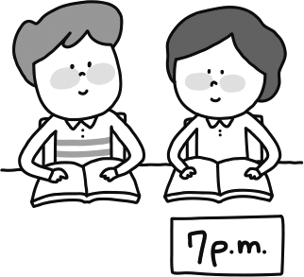 (Ｂ) 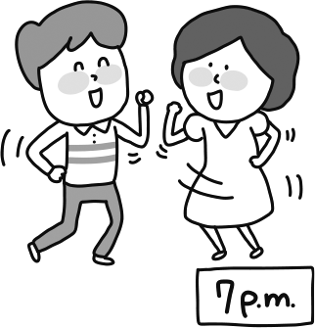 (Ｃ) 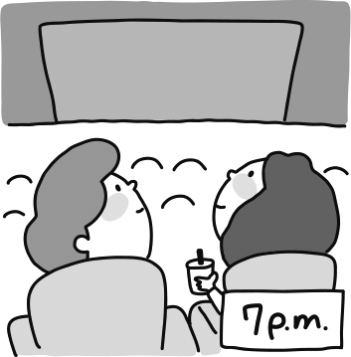
- (Ａ) 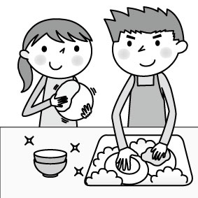 (Ｂ) (Ｃ) 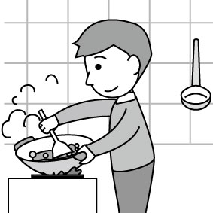

- (Ａ) 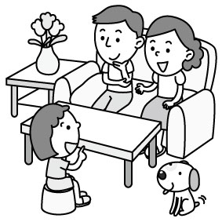 (Ｂ) 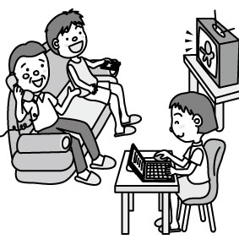 (Ｃ) 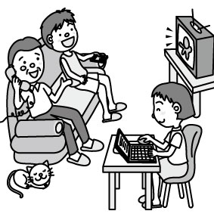

基本問答：根據聽到的內容，選出一個最適合的回應或最適合的問句。
- (Ａ) No, they are playing at the park.
(Ｂ) Aren’t they your students?
(Ｃ) Yes, their bathroom is beautiful and big.

- (Ａ) Wow! It’s a cute bag.
(Ｂ) Oh, I’m really sorry.
(Ｃ) Thank you for the new bag.

- (Ａ) Sorry. Let’s be quiet, Larry.
(Ｂ) Yes, we are very good students.
(Ｃ) OK! Let’s dance in the new museum.

- (Ａ) Maybe he is a new student in Class 901.
(Ｂ) He is talking on the phone in the living room.
(Ｃ) No, he is eating an apple in his room.

- (Ａ) It is 2 p.m.
(Ｂ) Today is Thursday.
(Ｃ) Henry is free today.

言談理解：根據聽到的內容，選出一個最適合的答案。
- (Ａ) He is sleeping in the bedroom.
(Ｂ) He is studying English in the bedroom.
(Ｃ) He is playing in the park.
- (Ａ) It’s 6 o’clock now.
(Ｂ) They are at the concert now.
(Ｃ) The concert is at 6 on Friday.

- (Ａ) 7:30 (Ｂ) 8:30 (Ｃ) 9:00

- (Ａ) It’s at 9 o’clock. (Ｂ) It’s at 8:30 (Ｃ) It’s at 8 o’clock.

- (Ａ) On Wednesday. (Ｂ) On Thursday. (Ｃ) On Sunday.

- (Ａ) Josh can go to the zoo in the afternoon.
(Ｂ) Tina and her family are in Japan now.
(Ｃ) Betty and Justin can go to the zoo in the afternoon.

- (Ａ) Mr. Lin’s parents. (Ｂ) Mr. Lin’s teachers. (Ｃ) Mr. Lin’s students.
四、綜合測驗 (每題2分)
- Tiger Moutain Park is a beautiful __________. My grandma is dancing there now.
( A ) kitchen ( B ) place ( C ) house ( D ) box
- Please _______ those test tubes after class. They are not clean.
( A ) wash ( B ) use ( C ) close ( D ) fight
- A: Are you _____ for the movie? B: Yes! Let’s go.
( A ) quiet ( B ) safe ( C ) careful ( D ) ready
- This new music video is very _________with high school students. They watch it many times on Youtube.
( A ) favorite ( B ) popular ( C ) red ( D ) quiet
- A: You can watch that cute bird ______ the binoculars (望遠鏡). B: Thanks! That’s great!
( A ) with ( B ) in ( C ) at ( D ) for
- A: _________ is your basketball class? B: It’s on Sunday.
( A ) What time ( B ) What day ( C ) Where ( D ) How
- A: Can you play baseball? B: _________. That’s my favorite sport.
( A ) No, I can’t ( B ) Yes, I am ( C ) I can ( D ) Sure
- This is the lab. Let’s _____ run and just listen to the teacher carefully.
( A ) don’t ( B ) can’t ( C ) not ( D ) no
- Look at the men at the door. I can go to the concert with _______ this Friday.
( A ) him ( B ) them ( C ) they ( D ) their
- Guys, ______ shout ______ run in the classroom. Be good to your classmates.
( A ) don’t ; or ( B ) can’t ; or ( C ) let’s ; and ( D ) please ; and
- A: What time is the concert? I can’t wait! B: __________.
( A ) It’s on Sunday ( B ) It’s seven o’clock ( C ) At 7 p.m ( D ) It’s two thirty
- A: _______ Cody and his friends jumping rope at the park? B: I’m not sure.
( A ) Can ( B ) Are ( C ) Let ( D ) Is
- _______ sit on this sofa, ________. It’s a gift for Grandma.
( A ) Let’s; Amy ( B ) Please; don’t ( C ) Amy ; please ( D ) Please don’t ; Amy
- A: ______ are you guys doing there? B: I’m dancing in my room, but Ted _____. He is sleeping.
( A ) What ; can’t ( B ) Where ; isn’t ( C ) Who ; can’t ( D ) What ; isn’t
30. What are people doing at the music party?
( A ) They are on the stage. ( B ) It is on Friday night.
( C ) They are the fans of this band. ( D ) They’re singing and dancing.

Jolie’s schedule of the week
Jolie is a fourteen-year-old student. She has many classes in a week. Her favorite class is the dancing class on Saturday. Jolie is busy , but she is happy.
11/1 | 7:30~8:30 | Drawing class.
11/2 | 7 :00~8:30 | Dancing class.
 | 8:30~10:00 | After dancing class, go to the night market with Mom and Dad.
11/3 | 7:00~9:00 | Go to Grandparents’ house and play games with her cousin, Amy
11/4 | 7:30~8:30 | English class.
11/5 | 7:30~8:30 | English class.
11/6 | 7:30~8:30 | English class.
11/7 | 7:00~9:00 | Science class
#schedule行程表market 市場
31. When are Jolie’s English classes? They are _____________.
( A ) only on Monday ( B ) on Saturday and Sunday
( C ) from Monday to Wednesday ( D ) three days
32. Joile is having dinner with her grandma now. What day is today?
( A ) It’s Thursday. ( B ) It’s Sunday. ( C ) It’s Tuesday. ( D ) It’s Monday.
33. When is Jolie’s favorite class?
( A ) It’s on Saturday evening. ( B ) It’s on Sunday morning. ( C ) It’s at 8:30. ( D ) It’s seven thirty.
34. Which is NOT true?
( A ) Jolie is a junior high school student. ( B ) Jolie has a drawing class on Friday.
( C ) Jolie can play games in Grandparents’ house. ( D ) Amy is Jolie’s mother’s sister.

Who am I? Fun questions about the animals!
- It is brown.  It likes bananas.  It can climb well. | - It is brown.  It likes honey.  _____(36_)_________ | - It is a kind of bird.  It can’t fly, but  it can swim.  # animals動物 kind 種類

35. What animal is it in Question 3?
( A ) A dog. ( B ) A penguin. ( C ) A mouse. ( D ) An elephant.
36. Which sentence may be in the blank(空格)?
( A ) It is an animal with a long face.
( B ) It is pink.
( C ) It can give milk and people like its milk.
( D ) It is big and strong.

( Today is Monday. Their dad’s birthday is coming. They are talking about how to celebrate it.)
Amanda：Everyone is talking about The Big Tiger. Let’s go there for Dad’s birthday.
Hank：Uh, but it is too far away from our home.
Amanda：How about Cool Evening? I have lunch there with Jane on Friday. Their fish is good.
Hank：Uh, but fish isn’t Dad’s favorite food.
Amanda：Oh, no. That’s too bad.
Hank：What about The Lake or Lee Harvey’s?
Amanda：The Lake? Is it near Long Lake Park?
Hank：Yeah. It’s big and new.
Amanda：How’s the food there?
Hank：Everything there is great, and its cooks are from Taiwan. I miss Taiwan.
Amanda：OK. Let’s go there this Sunday.
# far away 遠的 lunch 午餐 miss 想念 celebrate 慶祝
37. What is it?
( A ) The Big Tiger ( B ) the fish ( C ) Dad’s birthday ( D ) the cooks in The Lake
38. Which is true?
( A ) Hank and Amanda are in Taiwan. ( B ) Hank and Amanda are brother and sister.
( C ) The Big Tiger is near Hank and Amanda’s house. ( D ) The food in The Lake is not good.
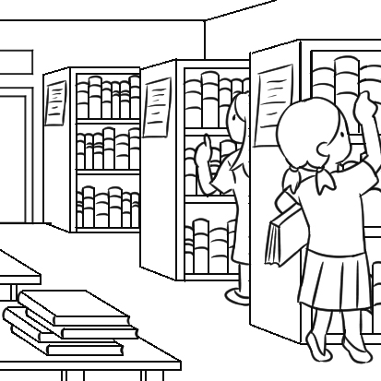
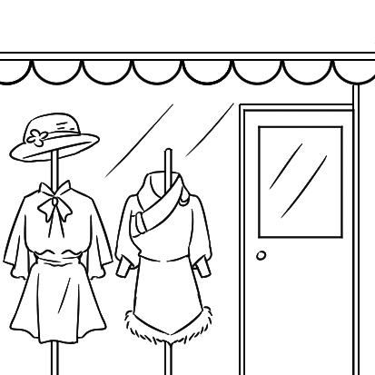
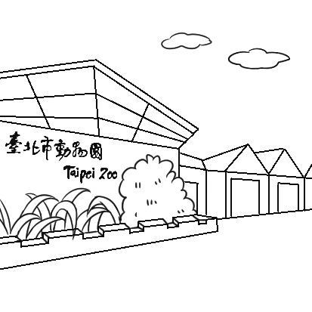
39. What is “Cool Cat Evening”?
( A ) ( B ) ( C ) ( D )
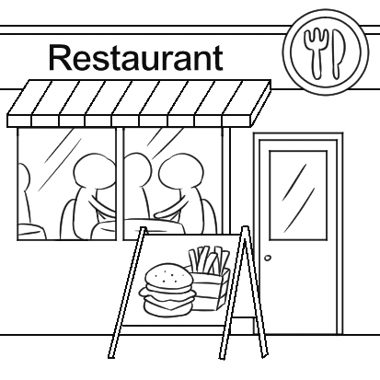
( On a video call)
Hi, Gina! Long time no see! Can you see me? I’m in my room now. Hey, take a look at the bag on the bed. It’s a gift from my daughter _(40)__ Mother’s Day. It’s really cute. I can make some cookies for __(41)___. Can you go to my house and make cookies with me this Friday? We can watch a movie _(42)__ the morning and make cookies at 2 p.m. I really hope you can come! I’m sure we will ____(43)____. See you then! # will 將要
40. ( A ) on ( B ) at ( C ) in ( D ) to
41. ( A ) we ( B ) our ( C ) him ( D ) her
42. ( A ) at ( B ) in ( C ) on ( D ) with
43. ( A ) fight with each other ( B ) talk on the phone ( C ) have a good time ( D ) look at the sign

非選擇題(請務必用黑筆作答於答案卷上，否則不予計分)
- 寫出下列中文的英文單字 ( 每格1分，共 4分)
- 使用__________ 2.今天 ___________ 3.報導 ____________ 4.醒來___________ up

二、填空式翻譯 ( 每格1分，共10 分)
- 這位歌手正在和他的粉絲拍照和握手。
The singer is __________ pictures and ____________ hands with ________ fans.
- 你這個周末有空嗎?
Are you ________ this _____________?
- 我們正坐在長椅上。他們可以看見我們。
_______ are _________ on the bench. They can see ________.
- 請檢查試管和保持安全。
Please _________ the test tubes and be _________.

