桃園市立大有國民中學111學年度第二學期第二次評量試卷
年級 | 八 | 考試  科目 | 英語科 |  |  | 命題  範圍 | Unit Three-Review 2 | 作答  時間 | 45分
班級 |  | 姓名 |  | 座號 |  | 分數

第一部分: 聽力測驗: 20分
- 辨識句意：每題均有三張圖片，請依據所聽到的句子，  選出最符合描述的圖片。(每題1分)  - (A) 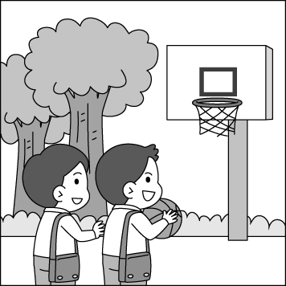 (B) 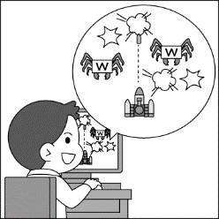 (C) 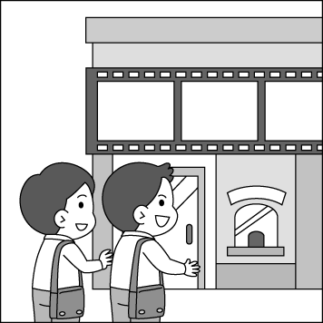  - (A) 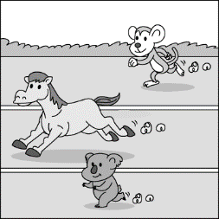 (B) 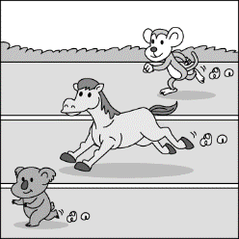 (C) 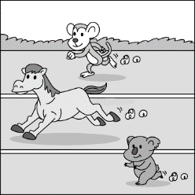  - (A) 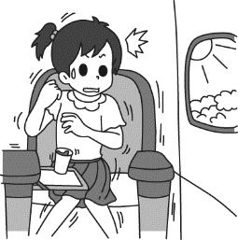 (B) 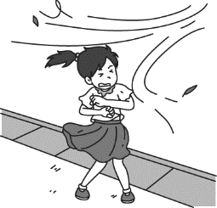 (C) 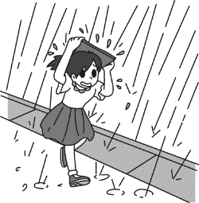  - (A) 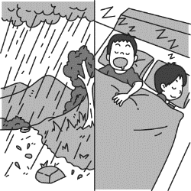 (B) 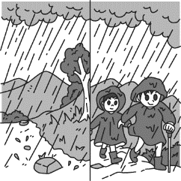 (C) 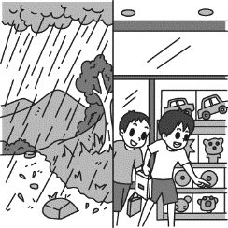  二、基本問答：每題均有三個選項，請依據所聽到的內容，  選出一個最適合的回應。 (每題2分)  (A) He has a lot of homework to do today.  (B) He did his homework carefully.  (C) He didn’t do his homework yesterday. | - (A) Yes, I do. I study with Jake.  (B) No, I didn’t because I was sick.  (C) No, I don’t. I play the piano.  - (A) I really need your help.  (B) No, it is not coming.  (C) I need to move the roses on our balcony.  (A) No, I won’t. It is too dangerous.  (B) Yes, it is on the balcony.  (C) No, let’s meet at three in front of my house.  三、言談理解：每題均有三個選項，請依據所聽到的對話  與問題，選出一個最適當的答案。(每題2分)  (A) It is dangerous to go out alone at night.  (B) The woman should pay for the man after  dinner.  (C) People shouldn’t go to the beach during a  typhoon.  (A) A lawyer.  (B) A soldier.  (C) A nurse.  (A) He missed the first bus to school.  (B) He ran too quickly and fell down.  (C) He couldn’t find his bag on the street.  (A) He didn’t have enough sleep last night.  (B) He forgot to bring his English homework to  School.  (C) He didn’t do well on the English test.

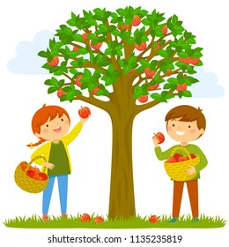
第二部分:綜合測驗: 60分
一、單選題 26% (每題2分)

13. Look at the picture. The girl and the boy are _______ the apples happily.
(A) having (B) treating (C) cutting (D) picking
14. David _______ his students take out the trash during the cleaning time.
(A) asked (B) made (C) have (D) wanted
15. Sophia helped her husband _______ the car yesterday.
(A) washes (B) washing (C) washed (D) to wash
16. Jerry didn’t finish his homework, so his mom didn’t let him _______ computer games.
(A) play (B) to play (C) playing (D) played
17. Eddie didn’t do well on the tests, so his dad had him _______ basketball with his friends.
(A) plays (B) playing (C) to play (D) not play
18. Alice felt happy when she heard the band _______ her favorite song.
(A) plays (B) is playing (C) playing (D) to play
19. The typhoon is coming. We can see the trees on the street ________.
(A) are swaying (B) swaying (C) were swaying (D) to sway
20. Lisa really likes the Korean group Twice(韓國女子團體). She has every album(專輯) of theirs. She still waits for the ________ album and wants to buy it.
(A) latest (B) late (C) last (D) least
21. Vivian likes to take a walk in the forest and feels the wind ________ on her face.
(A) blows (B) to blow (C) be blowing (D) blow
22. Mathew is _______ at sports. And he plays basketball and badminton _______.
(A) good ; bad (B) well ; well (C) good ; well (D) poor ; very good
23. If I _______ English for two hours and finish my homework, my mom _______ me watch TV.
(A) study ; doesn’t let (B) to study ; let (C) studied ; won’t let (D) study ; will let
24. Many people like to study in the library. Everyone _______ be quiet there. They _______ talk with each other.
(A) don’t have to ; shouldn’t (B) doesn’t need to ; must (C) must ; should (D) has to ; mustn’t
25. Jason jumps _______ than any other boy in his class, but he doesn’t want to join the school team. His PE teacher will talk with him _______ about it later.
(A) farther; far (B) farther; further (C) far ; further (D) further; farther
二、克漏字選擇 10% (每題2分)
Many years ago, an earthquake on September 21 cruelly killed thousands of people and caused billions of dollars in damages, and left about one hundred thousand people homeless. It was ____26.____ earthquake to hit Taiwan after 1935. The earthquake happened at 1:47 on the morning of September 21, with most people looking forward to (期待) celebrating the Moon Festival, a lot of Taiwanese were awoken by a 7.6 magnitude earthquake. Buildings fell and the roads cracked all over Taiwan. A ninety-year-old woman said, “ I was awoken by the earthquake and I felt my house ____27.____, so I ran out of my house ____28.____. I feel ____29. ___ whenever I think of the day, and I will never want to experience it again. It was like the end of the world, and I ___30. ___ forget it. It was an unforgettable memory(難忘的回憶).”
cruelly 殘酷地 damage 損害 awake/awoken 醒著的 magnitude 規模 crack 裂開

( ) 26. (A) smaller (B) the smallest (C) the most serious (D) seriously
( ) 27. (A) shakes (B) shaking (C) to shake (D) shook
( ) 28. (A) very happily (B) more slowly (C) badly (D) quickly
( ) 29. (A) scared (B) angrily (C) terribly (D) excited
( ) 30. (A) must (B) will (C) can’t (D) should

三、閱讀測驗 24% (第31~36題，每題2分; 第37~40題，每題3分) 請留意作答時間!!
題組A. 31-33題

Albert is a good student. He studies hard and gets high grades. He listens carefully in class. If he has questions, he will ask the teacher or his classmates. He also plays basketball on the school team. He spends one hour practicing it every day. He plays basketball with friends in his free time. He is popular at school.
He is also a good boy at home. His parents work very late because they are doctors. Although his parents are not often at home, he can take care of himself and his brother. He sometimes helps his grandmother do the housework. His grandma is good at cooking, and Albert and his brother enjoy eating dinner at home after school. After that, he usually spends thirty minutes helping his brother with his homework, two hours studying, and one hour listening to English songs to learn English. Both of his parents are proud of him.

take care of 照顧 housework 家務 be proud of 以…..為榮

( ) 31. What will Albert do if he has free time ?
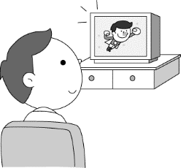
- (B) 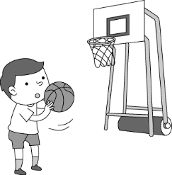
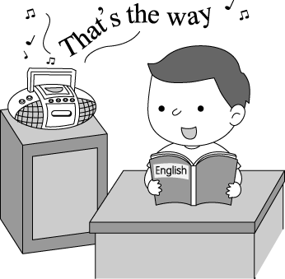
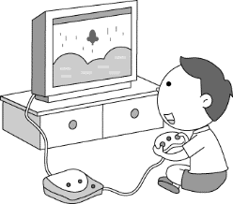
(C) (D)

( ) 32. How long does Albert practice basketball every day?
(A) For thirty minutes. (B) For one hour.
(C) For two hours. (D) For more than two hours.

( ) 33. Which is true?
(A) If Albert has questions, he will think on his own at home.
(B) Albert buys dinner home after school from Monday to Friday.
(C) Albert learns English by listening to English songs.
(D) Albert’s mom helps him with the homework.

題組B. 34-36題
Pakistan 巴基斯坦 shot 槍擊 bullet 子彈
When the whole world is silent, even one voice becomes powerful.

----- Malala Yousafzai -----

In some places around the world, all girls can’t go to school; only boys can. Take Pakistan for example. Many young girls cannot go to school. They have to work full time to feed themselves and their family. Some even become child wives because their family ask them to.

Malala, a girl from Pakistan, stood up for girls' right to education. "Everyone has a right to education, even girls," she thought. At the age of eleven, she started writing her ideas on the Internet. Little by little, her writing helped many girls in Pakistan to be strong and fight for their rights for education. She became very popular, and she spoke on TV and radio often. However, many people still don't agree with female education. Then one day, something terrible happened to her on her way to school. A man got on her school bus and shot her. The bullet went close to her left eye, but it didn't kill her. Luckily, she got better after a few months. “ I won’t let them stop me," said Malala bravely.

Now Malala is still fighting for female education rights, and she’ll keep doing it.

( ) 34. Which has the closest meaning to female ?
- children (B) women (C) everyone (D) old people
( ) 35. Which is true?
(A) Only a few girls can’t go to school in Pakistan.
(B) Someone hurt Malala on her way home from school.
(C) Malala started fighting for girls’ rights when she was young.
(D) All boys in Pakistan need to work, so they can't go to school.

( ) 36. How did Malala influence the girls in Pakistan? influence 影響
(A) She shared her ideas with them.
(B) She made TV shows for them.
(C) She asked them to work.
(D) She sold many books for them.

題組C. 37-38題
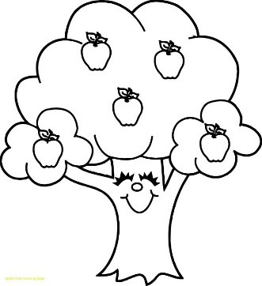
About the Game

The game is like
writing a love letter to trees. Your tree begins to grow and you must carefully look after it. When the branches grow tall enough to hit the sun, they flower and grow apples. When you have the right number of apples, you pass the level. The higher the level you get to, the more difficult it is for you to grow apples.
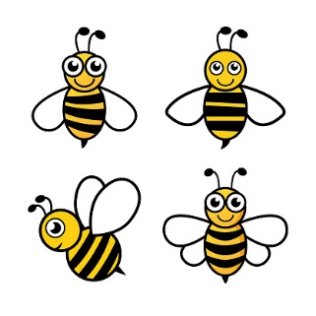
Apple Trees Busy Bees

About the Game

The game might look
like “Candy Crush”, but each level ends with a fight with a busy bee. If you finish the level, you'll face the busy bee. The more moves you have left when you finish the level, the more points you will get to help you catch the busy bee. So, you'd better play wisely at each level.

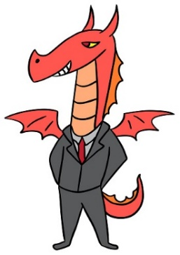
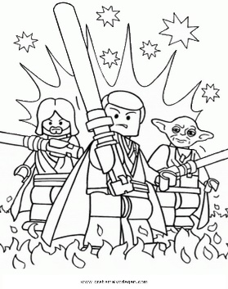
Star Fight Dragon Boss

About the Game

You must fight
a number of lesser dragons,
to meet the dragon boss
at the end of each level.
Kill the end-of-level dragon boss,
and you'll get a bag of gems to buy things and Ievel yourself up to win the next fight.
About the Game

Star Fight VII
is coming out next month.
If you want to start getting to know the new movie, this game will be your best choice. Level up your “Star Soldier”, learn new skills, and fight “the Dead Moon Empire” in this free-to-play RPG.

branch 樹枝 flower 開花 level 等級 level up (在電腦遊戲中)升級 come out 發行
RPG 電子角色扮演遊戲 lesser 次要的

( ) 37. What can a player do with the bag of “gems”?
(A) Give them away at the end of the game. give sth away 贈送;捐贈
(B) Finish the game in order to make money.
(C) Take them out and join another new game. exit 離開;結束
(D) Get things and level himself up to win the next fight.

( ) 38.
“I usually like some kinds of fighting games because they are quick and exciting.
But this game surprisingly caught my eye possibly because I am a farmer's daughter. Watching things growing gets me excited, too. Now I can’t stop playing it.”

Which game is the player now in love with?
(A) Busy Bees.
(B) Star Fight.
(C) Apple Trees.
(D) Dragon Boss.

題組D. 39-40題

Here are some people talking about a terrible accident at Sunshine Beach.

Jenny | My family and I were taking a sunbath on the beach. When I stood up, I heard someone crying loudly. Someone was crying and said, “Help me. Who can help me?”
Peter | I was playing in the water with my daughter then. Just when we stopped to take a rest, we saw something strange swimming in the sea. It looked like a big fish. Then we quickly ran away and stayed away from it. A few minutes later, we heard someone cry out for help.
Frank | When I saw the police take the poor little boy to the hospital, he looked painful, and his arms were bleeding because a shark tried to eat his arms for lunch. How terrible it was!
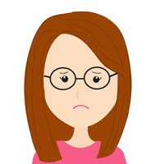  Amy | I shouldn’t let my son swim in the sea. He hurt himself seriously, and I am really sorry about that. Now, I have to go to the hospital and stay with my son.

sunbath 日光浴 bleed 流血 shark 鯊魚 seriously 嚴重地

( ) 39. What does “painful” mean?
(A) Not good.
(B) Happy.
(C) Friendly.
(D) Wonderful.

( ) 40. Which is true about the reading?
(A) Amy and Frank are mother and son.
(B) A boy hurt himself because he couldn’t swim well.
(C) It was an exciting and good experience for everyone.
(D) It is dangerous to swim at Sunshine Beach.

