桃園市立大有國民中學111學年度第一學期第二次評量試卷
年級 | 八 | 考試  科目 | 英語科 |  |  | 命題  範圍 | Unit Three-Review 2 | 作答  時間 | 45分
班級 |  | 姓名 |  | 座號 |  | 分數

第一部分: 聽力測驗: 20分
- 辨識句意：每題均有三張圖片，請依據所聽到的句子，  選出符合描述的圖片。(5分,每題1分)  - (A) 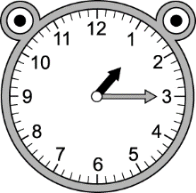 (B) 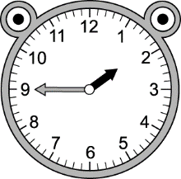 (C) 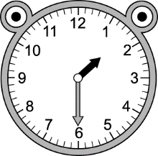  - (A) 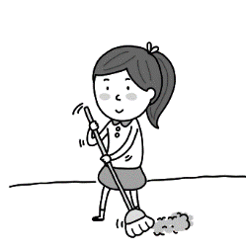 (B) 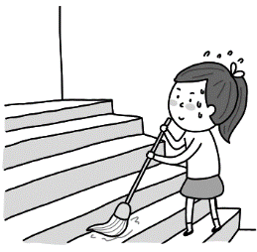 (C) 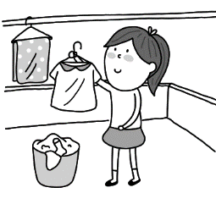  - (A) 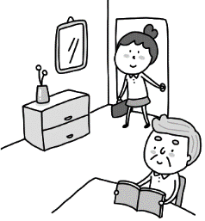 (B) 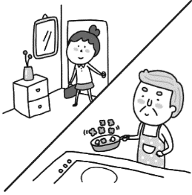 (C) 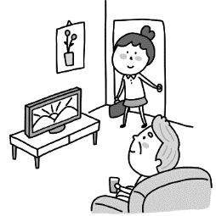  - (A) 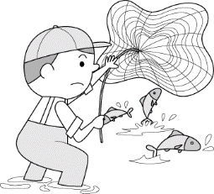 (B) 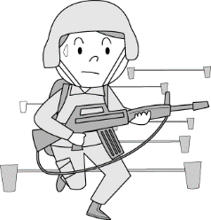 (C)  - (A) 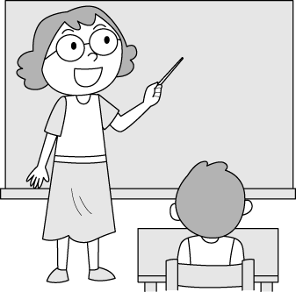 (B) 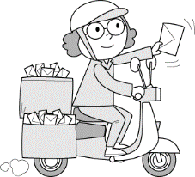 (C) 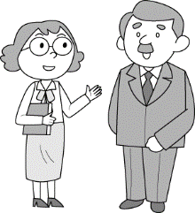 | 二、基本問答：每題均有三個選項，請依據所聽到的內容，  選出一個最適合的回應。 (5分,每題1分)  - (A) He is doing his homework.  (B) He was drying his hair.  (C) He didn’t come to my house.  - (A) A half past six.  (B) It is difficult to get up early.  (C) I don’t need to get up at 6.  - (A) Being a dentist is my dream job.  (B) I have to work eight hours a day.  (C) It is good to have your dream.  - (A) Yes, she likes to play the piano.  (B) Yes, she is.  (C) No, it isn’t difficult at all for her.  - (A) She has much time now.  (B) She enjoys reading in the coffee shop.  (C) She is doing her homework now.  三、言談理解：每題均有三個選項，請依據所聽到的對話  與問題，選出一個最適當的答案。(10分,每題2分)  - (A) It begins at 7:30.  (B) It begins at 8:30.  (C) It begins at 9 o’clock.  - (A) A salesperson.  (B) A secretary.  (C) A farmer.  - (A) Have the right food and exercise.  (B) Try to eat vegetables.  (C) Try to exercise every day.  - (A) 7:45.  (B) 7:50.  (C) 8:00.  - (A) He was having dinner with Hank.  (B) He was parking his car.  (C) He was playing basketball.

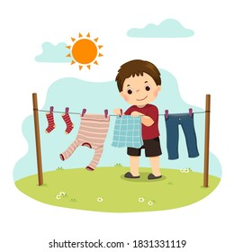
第二部分:綜合測驗: 60分

一、單選題 22% (每題2分)

16. Look at the picture on the right. What was the boy doing?
(A) He was drying the hair. (B) He was doing the dishes.
(C) He was taking out the trash. (D) He was hanging the clothes.
17. Drinking enough water _________ important for everyone.
(A) be (B) is (C) are (D) were
18. Leo __________ the piano at eight o’clock last night.
(A) plays (B) can play (C) is playing (D) was playing
19. BLACKPINK(韓國女子團體) thanked their fans for _________ to their concert in Kaohsiung.
(A) come (B) came (C) coming (D) to come
20. ________ Kevin taking the trash out at six yesterday afternoon?
(A) Does (B) Did (C) Was (D) Were
21. It’s nice for you ________ about becoming a successful lawyer in the future.
(A) to dream (B) dreaming (C) dream (D) not dream
22. What time is it now? It’s half ________ twelve.
(A) to (B) pass (C) past (D) of
23. Kelly and Paul played video games after they finished _________ their math homework.
(A) do (B) doing (C) to do (D) does
24. Ms. Chen _________ having a cup of coffee in the morning. She likes to drink coffee very much.
(A) enjoys (B) hates (C) stops (D) plans
25. It’s five _______ six now. Hurry! We need to arrive(到達) at the movie theater before six.
(A) at (B) from (C) after (D) to
26. _________ up early and _________ doing exercise every day are not easy for me.
(A) Get ; keep (B) Getting ; keeping (C) Get ; to keep (D) To get ; keeping

二、克漏字選擇 8% (每題2分)

James is a junior high school student. He likes ____27.____ basketball. When he was a little boy, he decided ____28.____ a basketball player. However, he ____29.____ in his stomach when he took part in a basketball game, and then he lost the game that day. So, he joined a sports club to practice ____30. ___. Finally, his team won the first prize. He had a great experience in this sports club.
take part in 參加(比賽) finally 最後 prize 獎項

( ) 27. (A) play (B) break (C) playing (D) to break
( ) 28. (A) to become (B) became (C) becoming (D) becomes
( ) 29. (A) gets butterflies (B) got butterflies
(C) takes it easy (D) took it easy
( ) 30. (A) reading books (B) singing songs (C) writing a story (D) playing basketball

三、閱讀測驗 20% (每題2分)
題組A. 31-33題
Miss Trouble was a good little girl. But she was also a lot of trouble for her family and friends. When her mother wanted her to get up, she slept. When her father wanted her to go to sleep, she stayed up. When her friends wanted her to go out, she stayed at home. When her family wanted her to watch TV, she listened to the radio. When her family wanted her to eat, she was not hungry. When her parents wanted her to do the homework, she talked on the telephone. When her friends wanted to talk to her, she didn’t have time. When her mother wanted her to do the dishes, she played the computer games. When her teachers wanted her to play ball in school, she had a headache. But when her mother and father wanted to give her some money, she said, “OK!” Yes, Miss Trouble was a good little girl. But she caused a lot
of trouble in her family and friends. play ball (與)…合作 cause 造成

scientist 科學家

( ) 31. What does the phrase “stay up” mean?
(A) Get up late. (B) Stay at home.
(C) Go to bed late. (D) Stay at the same place.
( ) 32. What did Miss Trouble want to do when her friends wanted her to go out?
(A) Watch TV. (B) Stay at home.
(C) Listen to the radio. (D) Stay up.
( ) 33. What did Miss Trouble want to do when her parents wanted her to do the homework?
(A) Talk on the phone. (B) Listen to the radio.
(C) Walk the dog. (D) Watch TV.
題組B. 34-35題

It’s OK to say “No”.
Saying “no” can be difficult for us because we usually worry about hurting others. However, learning to turn someone down is important. Sometimes we might really want to help others, but it’s not possible to help everyone with everything because we don’t have enough time to do so.

First, before we say no to others, we can say something kind. For example, we can say “That’s a good idea, but I’m sorry for having no time.” or “Thank you for thinking of me, but I can’t help you.” What’s more, when we don’t want to just say no, giving others another idea can be a good way. For example, we can say “ Sorry, I can’t. Maybe you can ask Susan for help.”

Now, start practicing saying no. It can be a great help to you when you need it.

possible 可能的 for example 例如 reason 理由 what’s more 此外

( ) 34. What does “turn someone down” in the second line mean?
- Hurting someone. (B) Helping someone.
(C) Saying no to others. (D) Worrying about others.
( ) 35. Why is learning to say “no” important?
- Saying “no” is fun and easy.
- It is good to help people when we can.
(C) We need to think about people around us.
- We might not have enough time to help everyone.

題組C. 36-38題

Sophia has a busy life. She is a dentist and works for ten hours every day. Also, she’s a writer and
works for a magazine company. On weekends, she is a deliver woman. She delivers foods for people. She is very busy, but she enjoys all her jobs.
Just like Sophia, many people work two or more jobs at the same time. We all call them “slashies”. Because they often use slashes when describing their jobs like “I’m a dentist / writer / deliver man”.
For slashies, they don’t work different jobs only for money. Some people become slashies because they have great interest in other things. They want to learn more things from jobs. What’s more, they also need another job to fulfill their passion.
A slashie’s life is really busy. They enjoy their way of working, and they have a happy and full life.

slash 斜槓 describe 描述 interest 興趣 fulfill 滿足 passion 熱情

( ) 36. What does Sophia do on weekends?
- She delivers foods for people.
- She fixes people’s teeth.
- She writes the articles. article 文章
- She drives a taxi.
( ) 37. Who is a “slashie”?
(A) Ivy, she is a taxi driver, and she only works on weekends.
(B) Tim, he is a mail carrier during the day and a salesman at night.
(C) Eric, his grandfather is a farmer, and he has the same job.
(D) May, she is an English teacher, but she decided to leave her job this year.
( ) 38. What does the writer think about “slashie”?
(A) They work because they need money.
(B) It’s not good for them to work two or more than jobs at the same time.
(C) It can be difficult for them to learn new things.
(D) They need another job to fulfill their passion.
題組D. 39-40題

Rachel: Vivian, did you sleep well last night? You look tired now.
Vivian: No. I didn’t. I had a nightmare because of a horror movie —The Tag-Along(紅衣小女孩).
Rachel: What? I thought you were fond of horror movies.
Vivian: Sometimes I did. I can watch horror movies many times. I mean I don’t hate them.
But that was really a scary movie. After I watched it, I had a nightmare last night.
Rachel: Are you kidding me? Why?
Vivian: Well, let me tell you why. Please read these lines in this movie.

……One day, a girl, Yijun(怡君), turned on her grandma’s camera, she saw a strange shadow in a red dress stood behind her grandma, and the shadow was wearing a weird smile in her face. …….

Rachel: Okay. This one really freaks me out. It’s amazing to make people scared in only three
sentences.
Vivian: You’re right. That’s why I didn’t sleep well last night.

nightmare 惡夢 horror 恐怖的 line(s) 台詞 shadow 影子 weird 詭異的
freak sb. out 嚇壞(某人)
( )39. Which has the similar (相似的) meaning to the phrase “be fond of” in the dialogue?
(A) Vitor loves to read comic books. He reads them every day.
(B) Jamie keeps playing the violin. She wants to be a musician in the future.
(C) Sandy stops making breakfast every morning because she is busy.
(D) Peter hates to mop the floor every day. He thinks it’s boring.

( ) 40. Which is true about the movie- The Tag-Along(紅衣小女孩)?
(A) For Rachel and Vivian, the movie was not horrible at all. horrible 可怕的
(B) Rachel and Vivian didn’t like watching horror movies.
(C) After Vivian watched the movie, she had a bad dream that night.
(D) Rachel would like to try to write her own horror story after watching the movie.

四、根據句意選出正確的動詞變化 10% (每題2分)

( ) 41. A: What were you doing when the window __________?
B: I was drying my hair. I wasn’t by the window then.
(A) break (B) broke (C) is breaking (D) was breaking

( ) 42. It is seven forty-five, and the students __________ the classroom now.
(A) are cleaning (B) were cleaning (C) is cleaning (D) clean

( ) 43. Lady Gaga hoped __________ a singer at a young age, but no one believed in her.
(A) become (B) became (C) being (D) to be

( ) 44. A: Why do you keep ________ numbers? B: I’m counting sheep because I can’t fall asleep.
(A) saying (B) to say (C) says (D) said

( ) 45. After a reporter interviewed someone in Itaewon area(梨泰院區) this Halloween. He said
many people ________ and toppled(推倒) one after another. Some people hurt and even died.
(A) fall (B) fell (C) are falling (D) to fall

