桃園市立大有國民中學109學年度第一學期第二次評量試卷
年 級 | 七 | 考 試  科 目 | 英文 |  |  | 命 題  範 圍 | L3~Review II | 作 答  時 間 | 45分
班 級 |  | 姓 名 |  | 座 號 |  | 分 數

一、辨識句意：根據聽到的內容，選出符合描述的圖片或符合圖片的描述。(一題2分)
- (A)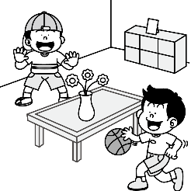 (B)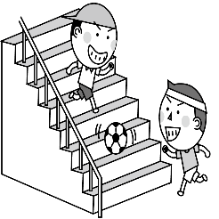
(C)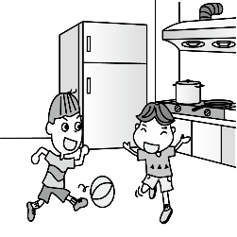
- (A) 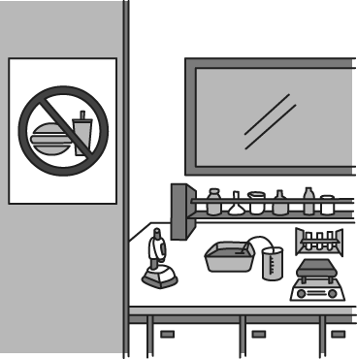 (B)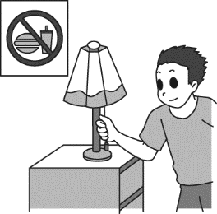
(C)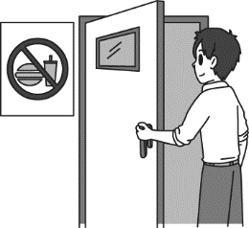
- (A)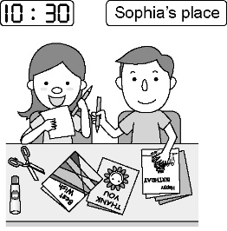 (B)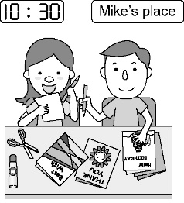
(C)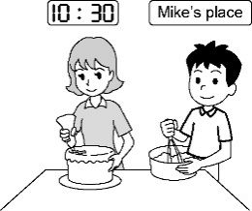
- (A)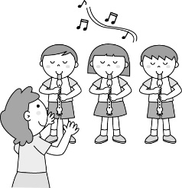 (B)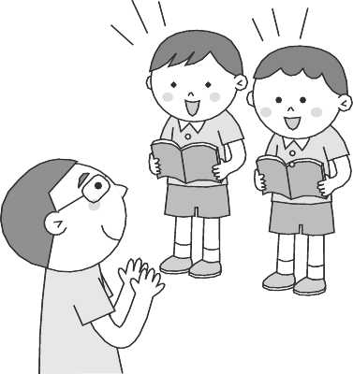
(C)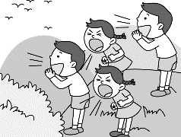
- (A)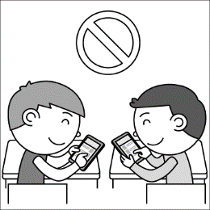 (B)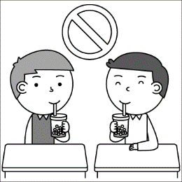
(C)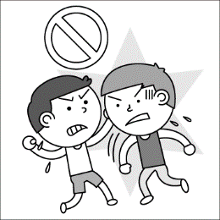

二、基本問答：根據聽到的內容，選出一個最適合的回應或最適合的問句。(一題2分)
- (A)Sorry, Dad.
(B)Where are you?
(C)Let’s play here.
- (A)Don’t sleep in class.
(B)Pick up the ball in the park.
(C)OK. Let’s go now.
- (A)They are watching the birds at the park.
(B)How is the ball game this afternoon?
(C)No, I am very busy doing my homework.
- (A)You are wrong again.
(B)Wow! Everyone is very busy.
(C)Maybe they are jumping up and down.
- (A)Yes, today is his birthday.
(B)His birthday party is at eight p.m.
(C)Let’s make a card and a cake for John at four p.m.

三、言談理解：根據聽到的內容，選出一個最適合的答案。(一題2分)
- (A)To the park.
(B)To the new 7-11.
(C)To Mr. and Mrs. Wilson’s home.
- (A)Jason is waiting for Terri in a toy shop.
(B)Terri’s cousin is handsome and young.
(C)Terri is waiting for the bus with Jason.
- (A)On Monday.
(B)On Thursday.
(C)On Sunday.
- (A)7:30
(B)8:30
(C)9:00
- (A)No one.
(B)Simon and Ruth.
(C)Benson and Laura.
四、文法選擇 (一題2分)
- Let’s ______ run in the lab.
(A) not (B) please (C) don’t (D) ╳
- Mom, the markers on Sister Sally’s desk are new. Can I use for a picture?
(A) it (B) him (C) her (D) them
- Please .
(A) Bernice, come in
(B) come in, Anna
(C) not come in (D), come in, Anna.
- A：Don’t fight your brother and please be polite (有禮貌的) to . Can you do that?
B：Okay.
(A) with ; he (B) on ; he (C) with ; him (D) on ; him
- Check the tubes cracks, thank you.
(A) for (B) in (C) on (D) from
- You can’t write draw on these books.
(A) but (B) on (C) or (D) with
- the key (鑰匙), you can open this door.
(A) Of (B) With (C) From (D) To
- Please turn off the phone.
(A) not (B) don’t be (C) can’t (D) don’t
- A: What time is it?
B: It’s six o’clock.
(A) ╳ (B) at (C) from (D) for
- Let’s have lunch together Father’s Day.
(A) in (B) at (C) on (D) ╳
- The concert is Saturday night.
(A) on (B) at (C) in (D) for
- A: are you taking a walk? B: At the park.
(A) What (B) How
(C) Who (D) Where
- It is seven thirty the morning.
(A) on (B) to (C) in (D) at
- A: is standing at the door?
B: That’s Benny.
(A) How (B) Who (C) What (D) Where
- A： is your brother doing?
B：He’s sleeping.
(A) How (B) Who (C) What (D) Where

五、克漏字(一題2分)
Lisa：What (31) you doing, Sam?
Sam： (32) a video of my cousin, Jeremy. Come and
(33) a look (34) it.
Lisa：Wow. He is handsome, and his voice is great.
Sam：Yes, he is really a good singer. By the way, are you
(35) tonight? His first concert is at 8:00 at Music
Party House. We can go together.
Lisa：I can’t wait.

- (A) am (B) are (C) is (D) can
- (A)Watch (B) To watch (C) Watches (D) Watching
- (A) take (B) report (C) study (D) blow
- (A) to (B) at (C) on (D) in
- (A)great (B) cute (C) free (D) sure

六、閱讀測驗 (一題2分)
Ray: Isn’t this card cute?
Claire：I am not sure. Richard’s favorite color is blue.
Ray：Let me see … Can I buy this blue card?
Claire：Not bad. And I can buy that blue card, too.
Ray：Great. Let’s have a birthday party for Richard, too.
How’s that?
Claire：No. These two birthday cards are enough, I think.
Ray：OK. And we’re going to his house for his birthday this
Sunday. Maybe we can buy something for Mr. and
Mrs. Miller, too. Richard’s parents are nice to us.
Claire:：Sure. Let’s do that. Can we buy these erasers?
Ray：Yes, they are good, but let’s buy them next time. Wait!
What time is it?
Claire：It’s five to eight.
Ray：Oh, no. My piano class is at eight. See you this
Sunday, Claire.
Claire：See you. Have a good time there, man.

buy 買 birthday 生日 something 某物品
next 下一個的
- Ray and Claire are having this conversation(對話) now. What time is it?
(A) Five o-eight. (B) Seven fifty-five. (C) Eight o- five. (D) Seven o-five.
- “That” in this conversation refers to(指的是)：
(A) A friend. (B) A color. (C) A card. (D) A party.
- “There” in this conversation refers to(指的是)：
(A) Ray’s piano class.
(B) Claire’s piano class.
(C) Mr. and Mrs. Miller’s house.
(D) Richard’s birthday party.
Alice is the Watts family’s baby girl. She is one year old. The birthday party is for Alice today, but her birthday is this Tuesday ─ two days from now. Alice’s grandpa and grandma are taking pictures of her. Alice’s brother is making a card for her. What are Alice’s parents doing? Alice’s mom is making a cake in the kitchen, and Alice’s dad is reading a picture book with Alice. Alice is very happy today.
- What day is today?
(A) Sunday. (B) Tuesday. (C) Thursday. (D) Friday.
- What is Alice’s mother doing?
(A) She’s reading.
(B) She is making a card.
(C) She is taking pictures.
(D) She is making a cake.
…………………………………………………………………..
※ 非選題 (填入答案卷) (一格一分 共20分)
七、文意字彙
- W e up, Nina. It’s time for school.
- Do not play with the test tubes. It’s not s e.
- Please f w the classroom rules.
- H y up. We are late for the movie.
- Be c l. The dog is not nice to people.
- A: Who’s your E h teacher? B: Jennifer.
- Please s n your name here at the bottom (底部).
- Let’s s e hands and be good friends again, okay?
- A: Isn’t the museum open day this W y?
B: No, it’s this Monday.
- The boy is tall and handsome and he is very p r with girls.

八、填充題
- 把括號部分用代名詞的主格、所有格或受格改寫
- Talk to (Rita and I), please.
- Da-You Junior High School is behind (she) house.
- (We) can’t talk louly (大聲地) in the museum.
- Joe and Adam are (George and Vivian’s) good friends.
- A: Can you go wash ( your car)?
B: Okay.
- 依提示填入正確的動詞形式 (不限一字)
- Two boys (sit) on the bench and reading their books.
- Do not (jump) on the sofa, girls.
- We can’t (take) pictures here.
- Look! The bus (come).
- (Close) the door, please.

