桃園市立大有國民中學109學年度第一學期第一次評量試卷
年 級 | 八 | 考 試  科 目 | 英語科 |  |  | 命 題  範 圍 | Lesson One- Review One | 作 答  時 間 | 45分
班級 |  | 姓 名 |  | 座 號 |  | 分 數

聽力(辨識句意)-根據聽到的內容，選出正確的圖片代碼：每題1分
1.
(A) |  | 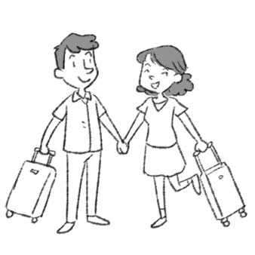 |  | (B) |  | 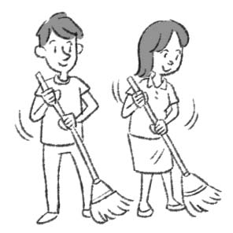 | (C) |  | 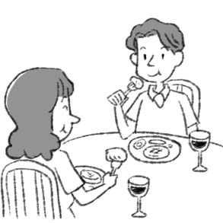
2.  (A) | 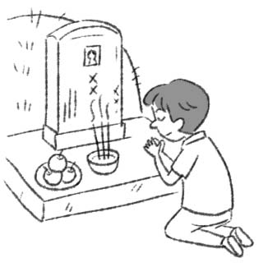 |  | (B) |  | 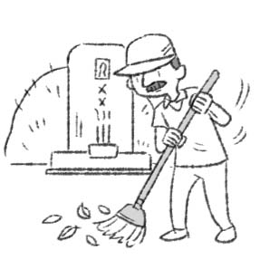 |  |  | (C) |  | 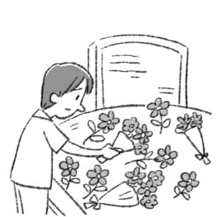
3.
(A) | 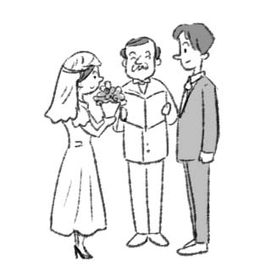 | (B) | 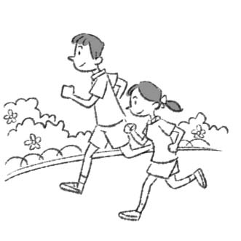 | (C) | 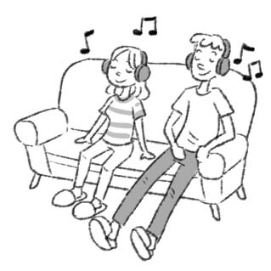
4.
(A) | 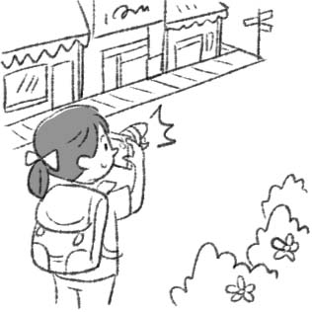 | (B) | 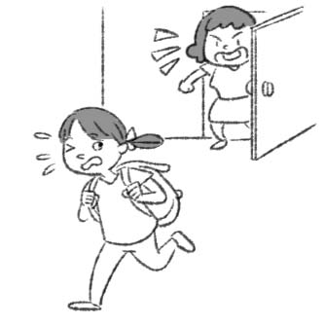 | (C) | 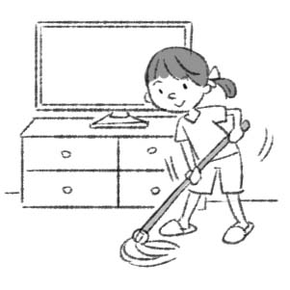

二、聽力(基本問答)-根據聽到的內容，選出合適的回應：每題2分
5. (A) No, I didn’t. (B) I watched a movie. (C) We are reading.
6. (A) Yes, I did. (B) No, we don’t have milk. (C) Yes, the bread is delicious.
7. (A) It was at six o’clock. (B) They didn’t invite me. (C) Almost everyone in my class.
8. (A) I drank some milk. (B) I ate some bread. (C) I drew a flower.
9. (A) Are you Okay? (B) Oh no, that’s terrible. (C) He did well yesterday.
10. (A) Nobody helped him. (B) She didn’t remember me.
(C) Because I didn’t have enough money.
11. (A) Guess what? (B) Did she see a doctor? (C) Why didn’t you go to school?
三、聽力(言談理解)-根據聽到的對話內容與問題，選出正確的答案：每題2分
12. (A) She was sick. (B) She was busy. (C) She was angry.
13. (A) Terry’s grandpa passed away.
(B) Terry and his mom were at the party on Sunday.
(C) The woman was at her grandpa’s house on Sunday.
14. (A) They cleaned the desk. (B) They walked on the street. (C) They celebrated the New Year.
15. (A) Jack sold it. (B) It is in Jack’s sister’s house. (C) Jack’s sister broke it.
16. (A) He ate some food at the market.
(B) He stayed in the car this morning.
(C) He was hungry because there was no more food.
17.(A) It was Jimmy’s old car. (B) The car was not very big. (C) Nick sold the car last week.
四、文法測驗 每題2分
18. Alex: Did Hank ________ any sport today?
Irene: No, he was at home.
(A) play (B) plays (C) played (D)playing

19. The men ________ very sad because of the bad news about Kobe Bryant.
(A) was (B) did (C) were (D) is

20. David: What did you ________ yesterday afternoon?
Vivian: I ________ my homework yesterday afternoon.
(A) did; do (B) do; did (C) do; do (D) did; did

21. Peter: Who ________ the sofa in the living room?
Julia: My father did.
(A) move (B) moves (C) moved (D) moving

22. It ________ , so we didn’t have a picnic with my friends.
(A) is raining (B) was rain (C) had rain (D) rained

23. Ken cried loudly because his grandfather ________ yesterday.
(A) was dead (B) was death (C) dead (D) did dead

24. Carson: Was Linda an actress before?
Joy: Yes, ________.
(A) Linda was (B) Linda did (C) she was (D) she did

25. Joy liked the stinky tofu before, and Bruce ________,too.
(A)was (B) did (C) liked (D) didn’t

26. Sophia: Were you happy at the birthday party ________?
Emma: Yes.
(A) on weekends (B) five years before (C) last one week (D) at that time

27. Nala: How ________ you go to the night market last Friday?
Lian: I walked there.
(A) did (B) can (C)were (D) could

28. There many things in the bedroom yesterday. But there anything in the bedroom today.
(A) are; aren’t (B) were; isn’t (C) are; wasn’t (D) were; weren’t

29. The party fun last night. Maybe you can join us next time.
(A) was (B) had (C) did (D) were

30. That pair of shoes very expensive, but my husband still it for me yesterday.
(A)was; didn’t buy (B) were; didn’t buy (C) was; bought (D) were; bought

31. Jack last Sunday.
(A) win the game (B) sells his old bike to me
(C) take a bus to Dayou Junior High School (D) hurt his right hand

32. Morgan didn’t feel well yesterday .
(A) , so he doesn’t go out (B) because he runs with us
(C) , so he couldn’t join the potluck (D) because he went to the doctor

五、克漏字測驗 每題2分
Teacher: Sophia, you 33. in my class today. Why?
Sophia: Sorry! 34. I didn’t sleep well last night 34. I was very tired.
Teacher: 35.
Sophia: I watched a ghost movie, and then I 36. all night.
Teacher: Terrible! Didn’t your brother sleep with you?
Sophia: No. He 37. in another room all night.
Teacher: Maybe you can’t watch a ghost movie before bed.
Sophia: I see.

tired 疲倦的
33. (A) slept (B) sleep (C) sleeps (D) was slept
34. (A) Because; so (B) X; because (C) So; , (D) Because; ,
35. (A) What was you happened? (B) What you happened?
(C) What did you happen? (D) What happened to you?
36. (A) scared (B) was scared (C) did scare (D) were scared
37. (A) read English (B) studied English (C) reads English (D) studies English

六、閱讀測驗 每題2分
(38.-39.)
Dear Lucky,
I miss you very much, so I write this letter to you. Although it’s not possible for you to get it, I still want to show my love and thanks to you.
Thank you for bringing me a lot of fun. Every time when I got home, I saw you wag your tail and ran quickly to me. And I knew you were happy to see me. On weekends, I walked you in the park and we had a great time. When I was down, you were also by my side. You just looked at me quietly and listened to me. You said nothing but I believed you knew my feelings.
But you left me forever last month because a car hit you. I am still very sad now. I can’t hear you bark and hold you in my arms. All I can do is only look at your photo.
Anyway, hope you live happily in the heaven.
Ben.
wag 搖動
38. What did Lucky do when Ben wasn’t happy?
(A) He looked at him quietly and listened to him.
(B) He wagged his tail.
(C) He talked to him to make him happy.
(D) He ran in the house.

39.Which is TRUE?
(A) Lucky passed away because he was sick.
(B) Ben walked Lucky every day before.
(C) Lucky can get the letter soon.
(D) Ben loves Lucky very much.

(40-42)
About two hundred years ago, robbers came to the villages in Pingxi to take away food or money. Some women, old people and young kids ran to hide somewhere in the mountains because they weren’t strong enough and couldn’t protect themselves. After the robbers left, their family released the sky lanterns. When they saw the sky lanterns flying in the sky, they knew they could go home. Besides, the words “sky lantern” sound like “adding sons” in Taiwanese. They hoped they could have more sons in the family to help them work on the farm. And they also prayed for good luck for the coming year by releasing sky lanterns.
Today, many people come here and write down their wishes on the sky lanterns. They release them and pray for good luck. People release more than 300,000 sky lanterns every year. They fall down in the mountain areas or river banks after they burn out. Some people pick them up because they can get some money by recycling them. Some volunteers clean them because they want to give people a clean place.
We can recycle 90% of sky lanterns, but there are still tons of garbage in the mountains. Except bamboo, the iron wire, tape, paper (resistant to water) take a long time to decompose.
Bank of Culture noticed it, and they designed eco- friendly sky lanterns. They used the paper and recycled paper to make the sky lanterns. The eco- friendly sky lanterns can burn out in the sky, and then they will be lost in the sky. An eco- friendly lantern is four hundred dollars. It costs two hundred dollars more than the traditional one, so most people don’t want to buy it.
Try to write down your wishes on the eco- friendly sky lanterns and release them next time. Maybe it can make the environment and your future brighter.

robber 搶匪 release釋放 wire 鐵線 resist 抗拒的 decompose 分解 traditional 傳統的
environment 環境
Taditional Eco- friendly
Sky Lanterns Sky Lanterns

BOTH
?
40.Victor is doing his report. He wants to tell the traditional sky
lanterns and eco- friendly sky lanterns.
He draws a picture, and what words can he put in “BOTH”?
(A) They will fall down after burning out.
(B) People can write down wishes on them.
(C) Volunteers can recycle them to get money.
(D) Visitors have to spend the same money on them.

41. Below are the writer’s points in the reading:
a. A different kind of sky lantern.
b. Why did people release sky lanterns before?
c. Where does the sky lanterns go out after they burn out?
In what order does the writer talk about his points?
(A) a→c→b. (B) b→c→a. (C) c→a→b. (D) c→b→a.

42. What can we NOT learn from the reading?
(A) How much a traditional sky lantern is.
(B) About how many sky lanterns people can recycle.
(C) Why people wanted to have more boys before.
(D) Where we can recycle the most sky lanterns.

