桃園市立大有國民中學111學年度第二學期第三次評量試卷
年 級 | 八 | 考 試  科 目 | 英語科 |  |  | 命 題  範 圍 | Unit Five-  Review III | 作 答  時 間 | 45分
班級 |  | 姓 名 |  | 座 號 |  | 分 數

第一部分：聽力測驗 每題兩分 30%

辨識句意：根據聽到的內容，選出符合描述的圖片或符合圖片的描述。
- （ ）
(Ａ) 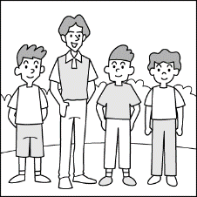(Ｂ) 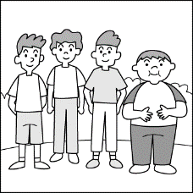(Ｃ) 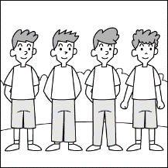
- （ ）
(Ａ) 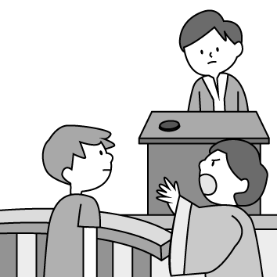(Ｂ) 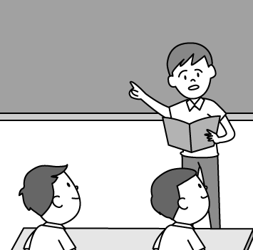(Ｃ) 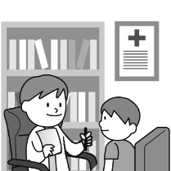
- （ ）
(Ａ) 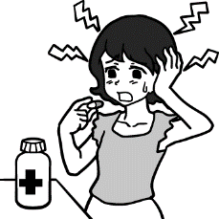(Ｂ) 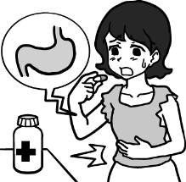(Ｃ) 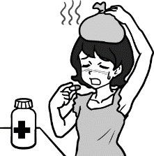
- （ ）
(Ａ) 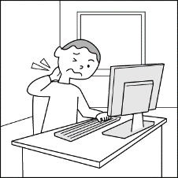(Ｂ) 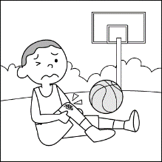(Ｃ) 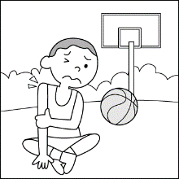
- （ ）
(Ａ) 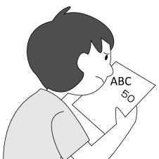(Ｂ) 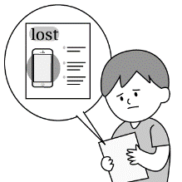(Ｃ) 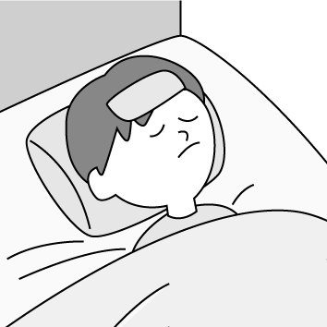

基本問答：根據聽到的內容，選出一個最適合的回應或最適合的問句。
- （ ）
(Ａ) I don’t like cold weather.
(Ｂ) My throat doesn’t hurt now. I feel much better.
(Ｃ) Yes, I can feel the ground shaking.

- （ ）
(Ａ) Yes, I am almost there.
(Ｂ) No, it is really not fair.
(Ｃ) Yes, count me in, please.
- （ ）
(Ａ) Yes, I am good at math.
(Ｂ) Yes, it was. So most of the students failed the test.
(Ｃ) No, it was really difficult.
- （ ）
(Ａ) My favorite one is Stephen Curry.
(Ｂ) Well, all of us love NBA games.
(Ｃ) The tickets to the NBA games are very expensive.
- （ ）
(Ａ) Come on! Grades don’t mean everything.
Don’t worry.
(Ｂ) Yes, I will hold a party for you next week.
(Ｃ) Yes, I am not afraid of making mistakes.

言談理解：根據聽到的內容，選出一個最適合的答案。
- （ ）
(Ａ) She had a headache.
(Ｂ) She had a stomachache.
(Ｃ) She got a runny nose.
- （ ）
(Ａ) A T-shirt.
(Ｂ) A nice car.
(Ｃ) A computer.
- （ ）
(Ａ) Both of Winnie’s parents are math teachers.
(Ｂ) Both of Winnie’s parents are teachers in the junior high school.
(Ｃ) One of Winnie’s parents is a Chinese teacher.
- （ ）
(Ａ) He has a headache.
(Ｂ) He has a sore throat.
(Ｃ) He hurt his neck.
- （ ）
(Ａ) He didn’t bring homework to school.
(Ｂ) He couldn’t go out with the girl.
(Ｃ) He failed the test again yesterday.

第二部分：閱讀理解 70%
一、文法與字彙：每題兩分 50%
( ) | 16. | A: Would you be my girlfriend?  B: To be __________, you are not my type.
 |  | (A) |  |  |  | simple |  |  |  |  |  | (B) |  |  |  |  |  | honest |  | (C) |  |  |  |  |  | smart |  |  | (D) |  |  |  |  | helpful
( ) | 17. | A: I am sorry for breaking your cup.  B: _______________ I can use another one.
 |  | (A) |  | What’s the matter? |  |  |  |  |  |  |  | (B) |  | No excuse. |  |  |  |  |  | (C) |  |  |  | It doesn’t matter. |  |  |  |  | (D) |  |  | Count me in.
( ) | 18. | I don’t quite understand the question. Could you _________ those words more clearly?
 |  | (A) |  | define |  |  |  |  |  |  |  | (B) |  | decide |  |  |  |  |  | (C) |  |  |  | download |  |  |  |  | (D) |  |  | draw
( ) | 19. | Tom ate something bad, and now he has a _____________.
 |  | (A) |  | headache |  |  |  |  |  |  |  | (B) |  | backache |  |  |  |  |  | (C) |  |  |  | toothache |  |  |  |  | (D) |  |  | stomachache
( ) | 20. | A: The ball game starts at 7:00 p.m., doesn’t it?  B: No. ____________, it begins at 6:30 p.m.
 |  | (A) |  |  |  | As for |  | (B) |  |  |  |  |  | Actually |  |  |  |  |  | (C) |  |  |  | Ouch |  |  | (D) |  |  |  |  | No worries
( ) | 21. | It’s ___________ to see people using cellphones on the metro. People almost can’t live without cellphones.
 |  | (A) |  |  |  | convenient |  |  |  |  |  | (B) |  |  |  |  |  | probably |  | (C) |  |  |  | common |  |  |  |  | (D) |  |  |  |  | useful
( ) | 22. | His drinking problem __________ his death in the end.
 |  | (A) |  |  |  | led to |  |  | (B) |  |  |  |  |  | failed |  |  |  |  |  | (C) |  |  | pictured |  |  | (D) |  |  |  |  | expected
( ) | 23. | “My parents treated us all the same when we were kids.”  Tom was reading a book, and he didn’t know the meaning of “treat”. He looked it up in the dictionary and found there were more than one meaning. Which of the following sentences has the same meaning?
 |  | (A) |  |  |  | A: I didn’t bring my wallet with me.  B: Don’t worry. My treat.
 |  | (B) |  |  |  | Put your money away. I am going to treat you this time.
 |  | (C) |  |  |  | My husband treats me as a princess. He is always kind to me.
 |  | (D) |  |  |  | The doctor treated my cold with some medicine. I am feeling better now.
( ) | 24. | “Tom felt ill, so he went to a doctor and took some medcicine. After getting some rest, he felt better.”  Amy’s teacher asked them to find the synonyms(同義詞) for “ill”.  Which of the following words will she NOT find in the dictionary?
 |  | (A) |  |  |  | sick |  |  |  |  | (B) |  |  |  |  |  | not feel well |  | (C) |  |  |  | under the weather |  |  |  |  | (D) |  |  |  |  | feel sad
( ) | 25. | Playing basketball is fun, __________?
 |  | (A) |  |  |  | is that |  |  |  |  |  | (B) |  |  |  |  |  | isn’t that |  | (C) |  |  |  |  |  | isn’t it |  |  | (D) |  |  |  |  | is it
( ) | 26. | Tom likes music very much, _________?
 |  | (A) |  |  | doesn’t he |  | (B) |  |  |  |  |  | does he |  |  |  |  |  |  | (C) |  |  |  |  | doesn’t Tom |  |  |  |  | (D) |  |  |  |  | does Tom
( ) | 27. | There was little water in the glass, _____________?
 |  | (A) | wasn’t there |  |  |  |  |  |  | (B) |  |  |  |  |  | was there |  |  |  |  |  | (C) |  |  | wasn’t it |  |  |  |  |  | (D) |  |  |  |  | was it
( ) | 28. | You should be careful when you drive, ___________?
 |  | (A) |  |  | should you |  |  |  |  |  | (B) |  |  |  |  |  | shouldn’t you |  |  | (C) |  |  |  |  | do you |  |  |  |  |  | (D) |  |  |  |  | don’t you
( ) | 29. | All his family went on a trip to Japan. Nobody was home, _____________?
 |  | (A) |  |  | was he |  |  |  |  |  | (B) |  |  |  |  |  | was they |  |  | (C) |  |  |  |  | wasn’t he |  |  |  |  |  | (D) |  |  |  |  | were they
( ) | 30. | I am afraid ________ going to a cram school after school every day may give my children a lot of pressure(壓力).
 |  | (A) |  |  | of |  |  |  |  |  | (B) |  |  |  |  |  | to |  |  | (C) |  |  |  |  | that |  |  |  |  |  | (D) |  |  |  |  | with
( ) | 31. | Some of __________ in the store is from the USA.
 |  | (A) |  |  | meat |  |  |  |  |  | (B) |  |  |  |  |  | the fish |  |  | (C) |  |  |  |  | the apples |  |  |  |  |  | (D) |  |  |  |  | them
( ) | 32. | If it rains tomorrow, we won’t go camping, _________?
 |  | (A) |  |  | will we |  |  |  |  |  | (B) |  |  |  |  |  | won’t we |  |  | (C) |  |  |  |  | does it |  |  |  |  |  | (D) |  |  |  |  | doesn’t it
( ) | 33. | He said that he was a basketball player, ______________?
 |  | (A) |  |  | was he |  |  |  |  |  | (B) |  |  |  |  |  | wasn’t he |  |  | (C) |  |  |  |  | did he |  |  |  |  |  | (D) |  |  |  |  | didn’t he
( ) | 34. | I believe that everything will be all right, _____________?
 |  | (A) |  |  | don’t I |  |  |  |  |  | (B) |  |  |  |  |  | do I |  |  | (C) |  |  |  |  | won’t it |  |  |  |  |  | (D) |  |  |  |  | will it
( ) | 35. | ________ I left home early this morning __________ I was late this morning.
 |  | (A) |  |  | Although；,but |  |  |  |  |  | (B) |  |  |  |  |  | Although；, |  |  | (C) |  |  |  |  | But；although |  |  |  |  |  | (D) |  |  |  |  | ╳；although
( ) | 36. | Tom thinks _________ is important to fight gender stereotypes.
 |  | (A) |  |  | that |  |  |  |  |  | (B) |  |  |  |  |  | this |  |  | (C) |  |  |  |  | ╳ |  |  |  |  |  | (D) |  |  |  |  | it
( ) | 37. | ________ of the fruit at this market _______ fresher and cheaper than that one.
 |  | (A) |  |  | Each；is |  |  |  |  |  | (B) |  |  |  |  |  | All；is |  |  | (C) |  |  |  |  | Most；are |  |  |  |  |  | (D) |  |  |  |  | Some；are
( ) | 38. | ________ of the students has to hand in the homework on time.
 |  | (A) |  |  | Every |  |  |  |  |  | (B) |  |  |  |  |  | Everyone |  |  | (C) |  |  |  |  | All |  |  |  |  |  | (D) |  |  |  |  | Each
( ) | 39. | Most of the water is clean；only _________of it is dirty.
 |  | (A) |  |  | few |  |  |  |  |  | (B) |  |  |  |  |  | a few |  |  | (C) |  |  |  |  | little |  |  |  |  |  | (D) |  |  |  |  | none
( ) | 40. | _______ of my classmates come from the USA, and _________ of them like Taiwan very much.
 |  | (A) |  |  | Two；one |  |  |  |  |  | (B) |  |  |  |  |  | All；one |  |  | (C) |  |  |  |  | Two；both |  |  |  |  |  | (D) |  |  |  |  | All；both

二、克漏字 每題兩分 10%
Before 2009, no one knew Jason Wu. However, that year, the fashion designer from Taiwan got a big surprise while(當) he ___(41)___ television. He saw Michelle Obama, the First Lady of the United States, ___(42)___ a dress he designed. After that night, he became one of the world’s most famous fashion designers. Wu became interested(感興趣) in fashion at a very young age. Unlike(不像) other boys, he didn’t like to play sports. Instead(反而), he ___(43)___ his free time drawing dresses. Her mother could see that he really loved fashion, so she never stopped him from ____(44)_____ with dolls and helped him chase(追尋) his dreams. They moved to Canada so he could learn English. Thanks to his mother’s support, Wu ____(45)______ do his favorite thing.
( ) | 41 | (A) | watch |  | (B) |  | was watching |  | (C) |  | watched | (D) |  |  | to watch
( ) | 42 | (A) | to wear | (B) |  | wore |  | (C) |  | wearing |  |  | (D) |  |  | worn
( ) | 43 | (A) | built | (B) |  | cost |  | (C) |  | took |  |  | (D) |  |  | spent
( ) | 44 | (A) | play | (B) |  | to play |  | (C) |  | playing |  |  | (D) |  |  | played
( ) | 45 | (A) | is able to | (B) |  | will |  | (C) |  | isn’t able to |  | (D) |  | won’t

三、閱讀測驗 每題兩分 10%
題組一46-48
Whose life is shorter than mine?
To the world I am about to say hi
To the world then I need to say goodbye
Shy during the daytime
Somewhere I may ____?______
Bright during the dark night
I try my best to shine
Do you see the silver(銀色的) line?
A flash in the sky
A wish in your eyes
Soon I am about to die
Just keep my words in mind:
Never be afraid to try
Never be afraid to shine
In such a short life!

( ) | 46. | What can we know about the wirter?
 |  | (A) | The writer only comes out at night.
 |  | (B) | The writer can bring hope to people.
 |  | (C) | The writer cries because he/she is going to die.
 |  | (D) | The writer can stay in the sky for a long time.
( ) | 47. | What does the writer trying to tell people?
 |  | (A) | Life is not easy, so sometimes we need to give up.
 |  | (B) | Life is full of ups and downs. Just face them happily.
 |  | (C) | We should work harder to make life as rich as possible.
 |  | (D) | There are always good things in life, so don’t worry too much.
( ) | 48. | What might the word be in “_____?________”?
 |  | (A) | leave
 |  | (B) | hide
 |  | (C) | go
 |  | (D) | sleep

題組二 49-50
Stay healthy and you will enjoy your life more. Want to know more about diets? Feel free to ask Dr. Lin.

Dear Dr. Lin,
I only eat fruit or juice for dinner. However, I am five kilos heavier than I was. What can I do?
Fatty Amy

Dear Fatty Amy,
Some fruits are high in sugar. You might eat too much fruit a day.
The picture shows one serving(份) size of fruit.
If you are on a diet, you can only have two servings a day.
Also, you should cut down on the juice from shops or supermarkets.
There is too much sugar in it.

Dr. Lin

orange*1 | watermelon*one slice
apple*1 | guava*1
kiwi*1 | papaya*1
banana*1/2 | strawberry*1
star fruit*1 | grape*13

Dear Dr. Lin,
I like sweet potatoes. Are they a kind of vegetables? Is eating sweet potatoes useful for losing weight(重量)?
Veggie Emily

Dear Veggie Emily,
Many doctors don’t think sweet potatoes are vegetables because they are just like rice. Some people even think that eating sweet potato might make one get heavier. However, I think the attack on sweet potatoes is enough. Sweet potatoes are healthier than you think. Just keep in mind that never eat too many sweet potatoes at a time, or you will have a stomachache.
Dr. Lin

( ) | 49. | Fatty Amy started to take notes of the fruits she ate. On which day did she eat too much?
 |  | (A) Monday |  | (B)Tuesday | (C)Wednesday | (D)Thursday
 |  | half a banana  1/3 of papaya |  | half an apple  1/4 of a guava | an orange  ten grapes | a star fruit  1/3 watermelon
( ) | 50. | Annie wants to lose weight, and she took notes from the reading above. What could she write at the bottom of the column(欄)?  1. Eating sweet potatoes is ok.  2. A banana a day is enough  3. Sweet potatoes are not vegetables.  4. _________________
 |  | (A) | Don’t eat rice but sweet potatoes.
 |  | (B) | Don’t drink too much juice from shops.
 |  | (C) | Have two kinds of fruit every day.
 |  | (D) | Eat less fruit and more vegetables.

Congratulations!
Summer vacation is coming~

