桃園市立大有國民中學111學年度第二學期第二次評量試卷
年 級 | 七 | 考 試  科 目 | English |  |  | 命 題  範 圍 | L3-4  Review2 | 作 答  時 間 | 45分
班 級 |  | 姓 名 |  | 座 號 |  | 分 數
電腦卡及答案卷請寫上班級、座號、姓名，電腦卡務必劃記正確；答案卷請用黑筆作答。

第一部分：聽力測驗
一、辨識句意-根據聽到的內容，選出正確的圖片代碼：6%
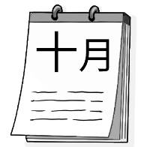
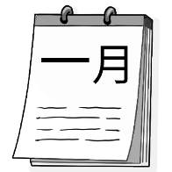
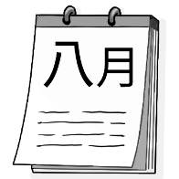
- (A) (B) (C)
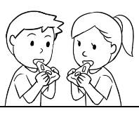
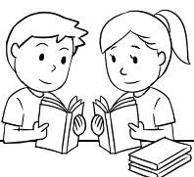
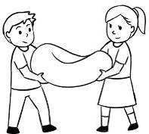
- (A) (B) (C)
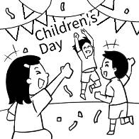
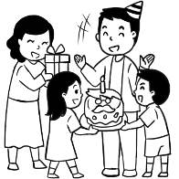
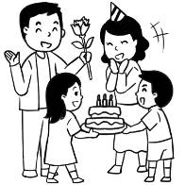
- (A) (B) (C)
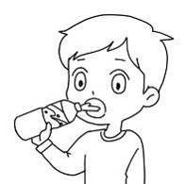
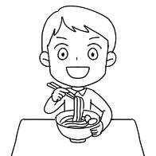
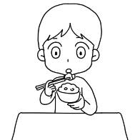
- (A) (B) (C)
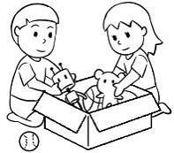
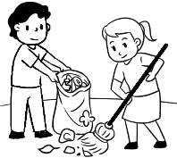
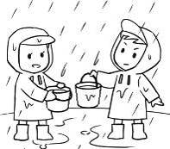
- (A) (B) (C)
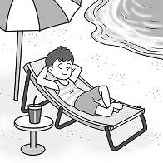
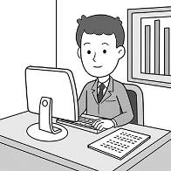
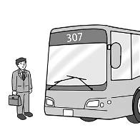
- (A) (B) (C)

二、基本問答-根據聽到的內容，選出合適的回應：10%
- (A) The Moon Festival.
(B) Once in a blue moon.
(C) The festival is just around the corner.
- (A) No, I like fried chicken.
(B) No, there is some pork.
(C) No, it’s the meat-free day.
- (A) No, it’s in February.
(B) No, it’s on Monday.
(C) No, it’s Cindy’s party.
- (A) When is it?
(B) Good health.
(C) It’s just around the corner.
- (A) What is it?
(B) What’s next?
(C) For example?

三、言談理解-根據聽到的對話內容與問題，選出正確的答案：10%
- (A) Some milk.
(B) Some bread.
(C) Some chicken.
- (A) It’s on June 21 every year.
(B) It’s on the third Sunday of June.
(C) It’s on the same date as Taiwan.
- (A) Make a cake.
(B) Wash her car.
(C) Cook some chicken.
- (A) They are garbage.
(B) They are old but good.
(C) They are from a charity.
- (A) He is a farmer.
(B) He is a bus driver.
(C) He is a tour guide.

第二部分：綜合測驗、閱讀測驗、克漏字測驗
三、綜合測驗：

32%
( )17.People around the world celebrate New Year different ways.
(A) with | (B) for | (C) in | (D) to

( )18. Amy: is the English singing contest? Lilian: It’s on Wednesday.
(A) What time | (B) What date | (C) What day | (D) What

( )19. Peter: When is your potluck party? Betty: .
(A)It’s on the third Sunday. | (B) It’s June 19.
(C) It’s Sunday. | (D) It’s at 4 p.m.

( )20. Emma and Robert are twins. They are born the same day.
(A) in | (B) on | (C) at | (D) for

( )21.Mark: Which do you want, fried chicken or pizza?
Wendy: Fried chicken of course.
Mark:
(A) Good job. | (B) Good choice. | (C) All is well. | (D) That’s all.

( )22. There is a Thanksgiving party at Paul’s place the fourth Thursday November.
(A) on ; of | (B) on ; in | (C) of ; in | (D) of ; on

( )23. Mia: Annie: It’s on June 16th.
(A) Do you have the time? | (B) When is your birthday?
(C) What day is it today? | (D) What time is the show?

( )24. Mimi: Father’s Day is just around the corner.
Eason: How about making a cake?
(A) How do we celebrate it? | (B) Let’s get our hands dirty.
(C) That’ a lot of work! | (D) How do you know that?

( )25. My mom doesn’t have much for breakfast.
(A) vegetables | (B) glass of water | (C) coffee | (D) eggs

( )26. Today is our meat-free day. , we don’t have any chicken or pork today.
(A) Believe it or not | (B) For example
(C) In other words | (D) Excuse me

( )27. We have water and tea, but we don’t have juice or cola.
(A) much ; some | (B) some ; many | (C) much ; any | (D) many ; some

( )28. Ken: time do you need for the math homework?
Bright: I need two hours.
(A) Which | (B) How much | (C) How many | (D) What

( )29. Megaport Festival in Kaohsiung starts April 1 to April 2.
(A) on | (B) in | (C) X | (D) from

( )30. Denny: I have a headache(頭痛). Can I , Mom?
(A) take a day off | (B) check it out
(C) take a look | (D) wash bad luck away

( )31. Vic: How much paper there in the office?
Chen: There at least ten boxes.
(A) is ; is | (B) is ; are | (C) are ; are | (D) are ; is

( )32. How many do you want?
(A) pumpkin pie | (B) slice of pizza | (C) fried chicken | (D) pieces of paper

四、閱讀測驗：
14%
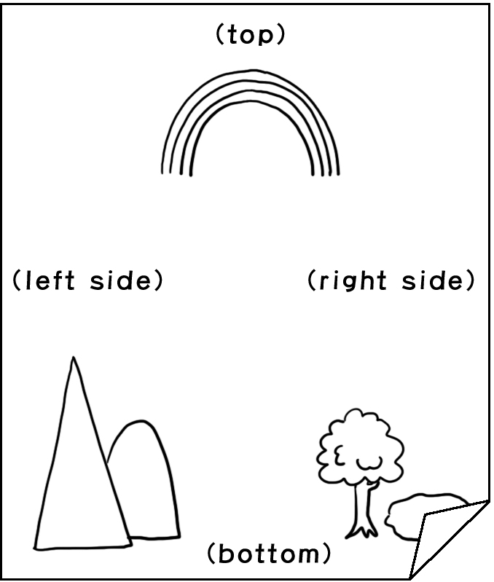
Hi, I’m Jack. Welcome to Draw Your Surprise again. Are you ready for today’s gift, a Sunny Dog? It can bring you joy every day. Just follow me and draw on your A4 paper. Now, draw two mountains at the left bottom and a big tall tree next to them. And a pool next to the tree. There are two ducks swimming on the pool. A rabbit is under the tree and looking at the ducks. Don’t draw dogs or cats, please. At the top, there is a rainbow. How about the right side? Please draw a flying bird.
E-mail your picture to my e-mail box, lincolnclassroom.email.com, before next Draw Your Surprise show. Don’t send it on LINE. Call me at the number 0901-123456 after sending it, please. Now send your picture! YOUR SURPRISE IS WAITING FOR YOU!
bottom底部；send寄送
( )33. Now you finish your picture. How can you give the picture to Jack?
 | (A) I can give it to Jack in class. | (B) I can tell Jack on the phone.
 | (C) I can send it to Jack on LINE. | (D) I can mail it to Jack’s mail box.
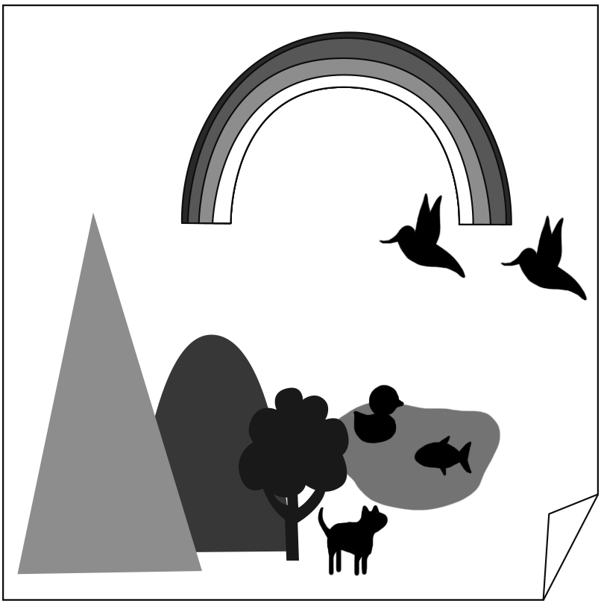
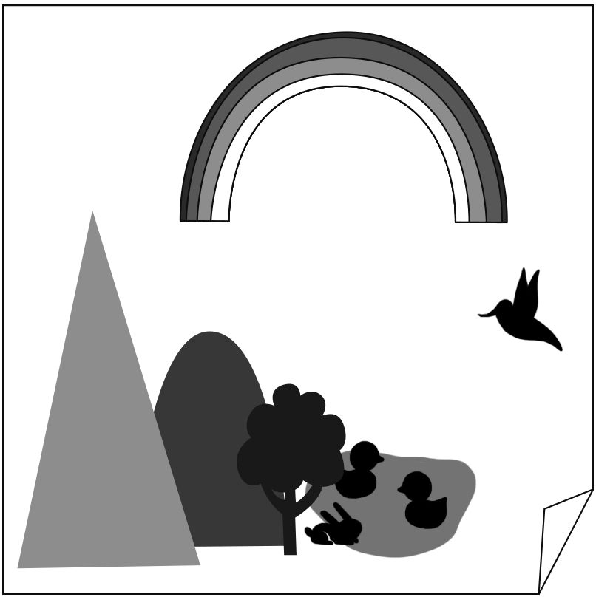
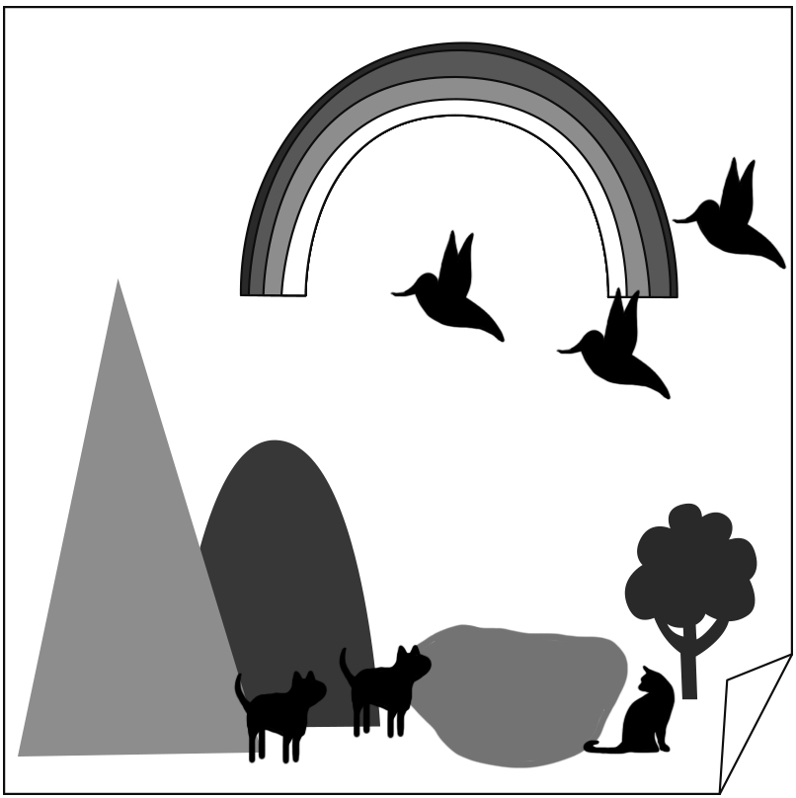
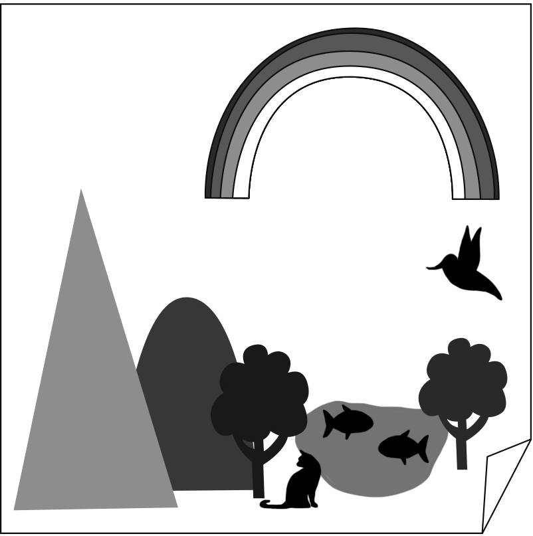
( )34. Which is most likely（最有可能）the right picture?
 | (A) | (B) | (C) | (D)

February 19 is the International Tug of War Day. It is a sport game we all like to play. The first tug of war can go back to the 16th century. It was even an Olympic event from 1900 to 1920.
Tug of war is a game between two teams at each end of a rope. Each team has eight players. One team must pull the other team across a central line to their side to win the game.
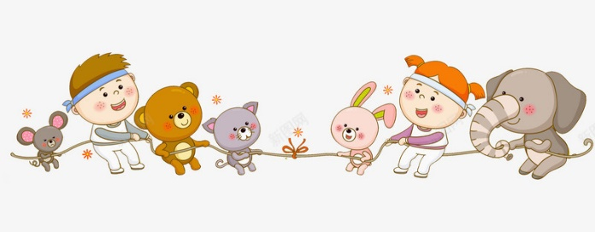
Tug of war is a fun and easy game, but it can be dangerous, too. Players can get hurt if they play it in the wrong way. Athletes must get a lot of training before they play the game.

international國際的；century世紀；Olympic event奧運競賽項目；pull拉；central中央的；atheletes運動員；training訓練
( )35. When do people celebrate the Tug of War Day?
 | (A) The ninth day of January. | (B) The ninth month of the year.
 | (C) The sixteenth century. | (D) The nineteenth day of February.

( )36. What can we learn about the tug of war from this reading?
(A) It can be fun and dangerous at the same time.
(B) Training for tug of war is easy.
(C) Players can never get hurt in the game.
(D) It’s a party game we all like.

Many people in Taiwan like afternoon tea. They can enjoy kinds of dishes, snacks, cakes, drinks, and coffee. But do you know when and where the traditional afternoon tea starts?
The story about it starts back in the mid 1800s in the UK. In those days, people have lunch at noon, but they can’t have dinner until 8 or 9 o’clock at night. One day, Anna Maria Russell is hungry during the long afternoon. She begins to have tea, sandwiches, and cakes at a low coffee table in her room in the afternoon. Then, she invites her friends to enjoy this meal with her, and it becomes the “in-thing” for the upper-class women in the country. The boring, hungry afternoon becomes their everyday happy time. So, Low Tea is born and is also known as Afternoon Tea, a light meal between 3:30 p.m. and 5 p.m.
When Low Tea becomes upper-class people’s favorite, the working people try to follow them. However, they can’t have tea until 6 p.m. after work. It is called High Tea because working people enjoy it at high dining tables, but Low Tea is enjoyed at low coffee tables. The foods are different between Low Tea and High Tea. The workers have meat, pies, fish, and bread with more tea or coffee.
Why not go for afternoon tea some time when you are free?
traditional傳統的；not…until直到…才…；become變成；upper-class上層階級；known as被視為
( )37. What do we know about afternoon tea in the world from the reading?
(A) The foods at afternoon tea can be sweet or salty.
(B) Afternoon tea are different from country to country.
(C) Afternoon tea is born because Anna likes to talk with her friends.
(D) The drinks at afternoon tea are green and black tea.

( )38. Which is right about the traditional “Low Tea” and “High Tea” in the UK?
(A) People can eat more food at Low Tea.
(B) All the people can have afternoon tea at 5 p.m.
(C) Upper-class women enjoy High Tea in the afternoon.
(D) High Tea and Low Tea are enjoyed before dinner.
( )39. What does “in-thing” mean in the reading?
(A) That is hungry.
(B) That is popular.
(C) That is delicious.
(D) That is difficult.

五、克漏字測驗：8%
(In a pizza house)
Clerk: 40.
Vita: Yes, I want a beef pizza and a chicken pizza.
Clerk: OK. How would you like your beef pizza? We can customerize to fit your taste. How much cheese do you want? How many tomatoes do you want? How much beef do you want? Do you want any basil leaves?
Vita: Well, I want double cheese, three tomatoes, and 41. basil leaves, please.
Clerk: No problem. And how would you like your chicken pizza? How much garlic do you want? How many tomatoes do you want? How much chicken do you want? By the way, 42. is no cheese inside. Is that OK with you?
Vita: Sure, I love the classical taste of the pizza. Bake it in the traditional way.
Clerk: Good. 43.
Vita: Yes, three bottles of cola. Thanks.
Clerk: Okay. Please have a seat and wait for 10 minutes.
customerize客製化；taste口味；basil leaves羅勒葉；garlic大蒜；classic經典的
( )40. | - May I help you? | - Is everything OK?
 | - What is it? | - Which do you like?

( )41. | - any | - a lot | - some | - much

( )42. | - it | - that | - there | - this

( )43. | - For here or to go? | - Anything to drink?
 | - What do you want? | - How much is it?

第三部分：非選擇題請將答案寫在答案卷上
七、單字：14%
1. February is the s d month. The next month is March.
2. Tom likes moon cakes. Moon Festival is his favorite h y .
3. The cellphone has no p r . I can’t turn it on.
4. It’s getting cold. Let’s put on the c es .
5. My cousin is a big fan of Blackpink. She c ts many pictures of them.
6. My father wants to drink hot tea. He needs to b l water.
7. Christmas is in D r . It is the last month of the year.
8. 滿的 9. 彼此 10. 一半 11. 篩子 12. 有用的 13. 南瓜派 14. 區域
八、依提示作答：6%
- It’s May 18th. (請寫出原問句)
- They need two buckets of poop. (請依畫線部分寫出原問句)
試題結束

