桃園市立大有國民中學111學年度第一學期第一次評量試卷
年 級 | 八 | 考 試  科 目 | 英語科 |  |  | 命 題  範 圍 | Unit One-  Review I | 作 答  時 間 | 45分
班級 |  | 姓 名 |  | 座 號 |  | 分 數

第一部分：聽力測驗30%

辨識句意：根據聽到的內容，選出符合描述的圖片或符合圖片的描述。 每題兩分 10%
- （ ）(Ａ) 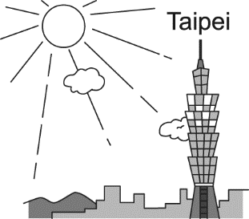(Ｂ) 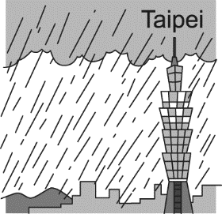(Ｃ) 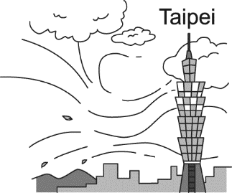
- （ ）(Ａ) 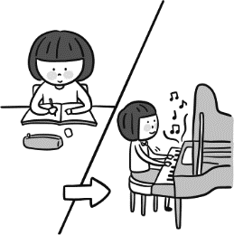(Ｂ) 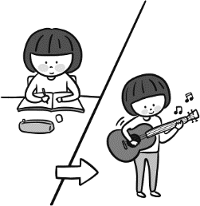(Ｃ) 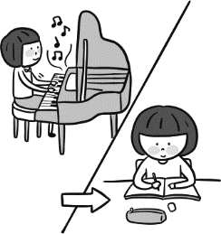
- （ ）(Ａ) 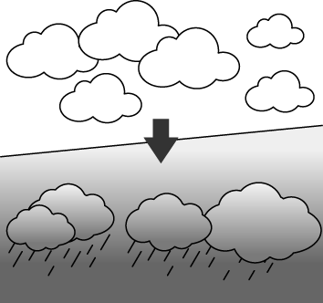(Ｂ) 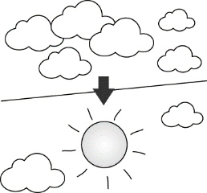(Ｃ) 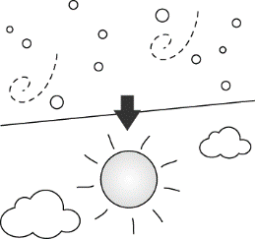
- （ ）(Ａ) 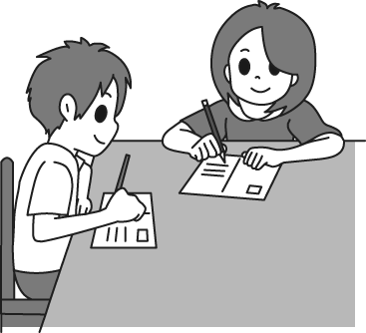(Ｂ) 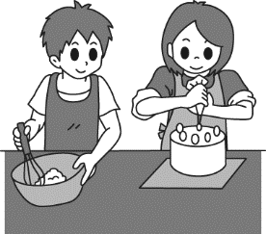(Ｃ) 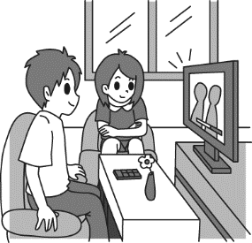
- （ ）(Ａ) 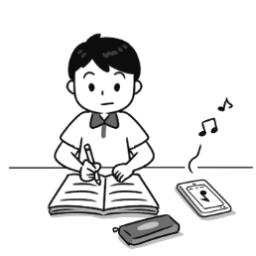(Ｂ) 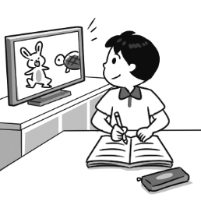(Ｃ) 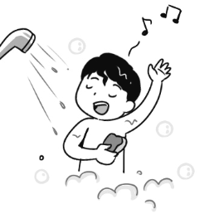

基本問答：根據聽到的內容，選出一個最適合的回應或最適合的問句。 每題兩分 10%
- （ ）(Ａ) There are so many things on the table.
(Ｂ) It is Mary’s.
(Ｃ) I need to buy a pen.
- （ ）(Ａ) She went to bed early.
(Ｂ) She brushes her teeth.
(Ｃ) She doesn’t watch any movies.
- （ ）(Ａ) I like sunny days like today.
(Ｂ) It is rainy and cold.
(Ｃ) Yes, I like the weather in Australia.
- （ ）(Ａ) Good. Thanks. How about you?
(Ｂ) I am writing a card to my best friend.
(Ｃ) I am doing my history report.
- （ ）(Ａ) Sorry, she is not in. Please call back later.
(Ｂ) No, she is studying with us.
(Ｃ) No, she is over there.

言談理解：根據聽到的內容，選出一個最適合的答案。 每題兩分 10%
- （ ） (Ａ) It is rainy. (Ｂ) It is cold. (Ｃ) It is sunny.
- （ ） (Ａ) The man had the wrong number.(Ｂ) The woman wanted to talk to Jason. (Ｃ) Jason wasn’t in the office.
- （ ） (Ａ) It is hot and sunny. (Ｂ) It is cool and rainy. (Ｃ) It is cold and snowy.
- （ ） (Ａ) We are not sure. (Ｂ) No, she doesn’t. (Ｃ) Yes, she does.
- （ ） (Ａ) He brushes his teeth. (Ｂ) He uses his cellphone. (Ｃ) He watches TV.
第二部分：閱讀理解 40%
一、文法與字彙：每題兩分 26%
( ) | 16. | ____________ the weather ____________ in Taiwan last winter?
 |  | (A) |  |  |  | How’s；╳ |  |  |  |  |  | (B) |  |  |  |  |  |  | What’s；like | (C) |  |  |  |  | How was；like |  | (D) |  |  |  | What was；like
( ) | 17. | George: Was it rainy last night?  Mary: Yes, it _____________ last night.
 |  | (A) |  | was a lot of rain |  |  |  |  |  |  |  | (B) |  |  | rained a lot |  |  |  |  | (C) |  |  | had a lot of rain |  |  |  | (D) |  |  | is raining
( ) | 18. | This is my book, and ___________ is over there.
 |  | (A) |  | his |  |  |  |  |  |  |  | (B) |  |  | her |  |  |  |  | (C) |  |  | their |  |  |  | (D) |  |  | your
( ) | 19. | Tom: Wow! You got a new cellphone “iPhone 14”. How cool!  Amy: Yeah, my father bought________________ as my 18th birthday gift.
 |  | (A) |  |  |  | me it |  |  |  |  |  | (B) | it to me |  |  |  |  |  |  |  | (C) |  | it for me |  |  | (D) |  |  |  | for me it
( ) | 20. | Lance: Hello, may I speak to Annie?  Annie: ___________________
 |  | (A) |  |  |  | Yes, I am Annie. |  | (B) |  |  |  |  |  |  | Yes, hold on, please. |  |  |  |  | (C) |  |  | Speaking. |  |  | (D) |  |  |  | Who are you?
( ) | 21. | I sent a letter __________ my cousin in Japan. I miss her very much.
 |  | (A) |  |  |  | to |  |  |  |  |  | (B) |  |  |  |  |  |  | for | (C) |  |  | of |  |  |  | (D) |  |  |  | from
( ) | 22. | Annie always takes a shower __________ she goes to bed. It helps her sleep better.
 |  | (A) |  |  |  | after |  |  | (B) |  |  |  |  |  |  | before |  |  |  |  | (C) |  | when |  |  | (D) |  |  |  | so
( ) | 23. | ___________ I was young ____________ there were many fish in the river.
 |  | (A) |  |  |  | When；╳ |  |  |  |  |  | (B) |  |  |  |  |  |  | Before；╳ | (C) |  |  |  |  | When；, |  | (D) |  |  |  | Before；,
( ) | 24. | (A) |  |  |  | 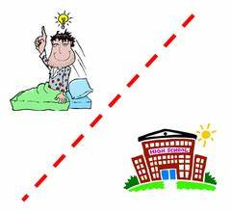  Gary got up after he went to school.  6:00
 |  | (B) |  |  |  | After Gary went to school, he got up.  7:00
 |  | (C) |  |  |  | Gary went to school after he got up.
 |  | (D) |  |  |  | Gary went to school before he got up.
( ) | 25. | Jenny: Look! Uncle Tom made this robot for us.  Jimmy: __________________
 |  | (A) |  |  |  | Whose is this? |  |  |  |  |  | (B) |  |  |  |  |  |  | The robot is his. | (C) |  |  |  |  | Not at all. |  | (D) |  |  |  | It was kind of him.
( ) | 26. | Leo: Was it fun at the party last night?  Lucy: Yeah! ___________________. You should come next time.
 |  | (A) |  |  | We had a lot of fun |  | (B) |  |  |  |  |  |  | It is fun |  |  |  |  |  | (C) |  |  |  | We were fun |  |  |  | (D) |  |  |  | It had a lot of fun
( ) | 27. | Kevin: Excuse me! Can you take a picture of ___________?  Joan: Sure!
 |  | (A) | my |  |  |  |  |  |  | (B) |  |  |  |  |  |  | me |  |  |  |  | (C) |  | mine |  |  |  |  | (D) |  |  |  | I
( ) | 28. | Before A-mei became a singer, she was a ________ winner of a singing contest in Taiwan. She was really good at singing.
 |  | (A) |  |  | five times |  |  |  |  |  | (B) |  |  |  |  |  |  | fifth time |  | (C) |  |  |  | fifth |  |  |  |  | (D) |  |  |  | five-time
三、克漏字 每題兩分 10%
Amy: Hello, 29. Is Tom there?
Tom’s mom: 30. , please.
Tom: What’s up, Amy?
Amy: Did you 31. any clubs?
Tom: Yes, I joined the music club, and we had our first class yesterday.
Amy: How was it? What did you do in class?
Tom: I played the guitar in my band.
Amy: Wow! So cool!
Tom: How about you? Did you join any clubs?
Amy: I can’t 32. because all the clubs are interesting to me. I am 33. the dancing club because I love dancing. But I like magic, too. It’s hard to make a choice.
Tom: I see. Maybe you can ask Jack. He is in the magic club.
Amy: Ok, thank you. Good-bye.
Tom: Good-bye.
( ) | 29. | (A) | I am Amy. | (B) | You are Amy. | (C) | This is Amy. | (D) | She is Amy.
( ) | 30. | (A) | Wrong number | (B) | Wait | (C) | Hang up | (D) | Hold on
( ) | 31. | (A) | sign up | (B) | hear about | (C) | speak to | (D) | think about
( ) | 32. | (A) | talk to you later | (B) | have a look | (C) | make up my mind | (D) | pull my leg
( ) | 33. | (A) | hearing about | (B) | thinking about | (C) | thinking of | (D) | talking about
四、閱讀測驗 每題兩分，14%
1.
As a fourteen-year-old student, maybe you want to live in another country, but you are not old enough to go on a working holiday, or you don’t have enough money to study in another country. Don’t give up. Now, there is “Study Tour”!
You can go on our three-week study tour in Australia. During the first two weeks, you go to the language school in the morning. At the language school, you study English with our teachers and practice English with your new friends.
After you finish the class at 12, you go back to your homestay and enjoy some family life or make new friends. On the last week of our tour, there is no school! We take you on a trip around Australia. It is a great part of our study tour!
Want to know more about our study tour? Call us at 02-23690999 now and we can give you a discount!
Amelia from Going around the Earth
tour 旅遊 language school 語言學校 homestay 寄宿家庭 part 部分 discount 折扣
according to 根據
( ) | 34. | What is this reading about?
 |  | (A) | Someone invites you to book their tour. | (B) | Someone tells you to practice your English.
 |  | (C) | Someone shares their experience in Australia. | (D) | Someone wants you to save money in a bank.
( ) | 35. | What is NOT right about the tour?
 |  | (A) | You can take a trip around Australia. | (B) | You can study English with your teacher.
 |  | (C) | You can work in Australia. | (D) | You can make new friends during the study tour.
( ) | 36. | Mary, a junior high school student, wants to study and travel in Australia. What can she do according to the reading?
 |  | (A) | Go on a working holiday. | (B) | She is too young, so she has to give up.
 |  | (C) | Call Going around the Earth. | (D) | Take a one-week trip to Australia.

2.
Lucy studies in a junior high school in Japan, and she wrote a postcard to her friend, Jane.

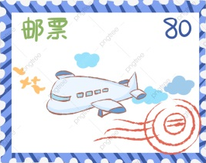
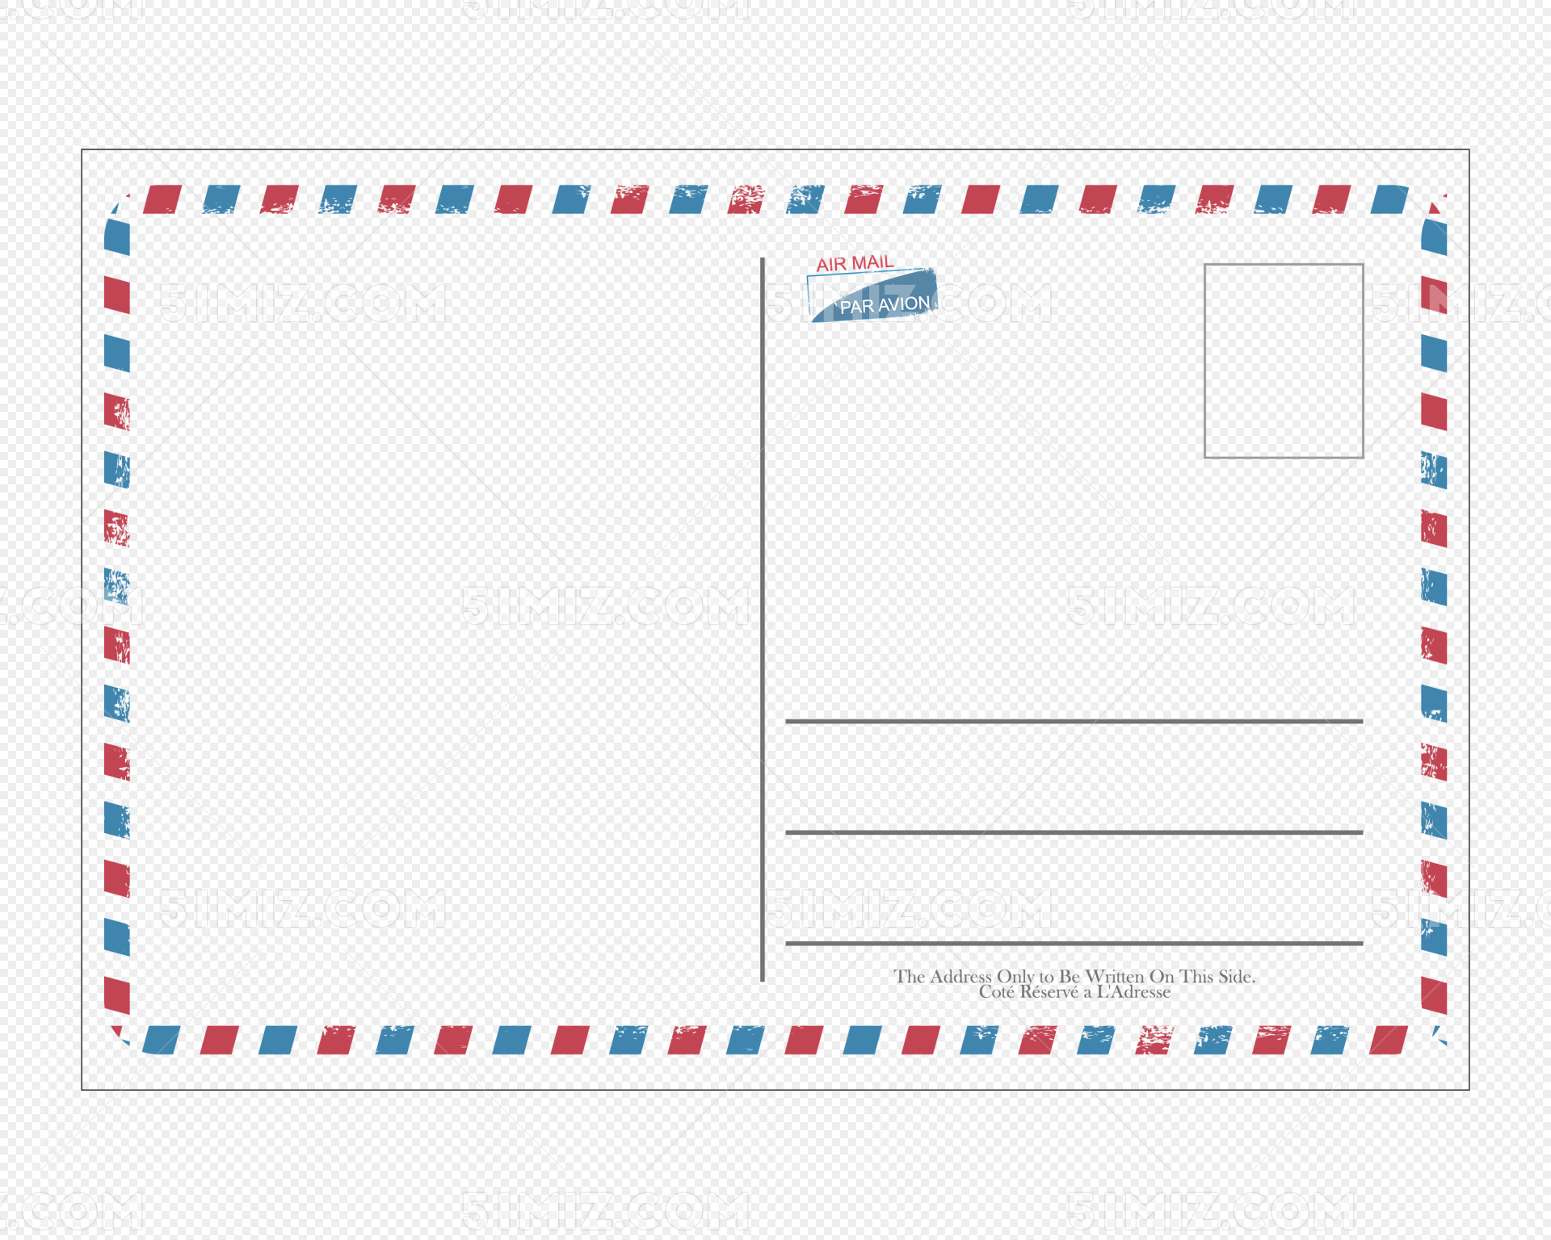
Jane Wang
台灣 高雄市三多路111號
Jane is writing a postcard back to Lucy. But she doesn’t know how to write the address on the postcard.
Let’s help her finish it.
Dear Jane,
How are you doing? I really have a good time here in Japan. There are so many cherry blossoms falling out of my window. They are so beautiful. And the weather here is warm and nice. I love spring. I will go picnicking with my classmates this afternoon. I hope you and Anna can be here, too.
Maybe next time, you guys can come visit me, and we can hang out together. I can show you guys around. Can’t wait to see you guys.

Yours,
Lucy

Dear Lucy,
I am so happy to get your postcard from Japan. The cherry blossoms must be very beautiful. The weather here in Kaohsiung is really hot and sunny. We have a bad drought here. Hope it rains a lot.
As for Anna, I just talked on the phone with her yesterday. She said it rains a lot in her city every day and it is very cold there. It was only 2℃ yesterday. And she got a cold.
Maybe we can get together this summer. Hope to see you soon.

Best wishes,
Jane

cherry blossom櫻花 will 將要 city城市 hope希望

( ) | 37. | Look at the map. Where might (可能) Anna live?
 |  | (A) | In Japan. | (B) | In the UK. | (C) |  |  | In Taiwan. | (D) | In Vietnam(越南).
( ) | 38. | What does “hang out” mean in the reading?
 |  | (A) | Hang the clothes outside the house. |  |  | (B) | Eat something.
 |  | (C) | Go out and have fun together. |  |  | (D) | Watch a show together.
( ) | 39. | What does a “drought” mean in the reading?
 |  | (A) | There is a lot of rain. |  |  | (B) |  | It is windy and cloudy.
 |  | (C) | There is not enough rain. |  |  | (D) |  | It is snowy and cold.
( ) | 40. | How does Jane write the address in English?
 |  | (A) | Lucy Lin  Japan, Tokyo, Park Rd., No. 215 |  |  | (B) |  | Lucy Lin  No. 215, Park Rd. Tokyo, Japan
 |  | (C) | Lucy Lin  Tokyo ,Japan, Park Rd., No. 215 |  |  | (D) |  | Lucy Lin  No. 215, Park Rd., Japan, Tokyo

桃園市立大有國民中學111學年度第一學期第一次評量試卷
年 級 | 八 | 考 試  科 目 | 英語科 |  |  | 命 題  範 圍 | Unit One-  Review I | 作 答  時 間 | 45分
班級 |  | 姓 名 |  | 座 號 |  | 分 數
請將此卷交回
第三部分 手寫 20%
五、文意字彙 每題兩分 10%
________________ | 41. | Amy is on v n in Kenting. She really needs to relax and have fun.
________________ | 42. | Do you know the s e man? He just followed me on my way home.
________________ | 43. | A: Dragon Boat F l is coming.  B: Wow! I can’t wait to eat rice dumplings and watch the Dragon Boat Race.
________________ | 44. | A: What’s your favorite s t?  B: English.
________________ | 45. | A: Math is so d t for me. I am worried about the test tomorrow.  B: Don’t worry. I can teach you.
六、依提示作答 每題兩分 10%
46. After I brush my teeth, I go to bed. (用...before…改寫)
____________________________________________________________________________
47. These pens are Tom’s pens. (將畫線部分改為所有格代名詞)
____________________________________________________________________________
48. There isn’t snow in Taiwan in winter. (用We…改寫)
____________________________________________________________________________
49. Mary wrote me a letter. (加入介係詞改寫)
____________________________________________________________________________
50.The bike is mine. (畫線造原問句)
____________________________________________________________________________

選擇分數 | 手寫分數 | 總分

