桃園市立大有國民中學111學年度第一學期第三次評量試卷
年 級 | 七 | 考 試  科 目 | 英語科 |  |  | 命 題  範 圍 | U5-6  Review3 | 作 答  時 間 | 45分
班 級 |  | 姓 名 |  | 座 號 |  | 分 數
題目卷3張5面共50題，請細心作答！ 電腦卡請寫上班級、座號、姓名，班級及座號務必劃記正確！

第一部分、聽力測驗

- 辨識句意-根據聽到的內容，選出正確的圖片代碼：

- (A) (B) (C)

- (A) (B) (C)
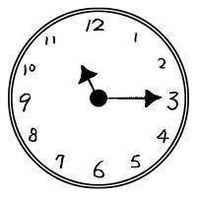 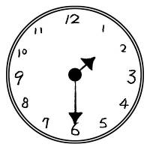 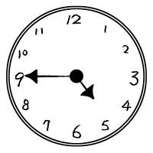

- (A) (B) (C)
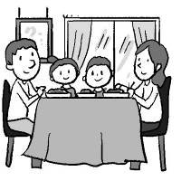 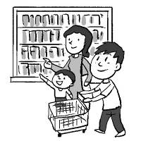 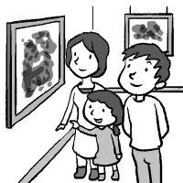

- (A) (B) (C)
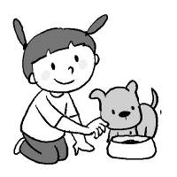 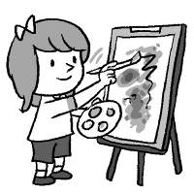 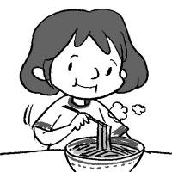

- (A) (B) (C)
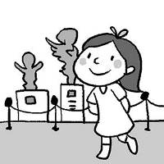 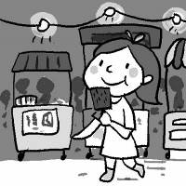 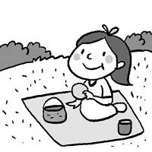

- 基本問答-根據聽到的內容，選出合適的回應：

- (A) He can dance.
(B) He is sleeping.
(C) Yes, he is in the bedroom.

- (A) It’s delicious.
(B) It’s in trouble.
(C) It’s in the night market.

- (A) It’s at seven thirty.
(B) It’s seven years old.
(C) It’s seven seventeen.

- (A) We’re having fun here.
(B) Let’s have breakfast.
(C) We can have beef noodles.

- (A) No, she is cooking in the kitchen.
(B) No, her bedroom is clean and beautiful.
(C) Yes, his bedroom is behind the living room.

- 言談理解-根據聽到的對話內容與問題，選出正確的答案：

- (A) Jimmy is lining up for snacks.
(B) Jane is eating the pig blood cake.
(C) Pig blood cake is delicious to Jane.

- (A) It’s at six thirty.
(B) It’s at seven thirty.
(C) It’s at seven o’clock.

- (A) He is eating snacks.
(B) He is showing his friend around.
(C) He is having a video call with his mom.

- (A) The snacks are delicious to the girl.
(B) The boy and the girl are from Taiwan.
(C) The boy and the girl are in the night market.

- (A)Taking pictures.
(B) Feeding animals.
(C) Lining up for food.
【聽力結束，綜合測驗從第二面開始】

第二部分、綜合測驗
16. Mary: Who is the boy at the door? He’s so cute.
Tom: He is my ____________.
( A ) aunt ( B ) wife ( C ) kid ( D ) actress
17. It’s ____________ today. Let’s have a picnic on the grass.
( A ) yummy ( B ) sunny ( C ) dirty ( D ) joy
18. The dog over there is Lucky. He is a __________ of our family. We all love him very much.
( A ) member ( B ) people ( C ) postcard ( D ) daughter
19. This _____________ is very famous. Many people come here for the great artworks here.
( A ) jacket ( B ) restaurant ( C ) bridge ( D ) museum
20. The ________ is in front of my grandma’s house. There are many fish in it.
( A ) river ( B ) mountain ( C ) grass ( D ) kitchen
21. Don’t touch those birds. They may(可能) __________ you.
( A ) talk ( B ) invite ( C ) save ( D ) attack
22. Tim: What are you doing? Gina: I’m ________ for my keys. Where are they?
( A ) looking ( B ) watching ( C ) seeing ( D ) rising
23. Can you _______ those chairs for me? Please use the color, red. It’s my favorite color.
( A ) move ( B ) paint ( C ) rise ( D ) join
24. Patty: What time is ________? Meg: It’s at eight p.m. Let’s go to the restaurant together.
( A ) it ( B ) the time ( C ) the showroom ( D ) the party
25. Mr. Yang is ________ the stories to those kids in the classroom now. They really like the funny stories.
( A ) telling ( B ) losing ( C ) saying ( D ) talking
26. Leo isn’t playing computer games, ________ his brothers ________.
( A ) and; can ( B ) but; are ( C ) and; isn’t ( D ) but; aren’t
27. Mia: Can you go to the party tonight?
James: ________. I have a math class tonight.
( A ) Yes, I can ( B ) Yes, I can’t ( C ) No, I can’t ( D ) No, I can
28. Wendy: ________ the parrot sing? Nancy: Yes, it ________.
( A ) Is; is ( B ) Isn’t; isn’t ( C ) Can’t; can ( D ) Can; can’t
29. Aaron: Take a look at the picture. _________________________? Bob: She is freezing the river.
( A ) What is Ice Queen doing ( B ) Ice Queen can do anything
( C ) What can Ice Queen do ( D ) Is Ice Queen freezing anything
30. Ken is from America. He ________ use chopsticks. He can only use forks.
( A ) can ( B ) isn’t ( C ) don’t ( D ) cannot
31. Jimmy: Sam, are you there?
Sam: Be quiet, Jimmy. My little sister _______ inside the room.
( A ) sleeping ( B ) is sleeping ( C ) sleep ( D ) are sleeping
32. Choose the CORRECT(正確的) sentence.
( A ) He is singing and danceing. ( B ) My father is siting on the chair.
( C ) Mary is running in the park. ( D ) We are haveing a great time at the potluck party.
33. Cindy: How are you doing? Amy: _________________
( A ) I am writing a letter to my friend. ( B ) I am at school.
( C ) Great! And you? ( D ) Yes, I am taking pictures.
34. Sam: Our Earth is in danger. What can we do to save it? Jimmy: ____________________
( A ) We can use more water. ( B ) We can cut down food waste.
( C ) We can go to the night markets tonight. ( D ) We can turn on the lights.
35. Adam: Can you run fast like a flash? Charile:_________. I can’t do it.
( A ) No sweat ( B ) No problem ( C ) You are all in ( D ) That’s not easy

Welcome to the Dayou Art Museum
1. Opening hours: 9 a.m. to 8 p.m., Tuesday- Sunday
2. Ticket: people (over 12 years old):NT$150 students (7-12 years old): NT$80
Children under 6 years old: free
3. Rules: Please be quiet. Don’t run or talk loudly. Don’t eat or drink.
There are also gift shops and restaurants next to the showrooms. You can buy some drinks and have meals there. We also have a meadow behind the museum, not in front of the museum. You can have a picnic on it.
Our museum is really a place of joy.
36. Jack is talking with his frineds. He is NOT in/on _________________.
( A ) the meadow (B)the gift shop (C) the restaurant (D) the showrooms
37. Lily, Peter and their nine-year-old daughter, Nini, go to the Dayou Art Museum at 3 p.m.
The three people give _____ for the tickets.
( A ) NT$ 450 ( B ) NT$ 230 ( C ) NT$ 300 ( D ) NT$ 380
38. Which is true about the museum?
( A ) A junior high school student can visit the museum for free.
( B ) People can have a picnic in the meadow behind the museum.
( C ) You can visit the museum on Monday.
( D ) You can have snacks in the showrooms.

I’m Jack. Today is Saturday. My mom is cooking dinner in the kitchen. My father and brother are in the living room now. There is a baseball game at 7:30 tonight. They don’t want to miss it. They are sitting on the sofa and watching the game now. Our dog is also there. My father is a big baseball fan, and my brother is, too. But I’m not a baseball fan. I’m doing English homework in my room. I can play computer games after that.
39. What is it in the reading?
( A ) The dinner. ( B ) The TV. ( C ) The baseball fan. ( D ) The baseball game.
40. Who is NOT in the living room?
( A ) Jack’s brother. ( B ) Jack and his mother. ( C ) Jack’s dog. ( D ) Jack’s father and brother.
41. What is that in the reading?
( A ) Watching TV. ( B ) Watching a ball game. ( C ) Doing homework. ( D ) Playing computer games.

The Kaohsiung Zoo is opening again, and it looks great! The old zoo is too small for the animals, but the new zoo has lots of space. The new zoo is clean and nice.
There are skywalks at the new zoo. They are like bridges. People can see the animals much better now, and the skywalks also hide the people from the animals. This is really good because it means the animals can feel happy and safe at the zoo.
One of my favorite things at the new Kaohsiung Zoo is the chimpan cage restaurant. Chimpans are super smart and of course, they are our animal relatives! The old chimp cage isn’t very nice. It is like a jail for them. But now that old cage is now a restaurant for visitors, and the chimps can live and play in the big new place.
A zoo can be a wonderful place for people to see and learn about animals, but a zoo should think about the animals first. Kaohsiung’s new zoo is not only a much better place for animals, but also a place of joy!
# space 空間 much better 更好 chimpan 黑猩猩 cage 籠子jail 監獄 visitors 訪客 hide…from 躲藏
42. Which is true about the skywalks at the new zoo?
( A ) Chimpans can climb on the skywalks.
( B ) People can feed animals on the skywalks.
( C ) The animals can see people much better.
( D ) The skywalks are good for visitors and the animals.
43. What can people do in the old chimpanzee cage now?
( A ) People can have some snacks and coffee there.
( B ) People can see more animals and have fun.
( C ) People can take selfies with the animals there.
( D ) People can play with the chimpans.
44. What does “not only…, but also” mean in the reading?
( A ) or ( B ) but ( C ) between ( D ) and

Winter is cold. Do you know what animals do to keep warm? People wear heavy coats and stay in their houses. But animals do something different to live through cold weather. Penguins get together in big groups. When they get together, they stay warm. Bears have thick fur to make their bodies warm. Frogs go to sleep in winter. They hide under rocks or in the ground. Sometimes their bodies freeze! But when the spring comes and the weather gets warm, they come back to life again.
Some animals leave their homes in winter. They go to warm places because they cannot live through cold weather. Many kinds of birds and butterflies move in winter. They fly very far to warm places. Some animals don’t move far. They eat a lot and then find a nice place to sleep in winter. Mice don’t sleep, but they make their homes in warm places.
# stay 待 different 不同的 live through 度過 fur毛皮 ground 地面
45. What can frogs do in winter?
( A ) They wear thick fur.
( B ) They go to warmer places and make their homes.
( C ) They sleep, hide under rocks, and freeze themselves.
( D ) They eat a lot and have a nice sleep.
46. What animals are mentioned(被提到) in the reading above?
( A )Birds, lions, frogs, pigs, and bats.
( B ) Penguins, frogs, birds, and turtles.
( C ) Frogs, foxes, rabbits and dogs.
( D ) Penguins , bears, frogs and mice.
47. What is the main idea (主旨) of the reading?
( A ) Winter is cold.
( B ) Animals have different ways to go through the winter.
( C ) Some animals leave their homes in winter.
( D ) People can live in cold winter.

Welcome, everyone. How’s everything? My name is Michael. I am your tour guide today. It’s a beautiful sunny morning in Nantou. We’re at Sun Moon Lake. Let me show you around. There 48. a lot of restaurants, hotels and gift shops near the lake. Many people visit here every year because they love this place a lot. It’s a famous spot in Taiwan. Look! Some people are taking pictures around the lake. Some people are 49. near the lake. Also, there is a swimming game today. Come with me. Let’s 50. the game.
# tour guide 導遊 spot 景點
48. ( A ) be ( B ) are ( C ) is ( D ) can
49. ( A ) picnic ( B ) can picnic ( C ) picnicking ( D ) go picnicking
50. ( A ) enjoy ( B ) to enjoy ( C ) enjoying ( D ) are enjoying

