桃園市立大有國民中學111學年度第一學期第一次評量試卷
年 級 | 七 | 考 試  科 目 | English |  |  | 命 題  範 圍 | Starter ~ Review1 | 作 答  時 間 | 45分
班 級 |  | 姓 名 |  | 座 號 |  | 分 數
第一大題到第四大題為聽力測驗，請仔細聆聽！

一、辨識圖片單字-根據聽到的單字，選出正確的圖片代碼(4%)
- (A) (B) (C)

- (A) (B) (C)
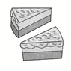
- (A) (B) (C)

- (A) (B) (C)
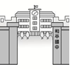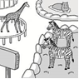

二、辨識句意：根據聽到的內容，選出正確的圖片代碼(4%)
- (A) (B) (C)
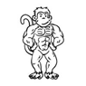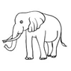
- (A) (B) (C)
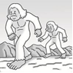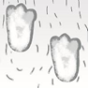
- (A) (B) (C)
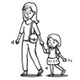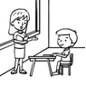

- (A) (B) (C)

三、基本問答：根據聽到的內容，選出合適的回應(12%)
- (A) Yes, she is.
(B) No, it isn’t.
(C) No, I’m not.
- (A) It is a box.
(B) They are boxes.
(C) No, they are boxes.
- (A) She’s my sister.
(B) She’s 19 years old.
(C) She’s from America.
- (A) They are good.
(B) I am from Japan.
(C) They are from the US.
- (A) Yes, it is very famous.
(B) Yes, he is a famous cartoon star.
(C) Yes, it is over 90 years old but it is very cute.
- (A) No, she is my wife.
(B) Yes, she is a doctor.
(C) No, she is an actress.
四、言談理解：根據聽到的對話內容與問題，選出正確的答案(10%)
15. (A) A pig.
(B) A bear.
(C) A goat.
16. (A) It is old.
(B) It is happy.
(C) It is not in the zoo.
17. (A) Eleven.
(B) Twelve
(C) Thirteen.
18. (A) He is a teacher.
(B) He is the man’s son.
(C) He is the man’s student.
19. (A) They are friends.
(B) They are mother and son.
(C) They are brother and sister.

五、綜合測驗 (24%)

20. | brother is tall, but brother is short.
 | - My ; he | - My ; you | - I ; his | - My ; his
21. | The cat is cute. eyes big..
 | - It’s ; is | - Its ; is | - Its ; are | - It’s ; are
22. | Matt: Are you doctors? Ann: Yes, .
Matt: Are you doctors? Ann: Yes, . | - I’m | - I am | - we are | - we’re
23. | Sara: is the girl from the USA? Kate: She is John’s friend, Meg.
 | - Where | - What | - Who | - How
24. | is a pen. are pencils.  (A) This; That (B) That; Those (C) These ; That (D)These; those
25. | Jack and Sue are brother and sister. father is a nice doctor.
 | - His | - Their | - Our | - Your
26. | David: ? Amy: It’s a birthday card from my friend.
 | - What’s that ? | - What are these? | - What is these? | - What are this?
27. | It’s bear, not elephant.
 | - a; an | - an; an | - an; a | - a; a
28. | My English teacher is nice. I like very much.
 | - she | - he | - his | - her
29. | Jell: Is this boy short?  Bill:  (Ａ) Yes, he is a tall boy.  (Ｂ) No, he is short.  (Ｃ) Yes, he is this tall boy.  (Ｄ) No, he isn’t short.
30. | Peter:  Lary: He’s 90.  (Ａ) Is your grandfather 85 years old?  (Ｂ) How tall is your grandfather?  (Ｃ) How old is your grandfather?  (Ｄ) Who is your grandfather?
31. | Ted: Tina is the winner of the game show.  Matt:
(Ａ) She is a beautiful girl.
(Ｂ) She is a smart cookie.
(Ｃ) She isn’t your smart sister.
(Ｄ) She is a piece of cake.
六、 克漏字、閱讀測驗(20%)
32~35
Mrs. White: Good afternoon, students.
Students: Good 32 , Mrs.White.
Mrs. White: This is 33 new student, Karen. She is very nice.
Karen: Hi, I’m Karen. Nice to meet you.
Students: 34
Mrs. White: Karen’s father is a teacher at our school, too.
Students: Really? 35 is he?
Mrs. White: He is our new English teacher.
Students: Wow! Cool!
32. (Ａ) morning (Ｂ) afternoon (Ｃ) evening (Ｄ) night
33. (Ａ) you (Ｂ) our (Ｃ) their (Ｄ) them
34. (Ａ) We’re fine. (Ｂ) Nice to see you, too. (Ｃ) Nice to meet you, too. (Ｄ) See you.
35. (Ａ) Who (Ｂ) Where (Ｃ) How old (Ｄ) What
36~38

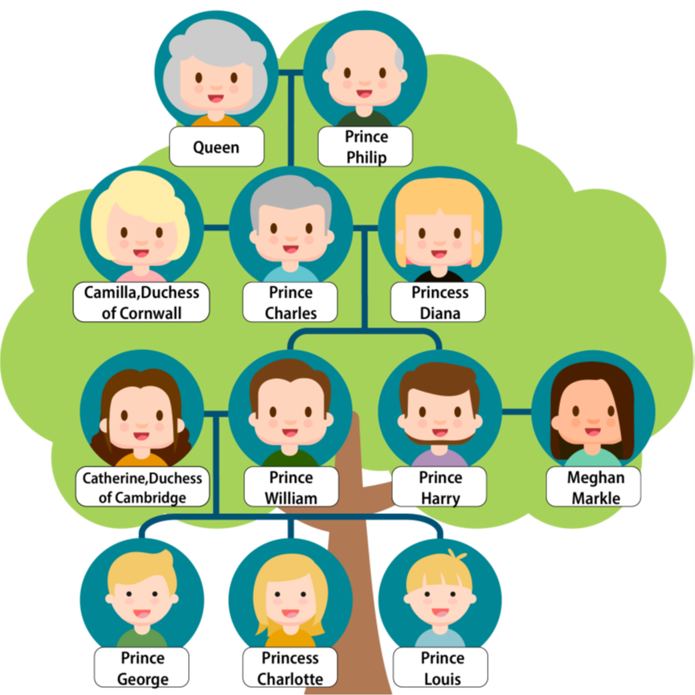
36. What CAN we know from the family tree?
(Ａ) Diana’s husband is Charles.
(Ｂ) Meghan and Catherine are sisters.
(Ｃ) Charlotte’s grandmother is Catherine.
(Ｄ) William is Camilla’s son.
 can 能夠
37.

Hi, there. This is my family. I’m a boy, and my baby cousin is Archie.
He’s one year old. I may draw a picture of him in this family tree. My great grandma’s name is Elizabeth. She is 94 and her husband, Philip, is 99. Their grandson is my father, William. He is 38 years old. And my brother is 7 and my sister is 5. We usually play with our dog, Lupo, at home.
Who is speaking?
(Ａ) Lupo.
(Ｂ) George.
(Ｃ) Charlotte.
(Ｄ) Harry.
38 . Which is True?
(Ａ) Lupo is the family’s pet cat.
(Ｂ) Archie is 10 years old.
(Ｃ) Charlotte and George’s grandmother is the queen.
(Ｄ) The name of the Queen is Elizabeth.
which 哪一個
true 正確的

39~41

Hello!
Hi,  My name is Wendy. I’m a writer.  That’s my cat’s photo. Its name is Orange. Is it cute?  Be our friends! Call me, please. My phone number is 2010-8855.  Wendy | 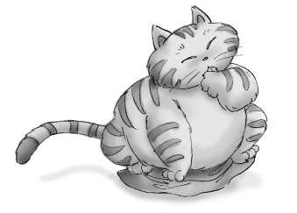
Hello,  My name is Jerry. My sister’s name is Emma.  I’m a doctor. Emma is a cook.  And Money is our dog. Are you a dog’s friend, too?  Be our friends! Our phone number is 2351-3177. Call us!  Jerry and Emma | 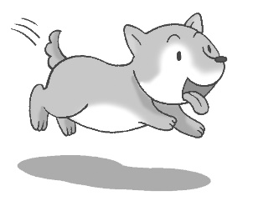
 writer 作家 photo 照片 call 打電話 please 請

39. Is Wendy a doctor?
(A) Yes, she is a doctor.
(B) No, she is a writer.
(C) Yes, Jerry is a doctor.
(D) No, she is a cook.
40. Is Emma Jerry’s sister?
(A) No, she isn’t Jerry’s sister.
(B) No, Wendy is Jerry’s sister.
(C) Yes, Wendy is Emma’s sister.
(D) Yes, she is. They are brother and sister.
41. Which is true?
(A) Emma’s phone number is 2010-8855.
(B) Jerry is a doctor.
(C) Money is Wendy’s cat.
(D) Wendy’s phone number is 2351-3177.

一~六大題答案請於答案卡畫卡作答，共41題。

桃園市立大有國民中學111學年度第一學期第一次評量答案卷
年 級 | 七 | 考 試  科 目 | English |  |  | 命 題  範 圍 | Starter ~ Review1 | 作答  時間 | 45分
班 級 |  | 姓 名 |  | 座 號 |  | 分 數
請用黑色原子筆於考卷下方答案欄作答，違者不予計分
七、單字：（10%）
1. 乾淨的 2. 斑馬 3. 水果 4. 毛茸茸的 5. 最喜愛的
6. 森林 7.困難的(h) 8. 明信片 9. 明天 10. 職員

八、寫出下列單字的複數形（6%）
11. leaf → 12. woman → 13. baby →
14. brush → 15. hippo → 16. goose →

九、依提示作答與翻譯(10%)
17. That is a cute monkey. (改寫成複數句) 2%
18. Annie is from Japan. （依畫線部分造原問句） 2%
19. Yes, that is a footprint. （依畫線部分造原問句）2%
20. Are these goats?（先否定簡答，再用sheep回答）3%
答案欄

1 |  | 2 |  | 3 |  | 4 |  | 5
6 |  | 7 |  | 8 |  | 9 |  | 10
11 |  | 12 |  | 13 |  | 14 |  | 15
16
17
18
19
20

注意：
1.試卷(含答案卷)共五面，請仔細做答。
2.一~六大題答案請畫卡作答，七~九大題請用黑色原子筆寫在答案卷上的答案欄，否則不予計分！
3.考試鐘響節結束，收回答案卡與答案卷。

