桃園市立大有國民中學111學年度第一學期第二次評量試卷
年 級 | 七 | 考 試  科 目 | English |  |  | 命 題  範 圍 | Lesson3 ~ Review2 | 作 答  時 間 | 45分
班 級 |  | 姓 名 |  | 座 號 |  | 分 數
第一大題到第三大題為聽力測驗，請仔細聆聽！

一、辨識句意-根據聽到的內容，選出正確的圖片代碼 (6%)
- (A) (B) (C)
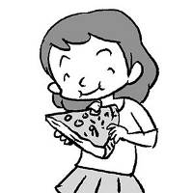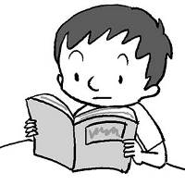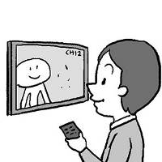

- (A) (B) (C)
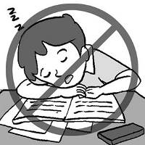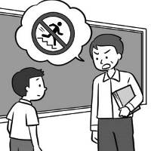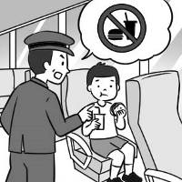

- (A) (B) (C)
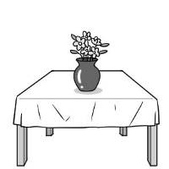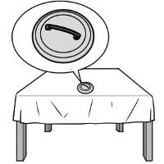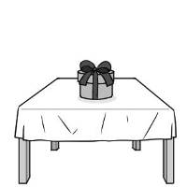

- (A) (B) (C)
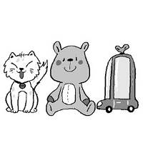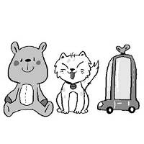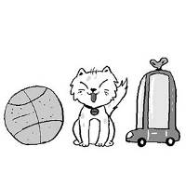
- (A) (B) (C)
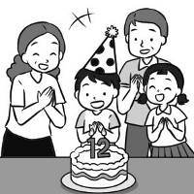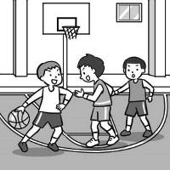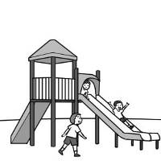

- (A) (B) (C)
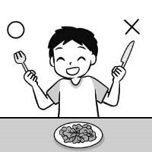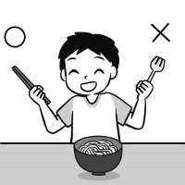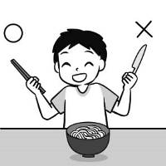

二、 基本問答-根據聽到的內容，選出合適的回應(12%)

- (A) Let’s go.
(B) Okay, Mom.
(C) I’m very angry.

- (A) Yes, there are some.
(B) The forest is big and beautiful.
(C) Yes, some animals are in the zoo.

- (A) It’s easy.
(B) It’s strong.
(C) It’s delicious.

10.(A) It is a desk.
(B) It is my pen.
(C) That is my desk..

11.(A) The party is fun.
(B) You’re welcome.
(C) The e-mail is about a party.

12.(A) She is fifty.
(B) In the garden.
(C) Let’s try again.

三、言談理解-根據聽到的對話內容與問題，選出正確的答案
(12%)

13.(A) At home.
(B) At a park.
(C) On a show.

14.(A) The party is in the morning.
(B) The party is on Double Tenth Day.
(C) Please bring some drinks for the party.

15.(A) Cakes.
(B) Tacos.
(C) Beef noodles.

16.(A) It’s behind the park.
(B) It’s near Nicole’s house.
(C) It’s in front of the school.

17.(A) A book.
(B) A jacket.
(C) Some pictures.

18.(A) Jackie is a teacher.
(B) Miss Chou is a student.
(C) Jackie and Miss Chou are in the classroom.

四、綜合測驗 (28%)

19. | _______________ some goats on the farm.
 | - There is |  | - Are there | - There aren’t any |  | - There are
20. | Wendy: Peggy, come here and play a game with us.  Peggy: OK. ___________________  - It’s a piece of cake.  - Where is Sam?  - Let’s get the ball rolling!  - You are a smart cookie.
21. | _____________ run on the bus.
 | - Please don’t |  | - Please no | - Don’t please |  | - Please not
22. | Ted: Yummy….The cake is delicious.  Leo: Hey, _______________. Use a fork, please.  - Just give it a shot (B) Christmas is around the corner  (C) don’t use your hands (D) We are having a good time
23. | Paul: I’m from Taiwan. ____________________  Mike: I’m from Japan.  (A) How are you? (B) Where are you?  (C) What about you? (D) Are you in Taiwan?
24. | Ben: There is _______________ in the bag. What is ________________?  Ivy : A gift for Mom.
 | - anything; there |  | - something; it | - some thing; there |  | - it; anything
25. | The toy car is in front of the sofa, not ______________it.
 | - in |  | - behind | - between |  | - next
26. | The movie is ____________3 pm __________5 pm.
 | - from; and |  | - from; to | - at; to |  | - from; for
27. | Lisa and Mary cook delicious dishes in the _________________.
 | - living room |  | - dining room | - bathroom |  | - kitchen
28. | Mr. White: Kevin, __________ a nice boy. Don’t talk in class.  Kevin : Sorry, Mr. White.  - is (B) not be (C) try (D) be
29. | This new watch ________ the table is ________ Japan. It’s a gift from my uncle.
 | - in back of; near |  | - between; on | - under; at |  | - on; from
30. | Look! A bird is __________ Peter’s shoulder.
 | - next | (B) between |  | (C) on | (D) under
31. | Susan: _____________ four pencils on the desk?  Mandy: _____________, there are two.
 | - Are there; No |  | - Is there; Yes | - Are they; No |  | - Are there: Yes
32. | Choose the wrong sentence. (選出錯誤的句子)
- Please, Jerry, open the window.
- Jerry, please open the window.
- Please open the window, Jerry.
- Jerry, open the window, please.

五 克漏字、閱讀測驗(20%)

33~36
(At the movie theater)
- movie theater 電影院 number 號碼
seat 座位 minute 分鐘
Nina: We are late. The movie is on!
Rock: 33 are our seats?
Nina: 34 Number 16 and 18.
(Ten minutes later)
Rock: Wow, the rabbit, Bunny, is so cute.
Nina: You’re right. She is smart, too.
Rock: But her friends aren’t nice to her.
Nina: Look at the monkey! No, 35 eat Bunny’s food. Poor Bunny.
Rock: The monkey is so bad!
Man: 36
Rock: Sorry, sir.

33. (A) What (B) Where (C) Who (D) How
34. (A) Please look at me. (B) There aren’t any seats.
(C) Oh, here. (D) Let’s give it a show.
35. (A) don’t (B) let’s no (C) let’s (D) do
36. (A) Please stand up.
(B) Please don’t eat my food, OK?
(C) Don’t eat or drink in the movie theater.
(D) Please don’t talk in the movie theater.

37~39
Hello Peter,
Welcome! This is your room. My name is Kevin. Ken and I are your new roommates. We are students, too. To share this house, please follow the rules:

- Please clean the house every day.
- Don’t make any noise.
- Take out the trash.
- Don’t go into my room or Ken’s room.
- Don’t open our letters. Don’t read them.

- roommate 室友 share 分享 make noise 製造噪音 follow 遵守
take out the trash 倒垃圾 letter 信件 rule 規則

37. What is the passage about? ＊ passage 文章
(A) House rules. (B) School rules. (C) Bus rules. (D) Park rules.
38. What are “ them ”?
(A) Students. (B) Letters. (C) Roommates. (D) Rules.
39. Which is NOT the rule? ＊ which 哪一個
(A) Take out the trash. (B) Clean the house. (C) Be quiet. (D) Don’t be late for school.

40~42
The lake in front of Black Mountain is “Magic Lake.” There are small and big fish in the lake, and around it are those beautiful cherry blossom trees. The “magic” is in its color. The lake looks blue in the morning. In the afternoon, it looks pink. And in the evening, it looks green. People come here in the morning and go home at night for it. Look! There are some people under the trees now.

- lake 湖泊 cherry blossom櫻花 look 看起來

40. What is the reading mainly about? ＊ mainly 主要地 different 不同的
(A) Black Mountain. (B) Cherry blossom trees. (C) A beautiful lake. (D) Different colors.
41. What is “ it ”?
(A) The people under the trees. (B) The fish in the lake.
(C) Black Mountain’s magic. (D) A different color at different times of a day.
42. Which is true? (何者正確?) ＊ nothing 沒有東西
(A) Magic Lake is beautiful. (B) There is nothing in the lake.
(C) No one is near the lake now. (D) The trees here are blue.

注意: 六、七大題非選擇題須寫在「答案卷」上，並用黑筆作答，否則不予計分!

六、字彙(16%)
1. I i e my friends to my birthday party.
2. Let’s give our teacher a s e on Teacher’s Day.
3. Simon is a h g student. He studies(研讀) English every day.
4. Please w r a white shirt(襯衫) to the party.
5. Is America a beautiful c y ?
6. Mom: Don’t leave(留下) any food on the p e .
Sam: OK, Mom.
7. 參加 8. 碗 9. 湯匙 10. 窗戶 11. 動物
12. 忙碌的 13. 帶 (b_____) 14. 在…裡面( i e ) 15. 午餐 16. 筷子

七、依提示作答(6%)
(2%) 1. Helen’s two dogs are next to the car. (造原問句)
(1%) 2. Let’s clean the house. (改為否定句)
(3%) 3. Are there three pencils on the desk? (先否定簡答後，再用2枝詳答)
試 題 結 束

