桃園市立大有國民中學111學年度第二學期第一次評量試卷
年 級 | 七 | 考 試  科 目 | English |  |  | 命 題  範 圍 | Lesson1~ Review1 | 作 答  時 間 | 45分
班 級 |  | 姓 名 |  | 座 號 |  | 分 數
第一大題到第三大題為聽力測驗，請仔細聆聽！

一、辨識句意-根據聽到的內容，選出正確的圖片代碼 (6%)
- (A) (B) (C)


- (A) (B) (C)
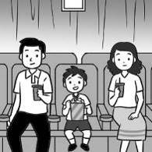

- (A) (B) (C)
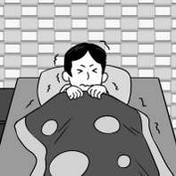

- (A) (B) (C)


- (A) (B) (C)


- (A) (B) (C)
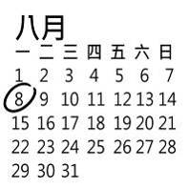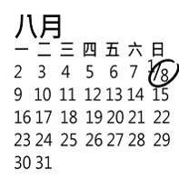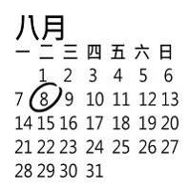

二、 基本問答-根據聽到的內容，選出合適的回應(10%)

- (A) I’m not very hungry.
(B) We can only have vegetables.
(C) I’m looking for my toy robot.

- (A) She knows a lot.
(B) You don’t like animals.
(C) We don’t have enough money.

- (A) It’s rainy.
(B) It’s so warm inside.
(C) On Saturday morning.

10.(A) Let’s book a trip to Japan.
(B) Let’s book a room at that hotel.
(C) Let’s book a table at that restaurant.

11.(A) It’s a piece of cake.
(B) Let’s find out more!
(C) Once in a blue moon!

三、言談理解-根據聽到的對話內容與問題，選出正確的答案
(10%)

12.(A) He has English class.
(B) He goes to the museum.
(C) He joins charity’s events.

13.(A) Vegetables.
(B) Beef noodles.
(C) Eggs and milk.

14.(A) The woman can help people check in.
(B) The robot can show people to their rooms.
(C) The robot can carry people’s bags to their
rooms.

15.(A) It’s the meat-free day today.
(B) They don’t have enough food today.
(C) They all love the vegetable noodles.

16.(A) They’re at home.
(B) They’re on a trip.
(C) They’re planning a trip.

四、綜合測驗 (28%)

17. | A lot of ______________help the children in Africa.
 | - checks | - cloudy | - charities | - hotel
18. | We are in the _________________ class. We are classmates.  - fight (B) different (C) taste (D) same
19. | John: _____________ your father wash his car every Sunday?  Molly: Yes, he always __________________.
 | - Does; do | - Is; does | - Does; washes | - Does; does
20. | A: What ___________ your sisters ________ on Saturdays?  B: They dance at home.  - does; do (B) do; do (C) does; doing (D) are; doing
21. | Stacy: Don’t you like to eat beef?  Jimmy: No. _______________________  (A) I like it very much. (B) I eat it every Sunday.  (C) Let’s get the ball rolling. (D) I eat it once in a blue moon.
22. | Simon: Who are you _________________?  Eric: A girl with short brown hair.
 | - looking for | - planning | - lining up | - chatting on
23. | Let’s book the Icehotel and _____________________.
 | - fall down | - check it out | - throw it away | - talk with it
24. | Emily doesn’t have breakfast at school, but her brothers _______________.
 | - have | - has | - do | - does
25. | Jay: The toy dog can even play with you.  Peter: _________________________
 | - It’s a piece of cake.  (C) That’s an event. |  | - You’re a smart cookie.  (D) You bet.
26. | We don’t have enough water now. Don’t ______________it.  - waste (B) west (C) style (D) know
27. | Lily: _________________  Chris: It’s Friday.  - What day do you have English class? (B) What day is it today?  (C) Can you help me? (D) Is it Monday today?
28. | ____________ the weather like in Taipei in winter?
- What’s (B) How’s (C) Who’s (D) Where’s
29. Kevin: ___________________
Emma: On Mondays and Fridays.
- What time is your English class?
- What do you do every day?
- What day do you go to math class?
- Do you have math class on weekends?
30. Lisa: Is it rainy in Tainan?
Sam: Yes, __________________
- I like snow a lot. (B) there isn’t snow.
(C) we don’t have rain. (D) but not much.

五 克漏字、閱讀測驗(26%)

31~33
Wang: My wife and I are looking for a hotel in Hsinchu. Any suggestions?
Chen: Does your wife like animals?
Wang: Yes, she does.
Chen: Well, there is a very special hotel in Guanshi. Its name is Leofoo Resort. This hotel is inside
a zoo. The animals live outside your rooms. Open the window, and they are right in front
of you.
Wang: That's awesome! Wait! Are we safe in this hotel?
Chen: You bet! You are very safe in this hotel. The animals there only eat fruit.
Wang: Great.
＊ suggestions 建議
31. What is Mr. Wang doing?
(A) He is planning a trip to Taipei.
(B) He is having a video call with his wife.
(C) He is looking for a hotel in Hsinchu.
(D) He is booking a restaurant.
32. What's special about Leofoo Resort?
(A) There is an animal inside every hotel room.
(B) Everything inside the hotel comes from animals.
(C) This hotel is inside a zoo.
(D) You can feed the animals inside your room.
33. What is true about the hotel? ＊ true 正確的
(A) You are not safe inside the hotel.
(B) Animals live outside your hotel rooms.
(C) You can play with the animals.
(D) An animal welcomes you at the door.

34~36
Diana and Mitchell are great singers from the Netherlands. They are only sixteen years old, but they have a lot of fans. Diana only writes three songs every year. Her songs are dark and sad. She doesn't have many music videos, but a lot of people know and love her songs. On the other hand, Mitchell writes many songs a year and has sixty music videos now. His songs are about love, and they are warm and happy. His fans love his songs very much. Diana and Mitchell both put their all into their music. Their songs are very different, but they are both great and popular singers.
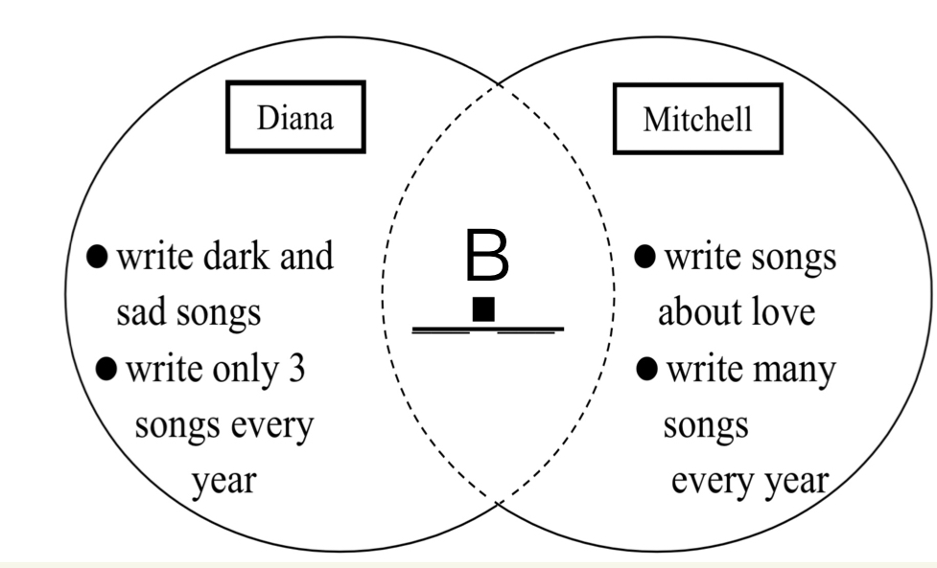

- 請根據上文完成的組織圖，回答34-36題 ＊ on the other hand 另一方面
34. Which of the following cannot be "B" in the picture? ＊following 以下
(A) a young singer
(B) a popular singer
(C) have many fans
(D) have many videos
35. Which is the best title? ＊ title標題
(A) Two love songs.
(B) Two dark countries.
(C) Two great singers.
(D) Two popular music videos.
36. What do we know from the reading?
(A) Diana's and Mitchell's songs are different, but they both work hard with music.
(B) Diana has many fans, but not many people know Mitchell.
(C) Diana's and Mitchell's songs are all about love.
(D) Diana writes songs, but Mitchell doesn’t.

37~39
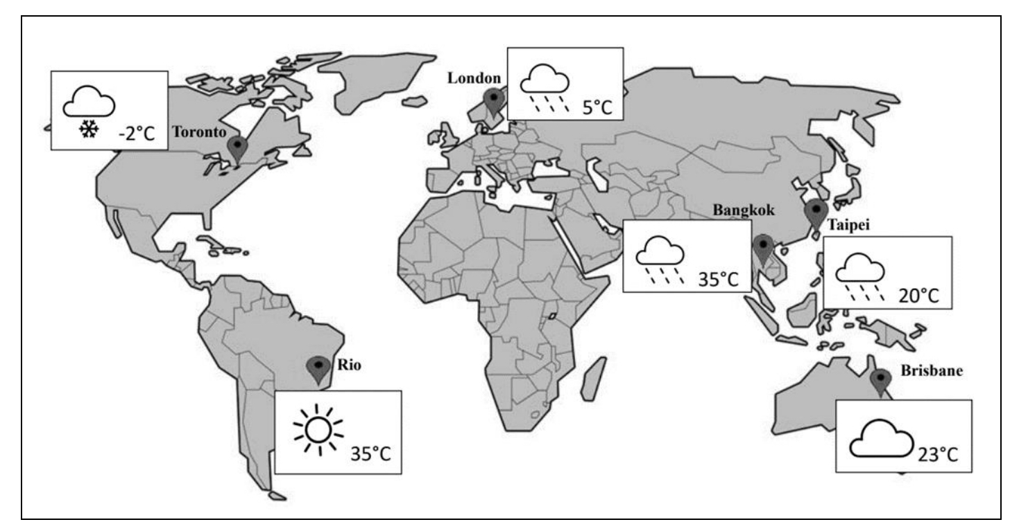

37. How's the weather in Rio?
(A) It's cold and snowy.
(B) It's hot and sunny.
(C) It's cold and sunny.
(D) It's hot and rainy.
38.
Hi, I'm Cathy. The weather today is nice. It isn't rainy, and it's not too hot. I am in a beautiful park near my home. There are many people here. Some people are picnicking, and some people are playing with their dogs.

Where may Cathy be?
(A) In Toronto.
(B) In London.
(C) In Bangkok.
(D) In Brisbane.

39.
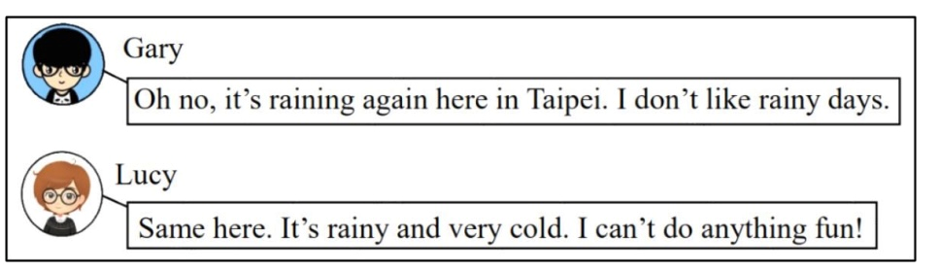

Where may Lucy be?
(A) In Toronto.
(B) In London.
(C) In Bangkok.
(D) In Brisbane.

40~43
Good morning. My name is Jeffery Cooper. Let's 40 the weather today. People in Taipei 41
enjoy a beautiful day. The sun is not very big, so you can plan a trip to the mountains and 42 a picnic. The
weather in Taichung is not that good. It is sunny in the morning 43 rainy in the afternoon. In Kaohsiung, it's
cloudy and windy all day.

40. (A) read (B) fall down (C) check out (D) look for
41. (A) can (B) do (C) does (D) is
42. (A) has (B) have (C) having (D) are having
43. (A) it's (B)and (C) but (D) doesn't

注意: 六、七、八大題非選擇題須寫在「答案卷」上，並用黑筆作答，否則不予計分!

六、填入適當的動詞形式，字數不限(6%)
1. Lisa ________________(write) a postcard, and her sister is, too.
2. Let’s _______________(plan) a trip to Tainan.
3. Eric ________________(play) basketball every Monday.
4. Does your brother _______________(enjoy) the show?
5. Mom is not in the living room. She ________________(make) cookies in the kitchen now.
6. The robot can ______________(help) us mop the floor

七、文意字彙(6%)
7. I don’t like s r . It’s too hot.
8. My father c ies an umbrella to school for me on rainy days.
9. My favorite s n is fall. It’s cool and windy.
10. Please g e me the book. I want to read it.
11. Let me close the door, and t n we can go home.
12. My favorite watch is g e_ . I’m so sad.

八、單字中翻英(8%)
13. 風大的 14. 建造 15. 鹽 16. 小時 17. 星期二 18. 乾燥的
19. 超過 20. 拜訪
試 題 結 束

