桃園市立大有國民中學111學年度第二學期第一次評量試卷
年 級 | 八 | 考 試  科 目 | 英語科 |  |  | 命 題  範 圍 | Unit One- Review One | 作 答  時 間 | 45分
班級 |  | 姓 名 |  | 座 號 |  | 分 數
試題共5頁，選擇題請將答案畫記於答案卡；翻譯試題，請將答案寫於答案卷
一、辨識句意：根據聽到的內容，選出符合描述的圖片或符合圖片的描述。每題1分
1. | (A) | 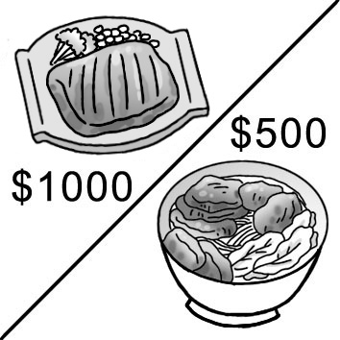 | (B) | 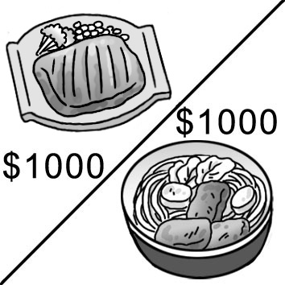 | (C) | 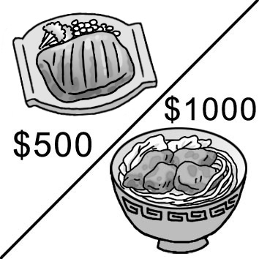
2. | (A) | 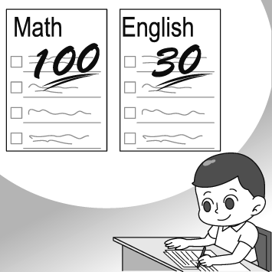 | (B) | 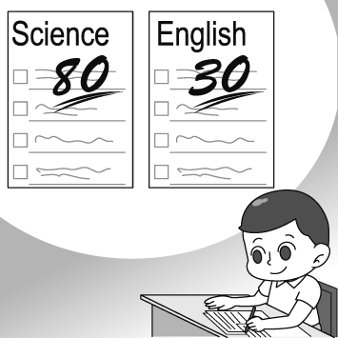 | (C) | 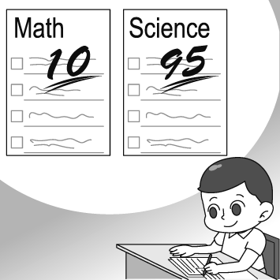
3. | (A) | 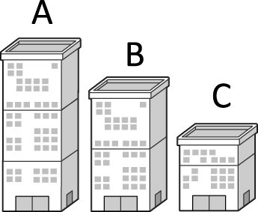 | (B) | 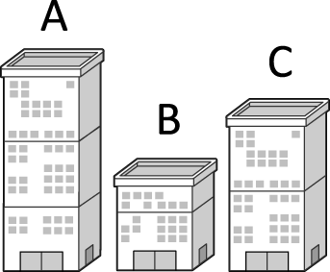 | (C) | 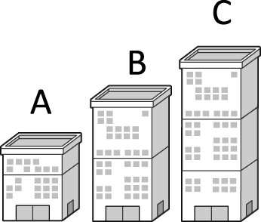
4. | (A) | 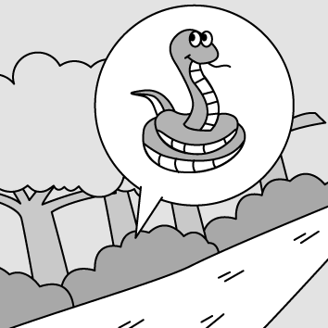 | (B) | 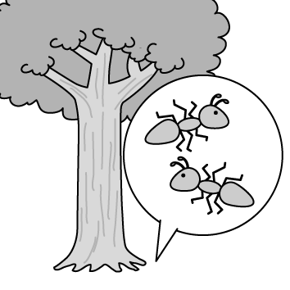 | (C) | 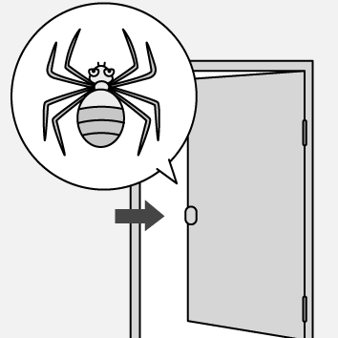
- 基本問答：根據聽到的內容，選出一個最適合的回應或最適合的問句。每題2分
5. | (A) Yes, he looks much older.
 | (B) Yes. I’d like the ham and cheese sandwich.
 | (C) Yes, it is very cold.
6. | (A) Jack is older.
 | (B) Jason is older.
 | (C) Jason is as old as Jack.
7. | (A) They taste pretty good.
 | (B) They are more expensive.
 | (C) I don’t really like pumpkin pies.
8. | (A) There are few people swimming.
 | (B) I enjoyed the sound of the wave best.
 | (C) I was not worried at all.
9. | (A) The blue one over there.
 | (B) I want the most beautiful one.
 | (C) There are more than ten cars there.

- 言談理解：根據聽到的內容，選出一個最適合的答案。每題2分
10. | (A) Math is as difficult as science for Yuki.
 | (B) Math is easier than science for Yuki.
 | (C) Math is more difficult than science for Yuki.
11. | (A) A sandwich.
 | (B) A hamburger.
 | (C) A steak.
12. | (A) Jim is.
 | (B) Jack is.
 | (C) James is.
13. | (A) The blue bag is the biggest in the store.
 | (B) The blue bag is the most expensive in the store.
 | (C) The red bag is the biggest in the store.
14. | (A) Yes, he will.
 | (B) No, his dad will go with him.
 | (C) No, his mom will go with him.

- 單題 每題2分
15. | Look at the picture. What is the man doing? |  |  |  | 
 | (A) He’s eating steak.
 | (B) He’s shouting.
 | (C) He’s watching a basketball game.
 | (D) He’s raising his hands.
16. | It’s very for us to take the metro from Zhongli (中壢) to the airport (機場). It only takes about 20 minutes.
 | (A) convenient | (B) delicious | (C) important | (D) scary
17. | It’s not easy for the Americans to eat noodles with a pair of .
 | (A) fries | (B) chopsticks | (C) spoons | (D) knives
18. | Our history teacher often gives us candy after we answer her .
 | (A) bugs | (B) buns | (C) questions | (D) miles
19. | Waiter: How would you like your steak?  Mr. Wang: , please.
 | (A) Cheap | (B) Medium | (C) Full | (D) Clean
20. | My English teacher asked me to stand in the back of the classroom because I forgot my book  again.
 | (A) brought | (B) brings | (C) to bring | (D) bringing
21. | Ryan: do the cookies smell like?  Jim: They smell like cheese.
 | (A) What | (B) How | (C) Why | (D) Which
22. | Dwight Howard is the most player on the basketball team.
 | (A) strong | (B) best | (C) happy | (D) popular
23. | Evan: Wow! The cheese cake delicious. Where did you buy it?  Kyle: At the department store near Taoyuan Train Station.
 | (A) taste | (B) taste likes | (C) tastes | (D) tastes like
24. | The price of eggs is getting today than before. I can’t believe a box of eggs costs 80 dollars now.
 | (A) expensive | (B) more expensive | (C) high | (D) higher
25. | I’d like to order a milk tea with sugar.
 | (A) fewer | (B) the fewest | (C) less | (D) the least
26. | Mary: Why did you take a taxi home yesterday?  Richard: I worked very late, and missed the bus home.
 | (A) latest | (B) last | (C) least | (D) late
27. | My jacket is uglier and older than , but it is very warm.
 | (A) my sister’s | (B) James | (C) myself | (D) your
28. | Boys, help to the snacks on the table.
 | (A) himself | (B) themselves | (C) yourself | (D) yourselves
29. | Richard: Which is , Chinese, English or math?  Evan: English. I can always get good grades in this subject.
 | (A) easy | (B) the easier | (C) easiest | (D) the easiest
30. | Because Sam is sick, he looks thinner now than before.
 | (A) much | (B) more | (C) a lot of | (D) very
31. | Our princial was very busy yesterday. He lunch until two o’clock.
 | (A) eats | (B) doesn’t eat | (C) ate | (D) didn’t eat
32. | Grace very sad after Chinese Taipei lost to Cuba.
 | (A) becomes | (B) sounded like | (C) felt | (D) smelt
33. | To us, watching movies than reading.
 | (A) are more interesting |  | (B) are the most interesting
 | (C) is more interesting |  | (D) is the most interesting
五、題組 每題2分
(34.-37.)
Once upon a time, there was a woodcutter. One day, when he cut a tree near a lake, his axe fell into it. The lake was very deep, so he couldn’t pick it up 34. . What’s more, he had no money to buy an axe again. The woodcutter was very 35. and didn’t know what to do.
Suddenly, the lake goddess came up and asked the woodcutter, “Why 36. you 36. so down?” The woodcutter said, “My axe fell down into the lake.” On hearing this, the lake goddess went into the lake to look for the woodcutter’s axe. She brought back a golden axe and asked, “Is this your axe?” The woodcutter said, “No, mine isn’t 37. .” The lake goddess went into the lake again.
Then, she brought a silver axe to the woodcutter and asked again, “How about this one?” The woodcutter answered again, “No, my axe is still older.” The lake goddess looked at him and said, “You are a very honest person.” She gave the woodcutter his axe and said, “The golden and the silver axe are also gifts for you.” The woodcutter thanked the lake goddess and happily went home.

woodcutter 樵夫 axe 斧頭 golden 金的 silver銀的 honest誠實的
34. | (A) himself |  |  | (B) from himself |  | (C) his own |  | (D) of his own
35. | (A) friendly |  |  | (B) scary |  | (C) worried |  | (D) true
36. | (A) did; looked |  |  | (B) do; look |  | (C) were; looking |  | (D) will; look
37. | (A) as new as this one |  |  | (B) as new as yourself |  | (C) the newest of all |  | (D) the least new of all
(38.-40.)
Dayou’s Newest Metro Line and Stations
From April 15, New Dayou Metro (NDM) customers will be able to start using a new line. There will be four new stations: Dayou Square, Summer Hill, Sunny Park, and Dayou Airport. After the new line and stations are open to the public, it will take just 10 minutes to travel from the airport to the park, about 20 minutes from the airport to Dayou Square, and 50 minutes from the airport to the train station.
◎ NOTICE
1. From April 15, the NDM Green Line will branch into two. The
Green Line will provide a line from Dayou Train Station (R01) to
Dayou Airport (R14) without switching trains at an interchange station.
2. Please switch trains at Dayou Library (R07) if customers want to go to
Brook Beach (R10).

38. | connect 連結 provide 提供 switch 轉換 interchange station 轉乘站  What does branch mean?
 | (A) To move something to another place.
 | (B) To make something become different parts.
 | (C) To close or stop using something.
 | (D) To connect two or more different things.
39. | Sam wants to take the metro from Dayou Train Station to Brook Beach on April 15.  Which is true about the ride?
 | (A) He will find there are four new stations on his way to Station R10.
 | (B) The train will run without stopping between Station R01 and Station R10.
 | (C) The trip will take him more than 50 minutes.
40. | (D) He may spend more time because he has to get off a train and get on another at Station R07.  Which is most likely the map of the Green Line on April 16?  (A) (B)  (C) (D)
(41.-42.)
 I would like to thank my best friend K.M. Seal for inviting me to write a foreword in this book. Honestly, I had some experience of writing book forewords before, but this is my first time to write for a blind writer. K.M.
Seal is famous for her first book To the Heart of the Dragon, and it won her a place in the world of children’s storybooks and her first Louis Prize.
However, See the World with Legs and Hands is a different book from the her old ones. It is a book about her life. She divided her life into five parts. The first part talked about the turning point of her life. She couldn’t see anything after becoming sick at age five. After that, her new life wasn’t easy at all. Her dream of being a train driver would never come true.
Everything was different and strange because she couldn’t see anything in the dark. Her family and friends couldn’t understand her, so she had to go to a school for the blind. She learned with other blind classmates and finally learned one important thing– If you believe in yourself, others will believe in you. We can see in the last part of the book. Of course, we can see she tried her best to become a famous writer in the other parts. Everyboby must read this book.
Michael Hills
foreword前言 divide分開
41. Which is right about K.M. Seal?
 |  | (A) She couldn’t see anyting after she studied at an elementary school.
 |  | (B) She hates her life in the school for the blind.
 |  | (C) She finally became a great writer after hard work.
 |  | (D) She showed great interest in writing when she was a kid.
42. |  | What can we know about the book See the World with Legs and Hands?
 |  | (A) This book will make Seal win another Louis Prize.
 |  | (B) This book sells better than Seal’s other works.
 |  | (C) This book is a book about a girl, and she has a gift for driving a train.
 |  | (D) This book is about Seal’s true story.
以下翻譯試題請於答案卷上作答，違者不予計分

六、單字中翻英 (第六大題單字若為名詞，請以單數形作答) 每格1分
(1.)蜜蜂 |  |  | (2.)火腿 |  | (3.)遠 |  | (4. )派 |  | (5. )螞蟻
(6.)地球 |  |  | (7.)氣體；汽油 |  | (8. )菜單 |  | (9. )寬的 |  | (10. )蜘蛛
七、翻譯填空 每格1分
1. 那隻蛇剛剛咬傷了男服務生。
The (11.) just (12.) the (13.) .
2. 今天天氣比昨天潮濕。
The weather today is (14.) (15.) yesterday.
3. 在三個女孩中，Ivy通常吃最少的肉。
Ivy usually has the (16.) (17.) of the three girls.
4. 這餐廳牛肉麵總是嚐起來很棒。
The (18.) (19.) in the restaurant always (20.) very great.

