桃園市立大有國民中學111學年度第二學期第二次評量試卷
年 級 | 九 | 考 試  科 目 | 英語 |  |  | 命 題  範 圍 |  | Book1~Book6 | 作 答  時 間 | 45分
班 級 |  | 姓 名 |  | 座 號 |  | 分 數
一、單字&文法選擇(32%)
（ ）1.Did you see the notice on the blackboard? It _______ we had to hand in our report before Friday.
(A) told (B) wrote (C) said (D) made
（ ）2. Keisha: Oscar is trying to ask me out. I don’t know how to _______ him _______.
Jack: Easy. Tell him you love girls.
Keisha: What?!
(A) turn ; down (B) put ; down (C) calm ; down (D) write ; down
（ ）3.Drunk-driving is wrong. It may ________ serious car accidents. Don’t do that please.
(A) lead (B) become (C) cause (D) affect
（ ）4. Dangerous tools like knives should be put away in places where little children can’t ________.
(A) play (B) reach (C) stand (D) carry
（ ）5.This is the restaurant _________ is the most famous for its delicious food and excellent service.
(A) what (B) which (C) where (D) in that
（ ）6.Timmy: Where is my comic book? I am very sure _______ I put it right here.
Wally: Maybe Nick took it away.
(A) where (B) whether (C) that (D) which
（ ）7. Beside those pencils _________ a note, which said, “I love you.”
(A) were (B) was (C) had (D) have
（ ）8.Kiki felt _______ because she felt someone _______ her body in the dark.
(A) angry ; touch (B) angrily ; touch (C) angry ; touched (D) angrily ; touched
（ ）9.Mr. Chen _______ an interesting book to us, and we really like it.
(A) made (B) bought (C) gave (D) cooked
（ ）10. Alex: Jeremy’s interested in comic books, _________ ?
Brian: I’m not sure. Let’s ask him.
(A) isn’t he (B) hasn’t he (C) doesn’t he (D) didn’t he
（ ）11. Vick: I’ve heard Howard will come to Taoyuan for the big game next week.
Jimmy: Really? If he _______, let’s go to the game, shall we?
(A) is (B) will (C) does (D) has
（ ）12. _______ rainy this afternoon, so bring an umbrella with you. After all, it’s the rainy season now.
(A) It will be (B) There will be (C) It will have (D) There will have
（ ）13. My brother went to Africa ten years ago and _______ there since then. He thinks it’s very close to nature
to live there and enjoys his life there very much.
(A) lives (B) lived (C) was living (D) has lived
（ ）14. Selina: What ________ you so long to get here? You are one hour late.
Betty: Sorrry, but the traffic on the road was too heavy.
(A) took (B) spent (C) cost (D) made
（ ）15. Leo is ________ my brother though he looks much younger. They’re of the same age.
(A) older than (B) younger than (C) less old than (D) as old as
（ ）16. She didn’t care about her schoolwork, so ________ good grades was really difficult for her.
(A) get (B) got (C) getting (D) to got
二、克漏字選擇(16%)
Living on the Earth, people often want to know if there is life on other planets in the space. To answer this question, many scientists have been looking for life on other planets for centuries. But so far they 17. any signs of life on other planets. In fact, for life to come into being on a planet, the planet 18. water, air, sunlight, and the right temperature. If a planet is short of any one of the four, it is almost impossible for life to appear on it. That’s why it is so hard to find another planet 19. there may be life. Although it’s difficult, scientists are not ready to give up anytime soon the hope of finding life in the space. Now, many of them are working hard to keep an eye on the space. Since the space is so large, perhaps they will find what they have been looking for in the future. If they do find that planet, it 20. the biggest news and make the world excited. Let’s just wait and see!
temperature溫度
( )17. (A) haven’t found (B) didn’t find (C) haven’t been found (D) aren’t going to find
( )18. (A) has had (B) used to have (C) will have (D) must have
( )19. (A) which (B) where (C) what (D) when
( )20. (A) was (B) has been (C) will be (D) was going to be

Most people think it’s normal to eat beef, pork, or chicken to get enough protein in everyday life. However, not every part of the world can do so. Some places in the world are so cold that it is hard to raise animals for meat, so
21. . Take Alaska for example. Alaskans don’t keep animals for meat. They catch a lot of fish in the sea, and they eat fish at every meal. Sometimes they get bored of eating fish meat all the time, so they change the way to eat fish. 22. for more than three weeks. Later, they dig them out and enjoy the smelly food.
Take the north part of Thailand for another example. Because it is hot, wet, and very close to mountains, keeping large farm animals for meat is hard for people there, but 23. . So, people living in this place eat bugs to get protein. When visiting there, you can taste bug dishes at almost every restaurant. Bugs are also canned and sold in supermarkets.
You might find it’s hard to taste such strange food, but you should still give it a try. If one day in the future you are faced with a plate of smelly fish heads or a bowl of bug salad, 24. ! Tasting foreign food is also a way to understand a different country. Just take a bite.
normal正常的 protein蛋白質 smelly有臭味的
( )21. (A) people have to stop eating meat and just eat vegetables
(B) people there don’t get enough protein
(C) people there have to find other ways to get enough protein
(D) people need to buy meat from other countries
( )22. (A) They throw fish eyes up to the top of a house
(B) They put fish heads in the ground
(C) They hang fish outside and let the wind and the sun dry them
(D) They cut fish into pieces and cook in hot water
( )23. (A) they can find a lot of big bugs
(B) nobody wants to eat little bugs
(C) they enjoy eating vegetables
(D) they can still catch fish from rivers
( )24. (A) close your eyes (B) turn around (C) don’t feel sick (D) feel free to run away

三、閱讀測驗(22%)
(一)
Stargazing with Us
Do the city lights and noise of traffic make you feel uncomfortable?
Join us for a fun experience at the top of Hehuan Mountain!
Find out what is hidden in the night sky!

Mt. Hehuan became Taiwan’s first International Dark Sky Park in 2019. At 3,417 meters above sea level, it is an excellent place to meet up with other stargazers. The key to making a Dark Sky Park lies in reducing light pollution. Come learn how light affects nature and how Mt. Hehuan became the first Dark Sky Park in Taiwan.

Where Hehuan Mountain Visitor Center
When Every Friday evening, August 4th to November 10th
Time 8p.m.
Cost Free

To keep yourself warm and comfortable, bring warm clothes, a hot drink, and a chair to sit on. It is better if you have both a star map and a good camera. Make sure to keep lights off along the way so that everyone can get the best night view. Everyone is welcome. To learn more about us, please visit us at
www.lovestargazewithus.com
( )25. What’s the reading mostly about?
(A) How to name the dark sky park.
(B) To tell people why they should keep lights off in mountains.
(C) How to go to the dark sky park.
(D) To invite people to come to an event.
( )26. Who might go to this event?
(A) Dora. She enjoys reading books about the stars.
(B) Nelson. He loves to swim in summer.
(C) Cindy. She loves learning about new things at home.
(D) Ryan. He enjoys taking pictures of cities.
( )27. According to the reading, what does stargazing mean?
(A) Looking up at the stars and things in space.
(B) Searching for information about stars online.
(C) Learning about the stars from a sky map.
(D) Taking pictures of stars with a good camera.
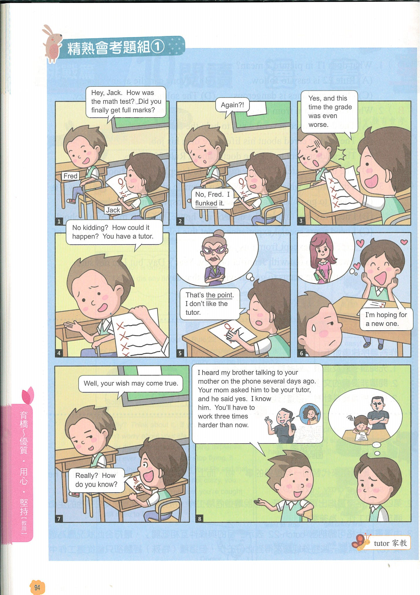
(二)
( )28. What does “flunked” mean?
(A) Passed.
(B) Failed.
(C) Prepared.
(D) Surprised.
( )29. What is “the point”?
(A) Jack got a terrible grade in order to change his tutor.
(B) Jack was not interested in math.
(C) Jack couldn’t believe his grades got worse when he had a tutor.
(D) Jack wanted to change his tutor to get full marks.
( )30. What do we NOT know from the comics?
(A) Jack hopes to have a pretty tutor.
(B) Jack’s mother was planning to find a new tutor for Jack.
(C) Fred’s grades are better than Jack’s because of his brother.
(D) Fred’s brother may become Jack’s new tutor.

(三) NNN News
Lately, the Internet has been filled with more and more fake news (see Figure1). Most people, more or less, will surely come across some fake news when they are surfing the Internet or using Facebook, Twitter, and so on. However, not everyone knows how to tell fake news from real news. A new study shows that younger people are more susceptible to fake news (see Figure 2).
About eight thousand students took part in this study, and these students were in three different groups: elementary school students, high school students, and university students. Every group was asked to read the same aiticles online. Then, they were asked if they thought the articles were fake news and why.
The study says that elementary school students have nothing to say about the news, not to speak of knowing how to tell. Most of them end up giving “true” to all the news. High school students believe that the news articles are true just because they would like to go along with their friends. As for university students, if a website looks pretty and its “ABOUT US” page looks good, the news articles are thought to be true most of the time.
The study hopes that what it has found can help parents and teachers know more about why their children or students easily believe fake news and think of how to deal with such a problem.

figure圖表 university大學

( )31. Below are the writer’s points in the reading:
a. Many students took part in a study.
b. Some news on the Internet are not true.
c. Why people of different age groups decided whether an article was true.
In what order are these points talked about in the reading?
(A) a→b→c.
(B) b→a→c.
(C) c→b→a.
(D) b→c→a.
( )32. What is true about Figure 1?
(A) The percentage (%) of fake news was the same in 2016 and 2019.
(B) Half of the news on the Internet was fake news in 2018.
(C) There was over 20% fake news on the Internet in 2012.
(D) The percentage (%) of fake news went up greatly from 2014 to 2015.
( )33. What does it mean when we say someone is susceptible to fake news?
(A) He or she will be cheated by fake news easily.
(B) He or she seldom reads fake news on the Internet.
(C) He or she is able to tell fake news from real news.
(D) He or she likes to write fake news for fun.
( )34. What can we learn from this reading?
(A) As people grow up, they still use the same ways to decide whether an article is fake news.
(B) For different reasons, people of different age groups decide if an article is fake news.
(C) High school students often read more fake news than elementary school students do.
(D) Parents should use Facebook or Twitter to help their children tell fake news from real news.
( )35. What do we know about the study?
(A) Parents and teachers may find it useful.
(B) It was done in the USA.
(C) The students in the study came from three schools.
(D) It took two years to do the study.

