桃園市立大有國民中學111學年度第二學期第三次評量試卷
年 級 | 七 | 考 試  科 目 | English |  |  | 命 題  範 圍 | Lesson5~ Review3 | 作 答  時 間 | 45分
班 級 |  | 姓 名 |  | 座 號 |  | 分 數
第一大題到第三大題為聽力測驗，請仔細聆聽！

一、辨識句意-根據聽到的內容，選出正確的圖片代碼 (6%)
- (A) (B) (C)
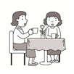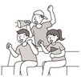

- (A) 06:00~21:00 (B) 06:00~12:00 (C) 06:00~17:00
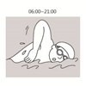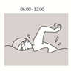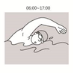

- (A) (B) (C)
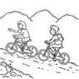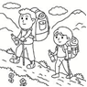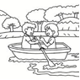

- (A) (B) (C)
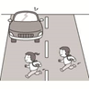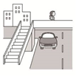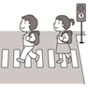

- (A) (B) (C)
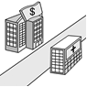

- (A) (B) (C)
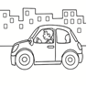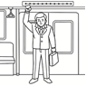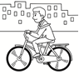

二、 基本問答-根據聽到的內容，選出合適的回應(12%)
- (A) Thank you.
(B) No problem.
(C) I see.

- (A) At three o’clock.
(B) Never on Monday.
(C) Once or twice a month.

- (A) We can take a bus.
(B) I never walk there.
(C) Let’s look at the map.

10.(A) By boat.
(B) Turn right.
(C) Around the corner.

11.(A) Just turn right.
(B) It’s never snowy.
(C) Well, sometimes.

12.(A) Yes, but only on weekdays.
(B) No, I seldom go to school on time.
(C) Why don’t you ask the woman for help?

三、言談理解-根據聽到的對話內容與問題，選出正確的答案(12%)
13.(A) Go to the market.
(B) Play with his kids.
(C) Visit his mom and dad.

14.(A) She always gets up late.
(B) She doesn’t like lunch.
(C) She doesn’t eat at home.

15.(A) By bus.
(B) On foot.
(C) By metro.

16.(A) Tommy’s Restaurant is on Happy Road.
(B) Tommy’s Restaurant is next to the park.
(C) The man can take a bus to Tommy’s Restaurant.

17.(A) By bus.
(B) On foot.
(C) By metro.

18.(A) She lives with her parents.
(B) She seldom cooks at her place.
(C) She only visits her parents on weekends.


四、綜合測驗 (40%)

19. | What does the boy do in the picture?
 | - Swim | - Jog | - Tug of war | - Jump rope
20. | It’s to swim in the river after heavy rain in summer.  - dangerous (B) wrong (C) get hurt (D) sick
21. | The museum opens only on , not on weekends.
 | - Sunday | - Saturday | - weekdays | - every day
22. | YA! Our school team wins the game. Let’s them.  - care about (B) cheer up (C) notice (D) cheer for
23. | I clean my room on Sundays. It clean.  (A) am usually ; is often (B) usually; usually  (C) usually am ; often is (D) usually; is often
24. | Simon: do you go to a museum ?  Eric: Not very often.
 | - How | - How many | - How often | - How long
25. | My brother likes to eat vegetables very much. He eats meat.
 | - always | - seldom | - usually | - often
26. | My daughters me some math questions after school.
 | - sometimes asks | - ask sometimes | - sometimes askigng | - sometimes ask
27. | Stacy: How often do you play sports?.  Peter: I play basketball .
 | - every two week  (C) twice every week. |  | - once every day.  (D) four times a week
28 | I don’t like this dress. Please show me .  - other (B) one (C) another (D) else
29. | Teacher:Do you often do your homework at school?  Chris: : I always do it at home.  - Yes, I do. (B) No, I never. (C) No, I never do. (D) Yes, I always do.
30. | Rachel and Fiona sometimes a bus to Tainan with their parents.
- ride (B) take (C) walk (D) drive
31. Go straight three blocks and you can see the museum on the right.
(A) for (B) on (C) at (D) with
32. The bank is the bakery and the park.
(A) in front at (B) under (C) cross (D) between
33. Michael lives near the school. He usually goes to school .
(A) by walk (B) by feet (C) on foot (D) walking
34. My sister is usually angry, but I .
(A) am never not (B) am never (C) never (D) never am
35. Lisa: Athletes usually train every day. Nothing can’t stop them.
Sam:
(A) The life of athlete is easy. (B) Once in a blue moon.
(C) I see. You rock! (D) Hard work pays off.
36. My father is never late for work. In other words, .
- he never goes to work on time (B) he always goes to work on time
(C) he seldom goes to work on time (D) he always goes to work late
37. Kevin: How often does your brother play basketball?
Emma: .
- For an hour.
- Yes, he plays it every day.
- He doesn’t like to play the guitar.
- He does it every day.

38. Lily:
Jerry: Walk along Dayou Road for 5 minutes. It’s across from Dayou Elementary School.
(A) How can I get to Dayou Junior High School?
(B) How do you go to Dayou Junior High School?
(C) How often do you go to Dayou Junior High School?
(D) Is Dayou Junior High School far away from here?

五 克漏字、閱讀測驗(30%)

39~41
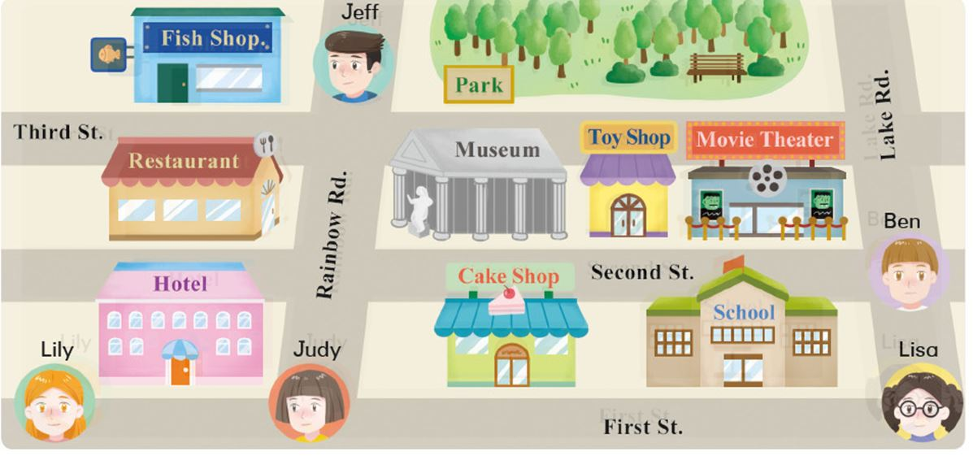
39. Look at the map, which is wrong ?
(A) The toy shop is between the museum and the movie theater.
(B) The restaurant is across from the museum.
(C) The school is in back of the movie theater..
(D) The cake shop is next to the school.

40. Lisa wants to go to the restaurant for dinner. She uses Google map for help. How can she get there ?
(A) Go down First Street and turn right on Rainbow Road. It’s next to movie theater.
(B) Walk along First Street and turn right on Rainbow Road. It’s on the corner of Rainbow Road and Second Street.
(C) Walk along Lake Road and turn left on Third Street. It’s on the corner of Third Street and Rainbow Road.
(D) Go straight on First Street and turn right on Rainbow Road. It’s across from the park.

41. After dinner, Lisa wants to invite Lily to excrcise in the park. How can Lily get to the park?
(A) Go along First Street for two blocks and turn left on Lake Road. It’s on her right.
(B) Cross Rainbow Road and walk along Second Street. It’s across from the museum.
(C) Go down Second Street and turn right on Rainbow Road. It’s on the corner of Rainbow Road and Third Street.
(D) Walk along First Street and turn left at the first corner. Then go straight for two blocks, and it’s on her right.

42~44
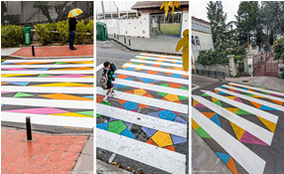
Madrid’s Colorful New Crosswalks
Crosswalks are an important part of everyday life. They keep us safe when we’re walking across a road. Usually, crosswalks aren’t very interesting to look at. They’re just white stripes on a gray road. But that’s changing in Madrid, Spain now. An artist, Christo Guelov, is turning Madrid’s crosswalks into art.
Guelov’s plan is called Funnycross. He adds colorful shapes between the whitestripes on the road. Some of his works are triangles, circles, and even zigzags. He turns boring zebra crossings into fun pieces of art.
However, these beautiful designs aren’t just beautiful. Guelov’s designs make the crosswalks easy to see. This makes crossing the road safe for both walker and drivers. It only takes a little paint to make crosswalks fun and safe for everyone.
 crosswalk 行人穿越道 stripe 條紋 turn into 轉變成 add 增加 triangle 三角形 zigzag 鋸齒狀 design 設計

42. What is Funnycross?
(A) A special art show in Madrid, Spain.
(B) A road with strange designs.
(C) A famous bridge in Spain.
(D) One of Christo Guelov’s paintings.

43. How does Guelov change the crosswalks?
(A) He paints colorful patterns between the lines. pattern 圖樣
(B) He changes the shape of the stripes.
(C) He only changes the color of the stripes.
(D) He draws cute animals on the road.

44. What is true about Guelov’s art?
(A) It helps people cross the street safe.
(B) It cost a lot of money to paint it.
(C) People don’t like his artwork.
(D) It makes the crosswalks difficult to see.

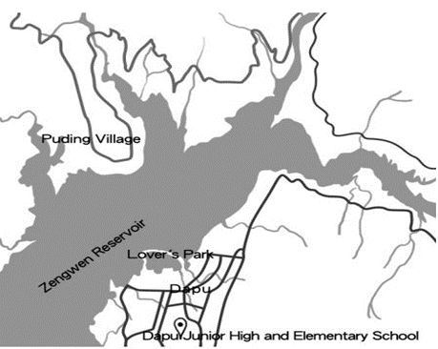
45~47

Dapu is a small, friendly town near Zengwen Reservoir in Chiayi. It is famous for fish in the lake and bamboos in the mountains. People like visiting there for delicious fish and bamboo dishes. Because there are not many people living there, Dapu Junior High and Elementary School is the only school in town. Most students go to school on foot, by bus, or by car, but Jean is different.
Jean lives in Puding, across the reservoir from Dapu. When it rains a lot and the reservoir is full of water, she can go to school by boat. She spends only twenty minutes taking a boat from Puding to Dapu, and then she takes a car to her school. But it does not rain much from February to June in Dapu. There is not enough water in the reservoir for the boat to sail on it. Jean has to get up before six, and her father drives her to school along the road near the reservoir. It takes them over one hour, but Jean still feels happy because she can see a lot of animals on the way to school, and she likes the school life. That is why people call her “the reservoir girl.”
 Zengwen Reservoir 曾文水庫 spend 花時間 enohgh 足夠的sail 航行 take 花時間

45. What is the reading mainly about?
(A) A trip to Zengwen Reservoir.
(B) The easy life in a small town.
(C) A girl’s special way to school.
(D) Delicious food in Zengwen Reservoir.

46. What do we know about Dapu from the reading?
(A) Dapu is a city on an island in the lake.
(B) Dapu has two schools in all. visitor 觀光客
(C) Visitors can go to Dapu by train.
(D) Visitors go to Dapu for its delicious food.

47. About Jean, the reservoir girl, which is true ?
(A) She lives in Reservoir.
(B) She enjoys the school life.
(C) She doesn’t go to school from February to June .
(D) Sometimes she goes to school on foot with her father.

48~49
This is Mindy’s schedule. Read it and answer the questions.
 | Sun. | Mon. | Tue. | Wed. | Thu. | Fri. | Sat.
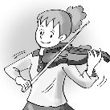 |  |  |  |  |  | 
 |  |  |  |  |  |  | 
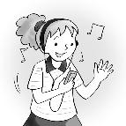 |  |  |  |  |  |  | 
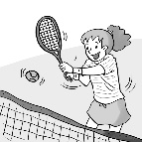 |  |  |  |  |  |  | 
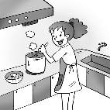

48. How often does Mindy play the violin?
(A) Once a week.
(B) Twice a week.
(C) Every two days.
(D) Three times a week.

49. What does Mindy never do in a week ?
(A) Listen to music .
(B) Cook meals .
(C) Surf the Net.
(D) Play sports. .

50~53

Ted：It’s my turn to clean the classroom this week. Can you tell me about it?
Jane：Yeah, I just finished my turn last week.
Ted：What do you do?
Jane：You have the key to the classroom door this week. So, be sure to be the 50 one to get to
the class.
Ted：OK. It’s my habit to get up early. I’m 51 late.
Jane：That’s good. It is a hard work for me.
Ted： 52
Jane：You have to take it out on Monday, Wednesday, and Friday. That’s three times a week.
Ted：OK. And does Ms. Lin 53 it every day after school?
Jane：Yeah, she makes sure we finish our job, but you don’t have to worry too much.
 turn 輪班 finish 完成 makes sure 確認

50. (A) first (B) last (C) only (D) another
51. (A) seldom (B) always (C) usually (D) often
52. (A) What day do you go to the school?
(B) What do I take out three times a week?
(C) How do I clean the classroom?
(D) How often do I take out the trash?
53. (A) clean (B) ask (C) check (D) train

試題結束，總共53題。
請確認答案卡的座號及作答題數。

