桃園市立大有國民中學112學年度第一學期第一次評量試卷
年 級 | 七 | 考 試  科 目 | English |  |  | 命 題  範 圍 | Get Ready~ Review1 | 作 答  時 間 | 45分
班 級 |  | 姓 名 |  | 座 號 |  | 分 數
第一大題到第四大題為聽力測驗，請仔細聆聽！

一、辨識句意：每題均有三張圖片，請依據所聽到的句子，選出符合描述的圖片。(10%)

(A) (B) (C) 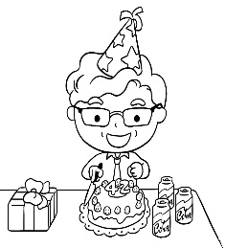 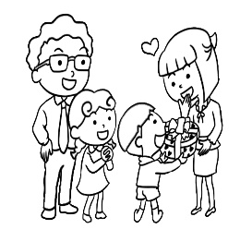 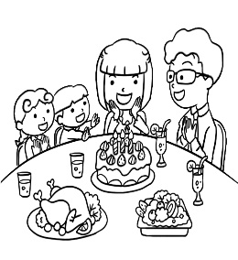
- (A) (B) (C)
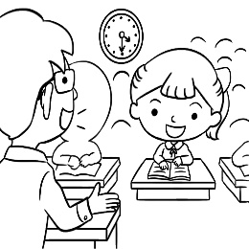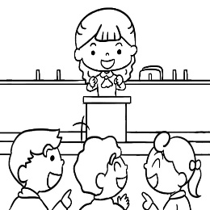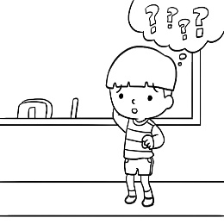

- (A) (B) (C)
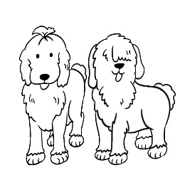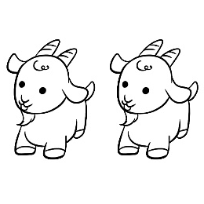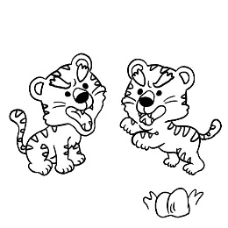

- (A) (B) (C)
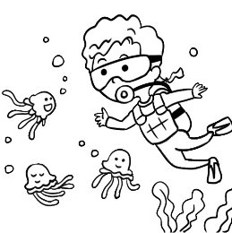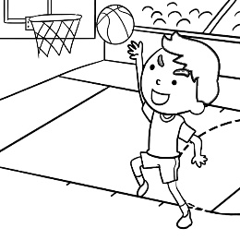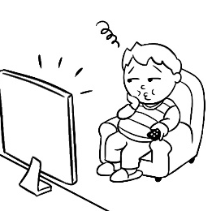

- (A) (B) (C)
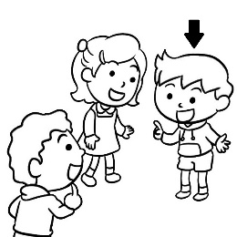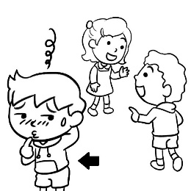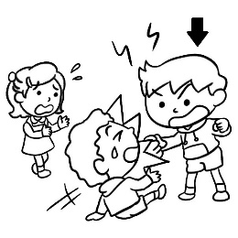

二、基本問答：每題均有三個選項，請依據所聽到的內容，選出一個最適合的回應。(10)

- (A) She’s my aunt.
(B) It’s a birthday gift for you.
(C) He’s my cousin Robert.

(A) That’s true. I’m a horse.
(B) No wonder you’re energetic!
(C) Yes, I am. What about you?

- (A) I’m five.
(B) I’m good.
(C) I’m at home.

- (A) Yes, it is.
(B) What is this?
(C) No, they’re not.

- (A) They are mice.
(B) Are they your dolls?
(C) It’s a cool picture.

三、言談理解：每題均有三個選項，請依據所聽到的對話與問題，選出一個最適當的答案。(10%)
- (A) A pencil box
(B) A banana.
(C) A pencil.

- (A) A dog’s name.
(B) The girl’s name.
(C) A cat’s name.

- (A) She’s Henry’s aunt.
(B) She’s Henry’s mom.
(C) She’s Henry’s doctor.

- (A) The boy and his mom are in a movie theater.
(B) The black rabbit is the boy’s pet now.
(C) The mouse is the boy’s pet now.

- (A) She’s Irene.
(B) She’s Irene’s sister.
(C) She’s Irene’s friend.

四、綜合測驗 (24%)

16. | is a doctor, and wife is a doctor, too.
 | - He ; her | - His ; his | - I ; my | - He ; his
17. | Sara: Are you cooks? Leo:
 | - Yes, I am. | - Yes, we’re. | - No, I’m not. | - No, we’re not.
18. | Matt: is that tall and handsome man? Ann: He’s my PE teacher.
 | - What | - Who | - How | - Where
19. | I keep a pet cat. eyes are big. so cute.
 | - It’s ; Its | - Its ; It’s | - It’s ; It’s | - Its ; Its
20. | This is . Those are .  (A) a bear; a goat (B) bears; goats (C) a bear ; goats (D) bears; a goat
21. | Peggy is these English teacher.
 | - girl | - girls | - girl’s | - girls’
22. | Dad: ? Amy: It’s a birthday gift for you.
 | - Is it a gift ? | - Are these my gifts? | - What’s that ? | - What about it ?
23. | It’s eraser, not pencil.
 | - a; a | - an; a | - a; an | - an; an
24. | Denny: is your sister?  Lary: She’s only 5.
 | - Is she | - Who | - What | - How old
25. | Jell: Is Mr.Wang a young man ?  Bill:  (Ａ) Yes, Mr. Wang is. He is a young man.  (Ｂ) No, he isn’t. He’s an old man.  (Ｃ) Yes, he is old.  (Ｄ) No, Mr.Wang is young.
26. | John: Hi, Judy. This is my classmate, Bob.  Judy: Nice to meet you.  Bob:  (Ａ) I’m fine. Thank you.  (Ｂ) You’re welcome.  (Ｃ) Nice to meet you, too.  (Ｄ) You are beautiful.
27. | Which sentence is right?   sentence句子  right 正確的  (Ａ) i am happy.  (Ｂ) WHO are they?  (Ｃ) Is she your Mom.  (Ｄ) Taiwan is nice.
五、 克漏字、閱讀測驗(20%)
28~31

Eddie is my new friend. He is 14 28 . His family is 29 the USA. His father is a tour guide. He is at a beautiful place in Japan now. Eddie’s mother is a 30 . She is at home every day. Eddie’s sister is a 31 in a senior high school. She is nice to me. This is a nice family.

 tour guide 導遊 every day 每天 friendly 友善的

28. (Ａ) years (Ｂ) year old (Ｃ) years-old (Ｄ) years old
29. (Ａ) to (Ｂ) from (Ｃ) at (Ｄ) for
30. (Ａ) farmer (Ｂ) teacher (Ｃ) housewife (Ｄ) doctor
31. (Ａ) student (Ｂ) cook (Ｃ) nurse (Ｄ) aunt

32~34

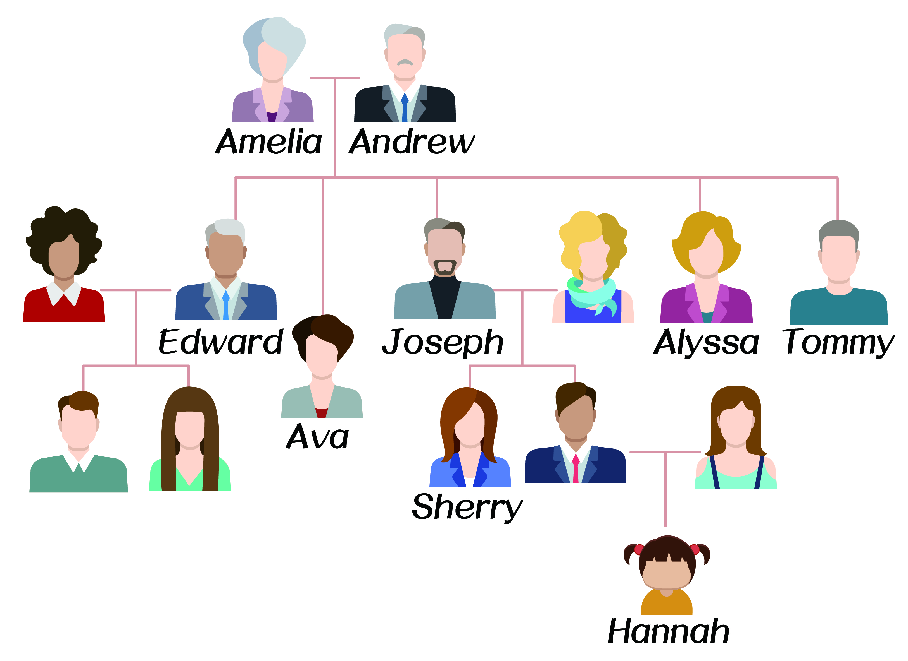
32. How many children do Amelia and Andrew have?
(Ａ) 3.
(Ｂ) 4.
(Ｃ) 5.
(Ｄ) 6.
how many 幾個
have 擁有

33. Who is Tommy?
(Ａ) He is Alyssa’s husband.
(Ｂ) He is Sherry’s uncle.
(Ｃ) He is Hannah’s grandfather.
(Ｄ) He is Andrew’s grandson.

34 . Which is True?
(Ａ) Joseph has three children.
(Ｂ) Sherry and Alyssa are sisters.
(Ｃ) Edward is Ava’s uncle.
(Ｄ) Hannah is Joseph’s granddaughter.

35~37
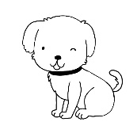  Lulu | Lulu is small and smart. It has long legs. Jack is Lulu’s owner, and he is ten years old. Jack is nice to Lulu.
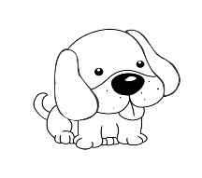  Henry | Henry is a cute dog. It has short legs. Kate is its owner. She is a doctor. They are good friends.
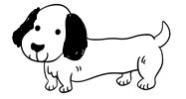  Bobo | Bobo is a small dog. It is black and white. It is energetic. Tina is Bobo’s owner. She is from Australia.
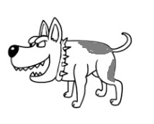  Cody | Cody is two years old. Its colors are brown and white. Mr. and Mrs. Lin are Cody’s owners.
 has 有 leg 腿 owner 主人 Australia 澳洲 brown 棕色的

35. Whose owners are husband and wife?
(A) Lulu.
(B) Henry.
(C) Bobo.
(D) Cody.
whose 誰的

36.
I am smart. My legs aren’t short. My owner is a boy. I like him very much.

Who is speaking?
speak 講話
(A) Bobo.
(B) Cody.
(C) Lulu.
(D) Henry.
which 哪一個
37. Which is true?
(A) Lulu and Bobo are big dogs.
(B) Cody’s colors are black and white.
(C) Lulu’s owner is a doctor.
(D) Henry and Kate are good friends.

一~五大題答案請於答案卡畫卡作答，共37題。

桃園市立大有國民中學112學年度第一學期第一次評量答案卷
年 級 | 七 | 考 試  科 目 | English |  |  | 命 題  範 圍 | Get Ready~ Review1 | 作答  時間 | 45分
班 級 |  | 姓 名 |  | 座 號 |  | 分 數
請用黑色原子筆於考卷下方答案欄作答，違者不予計分
六、單字：（10%）
1. 雙親之一 2. 廚房 3. 溫暖的 4. 堂(表)兄弟姊妹 5. 女兒
6. 動物 7. 斑馬 8. 人們 9. 老虎 10. 一樣的

七、寫出下列單字的複數形（6%）
11. mouse → 12. fly → 13. wife →
14. sheep → 15. watch → 16. monkey →

八、依提示作答與翻譯(10%)
17. This is a chair.(改寫成複數句) 2%
18. It is a long pencil. （改成疑問句）2%
19. They’re my toy cars. （ 依畫線部分造原問句）3%
20. Are those cats?（先否定簡答，再用robot回答）3%
答案欄

1 |  | 2 |  | 3 |  | 4 |  | 5
6 |  | 7 |  | 8 |  | 9 |  | 10
11 |  | 12 |  | 13 |  | 14 |  | 15
16
17
18
19
20

注意：
1.試卷(含答案卷)共五面，請仔細做答。
2.一~五大題答案請畫卡作答，六~八大題請用黑色原子筆寫在答案卷上的答案 欄，否則不予計分！
3.考試結束鐘響起，立刻停筆；收回答案卡與答案卷。

