桃園市立大有國民中學112學年度第一學期第二次評量試卷
年 級 | 七 | 考 試  科 目 | English |  |  | 命 題  範 圍 | Lesson3 ~ Review2 | 作 答  時 間 | 45分
班 級 |  | 姓 名 |  | 座 號 |  | 分 數
第一大題到第三大題為聽力測驗，請仔細聆聽！

一、辨識句意-根據聽到的內容，選出正確的圖片代碼 (6%)
- (A) (B) (C)
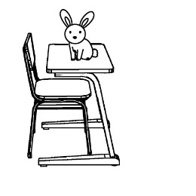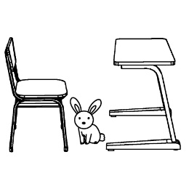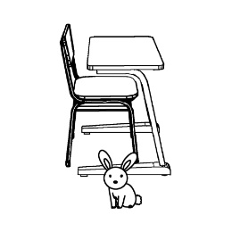

- (A) (B) (C)
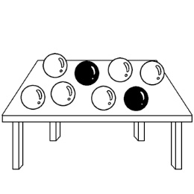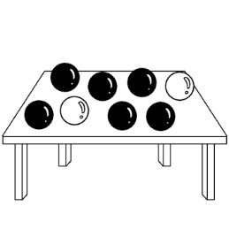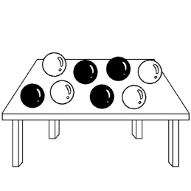

- (A) (B) (C)
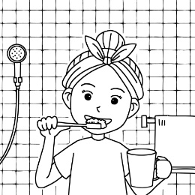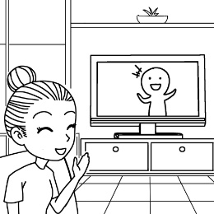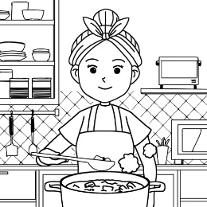

- (A) (B) (C)
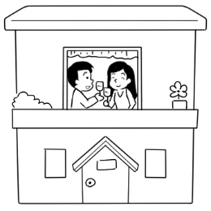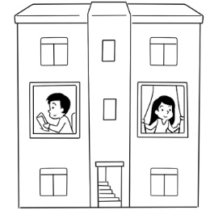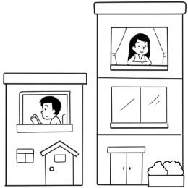

- (A) (B) (C)
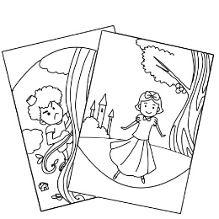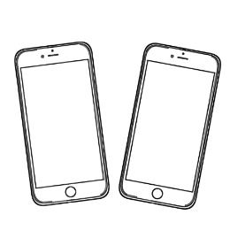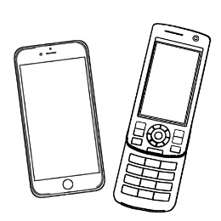

- (A) (B) (C)
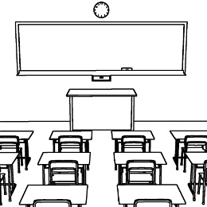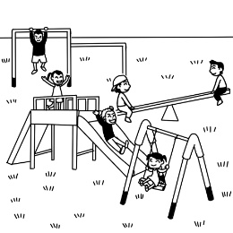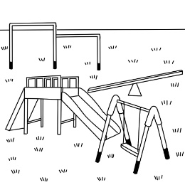

- 基本問答-根據聽到的內容，選出合適的回應(10%)

- (A) Yes, my house is inside it.
(B) Yes, my house is next to it.
(C) No, my house is next to it.

- (A) It’s different.
(B) It’s my blanket.
(C) It’s a magic school.

- (A) Yes, it’s behind these mountains.
(B) There are some schools around here.
(C) Yes, there is a junior high school.

10. (A) Isn’t it near the TV screen?
(B) Are there a lot of T-shirts here?
(C) That is not your favorite T-shirt.

11. (A) There are about thirty.
(B) Yes, it’s big and beautiful.
(C) It’s behind the mountains.

三、言談理解-根據聽到的對話內容與問題，選出正確的答案
(10%)

12. (A) In a castle.
(B) Near a lake.
(C) In a small house.

13. (A) In the bathroom.
(B) In the kitchen.
(C) In his bedroom.

14. (A) Sally’s new school.
(B) Sally’s PE teacher.
(C) Sally’s favorite place at school.

15. (A) A blanket.
(B) A cellphone.
(C) A newspaper.

16. (A) No, it isn’t.
(B) Yes, it’s a yellow blanket.
(C) Yes, it’s small and hard.

四、綜合測驗 (28%)

17. | There is a big ___________ in our school. We play ball games there.
 | - grade |  | - gym | - gift |  | - garden
18. | Edward, go to the _____________ and wash your face now. Your face is dirty.  - bedroom (B) bathroom (C) dining room (D) living room
19. | The girl and the boy beside the car ________ my classmates, and the man in front of the car ____ my uncle.
 | - are; is |  | - is; is | - are; are |  | - is; are
20. | Ted: Is the ball next to the sofa?  Leo: Yes. ____________________  - It’s beside the sofa. (B) It’s not next to the sofa.  (C) It’s inside the sofa. (D) It’s behind the sofa.
21. | Paul: How are Amy’s father and mother?  Mike: _____________ I like them very much.  (A) They are English teachers. (B) They are here.  (C) They are in the house. (D) They are nice.
22. | Mandy: Are your sisters in the park?  Peter : ________________
 | - Yes, there are. |  | - No, they’re not. | - Yes, I am. |  | - No, we aren’t.
23. | Amanda is _________________. She is from Singapore.
 | - five years old girl |  | - elven-years-old | - a seven-year-old girl |  | - a ten-year girl
24. | Grace: Where is my pencil?  Cathy: _______________  - It’s on table. (B) It’s in front of the TV.  (C) It’s not your pencil. (D) There are two pencils for you.
25. | Lisa: _________________  Chen: Sorry. We only have one bedroom for two people.  (A) Are there any people in the room?  (B) Is there a room for four people?  (C) There are only two bedrooms.  (D) Is the room for two people?
26. | Mr. White: ____________ is your mother?  Kevin : She is in the kitchen.  - What (B) How (C) How old (D) Where
27. | Look! A big tree is between ________________.
 | - two person |  | - car and bus | - a beautiful school |  | - two houses
28. | Jean: Is there a dining room in your house?  Lucy: ______________ We eat in the living room.
 | - No, there isn’t. | (B) Yes, it is. |  | (C) No, it isn’t. | (D) Yes, there is.
29. | Susan: Are Robert and Elsa brother and sister?  Harry: No. _________________  (A) No wonder they are nice. (B) They are very smart.  (C) In fact, they are husband and wife. (D) They are in the classroom.
30. | Bonny: What is your favorite sport?  Simon: ________________
- There are lots of books in the library. (B) They are my pet dogs.
(C) The playground. My sisters like there, too. (D) Basketball. I play basketball every day.

五 克漏字、閱讀測驗(20%)

31~35
(Jamie and her friends are talking at the zoo.)
Jamie: Andy, 31
Andy : Lions! They are the king of animals.
Jamie: How about you, Cindy?
Cindy: 32
Jamie: Why?
Cindy: Because 33 , and they are like my family.
Jamie: I see. And you, John?
John : I love 34 . Look! The one is over there. There is a big white V on its chest(胸膛).
Jamie: 35 It’s cool.

- (A) What is it?
(B) Where are the animals?
(C) What’s your favorite animal?
(D) Is that your favorite book?
- (A) I don’t like lions.
(B) I love cats.
(C) Harry Potter is my favorite.
(D) I like black.
- (A) the book is fun
(B) my uncle is a doctor
(C) the gifts are nice
(D) I have two cats at home
- (A) storybooks
(B) Formosan black bears
(C) the white house
(D) different people
- (A) That’s right.
(B) Thank you very much.
(C) It is a nice picture.
(D) That’s a special game.

36~37
There are one hundred students in Da-Da Junior High School. Today, students is voting on their favorite color to be the special activity logo. The results are here.
Thirty students choose pink. 15% of the students vote for green. Fifteen students like blue. Twenty students vote for yellow. 20% of the students like black.
Students can see the results on the blackboard in every classroom.

- hundred 百 activity logo活動徽章 results 結果 choose 選擇
can 可以 blackboard 黑板

36. Which(哪一個) picture is voting?
(A) 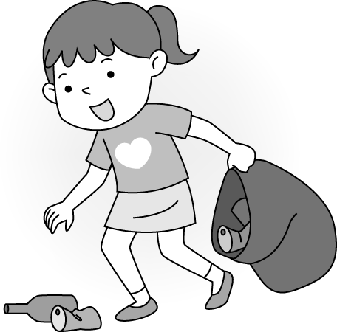 (B) 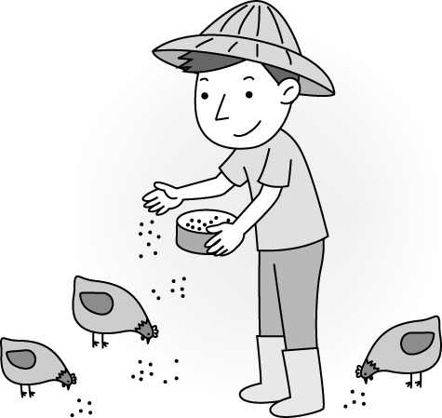 (C) 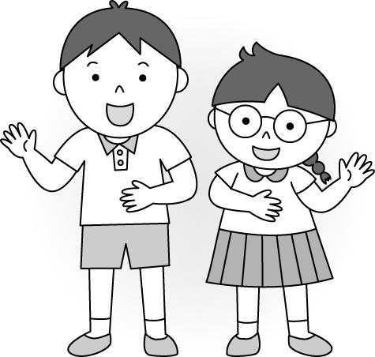 (D) 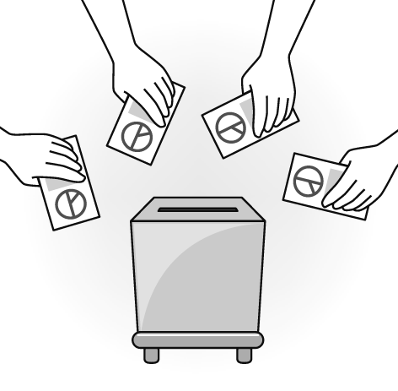

37. What can students see on the blackcoard?
(A) (B) (C) (D)
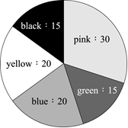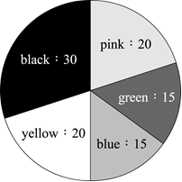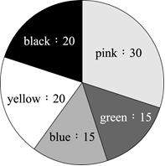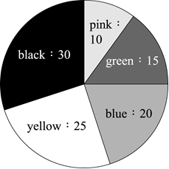

38~40
This is Monica’s new house. There is a big garden around the house. A lot of tall trees and beautiful flowers are in the garden.
In the house, there is a kitchen. It’s her favorite place. She makes cake there. The dining room is next to the kitchen. There is a table in it. We have fun there at dinner time.
There’s a bed, a desk, and a chair in Monica’s bedroom. On the desk is a storybook. Monica’s sisters like it very much. There is a picture on the wall. The chair is next to the desk. Monica’s cellphone is on the chair. There’s a toy car under the chair. Kitty, Monica’s cat, is under the chair, too. Where is Jenny? Is she in the room? No. She is in the garden.

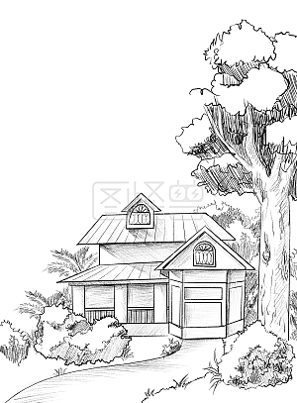

38. What is Monica’s favorite place?
(A) (B) (C) (D)
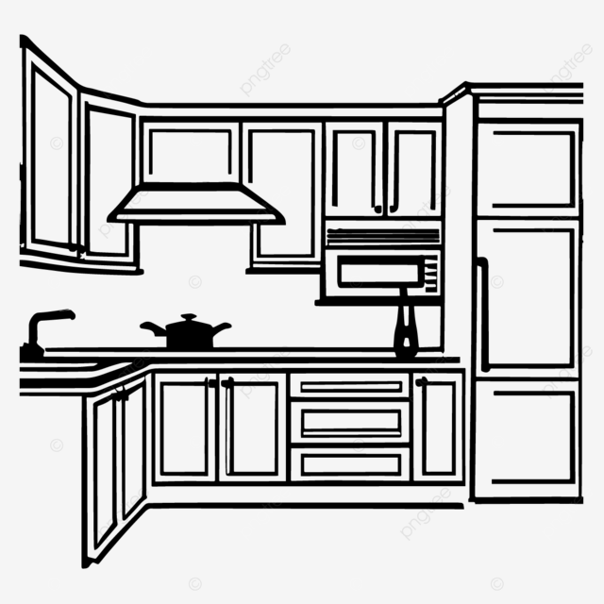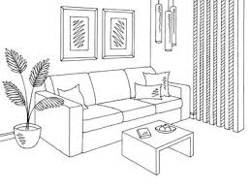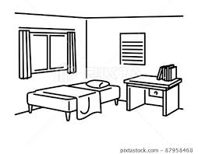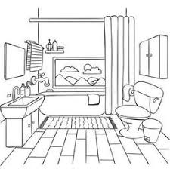
39. What is “ it ”?
(A) The desk. (B) The storybook. (C) The bedroom. (D) The picture.

40. Which is true? (何者正確?)
(A) No tables are in the dining room. (B) The chair is behind the desk.
(C) Jenny is in the room. (D) There are two things under the chair.

注意: 六、七大題非選擇題須寫在「答案卷」上，並用黑筆作答，否則不予計分!

六、字彙與填空 (21%)
1. It is a big p d . A lot of fish are in it.
2. Look at the w d map(地圖). South Africa is here.
3. Simon and I live in the same room. We’re r tes .
4. My grandfather and grandmother live in the m ns .
5. Tommy is in front of the school g e .
6. The math t t is not easy for me. It’s hard.
7. 螢幕 8. 籃球場 9. 分鐘 10. 派對 11. 滑梯
12. 鞦韆 13. 遊樂場 14. 休息 15. 圖書館 16. 柔軟的

填入a、any或some
- There is _________ tall tree at my school.
- There are ___________ balls in the box.
- Sam: Are there _____________ bananas in the kitchen?
- Jay : Yes, there are ______________ bananas there.
- There aren’t _____________ students in the classroom.

七、依提示作答(5%)
(2%) 1. The cute zebra is next to the monkey. (依畫線部分造原問句)
(2%) 2. There are some mice in the room. (將句子改寫為否定句)
(1%) 3. Yes, there is a pencil box on the table. (依畫線部分造原問句)

試 題 結 束

