桃園市立大有國民中學112學年度第二學期第一次評量試卷
年 級 | 七 | 考 試  科 目 | English |  |  | 命 題  範 圍 | L1~ Review1 | 作 答  時 間 | 45分
班 級 |  | 姓 名 |  | 座 號 |  | 分 數
第一大題到第三大題為聽力測驗，請仔細聆聽！

一、辨識句意：每題均有三張圖片，請依據所聽到的句子，選出符合描述的圖片。(10%)

(A) (B) (C) 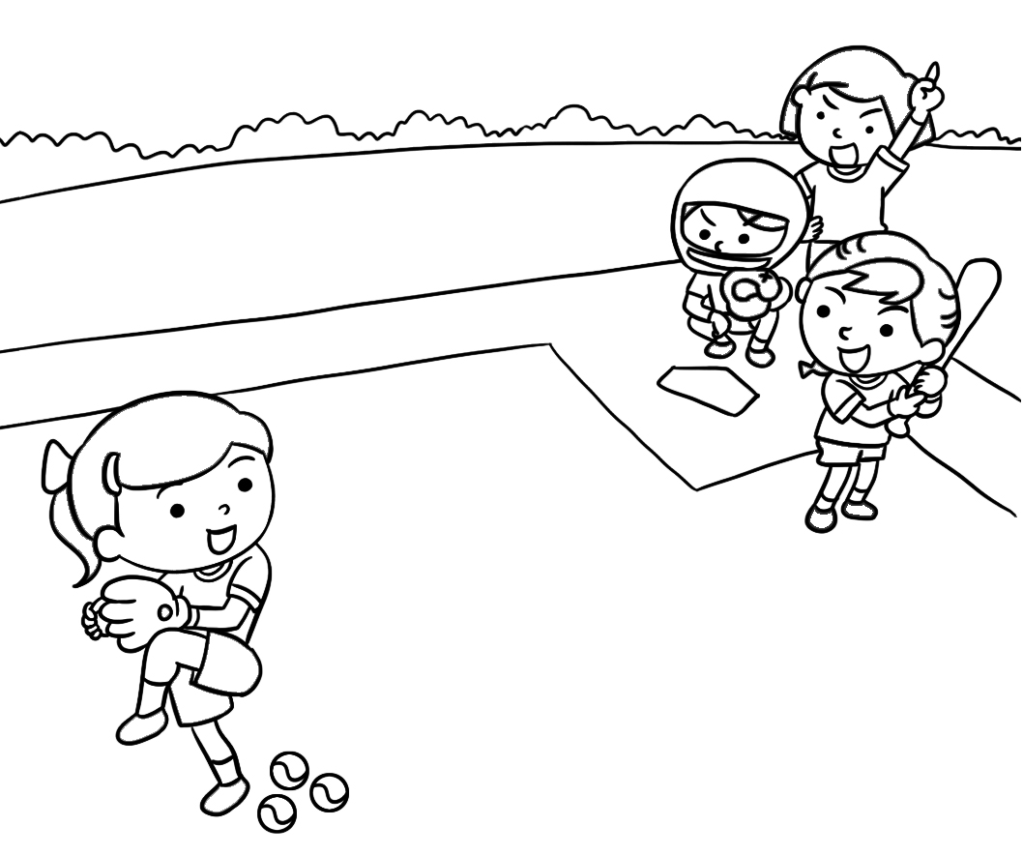 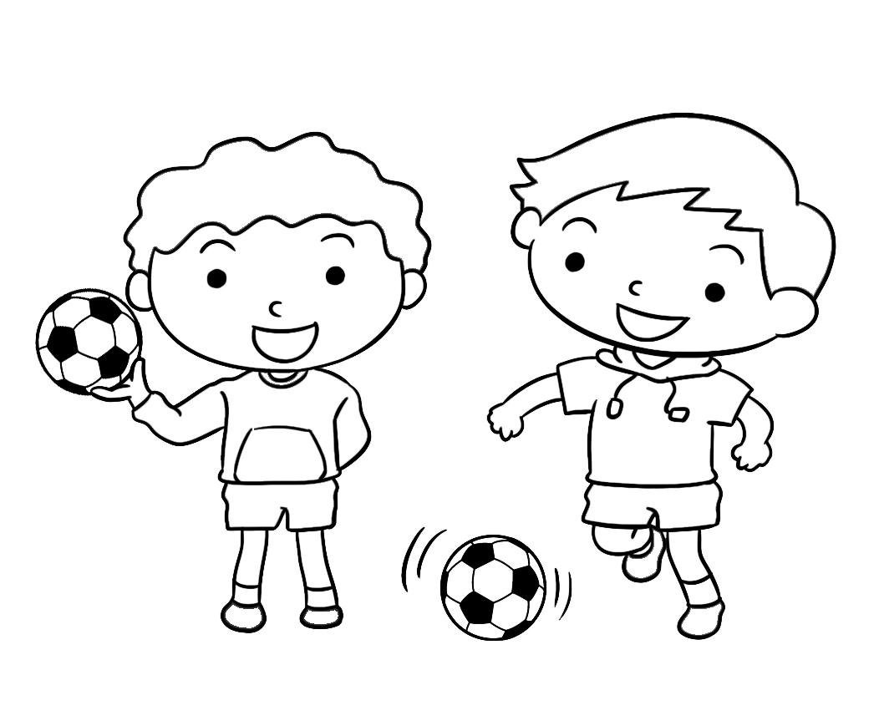 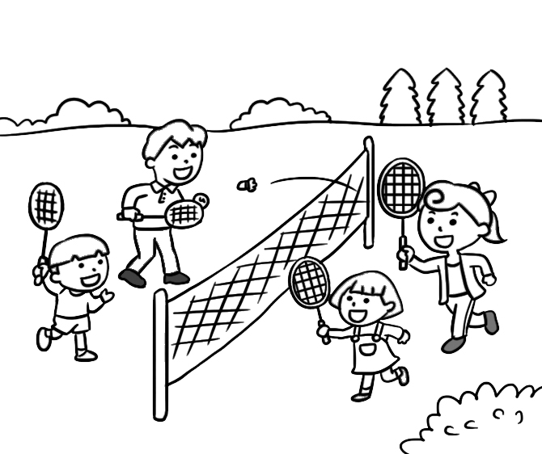

- (A) (B) (C)
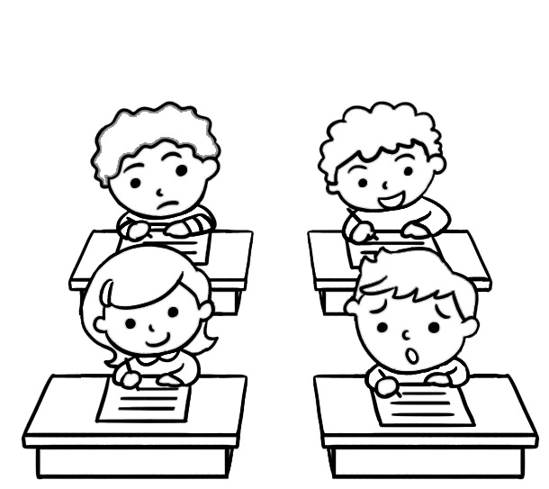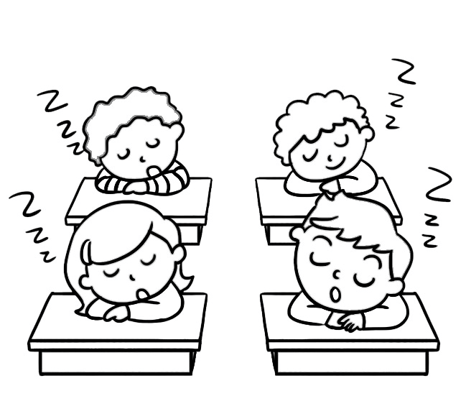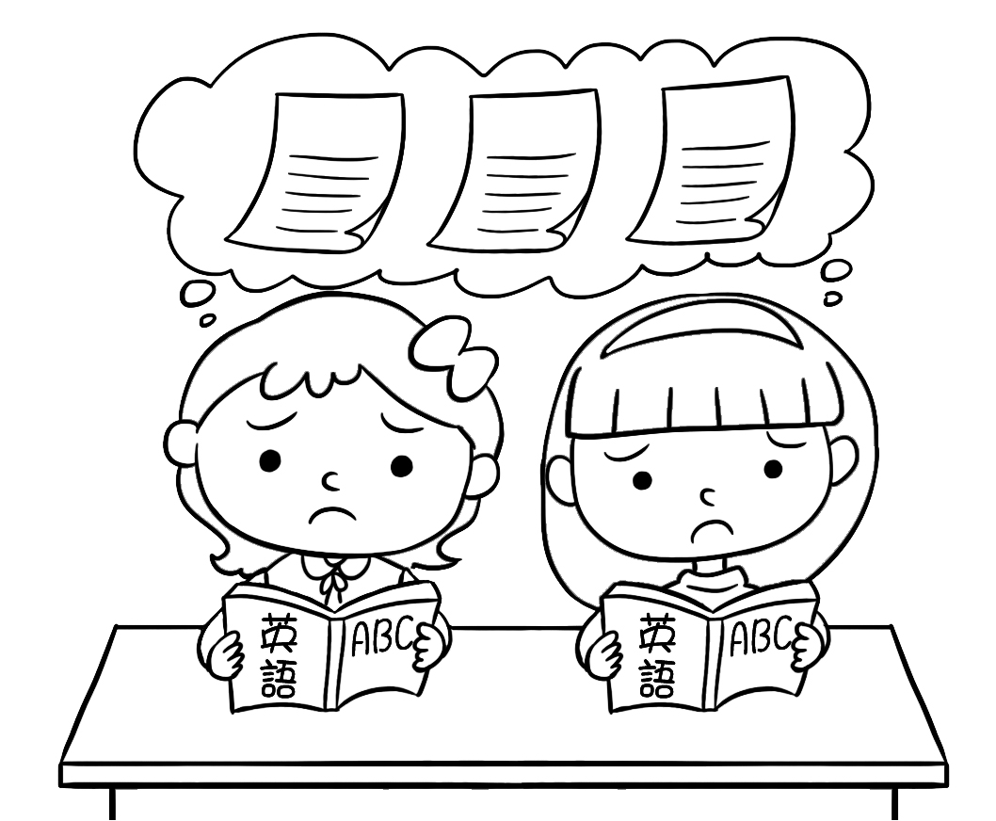

- (A) (B) (C)
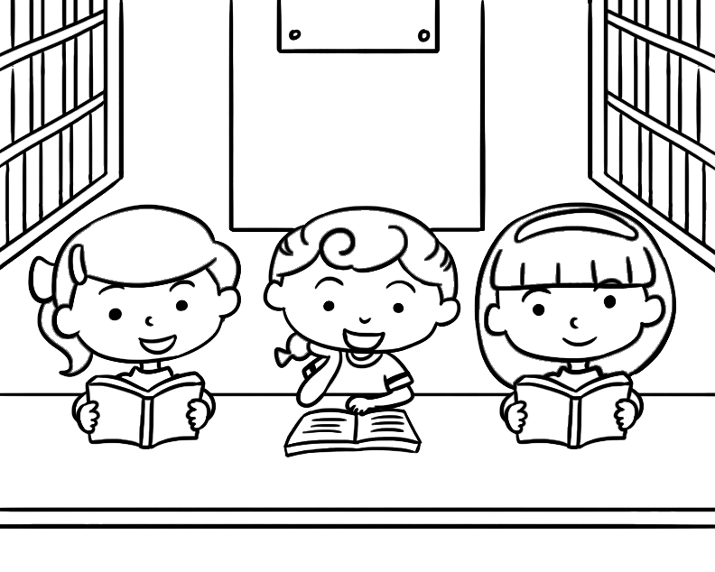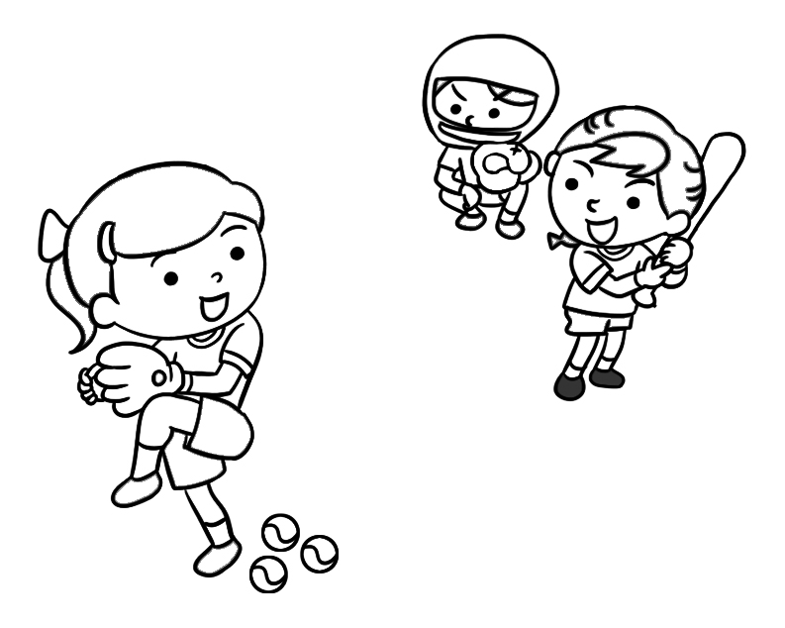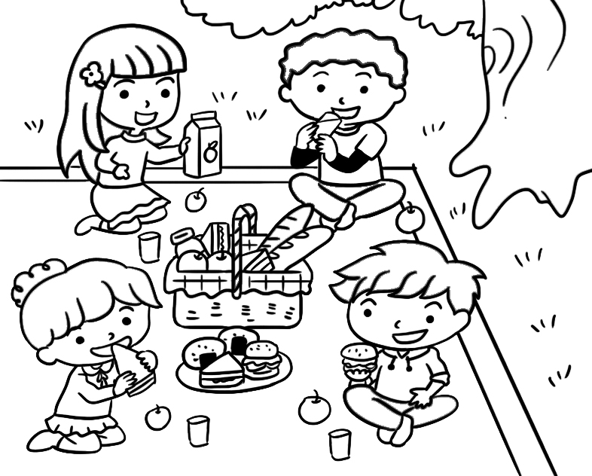

- (A) (B) (C)
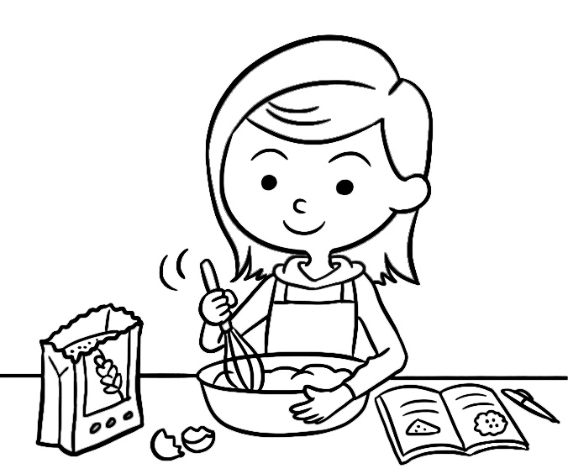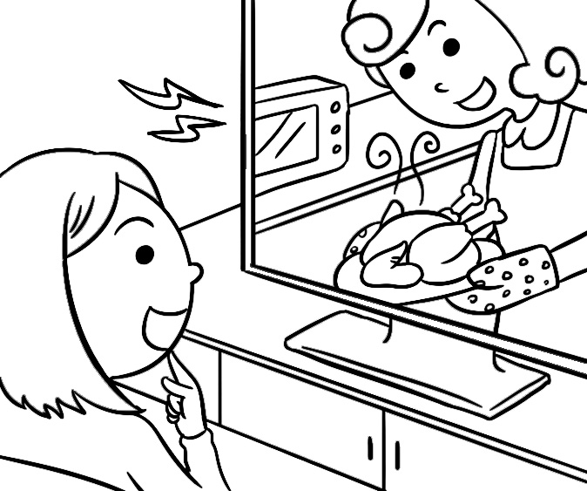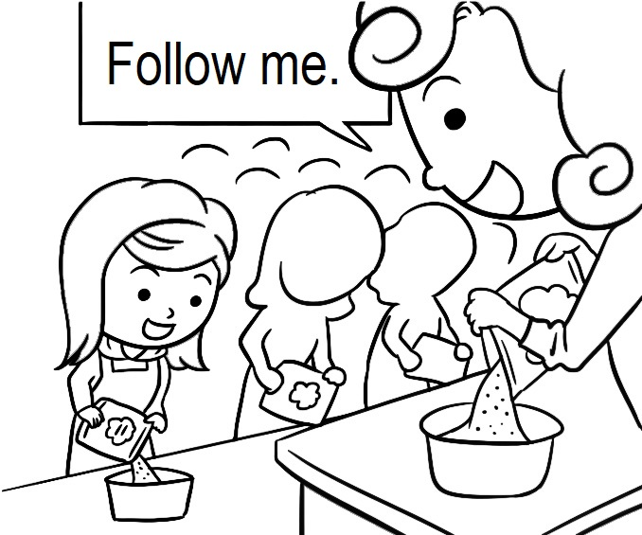

- (A) (B) (C)
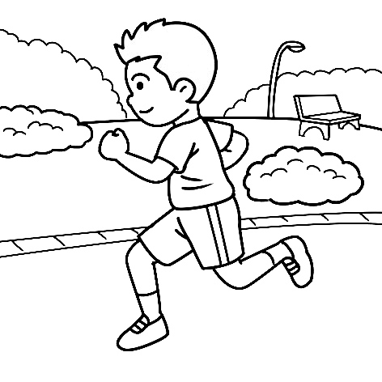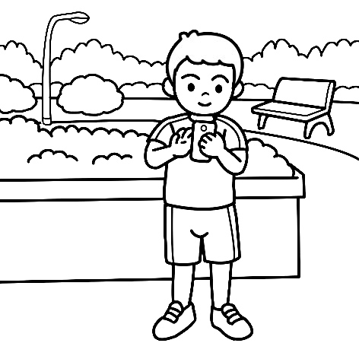

二、基本問答：每題均有三個選項，請依據所聽到的內容，選出一個最適合的回應。(10%)
- (A) They are one hundred and fifty dollars.
(B) They are my favorite fruit.
(C) I have a lot of them.
- (A) Let’s choose tennis club.
(B) The volleyball club. Tina is in the club, too.
(C) It’s my favorite film.
- (A) Yes, your phone is here.
(B) Yes, you can share it with me.
(C) Sure, it’s on the desk.
- (A) I see. Can we watch it again? It’s great.
(B) Sure. I can share that film with my classmates.
(C) I don’t have any ideas for the film, either.
- (A) Mr. Chen teaches me Chinese.
(B) Sorry. I don’t know it, either.
(C) Don’t do that again. That’s not nice.

三、言談理解：每題均有三個選項，請依據所聽到的對話與問題，選出一個最適當的答案。(10%)
- (A) He’s tall.
(B) He’s good at basketball.
(C) He’s the girl’s cousin.
- (A) Eat dinner.
(B) Play sports.
(C) Study.
- (A) She wants to use the bathroom now.
(B) She wants to use the bathroom again.
(C) She doesn’t want to share a bathroom with the boy.
- (A) The man.
(B) The woman and her sister.
(C) The man’s sister.
- (A) A special Chinese story.
(B) Their favorite video games.
(C) The man’s way to learn Chinese.  way 方式

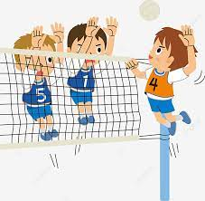
四、綜合測驗 (28%)

16. |  | Look at the picture. What sport do they play?
 |  | - Basketball. |  | - Volleyball. |  | - Soccer. |  | - Badminton.
17. |  | Debby: When you English classes?  Caesar: I have English classes from Monday to Friday.
 | - can ; have |  | - do ; has |  | - are ; having |  | - do ; have
18. |  | Mary: What can your little brother do ?  Ivy: He .
 | - can sing well |  | - is singing |  | - sings well |  | - sing well
19. |  | I don’t drink coffee, and my brothers don’t, .
 | - too |  | - either |  | - drink |  | - like
20. |  | Gina: ________ is the ticket for the movie?  Bill: It’s two hundred dollars.
 |  | - How long |  | - What |  | - How many |  | - How much
21. |  | Follow the class rules, and then you can a good student.
 |  | - be |  | - does |  | - like |  | - into
22. |  | My brother to play video games, but I .  (A) likes ; don’t like (B) like ; don’t (C) likes ; don’t (D) doesn’t like ; don’t
23. |  | I like to after school. It makes me happy.
 |  | - play the basketball |  | - play guitar |  | - playing the guitar |  | - play the guitar
24. |  | Bruce: you vegetables every day ?  Helen: Sure. I’m eating it now. It’s good for our body.
 |  | - What; eat |  | - Do; eat |  | - Are; eating |  | - Don’t; eating
25. |  | Lucy: I buy that pretty dress?  Mom: No. I have so much money.
 |  | - Can；can’t |  | - Do；can’t |  | - Can；don’t |  | - Do；don’t
26. |  | My sister walks our dog at the park .
 |  | - on every weekend |  | - every Sunday evenings |  | - in the weekend |  | - on weekends
27. |  | Mavis: Does ________ cook every day?  Hugo: Yes, ________ does.  (A) you; I (B) Nacy and Mary ; she (C) your mom; she (D) your friends; they
28. |  | Frank: Let’s get up at 5 a.m., and then go jogging in the park for 2 hours.  Ralph: . I want to sleep late on Sunday morning.  (Ａ) Help me.  (Ｂ) Don’t do that again.  (Ｃ) Give me a hand.  (Ｄ) Give me a break.
29. |  | Patrick: Wow! Our school team won(贏) the game in the last few seconds.  Lee: in a basketball game.  (Ａ) It’s on me  (Ｂ) Everything is possible  (Ｃ) Come into me  (Ｄ) What do you mean
五、 克漏字、閱讀測驗(22%)
30~34
Stella: 30 you busy on Sunday?
Vivian: Yes. I must 31 many things. I swim with my sister in the early morning. After breakfast,
I help my little brother 32 his math homework. In the afternoon, I have a piano class. I
have to practice for two hours. On Sunday evening, I study and prepare for the tests.
Stella: Do you do the housework?
Vivian: Yes, I do. My parents are usually tired after work. My brother and I do the
housework 33 .
Stella: Good for you two. Do you watch TV on Sunday?
Vivian: Sure. I usually watch TV with my family and chat with them after dinner.
Stella: By the way , do you 34 to go to the movies with me this Saturday?
Vivian: Of course. Let’s meet at your house. See you then.

 busy 忙碌的 housework 家事 usually 經常 tired 疲倦的
30. (Ａ) Does (Ｂ) Are (Ｃ) Do (Ｄ) Can
31. (Ａ) do (Ｂ) to do (Ｃ) does (Ｄ) doing
32. (Ａ) for (Ｂ) on (Ｃ) to (Ｄ) with
33. (Ａ) too (Ｂ) either (Ｃ) together (Ｄ) then
34. (Ａ) have time (Ｂ) must (Ｃ) have (Ｄ) enjoy

35~37

Do you eat breakfast every day? Before you go to school in the morning , remember to eat breakfast. It can give you a lot of power. A good breakfast can even help you to study hard. Eat your breakfast
before 8 a.m., and then you can be ready to have a nice lunch in the afternoon.
Also, you need to eat the right food. Eat some bread with boiled eggs or vegetables. You can choose sandwiches. Cheese and milk are good for children,too. They are helpful for children to be tall and strong. Do not eat or drink anything with too much sugar as your breakfast, like chocolate, cola or milk tea.
Breakfast is important for everyone. Let’s eat breakfast every day to stay healthy!

 before 之前 power 力量 remember 記得 boiled水煮的 helpful 有幫助的
sugar糖 chocolate 巧克力 important重要的 stay healthy 保持健康

35. What’s the main idea of this reading ?  main idea 主旨
(Ａ) Don’t eat sweet food.
(Ｂ) Breakfast is important.
(Ｃ) Sandwiches are yummy.
(Ｄ) Lunch is important.

36. A mother wants her children to be tall and strong. What food or drinks doesn’t she prepare for them?
(Ａ) Sandwiches.
(Ｂ) Bread and boiled eggs.
(Ｃ) Cheese and milk.
(Ｄ) Cola and milk tea.

37. What can we learn from the reading?
(Ａ) Breakfast is helpful to stay healthy.
(Ｂ) We can have breakfast and lunch together.
(Ｃ) Kids can eat everything as breakfast.
(Ｄ) Students can go to school without eating breakfast.  without 沒有

38~40

Allen’s schedule
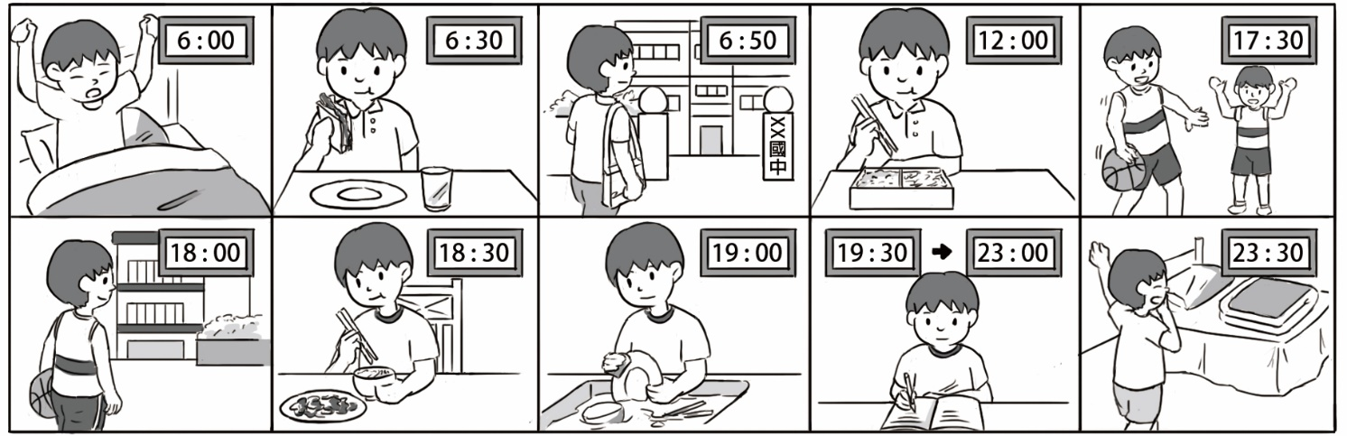
38. What does Allen do after school ?  schedule 行程
(A) Get up.
(B) Eat breakfast.
(C) Go to school.
(D) Practice basketball.
39. How long does Allen study in the evening?  how long 多久時間
(A) An hour.
(B) Thirty minutes.
(C) Two hours.
(D) Over three hours.
40. Which is true?
(A) Allen studies in the morning.
(B) Allen has time for video games at night.
(C) Allen goes to school early.
(D) Allen has breakfast at school.

一~五大題答案請於答案卡畫卡作答，共40題。

桃園市立大有國民中學112學年度第二學期第一次評量答案卷
年 級 | 七 | 考 試  科 目 | English |  |  | 命 題  範 圍 | L1~ Review1 | 作答  時間 | 45分
班 級 |  | 姓 名 |  | 座 號 |  | 分 數
請用黑色原子筆於考卷下方答案欄作答，違者不予計分
六、單字：（6%）
1. 社團、俱樂部 2. 生意 3. 幾乎 4. 上傳 5. 碰觸 6. 擔心

七、填入適當動詞時態（8%）每格不限一個字
1 . Look ! The pretty girl 7 (dance) on the street.
2. My father is a teacher. He 8 (teach) math in a junior high school.
3. I don’t 9 (swim) every day, but Johnny 10 (swim) every day.

八、依提示作答 (6%)
11. He has one hundred dollars. (改寫成否定句) 2%
12. Yes, he brushes his teeth every day. （依畫線部分造原問句）2%
13. Can she play basketball ? （先否定簡答，再用【打棒球】詳答）2%

答案欄

1 |  | 2 |  | 3 |  | 4 |  | 5
6 |  | 7 |  | 8 |  | 9 |  | 10
11
12
13

注意：
1.試卷(含答案卷)共五面，請仔細做答。
2.一~五大題答案請畫卡作答，六~八大題請用黑色原子筆寫在答案卷上的答案 欄，否則不予計分！
3.考試結束鐘響起，立刻停筆；收回答案卡與答案卷。

