桃園市立大有國民中學109學年度第一學期第一次評量試卷
年 級 | 七 | 考 試  科 目 | 英語 |  |  | 命 題  範 圍 | Starter~Review1 | 作 答  時 間 | 45分
班 級 |  | 姓 名 |  | 座 號 |  | 分 數

請將第1題至第37題答案畫至答案卡上
A. 聽力測驗，每題2分，共30分。

一、辨識句意：根據聽到的內容，選出符合描述的圖片或符合圖片的描述。

1. (A) 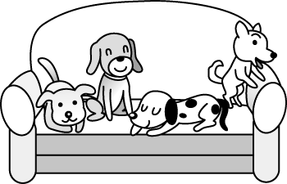 (B)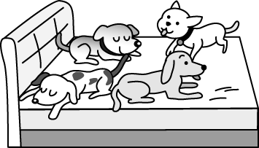 (C)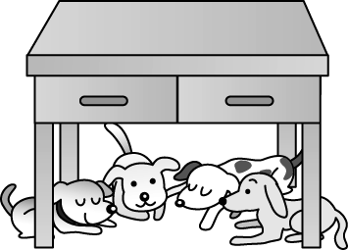
2. (A)  (B)  (C) 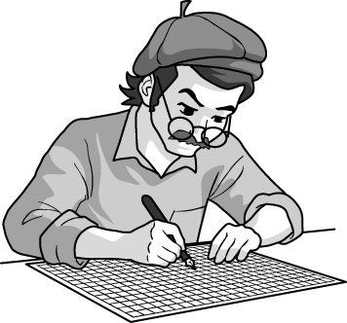
3. (A) 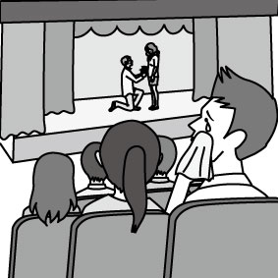 (B) 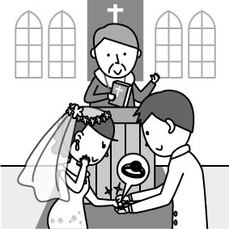 (C) 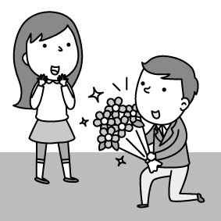
4. (A) 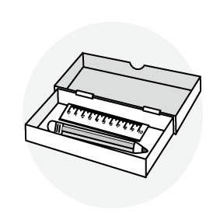 (B) 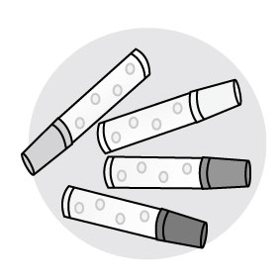 (C) 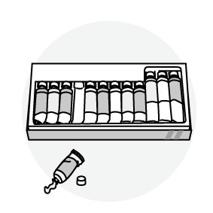
5. (A) 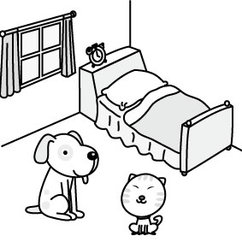 (B) 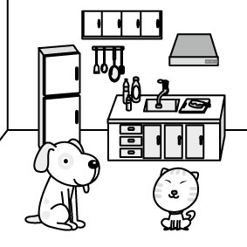 (C) 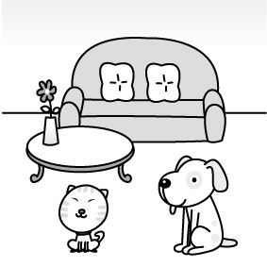

二、基本問答：根據聽到的內容，選出一個最適合的回應或最適合的問句。
6. (A) She is Terri, my cousin. (B) She is in the living room. (C) She is happy.
7. (A) It’s from a book. (B) It’s from my father. (C) It’s for you.
8. (A) I’m your classmate. (B) I am Nancy’s sister. (C) Tim. T-I-M.
9. (A) It’s my dog. (B) No, it’s not your cat. (C) Yes, it is. Its name is Mimi.
10. (A) Yes, I’m a good student. (B) No, my grandpa isn’t a teacher. (C) Yes, I am a teacher.
三、言談理解：根據聽到的內容，選出一個最適合的答案。
11. (A) The girl and the boy’s father. (B) The girl’s teacher. (C) The girl’s father.
12. (A) Judy. (B) Jane. (C) Jennifer.
13. (A) A nurse. (B) A doctor. (C) A cook.
14. (A) It’s on the sofa. (B) It’s under the chair. (C) It’s on the woman’s head.
15. (A)The bedroom is purple. (B) The kitchen is green. (C) Mom’s favorite color is purple.
B. 綜合測驗，共70分。
四、單字及文法測驗，第16-19題，每題1分；第20-27題，每題2分，共20分。
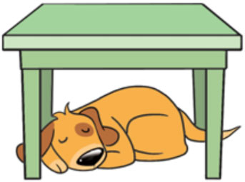
16. Look at the picture. Where is the dog?
(A) On the table. (B) Above the table.
(C) Behind the table. (D) Under the table.
17. Masha and the Bear _____ good friends.
(A) am (B) are (C) is (D) not
18. A: _____ your father a doctor? B: Yes, he is.
(A) Am (B) Are (C) Is (D) Be
19. Sally is my _____. She is my mom’s sister.
(A) grandma (B) sister (C) aunt (D) wife
20. Dr. Wang is only 25 years old. He is so _____.
(A) young (B) tall (C) nice (D) new
21. On some _____ days, my family and I have a big meal outside.
meal (n.) 餐
(A) special (B) gray (C) brown (D) dear
22. The _____ of our school bag is black.
(A) number (B) singer (C) room (D) color
23. 7-11 is just _____ my house. My grandpa buys newspaper there every day.
(A) near (B) on (C) next (D) in
24. A: _____ the boy?
B: That’s Zac, my boyfriend.
(A) What’s (B) Who’s (C) Where’s (D) How’s
25. A: _____
B: Mom is in the kitchen. She is busy cooking.
(A) How is your mom? (B) What’s her name? (C) Where is Mom? (D) What’s her job?
26. A: What’s your dad’s phone number?
B: _____
(A) He is a worker. (B) It’s 0911-366-663. (C) He is 42. (D) He’s OK.
27. A: Are those your new comic books?
B: Yes, _____.
(A) they are (B) we are (C) you are (D) it is

五、克漏字及閱讀測驗，每題3分，共30分
A.
Welcome to my new 28. !
It’s nice and beautiful. It has a 29. . My daughter and son love to watch TV, read and play there. My husband loves cooking in the kitchen. And our cat, Lucy, loves to sit 30. the sofa to watch TV, too. It’s playing with a small ball now. 31.
My house is not big, 32. .

28. (A) school (B) house (C) bedroom (D) brown box
29. (A) bathroom (B) dining room (C) living room (D) classroom
30. (A) on (B) in (C) above (D) at
31. (A) Is it short? (B) Isn’t it fat? (C) Is it sad? (D) Isn’t it cute?
32. (A) but it’s long and thin for me (B) but it’s enough and sweet for my family (C) but it isn’t your new table (D) but it isn’t purple.
sweet (adj.) 甜蜜的

B.
Cindy  Cindy is a student. Her brother is Jerry. | Kevin  Kevin is a policeman. His son is Jerry.
Jerry  Jerry is a student. His father is Kevin. | Andy  Andy is a businessman, and his wife, Kelly, is a businesswoman, too. His son is Kevin.

33. Who is Kelly?
(A) She’s a student. (B) She’s Jerry’s mom. (C) She’s Kevin’s wife. (D) She’s Cindy’s grandma.
34. “Hello, everyone. I am _____. I’m a student, and my sister is a student, too.”
(A) Jerry (B) Cindy (C) Kevin (D) Andy

C.
Where are my glasses?

Are my glasses in my book bag?
No, they aren’t. They’re my new pencils.
Are my glasses on the table?
No, they aren’t. They’re Ann’s picture books.
Are my glasses under the sofa?
No, they aren’t. They’re Ken’s balls.
Are my glasses in the toy box?
No, they aren’t. They’re cute dolls for my little sister.
Where are my glasses?
Oh, no!
From the mirror, they are on my face!



mirror (n.) 鏡子 glasses(n.) 眼鏡 doll (n.) 洋娃娃

35. What are those in the toy box?
(A) They’re pencils. (B) They’re picture books. (C) They’re balls. (D) They’re dolls.
36. Ann’s picture books are _____.
(A) in my book bag (B) on the table (C) under the sofa (D) on my face
37. From the reading, where are the glasses?
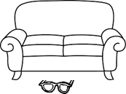
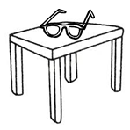
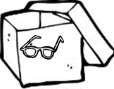
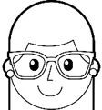
(A) (B) (C) (D)

=============================================================================
桃園市立大有國民中學109學年度第一學期第一次評量答案卷
班 級 |  | 姓 名 |  | 座 號 |  | 分 數
*請將下列答案直接作答於答案卷上*
六、請將下單數名詞改為複數，每題1分，共6分。
38. case → ______________________ | 39. housewife → _______________________
40. monkey → ______________________ | 41. woman → ________________________
42. box → _____________________ | 43. person → _______________________
七、文意字彙，每題2分，共10分。
______________ 44. A: This is Mr. Brown. B: Nice to m t you, Mr. Brown.
______________ 45. My brother is a j r high school student.
______________ 46. J.K. Rowling is my f e writer.
______________ 47. The Keret house is in a crack b n two houses.
______________ 48. William is my c n. He is my uncle’s son.
八、翻譯，每題2分，共4分。
49. 我們是一家五口。 課p.20
_________________________________________________________________
50. 那些在棕色盒子裡的是什麼？ 課p.29
________________________________________________________ the brown box?

***********試題結束************
請仔細檢查，並將答案卡及答案卷繳回

