桃園市立大有國民中學112學年度第二學期第三次評量試卷
年 級 | 七 | 考 試  科 目 | English |  |  | 命 題  範 圍 | Lesson5 ~ Review3 | 作 答  時 間 | 45分
班 級 |  | 姓 名 |  | 座 號 |  | 分 數
第一大題到第三大題為聽力測驗，請仔細聆聽！

一、辨識句意-根據聽到的內容，選出正確的圖片代碼 (6%)
- (A) (B) (C)
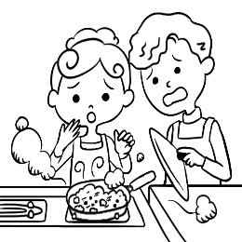

- (A) (B) (C)
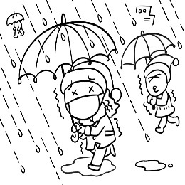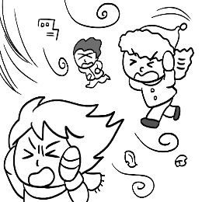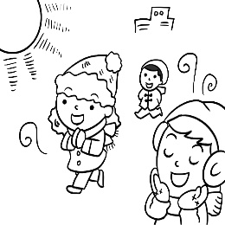

- (A) (B) (C)
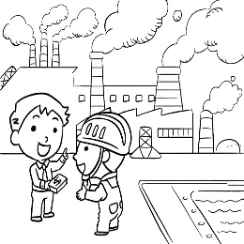

- (A) (B) (C)
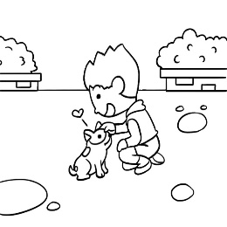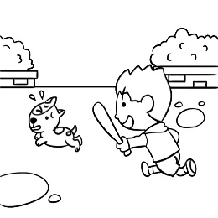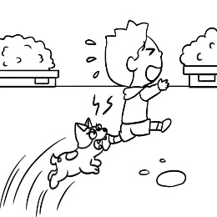

- (A) (B) (C)
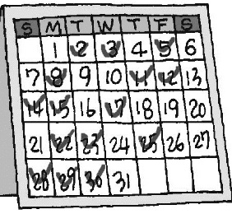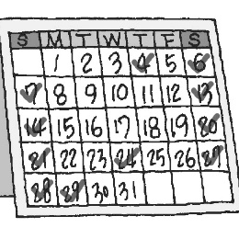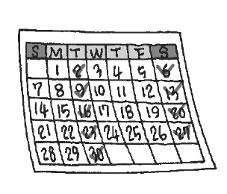

- (A) (B) (C)
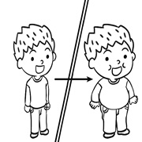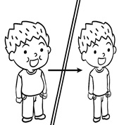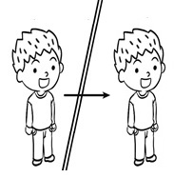

- 基本問答-根據聽到的內容，選出合適的回應(12%)
- (A) Yes, it always wins.
(B) It often joins big games.
(C) No, it never loses any games.

- (A) No, you can’t. I don’t want any gifts.
(B) No problem. You can buy them some gifts.
(C) How was the trip? Was it fun?

- (A) You can even see a lot of fish in the water.
(B) There is a lot of trash in the river.
(C) There are many factories here, and the water is dirty.

- (A) I never do, but my wife sometimes does.
(B) Always. He’s usually busy.
(C) Yes, I do it for him sometimes.

- (A) This is the boy’s photo.
(B) The boy was on the sports field.
(C) That’s your dad. He was very young then.

- (A) Yes, he is doing his homework now.
(B) No, he was in a restaurant with his family.
(C) Yes, he was out with his classmates 30 minutes ago.

三、言談理解-根據聽到的對話內容與問題，選出正確的答案
(12%)
13. (A) Jimmy’s fingers are not clean.
(B) Jimmy always puts fingers in his mouth.
(C) Jimmy never listens to his mother.

14. (A) She never studies after school.
(B) She seldom has free time.
(C) She seldom gets good grades.

15. (A) Never.
(B) On every weekend.
(C) Four times a week.

16. (A) Jenny likes to go out with Paul.
(B) Jenny wasn’t happy about the dishes.
(C) Jenny might not like Paul.
17. (A) There weren’t factories along the street.
(B) The air and river are clean.
(C) The man and the woman like the new Spring Field.

18. (A) Next to the TV.
(B) In the living room.
(C) In his bag.

四、綜合測驗 (44%)

19. | Edward: Do you see John? He _________ late for school.  Susan: No, I don’t.
 | - is never | - goes never | - never goes | - never is
20. | Ted: __________Bella’s house clean?  Sam: No, she never cleans it.  - Does (B) Do (C) Is (D) Are
21. | Leo: There is a new restaurant over there. Let’s go for lunch now.  Paul: _________________. My parents are waiting for me.
 | - We can go anytime.  (C) Sorry, I can’t go now. |  | (B) That’s a good idea.  (D) I have no idea.
22. | Jonny’s sisters always do the dishes, but he __________________.  - never does (B) always do (C) is never (D) never do
23. | Lisa is going to _____________ to Tainan next month.  (A) market (B) move (C) break (D) answer
24. | Mandy: ____________ does the girl make cake?  Peter : She makes cake every day.
 | - How | - How long | - How much flour | - How often
25. | The street is ____________ after the party. There is a lot of trash on it.
 | - free | - dirty | - rich | - clean
26. | Robert can be an actor. He can __________ his face in a second.  - check (B) kill (C) germ (D) change
27. | Rita goes to the library ___________________.  (A) three time a week (B) a week once  (C) once time a week (D) twice a week
28. | Simon: Shh….Don’t talk loudly in the museum, Susan. You need to read the _______ rules carefully.  Susan: Ok.  - terrible (B) finger (C) following (D) along
29. | Mandy: The town is beautiful.  Allen : Yes, I like it. I was a teacher here twenty years ago.  Mandy: Really? __________________  Allen : It’s a long time ago.  - Sorry about that. (B) You can say that again. (C) I can’t believe it. (D) Give me a break.
30. | There is a ___________ over there. Many workers work in it.  - factory (B) visitor (C) river (D) businessman
31. | The tree _______ short before, but it ________ really tall now.  - was; wasn’t (B) is; isn’t (C) was; is (D) was; wasn’t
32. | Nana: Where __________ Dora and Lisa yesterday morning?  Chen: _____________ they at school?  Nana: No.  (A) were; Weren’t (B) was; Weren’t (C) were; Wasn’t (D) was; Wasn’t
33. | ___________ a lot of rain in March. I don’t like rainy days.  - There are (B) It has (C) The weather has (D) We have
34. | Rober : ____________________  Mr. Lin: It was a lot of fun.  (A) Is the trip fun? (B) How was the trip there?  (C) How was the weather in Canada? (D) How about yours?
35. | Spring is my favorite ____________. I can see many beautiful flowers in my garden.  (A) space (B) activity (C) then (D) season
36. | There was little ________ last year.  (A) rains (B) snow (C) snows (D) rainy
37. | Cathy:______________ the weather like in New York in winter?  Grace: It is usually ________________.  - What’s; snowy (B) What; cold (C) How; rain (D) How’s; snow
38. | The ________ is so strong today. The trees are shaking(搖).  - cloud (B) air (C) wind (D) habit
39. | Ken: Don’t you listen to music every day?  Ben: _______________  (A) Don’t you do that with your sister every day?  (B) I sure do. I do that for about two hours every day.  (C) Yes, I exercise every day.  (D) No, you don’t, but I do.
40. | Alex: You weren’t at home last night. Where were you?  Beth: ______________  (A) I was in the living room.  (B) Weren’t you at my house?  (C) At my grandparents’ house.  (D) I was very busy last night.

五 克漏字、閱讀測驗(26%)

41~44
Patty: 41
Dora: Sometimes I watch TV at home, and I play basketball with my friends. 42
Patty: I usually play some sports with my family.
Dora: Like what?
Patty: Like badminton and table tennis, but 43 because they don't like it.
Dora: Do you like it?
Patty: Yes. 44
Dora: Maybe you can play with us next time.

41. (A) What do you usually do in your free time?
(B) What do you usually eat for dinner?
(C) Where do you usually go after school?
(D) When do you usually go to school?
42. (A) I see.
(B) And then?
(C) And you?
(D) How come?
43. (A) I always go to the park in the afternoon
(B) I always work at home in the morning
(C) I never watch TV at home in my free time
(D) I never play basketball with my family
背面尚有試題

44. (A) I don't like to play basketball.
(B) I don't have much free time.
(C) I really want to play basketball.
(D) I always take a shower at night.

45~47
There was a lake in Spot City twenty years ago. Its name was Yoyo Lake. It was very dirty.
There was a lot of trash in the lake and the water was not clean. There were not many tourists in Spot City. Now it is different. Yoyo Lake is clean. There are parks and coffee shops by the lake. People can take a walk or have coffee there. And there is also a new bike lane in Spot City now. People can go biking, and they like it very much.

＊ tourist 觀光客 lane 車道
- hundred 百 activity logo活動徽章 results 結果 choose 選擇
can 可以 blackboard 黑板

45. Which is the best title（最好的標題）for this reading？
(A) A Dirty Lake (B) A Good Coffee Shop ( C) A Beautiful City (D) A Great Bike Lane
46. What is it?
(A) The bicycle. (B) The bike lane. ( C) The lake. (D) The park.
47. Which is true?
(A) Yoyo Lake was dirty twenty years ago.
(B) Yoyo Lake is not clean now.
(C) There were many tourists in Spot City before.
(D) There is no bike lane in Spot City now.

48~50
Alex and May are talking with each other in the living room.
Alex: Do you use your smartphone often?
May: Sure, I always do. The smartphone is one of my best friends.
Alex: How many hours a day do you use your smartphone?
May: Well, almost four hours a day. I always play phone games every night after school.
Alex: Wow, that's very much. I can only use my smartphone for thirty minutes after dinner every day.
My mom told me it's not good for my eyes to use the smartphone too often.
May: Yes, you are right. That's why I always have to see the eye doctor and get a new pair of glasses
every year.

48. How often does May use her smartphone?
(A) She seldom uses her smartphone.
(B) She only uses it once a week.
(C) She uses it thirty minutes after dinner every day.
(D) She uses her smartphone for four hours every night.
49. What does May always do on the smartphone?
(A) Play phone games.
(B) Chat with her classmates.
(C) Make new friends from the app．
(D) Listen to music.

背面尚有試題

50. Which is true?
(A) May doesn't have good eyes.
(B) Alex plays many phone games on the smartphone.
(C) May never goes to see the eye doctor.
(D) Alex usually uses his smartphone before school every morning.

51~53
Here is York and Nina’s schedule for this week.

51. How often do York and Nian clean their bedroom?
(A) They clean their bedroom twice a week.
(B) They clean their bedroom once a week.
(C) They clean their bedroom three times a week.
(D) They clean their bedroom every day.
52. What do York and Nina NOT do on weekends?
(A) Walk the dog.
(B) Watch TV.
(C) Use the computer.
(D) Study English.
53. Which is true?
(A) York and Nina study English three times a month.
(B) York and Nina watch TV every day.
(C) York and Nina walk the dog every day.
(D) York and Nina seldom use the computer.

試題結束
(請檢查答案卡座號)

