桃園市立大有國民中學112學年度第二學期第三次評量試卷
年 級 | 八 | 考 試  科 目 | 英語 |  |  | 命 題  範 圍 | Unit5~Review3 |  | 作 答  時 間 | 45分
班 級 |  | 姓 名 |  | 座 號 |  | 分 數
一、辨識句意-根據聽到的內容，選出正確的圖片代碼(10%)
- (A) (B) (C)
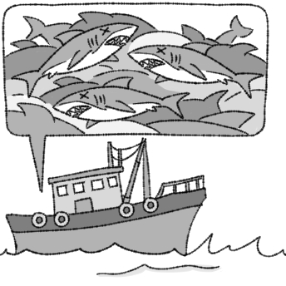 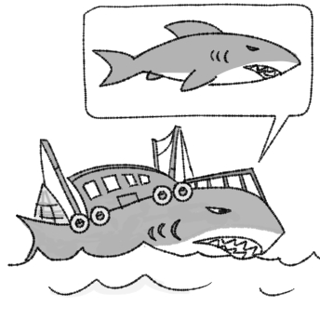 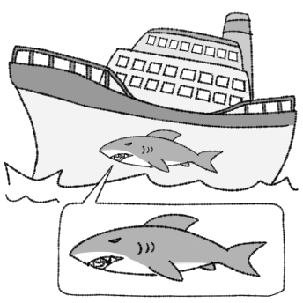
- (A) (B) (C)
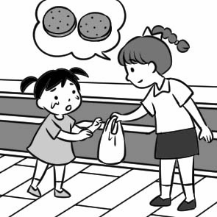 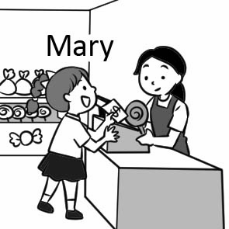 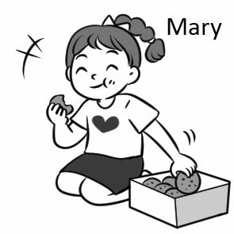
- (A) (B) (C)
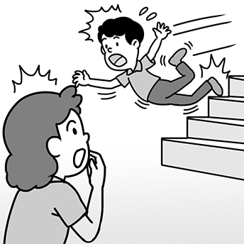 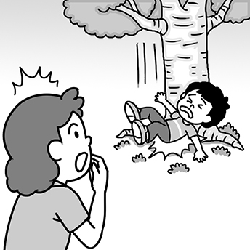 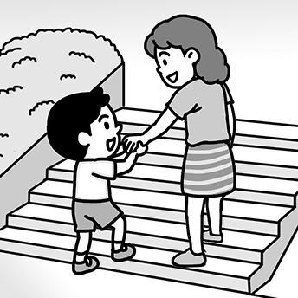
- (A) (B) (C)
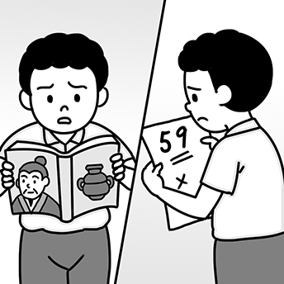 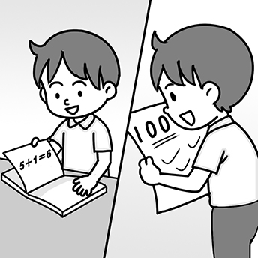 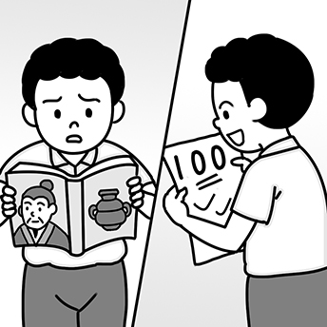
- (A) (B) (C)
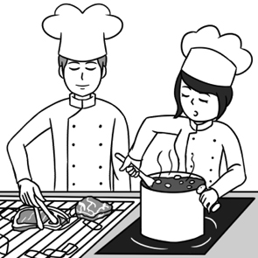 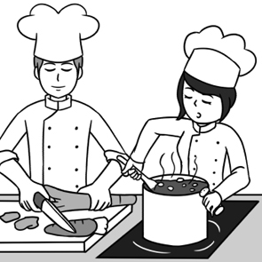 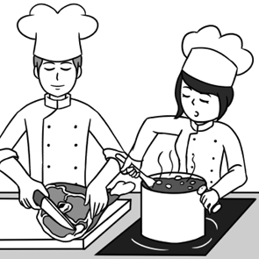
二、基本問答-根據聽到的內容，選出合適的回應(10%)
- (A) He became a full-time writer.
(B) He was an excellent engineer.
(C) He looked good in that uniform.
- (A) Please bring an umbrella with you.
(B) If so, let’s stay home and watch TV.
(C) How about playing basketball at the park?
- (A) Yes, it gets dirty easily.
(B) That’s my favorite color.
(C) No. We think differently.
- (A) Yes, I bought it at the store.
(B) No, I borrowed it from my sister.
(C) Sure, my mom made all of them for me.
- (A) You should have long hair and sharp nails.
(B) Don’t be afraid, and you are one of them now.
(C) Then you should get stronger and be braver.
三、言談理解-根據聽到的對話內容與問題，選出正確的答案(10%)
- (A) He will review the lesson for the students.
(B) He went out to look for the other students.
(C) He will be angry and shout, “Don‘t be late next time!”
- (A) Buy an umbrella at the shop.
(B) Share his umbrella with the girl.
(C) Borrow an umbrella from the box.
- (A) Watered the flowers.
(B) Watched the full moon.
(C) Answered Lisa’s phone call.
- (A) Watch the woman leave.
(B) Follow the woman outside.
(C) Ask the woman to stay at home.
- (A) Helen was alone during the earthquake.
(B) Many people died during the earthquake.
(C) The man was at home during the earthquake.
四、單字&文法選擇(40%)
（ ）16. Ivy wants to design a key chain in the _______ of a heart.
(A) head (B) shape (C) skin (D) noise
（ ）17. Going camping is a good way to get closer to ________.
(A) sign (B) tunnel (C) kingdom (D) nature
（ ）18. BTS is Cherry’s favorite Korean group. She _______ all the up-to-date news about all the members.
(A) belongs (B) covers (C) follows (D) orders
（ ）19. Terry: Who is the _______ of Kimetsu no Yaiba (鬼滅之刃)?
Tiffany: I only know she is a young and pretty girl.
(A) keeper (B) soldier (C) driver (D)writer
（ ）20. Luckily, Gavin was _______ after the police caught the bad guy.
(A) not at all (B) full-time (C) safe and sound (D) playing an important part
（ ）21. Ketty: Why do you always wear the same shirt to work? Is it your _______ ?
Kevin: Yes. I have to wear it to work.
(A) uniform (B) shape (C) part (D) body
（ ）22. Mr. Gates makes a lot of money. He puts ________ in the bank.
(A) one of it (B) one of them (C) most of it (D) most of them
（ ）23. Peter: ________ of the fish in the pond are really big.
Nick: Yes. ________ people throw in pieces of bread to feed the fish every day.
(A) Some ; Many (B) Few ; Much (C) Much ; Many (D) A little ; Lots of
（ ）24. _______ it rained heavily last night, the ground is already dry now.
(A) If (B) Although (C) Because (D) So
（ ）25. I heard someone _______ on the door. Could you go and answer it?
(A) knocks (B) knocked (C) knocking (D) was knocking
（ ）26. Jenny bought a beautiful dress yesterday. I want to borrow _______ for my school play next week.
(A) one (B) ones (C) it (D) them
（ ）27. The skirt on Cindy looks so pretty that I’d like to buy _______ like that.
(A) one (B) ones (C) it (D) them
（ ）28. Jacky: Where did Betty buy the cake? It was so special and delicious.
Selina: Don’t you know she didn’t buy it, but she made the cake for ________
(A) himself (B) her (C) you (D) yourself
（ ）29.We will go picnicking if it _______ tomorrow.
(A) isn’t raining (B) didn’t rain (C) doesn’t rain (D) won’t rain
（ ）30. Teacher: Do it ________, guys.
Students: Oh, teacher, please help us. It’s too hard for us to do it without your help.
(A) by myself (B) by themselves (C) by yourself (D) by yourselves
（ ）31. ________ of my brothers enjoys playing computer games. They all love it.
(A) Both (B) All (C) Most (D) Each
（ ）32. I got three books from my dad. _______ of them are about computers.
(A) Both (B) One (C) Two (D) Much
（ ）33. I saw him _______ after a dog and playing with it happily. They looked free from worry.
(A) runs (B) running (C) ran (D) was running
（ ）34. Dennis didn’t feel tired at all _______ he slept only for five hours last night.
(A) although (B) but (C) because (D) so
（ ）35. Many of ________.
(A) the beef comes from Japan (B) the sandwiches are yummy
(C) the flower look beautiful (D) the cookies on the plate tastes yummy
（ ）36. I ________ someone sing when I was studying in my room. The song ________ a famous song, Let it go.
(A) heard ; sounded (B) listened ; sounds like (C) listened to ; sounded (D) heard ; sounded like
五、克漏字選擇(14%)
Angela 37. . Sometimes the family ate only two meals a day. They couldn’t even take a hot bath on some winter days. The children read books in the library because their parents had no money to buy books for them.
When Angela was thirteen years old, her father died. Her mother had to 38. so that Angela and her younger sister could go to school. She worked so hard that she got sick when Angela was in the eighth grade. Needing money to buy medicine and food, Angela worked at a 7-11 near her school after class. When she was working, her sister took care of their mother.
After finishing junior high school, Angela 39. . She worked in a factory. One day on her way to work, she saw two of her junior high school classmates 40. to school happily. She thought to 41. , “Will I be a factory worker all my life?” Then she decided to study at a night school. She studied very 42. and did very 42. in school. Her teachers encouraged her to 43. , and she followed their advice. Finally, she got a doctor’s degree and taught at a college.
encourage鼓勵 advice忠告 doctor’s degree博士學位 college大學

( )37. (A) had a wonderful family (B) lived a comfortable life
(C) grew up in a poor family (D) lost her parents when she was born
( )38. (A) work day and night (B) buy a new apartment (C) take care of Angela’s father (D) get married again
( )39. (A) became a popular singer (B) decided not to study
(C) learned to do business (D) entered a good senior high school
( )40. (A) went (B) goes (C) to go (D) going
( )41. (A) myself (B) herself (C) himself (D) themselves
( )42. (A) hard ; well (B) hardly ; well (C) harder ; better (D) hard ; good
( )43. (A) find a better job (B) work in a hospital (C) go to college (D) teach at an elementary school
六、閱讀測驗(14%)
(一)
The Missing Post Office
Do you want to send a letter to a stranger? Or would you like to send one to a person who has left this world? The Missing Post Office in Awashima, Japan, can help you do that. Well, this post office does not actually send the letters but keeps them open in the office for people to read. When you visit this place, you can take a letter home if you believe the letter was written to you.
To get here, you can take a train to JR Takuma Station and then a bus to Suda Port. From this port, you can take a ship or a water taxi to Awashima. A ship ticket only costs 360 yen each way. However, if you are in a hurry, you can take the water taxi. The cost for that is 2,000 yen per person.
So, if you ever have the chance to visit Japan, remember to put this place on your traveling list. You will not regret coming here to read the letters and experience this very curious and special place.
Awashima 栗島JR Takuma Station 日本鐵道詫間車站Suda Port 須田港regret 後悔
( )44. What does “do that” refer to (指稱) in the reading?
(A) Send a letter to a stranger or to someone dead.
(B) Keep the letter you wrote to your friends in the post office.
(C) Visit the post office and take a letter home.
(D) Take a bus to Suda Port and take a water taxi to Awashima.
( )45. Vivian would like to go to the Missing Post Office, but she does not have too much money on her. According to the reading, what is the best way for her to go there?
(A) take a bus to JR Takuma Station → take a train to Suda Port → walk to the post office
(B) take a train to JR Takuma Station → take a bus to Suda Port → take a ship to the post office
(C) ride a bike to JR Takuma Station → take a bus to Suda Port → go to the post office on foot
(D) take a train to JR Takuma Station → ride a bike to Suda Port → take a taxi to the post office
(二)
I was sitting by the window,
Lightly kissing my sleeping cat,
The half-finished coffee in the table,
The blowing fan on the wall,
The sweet music on the radio.

A little girl was riding a yellow bike,
Slowly passing by my window,
The light wind on her face,
The flying hair behind her ears,
The quiet lazy summer afternoon.
Henry W.
( )46. What’s the tone (語調) of the reading ?
(A) It is very sad.
(B) It is exciting.
(C) It is easy and slow.
(D) It is serious and worried.
( )47. Which is NOT true about the writer ?
(A) He wrote about the moment in summertime.
(B) He was drinking coffee with the little girl.
(C) He liked the music on the radio.
(D) He was looking out from a window.
(三)
The African Sacred Ibis: From Egypt to Taiwan
The African sacred ibis is a big bird that is native to Africa. They usually live near water. They eat fish, frogs and insects. The most interesting part of the African sacred ibis is its long, black beak and its white body. Why is this bird “sacred”? Because it was used to symbolize Thoth, the Ancient Egyptian god of wisdom. Ancient Egyptians believe the African sacred ibis can protect them from diseases.
The African sacred ibises first came to Taiwan when a zoo bought 30 birds from Egypt in 1979. They thought the birds would not fly out of the zoo, but after a few years, people near the zoo saw lots of these birds in fields. Now, it is believed that there are more than 10,000 wild African sacred ibises in Taiwan. Because these birds can live almost anywhere, including places covered in garbage, and they have no predators in Taiwan; they are starting to affect Taiwanese birds. It is harder for Taiwanese birds to find food, and that is not what we want.
Although these animals are lovely, it is not always a good idea to bring animals into a country. We are trying to cut down the number of the African sacred ibises so that they won’t affect animals native to Taiwan. So if you see the African sacred ibises, please help report the sighting to @sacredibistw, the Facebook fan page, include the date, time, place, and numbers.
native產於 symbolize象徵 wisdom智慧 disease疾病 field原野 predator獵食者affect影響
( )48. From the reading, which is closed to the meaning of sacred?
(A) An animal makes people sick.
(B) A bird with a long, black beak.
(C) Someone doesn’t believe in god.
(D) Someone or something about a god.
( )49. Which can we find out from the reading?
(A) We should bring another big bird to Taiwan to kill the African sacred ibises.
(B) We should think twice before bringing an animal from another country to Taiwan.
(C) The African sacred ibises flew from Egypt to Taiwan in 1979.
(D) The African sacred ibises are making trouble because they eat Taiwanese birds.
( )50. What might be on the newspaper in 1979 after the big birds were brought into Taiwan?
(A) A zoo spent a lot of money buying 10,000 birds from Egypt!
(B) The African sacred ibises caused diseases in Taiwan!
(C) Lots of people want to go to the zoo to see the African sacred ibises from Egypt!
(D) People found the African sacred ibises in fields outside the zoo!

