桃園市立大有國民中學113學年度第一學期第二次評量試卷
年 級 | 八 | 考 試  科 目 | English |  |  | 命 題  範 圍 | Unit3 ~ Unit4 | 作 答  時 間 | 45分
班 級 |  | 姓 名 |  | 座 號 |  | 分 數
第一大題到第三大題為聽力測驗，請仔細聆聽！

- 辨識句意：每題均有三張圖片，請依據所聽到的句子，選出符合描述的圖片。(5%)

- (A) (B) (C)
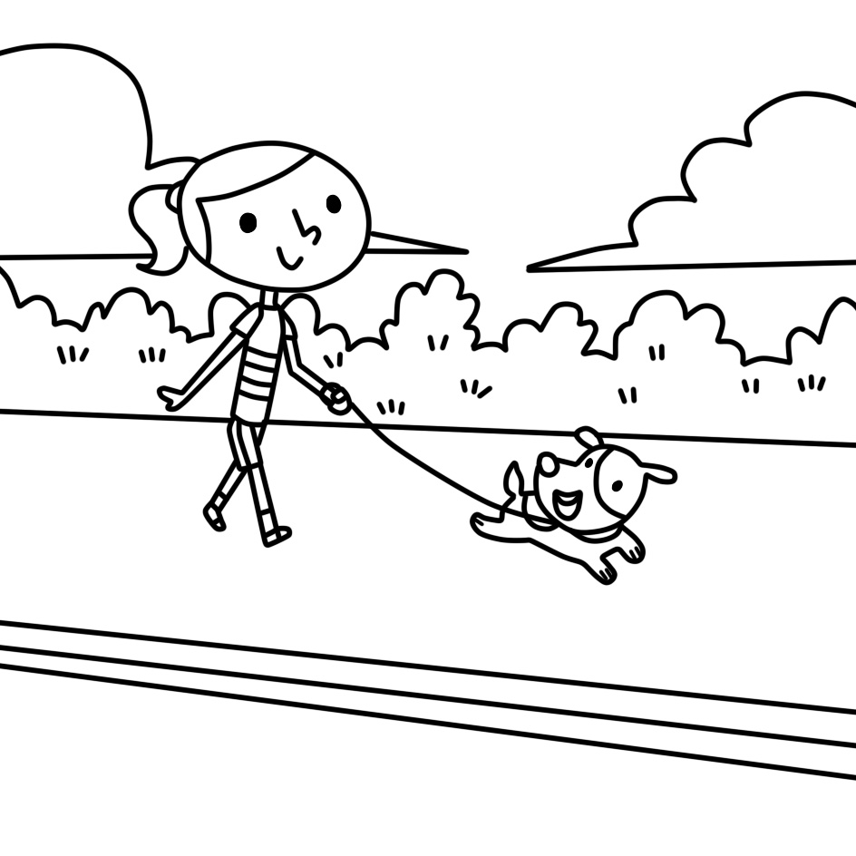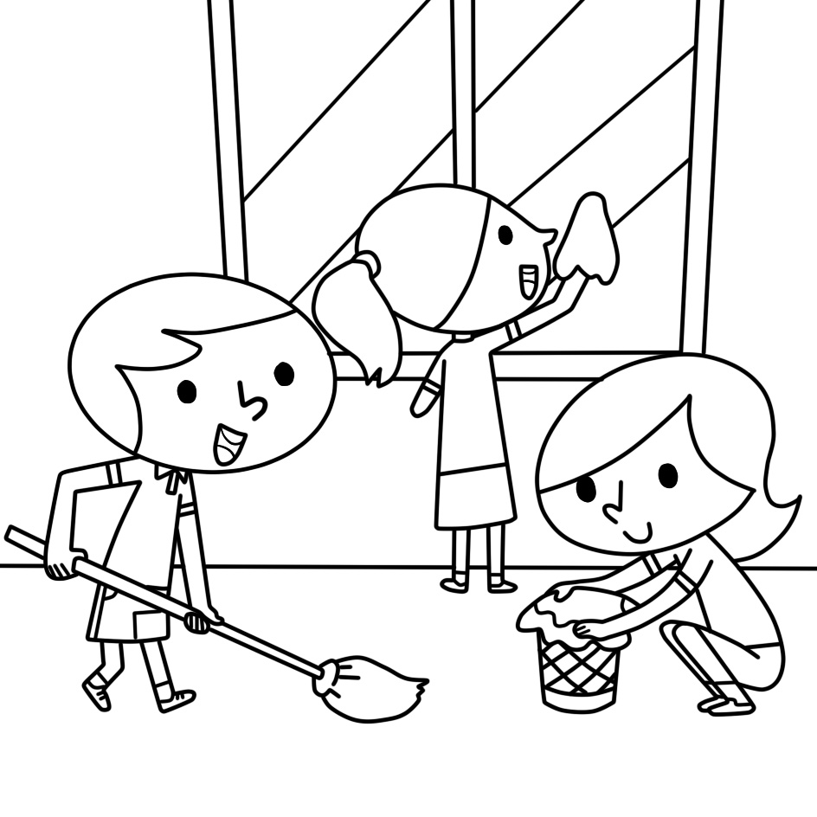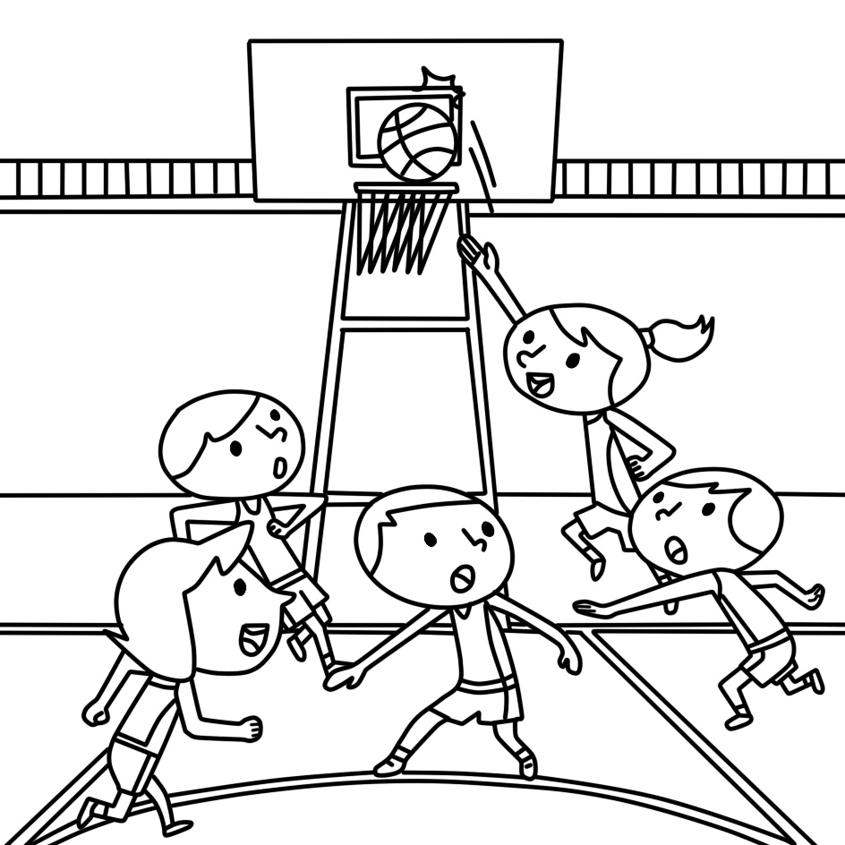
- (A) (B) (C)
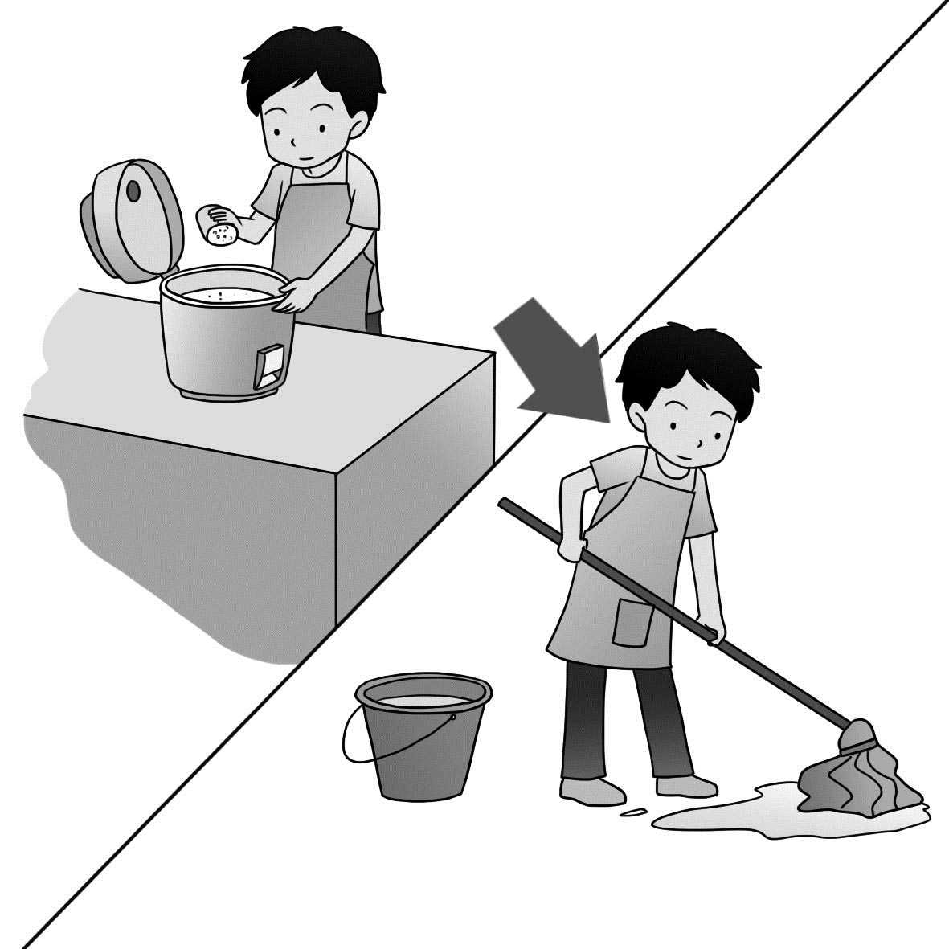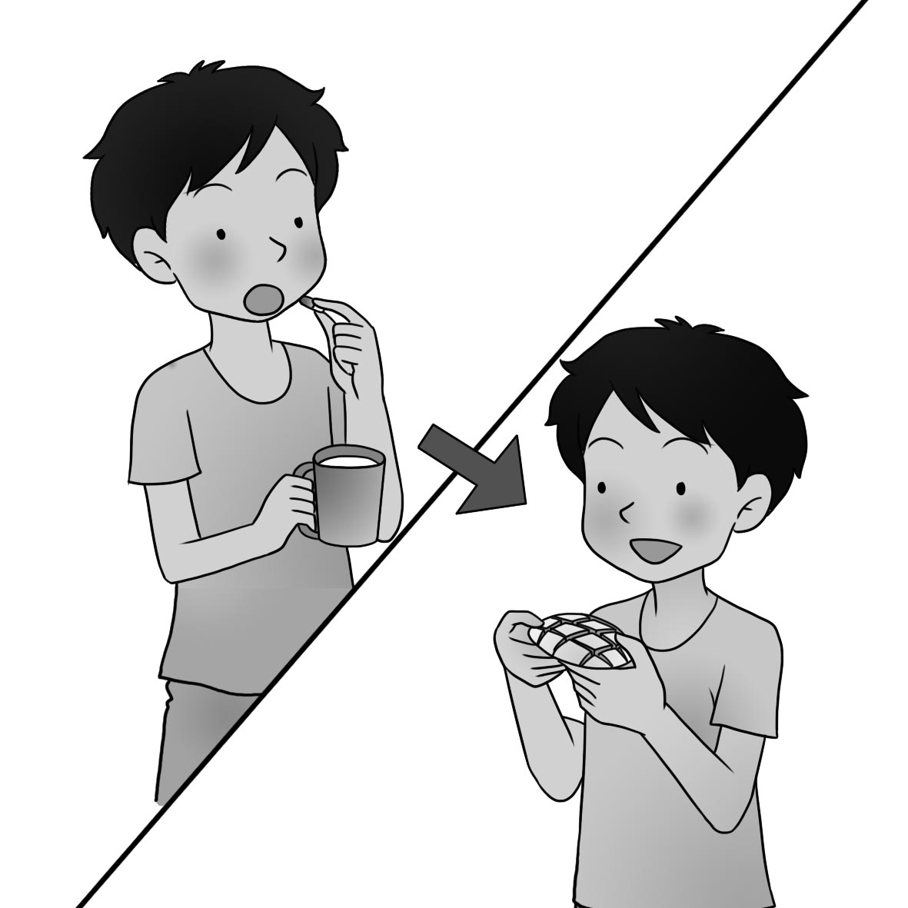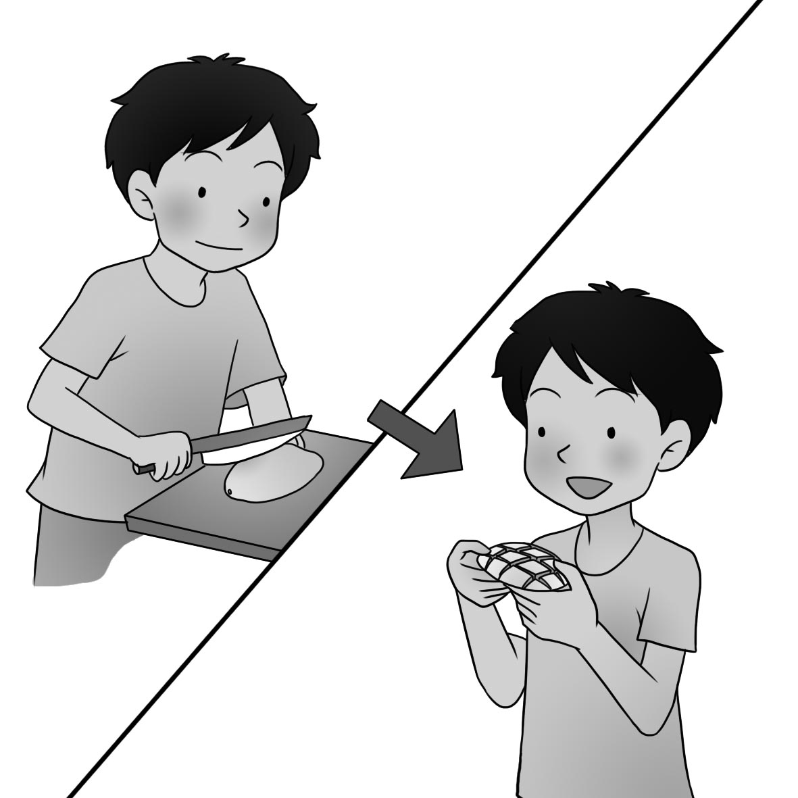
- (A) (B) (C)
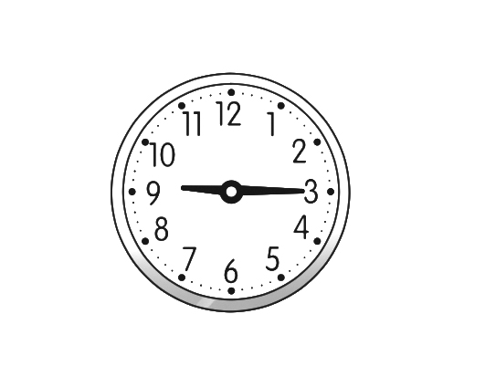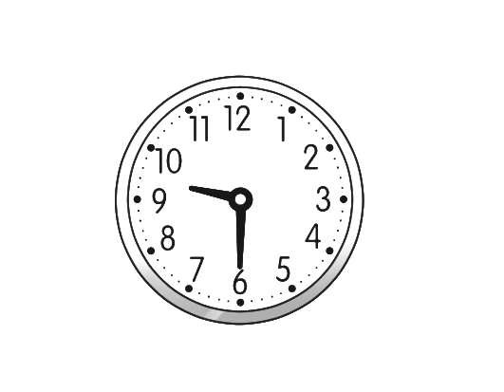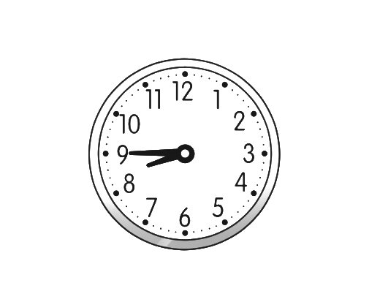
- (A) (B) (C)
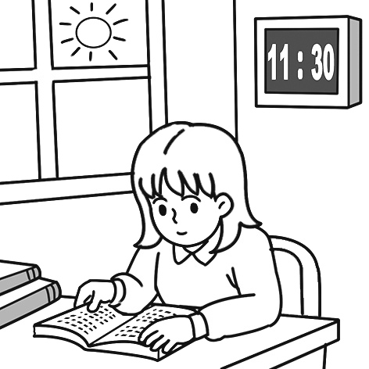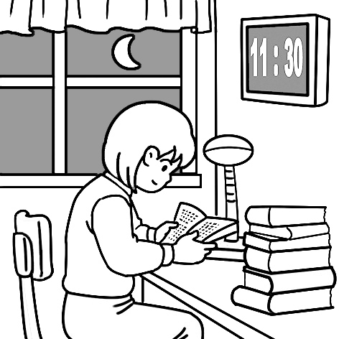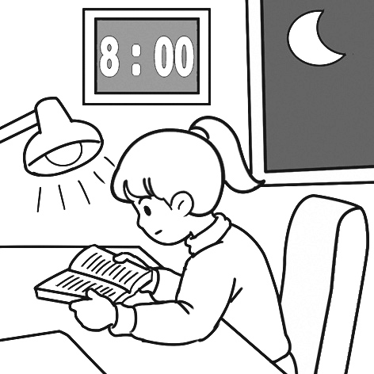
- (A) (B) (C)
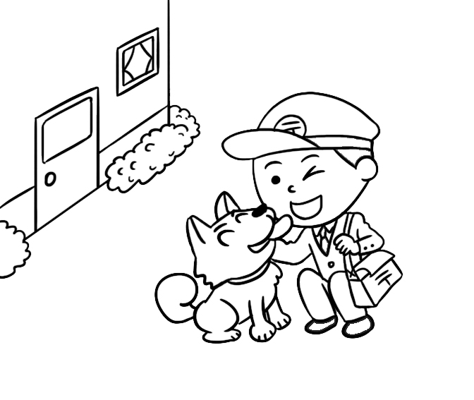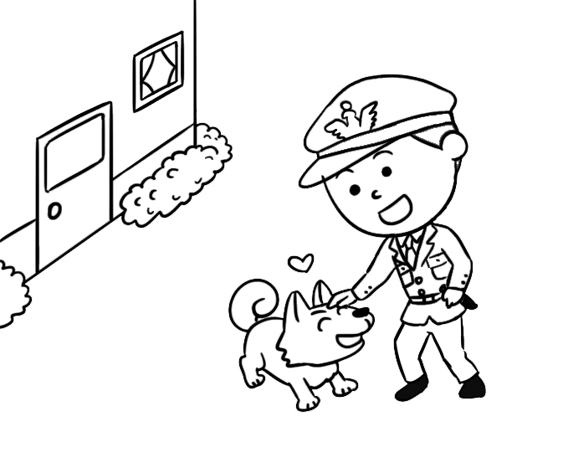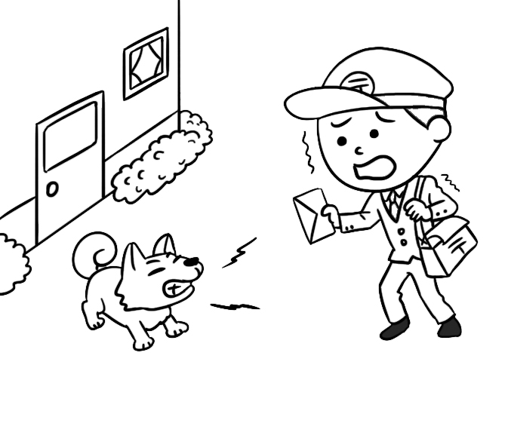

二、基本問答：每題均有三個選項，請依據所聽到的內容，選出一個最適合的回應(10%)
- (A) His dad found him on the road.
(B) He was crying by the side of the road.
(C) His father walked back and forth then.

- (A) I don’t have any homework today.
(B) That’s a good habit. I usually watch TV first.
(C) Finish your homework first.

- (A) No, I have to work long hours.
(B) Yes, I plan to work as a reporter this summer.
(C) Yes, we need to train a lot of waiters and
waitresses.

- (A) But I don’t have a gift for singing.
(B) Right. I always like acting in front of people.
(C) Yeah, I’m happy to get the job.

- (A) Yes, I want to be a famous actor.
(B) No, he didn’t train to be a reporter.
(C) Yes, and he really has a gift for acting.

三、言談理解：每題均有三個選項，請依據所聽到的對話與問題，選出一個最適當的答案。(10%)

11.(A) Before the meeting.
(B) After the meeting.
(C) In the meeting.

12.(A) They took out the trash.
(B) They cleaned their rooms.
(C) They ate some ice cream.

13.(A) They watched the stars.
(B) They took a walk in the forest.
(C) They set up camp by the lake.

14.(A) She has a gift for cooking.
(B) She wants to be a cook in the future.
(C) She plans to start learning to cook.

15.(A) She has to finish writing the story.
(B) She has to make some money.
(C) She has to find her dream job.

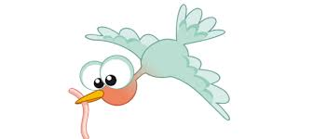
四、綜合測驗 (30%)

16. | Most birds use their to pick up insects(昆蟲) to eat.
 | - beaks |  | - legs | - hands | - fly
17. | Denny his sister at the library at three o’clock this afternoon.
 | - sees |  | - saw | - was seeing | - see
18. | They were playing video games then, but I .
 | - wasn’t |  | - didn’t | - don’t | - am not
19. | When the phone rang, Mom in the kitchen and didn’t hear it.
 | - is cooking |  | - cooking | - cooks | - was cooking
20. | Watching basketball games with my classmates fun.  (A) are (B) were (C) is being (D) is
21. | Many students enjoy _______ their homework and _____ to music at the same time.
 | - to do; to listen |  | - doing; to listen | - doing ; listening | - do; listen
22. | It is important for secretaries their work on time.
 | - finished |  | - finishing | - to finish | - finish
23. | now, or（否則）you can’t catch the school bus.
 | - Get up |  | - To get up | - Getting up | - Got up
24. | Josh plans to Japan next month and some of his friends there.
 | - to go; visiting |  | - going; visiting | - to go; visit | - go; visit
25. | you finish dinner, please do the dishes.
 | - When |  | - However | - Before | - After
26. | Lucy: Does the movie start at three forty-five?  Joe: Yes. It’s three now. Fifteen minutes later, we can watch it.
 | - ten minutes to |  | - half past | - a quarter past | - a quarter to
27. | Billy was reading on the sofa, and Kelly was working at the desk .
 | - yesterday | - this morning |  | - last night | - at that time
28. | a teacher isn’t a good idea for Philip because he is afraid of speaking in front of people.
 | (A) Be | (B) Being |  | (C) To being | (D) Become
29. | It’s not right for you to take my new cellphone asking me.
 | - with |  | - until | - by | - without
30. | Lisa: Dad, I got 100 on the math test.  Dad: Good job!
- I can’t reach you. (B) Just wait and see.
(C) I’m so proud of you. (D) Together we can do anything.

五、 克漏字、閱讀測驗(20%)
31~35
Jacky: Hey, Cindy and Emma. I brought a new game for you. Do you want to play it with me?
Cindy: Why not? It is fun for me 31. games.
Emma: What is the game about?
Jacky: About 32. stories. You have to choose a card first and tell a story.
Cindy: Tell a story?
Emma: Well, 33. , so don’t ask me to do it.
Jacky: Don’t worry. We can practice 34. it before we start to play. Emma, look at this card and say something about it.
Emma: OK. There’s a bird in the sky. Also, there is a man sitting under a tree and drawing.
Jacky: Wow! You are not that bad. Let’s 35. .

31. (Ａ) to play (Ｂ) playing (Ｃ) to playing (Ｄ) played
32. (Ａ) telling (Ｂ) tell (Ｃ) told (Ｄ) to tell
33. (Ａ) tell a story is hard for me (Ｂ) it is hard to telling a story for me
(Ｃ) it is hard for me to tell a story (Ｄ) it is hard for me telling a story
34. (Ａ) do (Ｂ) doing (Ｃ) to do (Ｄ) did
35. (Ａ) to begin (Ｂ) beginning (Ｃ) begin (Ｄ) begins

36~38
Dear parents,
Thank you for joining our winter camp. We have a lot of interesting activities for your children this winter.
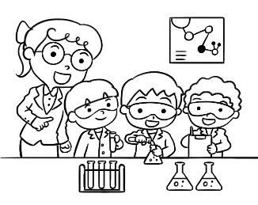
1. Little Scientist
We will group your children into small groups. They have to work together to do many food science experiments. It’s fun and educational.
~From January 15th to January 31st~
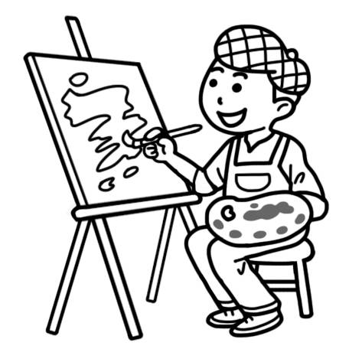
2. Little Artist
Our art teachers will teach your children to draw. They will also visit many art museums. They will learn drawing skills and develop knowledge about art at the camp.
~From February 1st to February 15th~
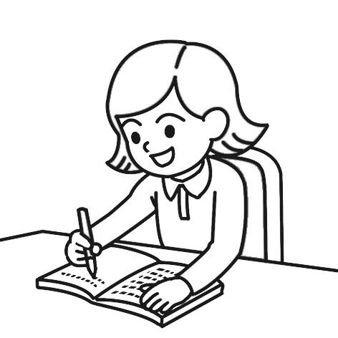
3. Little Writer
It’s not difficult to write in English. Our teachers will teach your children lots of writing skills. Your children will also work in groups to write a short story.
~From February 16th to February 28th~

For more information, you can call me at 8665-9876. Thank you.
Jenny
- will 將會 experiment 實驗 educational 有教育意義的 skill 技巧 develop 發展
knowledge知識 information 資訊

knowledge 知識 information 資訊

- might 也許
36. Ian has a dream to be a storybook writer. Which camp might he want to join?
(A) Little Artist. (B) Little Cook. (C) Little Scientist. (D) Little Writer.

37. It was 10 a.m. on February 11th. What were the children at the camp doing?
(Ａ) They were writing a short story in groups .
(Ｂ) They were doing a fun science experiments .
(Ｃ) They were learning lots of writing skills .
(Ｄ) They were visiting an art museum to learn knowledge about art.

38. Where might Jenny work?
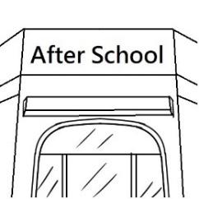
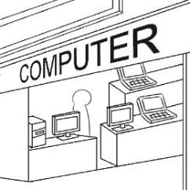
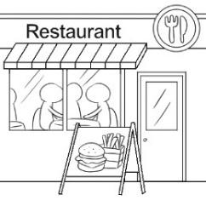
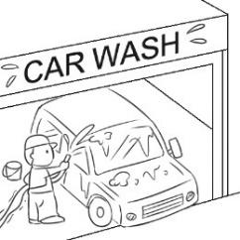
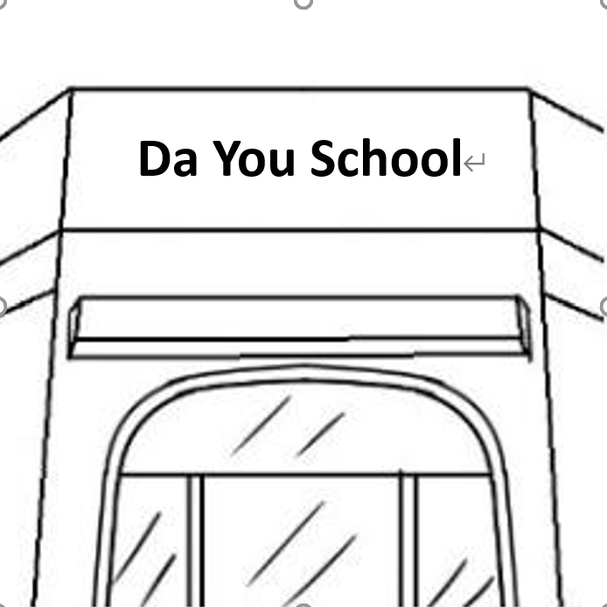
(Ａ) (Ｂ) (C) (D)

39~40
One day, a family went to a museum. They looked at many old things. The family has a four-year-old boy. He saw a vase. It was three thousand five hundred years old! The boy wanted to see the inside of the vase. The vase was tall. The boy was short. So he pulled it a little... Uh-oh! The parents heard the crash. They saw their boy! They saw the broken vase! There were many pieces! Oh no! The boy was scared! He cried! But the museum workers were very kind. They knew it was a mistake. And they wanted kids to feel welcome. So they invited the family to come back.
The family came back. The boy saw how the vase was fixed. The museum workers showed him that mistakes are a part of learning. The museum workers hope more kids will visit. They want everyone to know it's okay to make mistakes. Well, they don't want more broken things. But they think broken things can be beautiful again!
- vase 花瓶 pull 拉 crash 碰撞 scared 感到害怕 fix 修理 more 更多的
will 將會 make mistakes 犯錯

39.Which is the right title for this reading?
(A) Something Terrible Happened
- title 標題
(B) Rules When Little Children Visit A Museum
(C) A Boy Broke A Vase And Learned A Lesson
(D) Kids Can Do Everything They Like

40. Which is true?
(A) The boy and his family couldn’t visit the museum again.
(B) The boy was excited when he broken the vase.
(C) The vase was three thousand five hundred dollars.
(D) The museum workers think about making mistakes is a part of learning.

六~九大題請用黑筆在答案卷上作答，並於考後繳交答案卷。

