桃園市立大有國民中學113學年度第二學期第一次評量試卷
年 級 | 七 | 考 試  科 目 | 英語科 |  |  | 命 題  範 圍 | Unit 1 – Review 1 | 作 答  時 間 | 45分
班 級 |  | 姓 名 |  | 座 號 |  | 分 數

聽力測驗，每題播放兩次，請依題意選出最好的答案，共20分。
- 辨識句意：根據聽到的內容，選出符合描述的圖片或符合圖片的描述，每題1分，共5分。

1. (Ａ) 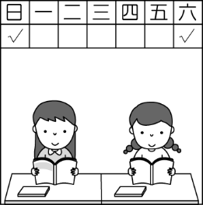 (Ｂ) 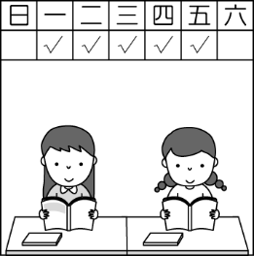 (Ｃ) 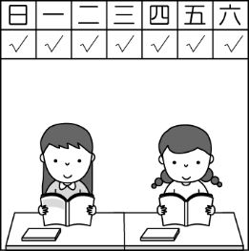
2. (Ａ) 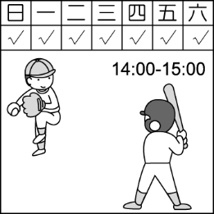 (Ｂ) 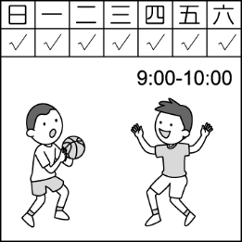 (Ｃ) 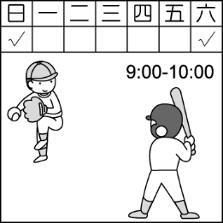
3. (Ａ) 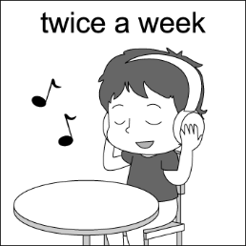 (Ｂ) 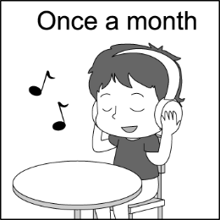 (Ｃ) 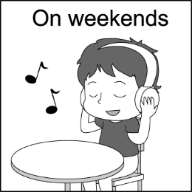
4. (Ａ) 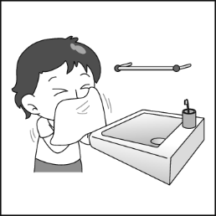 (Ｂ) 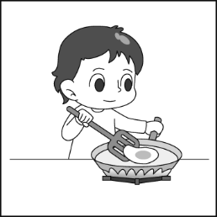 (Ｃ) 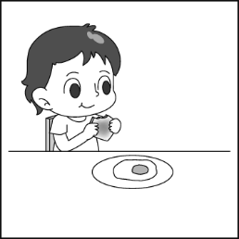
5. (Ａ) 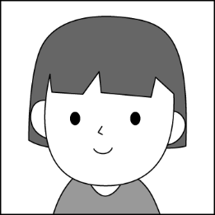 (Ｂ)  (Ｃ) 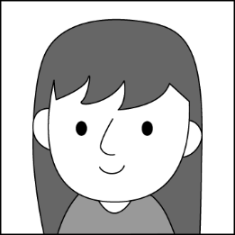
二、基本問答：根據聽到的內容，選出一個最適合的回應或最適合的問句，每題1分，共5分。
- (Ａ) Yeah, they are in big trouble.
(Ｂ) Yeah, they are not like each other.
(Ｃ) Yeah, they put their all at school.
- (Ａ) He is thirteen years old.
(Ｂ) He is my classmate.
(Ｃ) He is only 140 centimeters tall.
- (Ａ) Yes, she has red lips.
(Ｂ) Yes, her nose is small.
(Ｃ) Yes, her eyes are not big.
- (Ａ) Jason and I like cats.
(Ｂ) I don’t have music classes.
(Ｃ) Yes, he exercises after school.

- (Ａ) He has a clean bedroom.
(Ｂ) He has the same bedroom with his brother.
(Ｃ) He cleans his room once a month.
- 言談理解：根據聽到的內容，選出一個最適合的答案，每題2分，共10分。
- (Ａ) The USA.
(Ｂ) England.
(Ｃ) Japan.
- (Ａ) Albert is good at playing baseball.
(Ｂ) Albert is 190 centimeters tall.
(Ｃ) Albert is standing over there.
- (Ａ) He swims.
(Ｂ) He cleans the dog house.
(Ｃ) He studies and plays baseball.
- (Ａ) Go to cram school.
(Ｂ) Play sports with her friends.
(Ｃ) Study for the tests.
- (Ａ) Thirteen days.
(Ｂ) Three days.
(Ｃ) Thirty or thirty-one days.
綜合測驗
四、請依題意選出最好的答案，第16-30題，每題2分，共30分。
16. Lisa doesn’t have a smartphone. She ______ checks her phone when she’s outside.
(A) usually (B) often (C) sometimes (D) never
17. Nobody is ______ perfect. Everyone makes mistakes(錯誤).
(A) never (B) seldom (C) sometimes (D) always
18. Rosé: ______ do you go to the library?
Jennie: Every weekend.
(A) What time (B) What day (C) How long (D) How often
19. Karina: Sabrina is very smart! She ______ three different languages (語言) really well.
Ariana: Wow. How can she ______ them?
(A) speaks; learns (B) is speaking; learns (C) speaks; learn (D) speak; learn
20. Olivia: Bruno ______ the piano. He can play very difficult songs.
(A) good at play (B) is good at (C) plays good at (D) is good in
21. Jung Kook and his brother ______ basketball every weekend. Look! They ______ it in the park now.
(A) play; are playing (B) is playing; play (C) plays; play (D) are playing; are playing
22. Everyone in the class ______ English for an hour every morning.
(A) practice (B) practices (C) practicing (D) is practicing
23. Jisoo: Do you go to the library on __________?
Taylor: Yes, but not always. I do my homework there. What about you?
Jisoo: I go every ________because I love reading books.
(A) weekend; weekend (B) weekends; weekends (C) weekends; weekend (D) weekend; weekends
24. Sam: _________________
Meg: She does sports or paints.
(A) Does she play sports? (B) What does she do on Sundays? (C) What can she do? (D) Does she have strong arms?
25. Wonyoung: What does she ______ on Saturdays? Liz: She ______ her homework.
(A) doing; do (B) does; do (C) does; does (D) do; does
26. Though (雖然) Curry is not very tall, but he __________ for it ___________a lot of practice.
(A) make up; by (B) makes up; from (C) makes up; with (D) make out; on
27. Billie: __________ go to the library in the morning? Justin: Yes, I usually do it on Sundays.
(A) Do you often (B) What do you (C) How often do you (D) What time do you
28. ________ quiet in class.
(A) Be always (B) Always be (C) Do always (D) Always do
29. Lady Gaga is a ______ singer; she has a beautiful voice.
(A) born (B) being (C) borned (D) borns
30. Today is Minnie’s birthday! Let’s ______________ for her.
(A) fly a kite (B) wake up (C) make a cake (D) play basketball

五、克漏字及閱讀測驗，第31-44題。
A. 每題2分，共10分。
Jimin：I’m the student on duty this week. It’s my turn to clean the classroom. What do I have to do?
Momo：You have the key to the classroom door this week. So, never 31. for school.
Jimin：Don’t worry. I 32. on time. I 33. at 6:00 every day.
Momo：That’s good.
Jimin： 34.
Momo: You have to do it after school every day. That’s five times a week.
Jimin：OK. And does Ms. Lin always check it after school?
Momo：Yeah, she 35. .
student on duty 值日生 have to 必須 on time準時
31. (A) late (B) be late (C) do late (D) later
32. (A) always am (B) am usually (C) often am (D) am always
33. (A) got up (B) gets up (C) get up (D) getting up
34. (A) Where do I close the door? (B) What time do you clean the classroom?
(C) How often do I need to close the door? (D) How to turn off the light(燈)?
35. (A) is (B) always is (C) does (D) does always

B. 每題2分，共10分。
Andy: Hi, Popo. You don’t look good.
Popo: I’m hungry.
Andy: 36.
Popo: No, I don’t.
Andy: 37. do you get up every day?
Popo: At seven.
Andy: That’s a little late.
Popo: 38. Do you have breakfast at home every day?
Andy: Yes, I have it at six thirty.
Popo: You get up very early, right?
Andy: Yes. I get up at five every day.
Popo: 39. By the way, what do you do on weekends?
Andy: I read story books. Do you read them, too?
Popo: 40. .
36. (A) Don’t you have breakfast? (B) Ice cream? (C) Let’s have lunch. (D) There’s a banana on the table.
37. (A) What (B)What time (C) How often (D) How
38. (A) Thank you. (B) How about you? (C) I can’t wait! (D) That’s nice.
39. (A) You’re welcome. (B) Nice to meet you.
(C) You’re an early bird. (D) You can have breakfast at school.
40. (A) No, but I read comic books. (B) Yes, I love comic books. (C) No, I like to read. (D) What do you read?

C. 每題2分，共8分。
Tom, Jack, and Eric are junior high school students. They are in the same class. They study hard and does well in some subjects. Tom is good at Chinese, science, math, and music. Jack is good at in Chinese, English, science, and history. And Eric is great in Chinese, math, English, and geography.
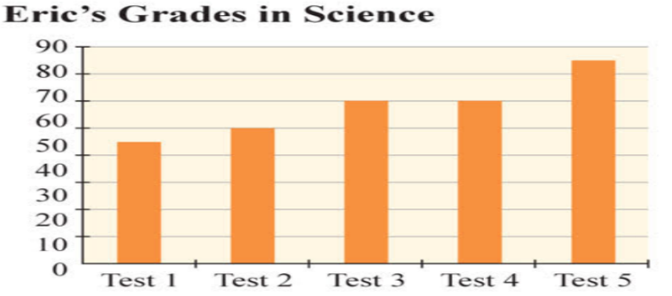
On Saturday afternoon and Sunday evening, the three friends usually study together and help each other. For example, Eric is not good at science. He often asks Tom and Jack questions about science, and they try their best to help him understand it. Does it work for Eric? Look at the picture below, and you can see that Eric is making good progress in science. All the three students are proud of their study group.

below 下方 well 好地 geography 地理 science 自然科學 history 歷史 subject 科目 try one’s best 盡全力 grade 成績 be proud of 感到驕傲

41. What does "making good progress" mean? mean 意指
(A) Eric is good at science now.
(B) Eric is tired of science.
(C) Eric does not like science.
(D) Eric finishes all his science homework.

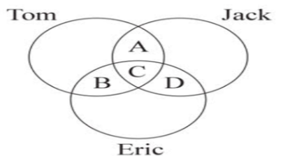
42. According to the picture, which is NOT right?
(A) A=science
(B) B=math
(C) C=Chinese
(D) D=geography

43. What can we learn from the reading?
(A) The three students are fifteen years old.
(B) Tom and Jack are good at music.
(C) Jack is the top student in the class.
(D) Only Jack is good at history.

44. What do Tom, Jack, and Eric usually do on weekends?
(A) They play video games together.
(B) They study and help each other.
(C) They go to the movies.
(D) They practice sports.

<<尚有試題，請仔細作答>>

