桃園市立大有國民中學113學年度第二學期第二次評量試卷
年 級 | 七 | 考 試  科 目 | 英語科 |  |  | 命 題  範 圍 | Unit 3 – Review 2 | 作 答  時 間 | 45分
班 級 |  | 姓 名 |  | 座 號 |  | 分 數

聽力測驗，每題播放兩次，請依題意選出最好的答案，共20分。
- 辨識句意：根據聽到的內容，選出符合描述的圖片或符合圖片的描述，每題2分，共6分。
1. (Ａ) 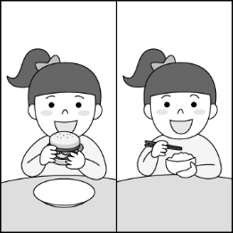 (Ｂ) 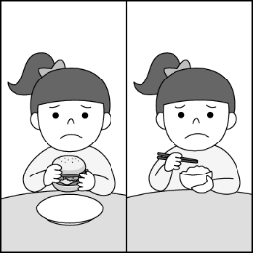 (Ｃ) 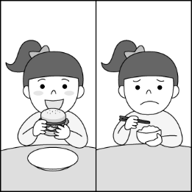
2. (Ａ) 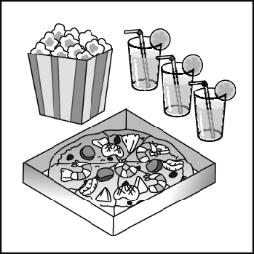 (Ｂ) 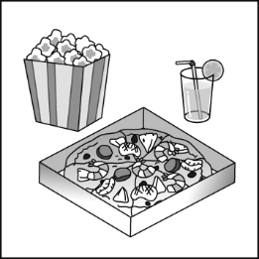 (Ｃ) 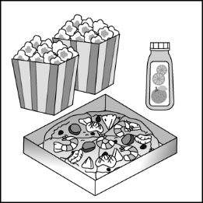
3. (Ａ) 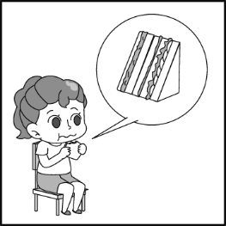 (Ｂ) 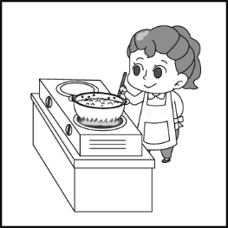 (Ｃ) 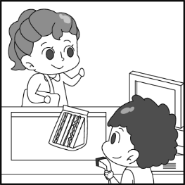
二、基本問答：根據聽到的內容，選出一個最適合的回應或最適合的問句，每題2分，共6分。
4. (A) Well, I am in the hospital now. (B) Are you thirsty? (C) Yes. I need some water first, please.
5. (A) Yes, a bag of sugar, please. (B) I need one bag of flour, but I don’t need any sugar. (C) No, I can’t make a birthday cake.
6. (A) They are two hundred dollars. (B) Green salad can be our breakfast on School Day. (C) Let’s get thirty. Ten for Alice and twenty for our family.
- 言談理解：根據聽到的內容，選出一個最適合的答案，每題2分，共8分。
7. (A) They are making milkshakes. (B) They are making chocolate. (C) They are making a cake.
8. (A) Make some banana pies. (B) Make some apple pies. (C) Buy some fruit at the supermarket.
9. (A) The age of the picture. (B) A painting in the museum. (C) A great coffee shop.
10. (A) They may be at a cake shop. (B) They may be making a cake at home. (C) They may be eating a cake at the park.綜合測驗
四、請依題意選出最好的答案，第11-27題，每題2分，共34分。
11. The ice ______ water in the hot sun.
(A) stands out (B) turns into (C) cleans up (D) makes up for
12. Jolin: ________________ Clerk: They are 170 dollars.
(A) How much is the apple juice?
(B) How many apples do they need?
(C) How many apple cakes are there in the kitchen?
(D) How much are two cans of apple juice?
13. Irene: ________________ Wendy: There are six bags.
(A) How many bags do you have?
(B) How much salt is there on the table?
(C) How much salt do they eat every day?
(D) How many cans of juice are there in the kitchen?
14. Kendrick: ________ do you like, the red card or the blue card? Drake: I like the red ___________.
(A) What; one (B) Which; one (C) Which; X (D) What; it
15. I don’t need _________sugar. I only need _________bags of them.
(A) much; many (B) much; a little (C) a lot of; a little (D) much; a few
16. Yuqi: _____________ Shuhua: Because I need it for my art class.
(A) What is this? (B) Do you need to go to class? (C) Why do you buy this paint? (D) Why don’t you buy this paint?
17. Liz: Mom, I need an eraser to do my homework. Mom: How about the ________ in the pencil box? ________ new.
(A) one; It’s (B) one; One is (C) ones; They’re (D) ones; Ones are
18. G-Dragon: There is a gift for you! It’s an album (專輯) ______ BIGBANG. Hoshi: How nice! That’s so sweet ________ you.
(A) by; of (B) for; in (C) from; for (D) by; to
19. We often go to__________ because we love__________.
(A) sky; streets (B) clerk; museums (C) flowers; burgers (D) coffee shop; snacks
20. Andy: I want these paints. NingNing: All right. ________________
(A) Here you go. (B) Here are they. (C) Here they go. (D) Here it is.
21. Soojin: Which does Scarlett like, coffee or tea? Peter:_______________
(A) Yes, she likes coffee. (B) She likes both. (C) She likes a coffee. (D) She has a cup of tea.
22. Daddy, my watch doesn’t work. I can’t use _____ now. Can you buy me a new _____?
(A) it; one (B) one; one (C) one; it (D) it; it
23. Rosé: What do we need to make a cake?
Steve: We need _____ chocolate, flour, and…. Oh, no, we don’t have _____ eggs.
(A) some; some (B) any; any (C) any; some (D) some; any
24. I take my umbrella to school ___________it’s raining.
(A) because (B) , so (C) or (D) if
25. Which one is right?
(A) I’m tired so I go to bed early.
(B) I go to bed early, because I’m tired.
(C) Because I’m tired I go to bed early.
(D) I go to bed early because I’m tired.
26. Jim: How much salt _____ in the kitchen? Jane: There ___ four bowls of salt.
(A) are there ; have (B) is there; are (C) have ; have (D) has ; is
27. Taeyang: How to get to the museum? Mino: I will ___________ you the way. It’s not far from here.
(A) create (B) work (C) show (D) want

五、克漏字及閱讀測驗，第28-40題。
A. 每題2分，共10分。
Sandy: Hey, Dad’s birthday is this Sunday. Let’s eat dinner at a coffee shop nearby. What do you think?
Jennie: _____28. But there 29. a lot of them near here. _____30. do you want to go?
Sandy: How about the one in the museum?
Jennie: Good idea! Dad likes art. We can see the paintings after lunch.
(After lunch)
Dad: This is my favorite painting. Do you like it?
Sandy: _____31. We can put it in the living room. Let’s ask the clerk about the price.
Clerk: May I help you?
Jennie: Yes. _____32. is this painting?
Clerk: It’s just NT$1,500.
Jennie: I will take it.
Clerk: OK. I will wrap it up for you.
Jennie: Thank you.
28. (A) That’s not a good idea. (B) I’m not sure. (C) For here. (D) All right.
29. (A) is (B) has (C) are (D) have
30. (A) How many (B) What (C) Which (D) When
31. (A) I’m sorry to hear that. (B) I don’t like it.
(C) That’s nice. (D) I’m not sure.
32. (A) How much (B) How many (C) Which (D) How

B. 每題2分，共16分。
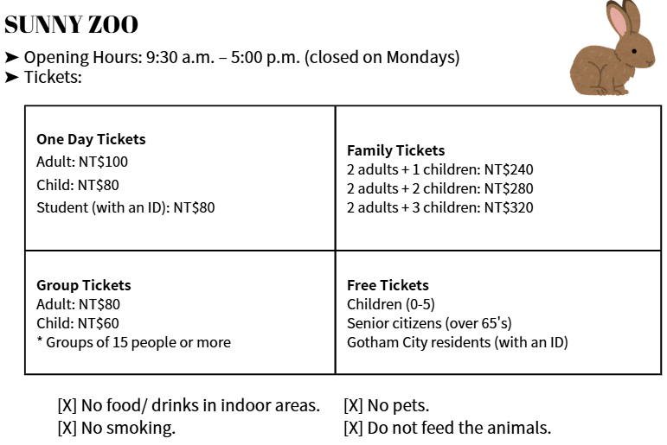
opening hours營業時間 adult成人 more更多的 citizen公民 resident 居民 senior年長的 indoor area室內區 smoking 抽菸 feed 餵食
33. It's Sunday. Felix and his family are at Sunny Zoo. How much are the tickets?
Felix | 38 years old, Raccoon City resident
Felix's wife, Ann | 35 years old, Raccoon City resident
Felix's son, Eddie | 6 years old, Raccoon City resident
Felix's daughter, Rita | 2 years old, Raccoon City resident
Felix's sister, Julia | 42 years old, Gotham City resident
Felix's father, David | 72 years old, Gotham City resident
(A) NT$240. (B) NT$360. (C) NT$440. (D) NT$480.
34. Which is true?
(A) Eddie can take his rabbit to the zoo. (B) A group of five can buy group tickets.
(C) People can't go to the zoo on Mondays. (D) Students can have free tickets to the zoo.

Pizza is very popular. Many people like to have pizza. Pizza is an Italian（義大利的）food, but not many people know: the most classic pizza is Margherita（瑪格麗特）pizza.
Margherita pizza was made in Naples（拿坡里）for a visit of Queen Margherita. Now, people still use red tomatoes, white cheese, and green basil to make Margherita Pizza. The colors of the pizza are the colors of the Italian flag. The three colors from left to right show the green hills, the snowy mountains, and the blood in the wars.
If you like pizzas, you can try to make it at home. It’s very easy. You only need a pizza crust, tomatoes, cheese, basil, oil, and salt. First, mix oil, a little salt, and eight pieces of tomatoes. Put it on the pizza crust, and then add basil and cheese. Last, toast the pizza for seven to ten minutes, and then get ready for a hot and yummy Margherita pizza!

most 最 classic 經典的 tomato番茄 basil 羅勒 flag 旗子 hill 山丘 snowy 雪白的 blood 血 war 戰爭 if 如果 crust 餅皮 oil 油
35. What are the colors of the flag from 1 to 3?
(A) Red, green, white. (B) White, red, green.
(C) Green, red, white. (D) Green, white, red.
36. What do you need to make a Margherita pizza?
(A) Basil, tomato, oil, salt, pizza crust, and cheese.
(B) Cheese, oil, salt, egg, tomato, and basil.
(C) Pizza crust, oil, sugar, apple, tomato, and basil.
(D) Oil, pizza crust, tomato, milk, sugar, and cheese.
37. Which is NOT true about Margherita pizza?
(A) The pizza shows the colors of the Italian flag. (B) It’s very easy to make at home.
(C) It is different from the pizza people eat in Italy today. (D) It’s very popular around the world.

Karina: See! The cat is jumping high!
Natasha: Is that a leopard cat?
Karina: Leopard cats?
Natasha: Most people don't know them. They are the last of our native wild cats. They are like pet cats, but they have two white lines on the inner side of their eyes. And behind their ears, there are obvious white patches. You can see them in the mountains or forests.
Karina: Really? Can I look for one when I go hiking in the mountains?
Natasha: It’s not easy to find one.
Karina: Why not?
Natasha: It's because they are endangered. There are only about 500 leopard cats in Taiwan. We need to do something to protect them.
Karina: Why are they so few?
Natasha: They lose their place to live because of land development.
Karina: I am sorry to hear that. Are there any other reasons?
Natasha: Of course. Many stray dogs and cars may hurt them, so their number is falling.
Karina: I can't believe it. We are killing them.
Natasha: Yeah! So, we need to do something for them.

leopard cat石虎 native原生 wild野生的 inner內部的 obvious明顯的 patch斑塊 forest森林 protect保護
land development土地開發 stray流浪的

38. What is NOT true?
(A) Cars may kill leopard cats.
(B) There are few leopard cats now.
(C) Leopard cats have small eyes and white ears.
(D) Stray animals may hurt leopard cats.
39. Which picture shows endangered?
(A) (B)
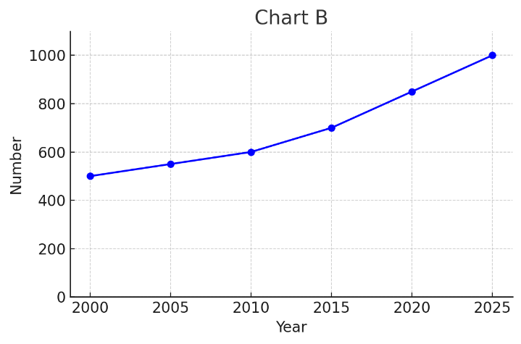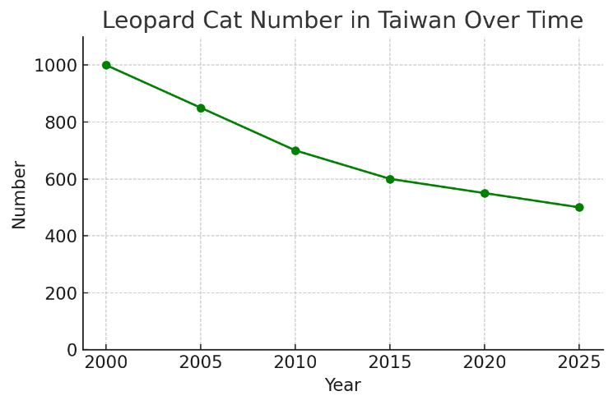

(C) (D)
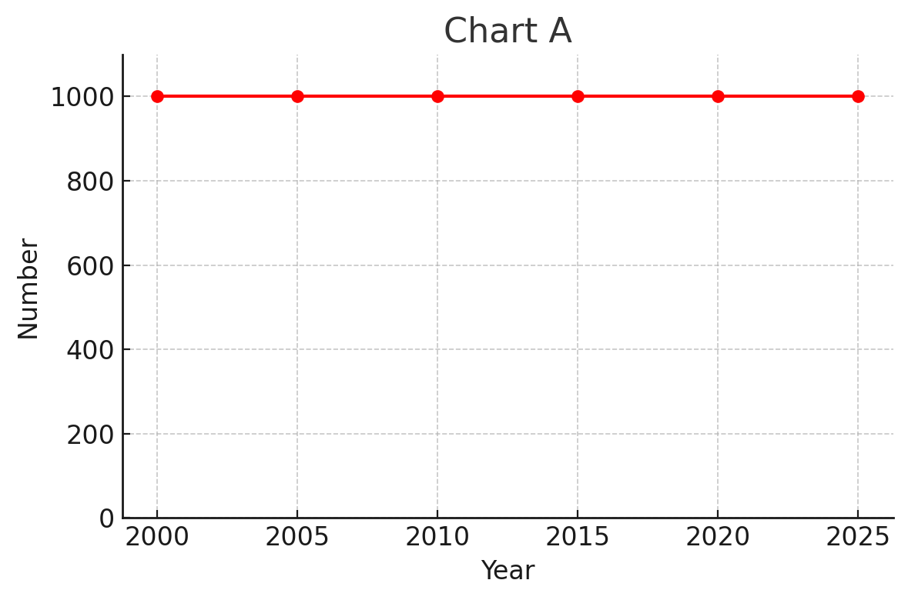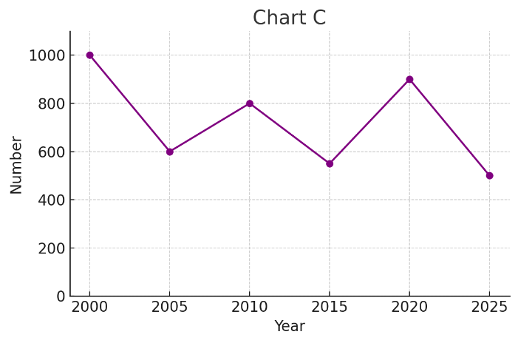
40. What do we learn from the reading?
(A) The leopard cat is good at running and climbing trees. climb攀爬
(B) We can’t find any leopard cats because there are only 500 in the world now.
(C) Leopard cats mainly eat birds, rabbits, and mice. mainly 主要地
(D) The number of leopard cat is falling because of land development.

<<尚有手寫題，請仔細作答 >>

