桃園市立大有國民中學113學年度第二學期第三次評量試卷
年 級 | 七年級 | 考 試  科 目 | 英語 |  |  | 命 題  範 圍 | Unit 5, Unit 6, Review 3 | 作 答  時 間 | 45分
班 級 |  | 姓 名 |  | 座 號 |  | 分 數

一、 辨識句意：根據聽到的內容，選出符合描述的圖片或符合圖片的描述。 (10%)
- (A) (B) (C)
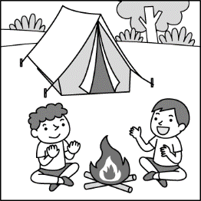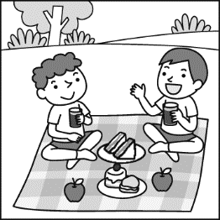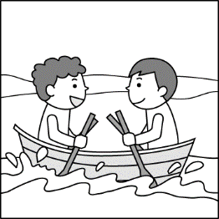
- (A) (B) (C)
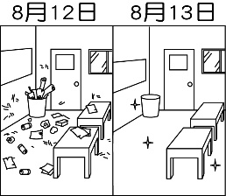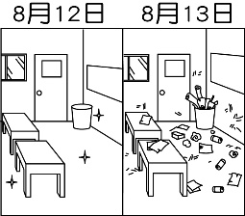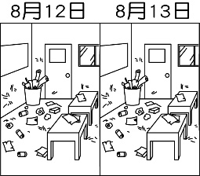
- (A) (B) (C)
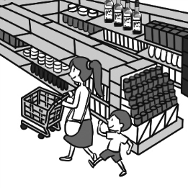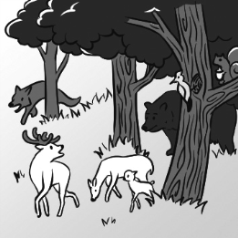
- (A) (B) (C)
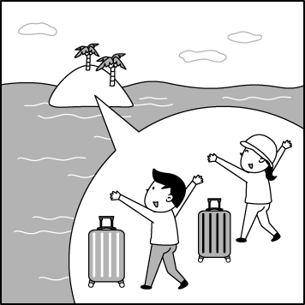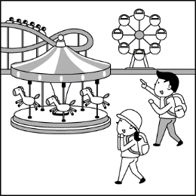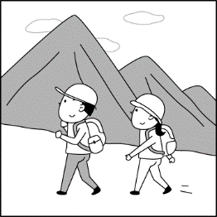
- (A) (B) (C)
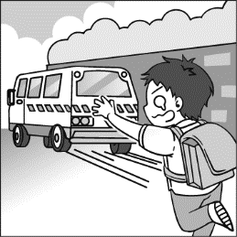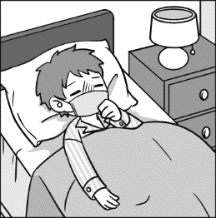

二、 基本問答：根據聽到的內容，選出一個最適合的回應或最適合的問句。 (10%)
- ( ) (A) It was hungry at that time.
(B) It is climbing a tree now.
(C) It was in the forest.
- ( ) (A) I like to do some activities, like rowing
a boat and going hiking.
(B) I was free yesterday afternoon.
(C) It was a bad week.
- ( ) (A) Yes, there was one.
(B) No, they weren’t there before.
(C) Yes, there are many people there.
- ( ) (A) I cried a lot last time.
(B) Because I lost my favorite cat.
(C) Mom and Dad were in the kitchen.

- ( ) (A) Yes, she wakes up at 6:30 every
morning.
(B) Yes, she did. She woke up at 5:30 this
morning.
(C) Yes, she went to a restaurant last night.

三、言談理解：根據聽到的內容，選出一個最適合的答案。(10%)
- ( ) (A) She was in the mountains.
(B) She was in the man’s house.
(C) She was at Lily’s house.
- ( ) (A) Wednesday.
(B) Thursday.
(C) Friday.
- ( ) (A) Planted trees.
(B) Made a cake.
(C) Played water sports.
- ( ) (A) He doesn’t want to see anybody.
(B) He got a bad grade.
(C) He is hiding something.
- ( ) (A) She did not go there.
(B) She walked there.
(C) She took the bus there.

四、單字與文法選擇題 (40%)
- ( ) There are many beautiful flowers and tall trees
in the . Many kids like this place.
(A) theater (B) sea
(C) river (D) mountains
- ( ) People in Japan often under cherry blossom（櫻花）trees at the park. They can share food with friends.
(A) picnic (B) climb
(C) hike (D) fly a kite
- ( ) We went to Taipei and took a rest at a
for three days. It was a nice place.
(A) hotel (B) story
(C) airplane (D) way
- ( ) Cameron is an office worker from a big . He makes a lot of money with other workers.
(A) boat (B) travel (C) rainforest (D) company
- ( ) James: Aunt Patricia died at a young age.
Bryce: When did she her life? James: At the age of 31. It was a sad news.
(A) visit (B) hide
(C) lose (D) cry

<下一頁尚有試題>
- ( ) Mrs. Watson can’t sleep well (好)
the night. Did she see a doctor last week?
(A) between (B) before
(C) during (D) sadly
- ( ) The lake was full of ten years ago.
Thanks to the mayor’s (市長) help, it is clean
now. Many people are happy about it.
(A) turkeys (B) trash
(C) trains (D) sheep
- ( ) It is today. Let’s go take a walk on
the street.
(A) tired (B) yummy
(C) famous (D) cool
- ( ) Donovan never cleans his bedroom. ,
everything in his room is like trash.
(A) Row a boat (B) See the sights (C) Plant some trees (D) Little by little
- ( ) Eden: What did you do at the train , my friend?
Romeo: What else can I do? I took the train !
(A) station (B) restaurant
(C) theater (D) hill
- ( ) Margo: I breakfast this morning. I am very hungry now.
Grace: We can have lunch together at twelve.
(A) didn’t eat (B) don’t eat
(C) am eating (D) eating
- ( ) Brie: Where was your brother ? I
didn’t see him then.
Stan: He was in the mountains with his
friends.
(A) tomorrow (B) next Friday (C) two weeks ago (D) every weekend
- ( ) Thomas put his book into the drawer (抽屜),
but Victor .
(A) does (B) didn’t
(C) can’t (D) are
- ( ) Pete: Did Raul read a book this morning?
Brad: Yes, he . He a book this
morning.
(A) does; reads (B) did; read
(C) do; reading (D) did; reading
- ( ) Steven seldom sleeps early, but he to
bed early last night.
(A) never go (B) goes
(C) went (D) are going
- ( ) Daniel: Jalen a good swimmer before. However, he it up (放棄) last
year.
Enzo: How come? Was he tired of (厭倦) it?
(A) are; giving (B) were; giving
(C) is; gives (D) was; gave
- ( ) Mr. Lux: What after school?
William: I just had a piece of cake.
(A) are you doing (B) were you
(C) did you do (D) do you do

- ( ) Mr. Thornton’s wife died last week, and
Mr. Thornton .
(A) cried for many days and hid from his friends
(B) get some coffee with her every morning
(C) has a picnic with her every Friday evening
(D) did not like his love for her
- ( ) There were . Mr. Robinson liked them.
(A) two old houses near the river
(B) a comic book under the chair then
(C) so many children at the park now
(D) lots of trash on the hill many years ago .
- ( ) Stella: Hey, you traveled a long way. Do you need a rest?
Evelyn: No. Let’s go see the famous building.
(A) I didn’t take a rest on the plane.
(B) The boat was cool but small.
(C) I woke up at six in the morning.
(D) I slept a lot on the train.

五、克漏字與閱讀測驗選擇題 (30%)
(36-40)
(The phone is ringing...)
Tammy: Hello, who is this?
Casper: This is Casper speaking. (36)
I called you many times, but you didn’t answer the calls.
Tammy: I just came back from Dream Mall, the department store. My cousin’s birthday is coming. I want to (37) for him.
Casper: What did you buy then?
Tammy: I didn’t buy anything.
Casper: (38)
Tammy: There were so many good things in the department store, but I (39) enough money.
Casper: That’s too bad. How about making a special gift for him by yourself?
Tammy: Like what?
Casper: I borrowed a book about making gifts from the library last week. I can bring it to school, and you can check it out.
Tammy: Did you see anything cool in the book?
Casper: I (40) a working compass in the book.
Tammy: Cool. I didn’t know you can make a compass by yourself.

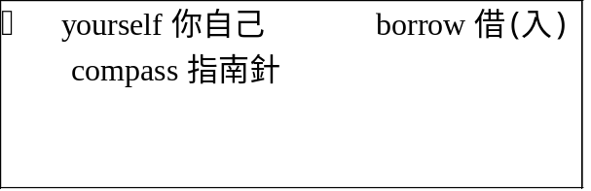
<下一頁尚有試題>

- ( ) (A) You were in the dining room.
(B) Where were you this morning?
(C) Who is your husband?
(D) What is your number?
- ( ) (A) cook a meal
(B) drink a cup of coffee
(C) buy a gift
(D) see a movie
- ( ) (A) Here you go.
(B) Where is the bus stop?
(C) I don’t think so.
(D) How come?
- ( ) (A) didn’t have
(B) don’t have
(C) had
(D) has
- ( ) (A) am seeing
(B) seeing
(C) saw
(D) didn’t saw
(41-44)
Last Saturday was my seventeenth birthday. (41) a great party at my place. My good friends, Fiona and Zoe, were at the party. My mother was busy all day, and my father (42) . They both cooked such a yummy big dinner. No wonder everyone (43) a lot and was very full. At the end of the party, Fiona played the piano, and Zoe played the guitar. Everyone wished me a happy birthday. I (44) everyone at the party for the happy time with me.
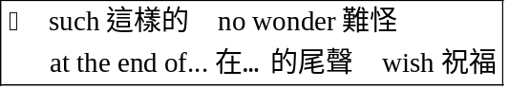
- ( ) (A) There are (B) There was (C) Here comes (D) There goes
- ( ) (A) was, too (B) wasn’t
(C) did, too (D) didn’t
- ( ) (A) did not like it (B) eats (C) enjoyed it (D) drinks
- ( ) (A) kiss (B) look at (C) stood (D) thanked

<下一頁尚有試題>

(45-47)
Cool Buses Around the World
Do you like buses? Let’s take a look at these cool buses around the world. They are so different from normal buses. Let’s check them out!
 | Ambition Bus in the Netherlands is an amphibious bus. It can run on land and in water. Many people like its red color. An Ambition Bus can hold about 50 people at a time.
 | DUWK in the United Kingdom can run both on land and in water. People often call it “duck” because its name is like “duck” and its color is yellow. The army used it during World War II. Now, everyone can take it. A DUWK can hold 22 people at a time.
 | Juku Water Bus in Japan is a teardrop-like boat. It holds more than 200 people at a time. You can sit at its table and have tea, coffee, or milkshake on it.
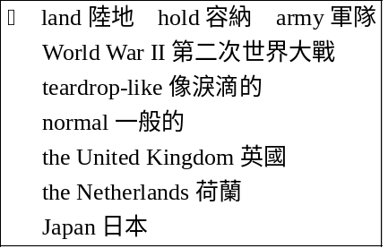
- ( ) What does amphibious mean（意指）? (A) The bus has two names.
(B) The bus can run on land and in water.
(C) The bus is only in the Netherlands.
(D) The bus has two seats in the front of it.
- ( ) Check out the size（尺寸）of the three buses.
Which is right?
(A) Ambition bus> DUWK> Juku Water Bus (B) Juku Water Bus> Ambition Bus= DUWK (C) DUWK= Juku Water Bus= Ambition Bus (D) Juku Water Bus> Ambition Bus> DUWK
- ( ) What can we learn from this reading? (A) DUWK was not a bus before.
(B) The three buses can run on land. (C) Juku Water Bus is a green boat. (D) People call Ambition Bus “duck.”

(48-50)
Dear Bella,
Long time no see!
I just came back to Taipei from Washington, D.C., the USA. 19 hours on the airplane really made me tired.
I knew about Typhoon Villa from the TV news. The typhoon hit Taiwan in September. On TV, I saw many houses in Kaohsiung were damaged. Are you safe down there?
The weather in the mountains of the USA was very different from the weather in Taiwan. It was just early October, but it started to snow here.
But my trip to the USA was great. My English is poor, but here I talked to people without any problem, and I even made some new friends on the bus!
I will go to New York next July. Do you want to join me?
Your friend,
Rose

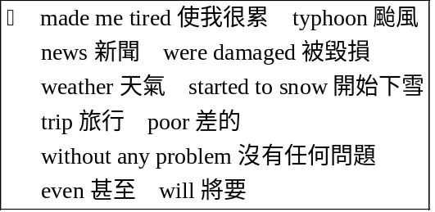
- ( ) Where does Bella live?
(A) In New York.
(B) In Taipei.
(C) In Washington, D.C.
(D) In Kaohsiung.
- ( ) Rose was in the USA in early October. How
was the weather at that time?
(A) There wasn’t any snow.
(B) It was cold.
(C) It was hot.
(D) There was a strong typhoon.
- ( ) Which is right (正確) about Rose?
(A) She did not speak English to anyone in the USA.
(B) She didn’t know anything about Typhoon Villa.
(C) She made some friends in the USA.
(D) Her English is very good.

<試題結束>

