桃園市立大有國民中學113學年度第二學期第一次評量試卷
年 級 | 八 | 考 試  科 目 | 英語 |  |  | 命 題  範 圍 | L1 ~ L2, Review1 | 作 答  時 間 | 45分
班 級 |  | 姓 名 |  | 座 號 |  | 分 數
A: 聽力測驗
一、辨識句意：每題均有三張圖片，請依據所聽到的句子，選出符合描述的圖片。5%
- (A)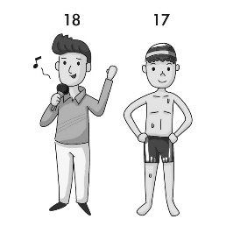 (B)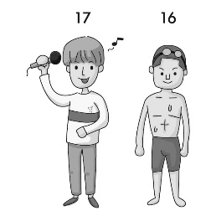 (C)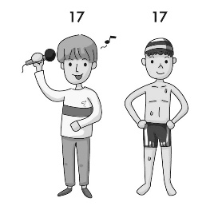
- (A)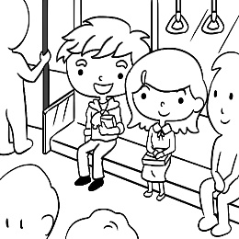 (B)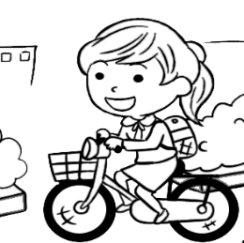 (C)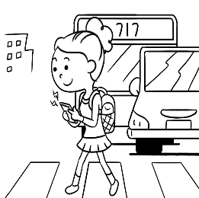
- (A)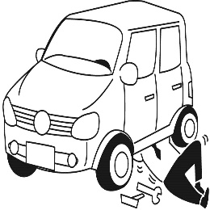 (B)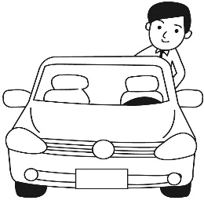 (C)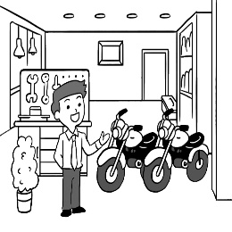
- ＿＿＿
(A)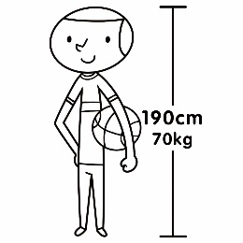 (B)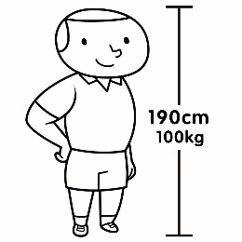 (C)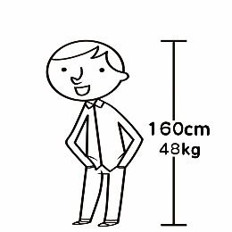
- ＿＿＿
(A)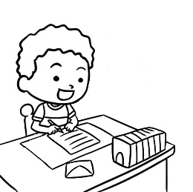 (B) (C)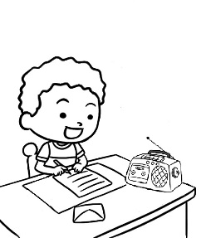

二、基本問答：每題均有三個選項，請依據所聽到的內容，選出一個最適合的回應。10%
- (A) The new department store will be open this week.
(B) All the clothes at the store are in style.
(C) The store already began the sale.
- (A) What size do you wear?
(B) Where is the fitting room?
(C) Don’t you like the style?

- ＿＿＿
(A) Oh, I didn’t think of that. It’s a good idea.
(B) I have no idea. Let’s find the answer together.
(C) That’s right. Kevin is the nicest of all.
- ＿＿＿
(A) It can take care of your broken machines.
(B) This old camera doesn’t work anymore.
(C) You can record and take photos at the same time.
- ＿＿＿
(A) No problem. Let me tell you the story of our town.
(B) Sure. You can view the picture files on my computer.
(C) Yes, you can save the videos on your smartphone.

三、言談理解：每題均有三個選項，請依據所聽到的對話與問題，選出一個最適當的答案。10%
- (A) A sweater and a skirt.
(B) A jacket and a pair of jeans.
(C) A sweater and a pair of pants.
- (A) In a clothes shop.
(B) In a restaurant.
(C) On the street.
- (A) Because it cost less to get to North City.
(B) Because it took less time to get to North City.
(C) Because Bus 404 was more comfortable.
- ＿＿＿
(A) Her smartphone is dead.
(B) Her watch is out of order.
(C) She doesn’t wear a watch anymore.
- ＿＿＿
(A) Her voice is the best.
(B) Her voice is better than it was.
(C) Her voice is not good anymore.

B 綜合測驗 (16 --- 40每題2分) 50%
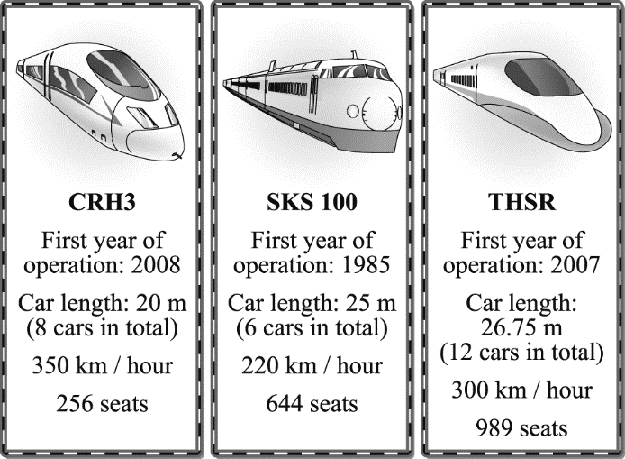
Look at the picture, and answer the following question 16 to 18.
16. Which train is the fastest?
(Ａ) SKS100 (Ｂ) THSR (Ｃ) CRH3 (Ｄ) I don’t know.

17. Which is NOT true about the THSR?
(Ａ) It began to operate（營運）in 2007.
(Ｂ) Its total car length is more than 300m.
(Ｃ) It has less than 900 seats.
(Ｄ) A THSR train has twelve cars in total.

18. Which is true about the three trains?
(Ａ) CRH3 is the fastest of the three.
(Ｂ) SKS 100 can have less people on it than CRH3.
(Ｃ) THSR is older than CRH3 but younger than SKS 100.
(Ｄ) CRH3 is the shortest train of the three.
operation 營運 length 長度

- Those apples in this store are nicer than the ________ in that store, and I want to buy the bigger ________.
- one ; them (B) ones ; ones (C) ones ; them (D) one ; it
- The red box is really heavy. Can you help me move ________ outside?
- them (B) it (C) one (D) ones
- Mom: Keep those shopping bags. Don’t ________.
Son: Okay, Mom.
- throw it away (B) throw away them (C) throw them away (D) throw away it
- Justin: It’s so cold today. Why not ________ some hot drinks at the new tea shop?
Alice: It’s a good idea.
- to buy (B) buys (C) buying (D) buy
- During the Chinese New Year, all the shops in Taiwan must ________ , people always buy more than they need
because all things are ________.
- are having a big sale ; on sale (B) have a big sale ; on sale
(C) is having a sale ; sale (D) has a sale ; for sale
- In Taoyuan, we have ________ rain in summer ________ in winter.
- much ; than (B) most ; as (C) more ; than (D) many ; as
- Mom used ________ happy, but everything changed after Dad left her.
- be (B) to be (C) being (D) to being
- Jessica is the smartest girl ________. She is always at the top of her class.
- of the two (B) than us (C) in the class (D) than others
- Taylor Swift is ________ singer in 2024. She has thousands of ________ in the world.
- the best ; fans (B) the worst ; fan (C) the better ; fans (D) the worse; fan
- Tom is ________ smart than Joe and Mart, so Tom is ________ of all.
- little ; the most smartest (B) less ; the most stupid (C) not ; smarter (D) least ; more stupid
- Amanda is ________ of the two girls although she is shorter than the other one.
- the prettiest (B) pretty (C) prettier (D) the prettier
- Living in the the big city, we can see ________ movie at any time.
- the latest (B) the last (C) later (D) late

克漏字測驗

Lions and cheetahs are members of the cat family, but they are very different. A lion is about 180cm long, but a

cheetah is only 130cm. So a lion is (31. ) than a cheetah. Lions are about 100cm tall, but cheetahs are

only about 70 cm. So lions are taller too. Lions are also (32. ) than cheetahs (33. ) because the

lion weighs about 160kg, but the cheetah only weighs about 50 kg. So the lions’ bigger size makes them stronger

than cheetahs and (34. ) when they sometimes attack people. But as everyone knows, cheetahs are a lot

faster than lions. They can run up to 100km an hour. Both animals are beautiful, but I think the cheetah is more

beautiful because of its lovely spot. Sadly, both animals are becoming (35. ) because they are killed and

their homes are destroyed.
cheetah 獵豹 attack 攻擊 spot 斑點 destroyed 摧毀

31. (A) long (B) longer (C) the longest (D) the longer
32. (A) very heavier (B) so heavy (C) much heavier (D) the heaviest
33. (A) are (B) is (C) do (D) does
34. (A) less dangerous (B) dangerous (C) the most dangerous (D) more dangerous
35. (A) less and less (B) fewer and fewer (C) more and more (D) little and little

閱讀測驗一
The table（表格）shows the result（結果）of the four students’ midterm exam（期中考）. Look at the table and answer the questions.
36. Of the four students, which one had the best score（分數）in Chinese and the worst score in Math ?
(A) Daniel. (B) Luke. (C) Max. (D) Paula.

37. Which is true about the four students’ midterm exam?
(A) Max’s total score is the highest of the four.
(B) Paula’s total score is a little lower than Daniel’s.
(C) Daniel’s average score is much lower than Luke’s.
(D) Luke’s math test is the best of the four.

閱讀測驗二

On a cold winter day, Peter, a poor young man, saw an old lady on the side of the road. The old lady was looking for food in a trash can. She was as stinky as a street dog. Her legs were longer than her pants, and her feet were also bigger than her shoes.
Peter only had one sandwich, but he thought, “she must be hungrier than me.” He gave the old lady his lunch. The old lady ate the food at once. Peter then took out some money and gave it to the old lady. “Take the money to buy some new clothes,” Peter said. The lady wanted to thank Peter, but he was already gone.
A month later, Peter met the old lady again. She came to him. This time, the old lady was totally different. “I used your money to buy a lottery ticket and I won ten million dollars!” said the old lady, “You are kinder than anyone in the world. Let’s share the money!”
totally完全地 lottery彩券

38. Why did Peter give the old lady his sandwich?
(A) It was not as delicious as he thought. (B) He wasn’t hungry at all at that time.
(C) He was not as hungry as the old lady. (D) He had something else to eat.

39. Why did Peter give the old lady his money?
(A) The old lady was not hungry. (B) The old lady wanted a pair of jeans.
(C)The old lady should take a hot bath. (D) The old lady needed some new clothes.

40. What does the story try to tell us?
(A) Be kind and you might change your world. (B) Make more money, so you can help people.
(C) Helping people doesn’t cost you any money. (D) You need enough money to be kind and helpful.
C. 非選擇題： 共25分 請用黑色原子筆作答，否則，零分計算！

一 中翻英 5%
1. 星球 2. 頁，網頁 3. 抽屜 4. 檔案 5. 試衣間

二 文意字彙 5%
6. Mom asked me to put milk in the (r r) to stop it from going bad.
7. I live in a small (a t) near Dayou Junior High School.
8. Looking at those photos brings back so many sweet (m s).
9. Tim doesn’t have a washing machine at his place, so he has to take his dirty clothes to the (l y).
10. Short blue skirts are in (f n) for girls in 2025.

三 填空式翻譯 5%
對我來說，錄有你爸爸聲音的那個錄音帶是全部當中最有價值的。
To me, the 11. with your dad’s voice on it is the 12. 13. of all.

藉由給予舊衣服新生命，我們將會製造比較少的垃圾。
By 14. new life to old clothes, we will make 15. trash.

四 根據提示字，填入正確的原級，比較級，或最高級形容詞（一格不限一字）。4%
Andy is 50 kg，Hank is 80 kg，and John is 100 kg. So, Andy is 16. (thin) of the three boys.

Cindy is much 17. (tall) than she was two years ago, so her old pants are too 18. (small) for her.

My parents always have to work late every day. They are as 19. (busy) as bees.

五 改寫句子 6%
1. Robert has many baseball cards. （用最高級造句，並在句尾加入 in his class）
Robert ________________________________________________________________________.
2. Mary’s smartphone is new. His smartphone is old. （用比較級改寫句子, 並使用所有格代名詞）
Mary’s smartphone _________________________________________________________________.

END

