桃園市立大有國民中學114學年度第一學期第一次評量試卷
年 級 | 七 | 考 試  科 目 | 英語科 |  |  | 命 題  範 圍 | Starter Unit- Review I | 作 答  時 間 | 45分
班 級 |  | 姓 名 |  | 座 號 |  | 分 數
試題共4頁，
選擇題請將答案以2B鉛筆畫記於答案卡；
單字中翻英、引導式翻譯試題，請將答案以黑色原子筆寫於答案卷。
一、辨識句意：根據聽到的內容，選出符合描述的圖片或符合圖片的描述。 （每題1分）
1. | (A) | 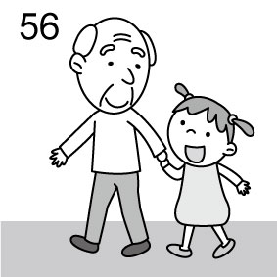 | (B) | 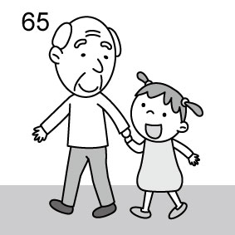 | (C) | 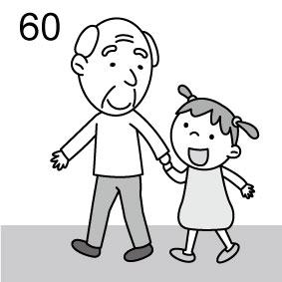
2. | (A) | 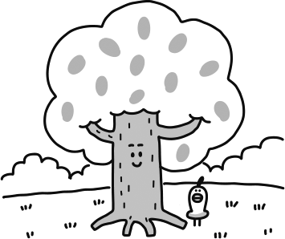 | (B) | 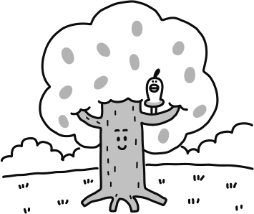 | (C) | 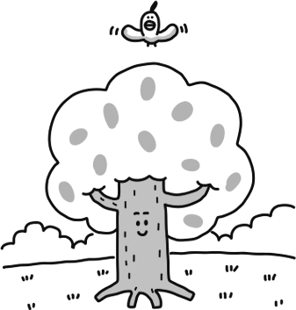
3. | (A) | 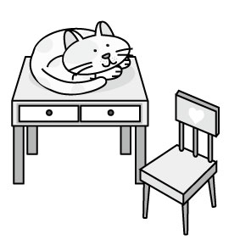 | (B) | 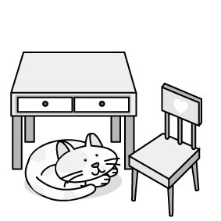 | (C) | 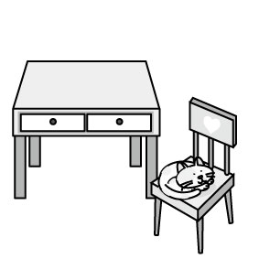
二、基本問答：根據聽到的內容，選出一個最適合的回應或最適合的問句。 （每題1分）
4. | (A) He’s old. |  | (B) He’s nineteen years old. |  | (C) He’s a young boy.
5. | (A) He is Mark’s uncle. |  | (B) He is from Poland. |  | (C) He is in the living room.
6. | (A) He is really handsome to me. |  | (B) His favorite singer is Goodie. |  | (C) He is Gary.
7. | (A) Isn’t it heavy? |  | (B) It is behind your desk. |  | (C) It is Sophie.
8. | (A) Yes, they are new pencils. |  | (B) Yes, they are from my brother. |  | (C) No, they are old.
9. | (A) It’s behind the kitchen. |  | (B) It’s on the bed. |  | (C) Mom is in the bedroom.
10. | (A) They are my brother’s books. |  | (B) They are Kelly and Betty. |  | (C) They’re my favorite colors.
- 言談理解：根據聽到的內容，選出一個最適合的答案。 （每題2分）
11. | (A) Brenda’s teacher. |  | (B) Brenda’s mother. |  | (C) Brenda’s cousin.
12. | (A) No, he is a cook. |  | (B) Yes, he is a singer. |  | (C) Yes, he is a teacher.
13. | (A) White. |  | (B) Green. |  | (C) Blue.
14. | (A) It’s on the sofa. |  | (B) It’s under the chair. |  | (C) It’s on the cookie.
15. | (A) Books and pens. |  | (B) Comic books and pencils. |  | (C) Notebooks and markers.

四、文法選擇 （每題2分）
16. | my good friends.
 | (A) They’re | (B) Their | (C) They | (D) Their are
17. | Our new teacher, Mr. Wang, very handsome.
 | (A) am | (B) are | (C) is | (D) X
18. | George: What is that?  Max: That’s .
 | (A) pens | (B) a book | (C) doll | (D) a apple
19. | Mr. and Mrs. Lin tall and thin.
 | (A) am | (B) are | (C) is | (D) X
20. | Ben: is in the office? Roy: Nick and his students are.
 | (A) How | (B) Where | (C) Who | (D) What
21. | James: are you?  Ken: I am twelve.
 | (A) How | (B) Who | (C) Where | (D) How old
22. | Emma: Are those your pens?  Jill: No, .
 | (A) those are | (B) they are | (C) those aren’t | (D) they aren’t
23. | Ben: Is this your dog?  Sophie: Yes. And name is Lucky.
 | (A) its | (B) it’s | (C) it | (D) it is
24. | Andy: Where is my ball?  Ken: It’s the chair.
 | (A) in | (B) for | (C) next | (D) behind
25. | Amy and Lisa’s father a good teacher, too.
 | (A) am | (B) are | (C) is | (D) X
26. | Ben: Who is the tall woman?  Nancy: She’s .
 | (A) Lisa | (B) my husband | (C) nice | (D) a sister
27. | Jim: Is Miss Lee your teacher? Sue: Yes, is.
 | (A) Miss Lee | (B) she | (C) he | (D) it
28. | Look at the . Who are they?
 | (A) person | (B) man | (C) women | (D) student
29. | Gary: Where is my ruler?  Cindy: It’s between .
 | (A) the pencil box | (B) the two books | (C) a pen | (D) your eraser
30. | James is tall, but his daughters .
 | (A) is | (B) isn’t | (C) are | (D) aren’t
31. | Sam:  Andy: They are erasers.
 | (A) What are these? | (B) Where are they? | (C) Are they erasers? | (D) Who are they?
32. | Hank: Hi, I’m Hank. Nice to meet you.  Patty: I’m Patty.
 | (A) Nice to meet you, too. |  | (B) You’re welcome.
 | (C) I see. |  | (D)Thank you.
五、克漏字測驗 (每題2分)
Zac: Welcome to my 33. ! This is our living room.
Sue: Wow! It is big and beautiful. Who is that man on the 34. ?
Zac: He is my father. He is a 35. . He is nice to students.
This is my bedroom. It’s not big, but I like it very much.
This is my 36. bedroom. These are their dolls.
Sue: They are so cute.
Zac: This is our dining room. 37. are for you.
Sue: Thank you very much. You are so nice.
33. | (A) house |  | (B) school |  | (C) office | (D) farm
34. | (A) family |  | (B) gift |  | (C) wall | (D) sofa
35. | (A) police officer |  | (B) teacher |  | (C) doctor | (D) writer
36. | (A) sister |  | (B) sister’s |  | (C) two sister’s | (D) two sisters’
37. | (A) This apple |  | (B) Those cookies |  | (C) That banana | (D) The drink
六、閱讀測驗 (每題2分)
(38-41)
This is Shohei Ohtani. He is 31 years old, and he is from Japan. He is tall and strong. Shohei Ohtani is a baseball player. He is good at baseball.
Mamiko is Shohei Ohtani’s wife. She is 28 years old. She is tall and beautiful. They have a daughter, and she is very cute. Decoy is Shohei Ohtani’s dog. It is brown and white. It is his good friend and it is very special to him.
Many people like Shohei Ohtani. He’s a good husband, a good father, and a good player. He is a super star!
38. | How old is Shohei Ohtani?
 | (A) He is thirteen. | (B) He is twenty-one. |  |  | (C) He is thirty | (D) He is thirty-one.
39. | What color is Shohei Ohtani’s dog?
 | (A) White. | (B) Brown. |  |  | (C) Black abd white. | (D) Brown and white.
40. | What is the reading about?
 | (A) Shohei Ohtani’s favorite color. |  |  |  | (B) Shohei Ohtani’s school.
 | (C) Shohei Ohtani’s family. |  |  |  | (D) Shohei Ohtani’s friends.
41. | Which is true? which 哪一個
 | (A) Shohei Ohtani is from Japan. |  |  | (B) Shohei Ohtani’s daughter is a student.
 | (C) Shohei Ohtani’s wife isn’t tall. |  |  | (D) Shohei Ohtani is very old.
(42-45)
My name is Tina. I’m thirteen years old. We are a family of four.
My father is a doctor. He is tall and handsome. My mother is a singer. She is tall and beautiful, and her songs are great. They are thirty- nine years old. Jenny is my sister. She and I are junior high school students.
My house isn’t big. It’s near Dayou Junior High School. Look at the pictures. This is my living room. The sofa and the TV are small. The kitchen is behind the living room. My room is next to the living room. It’s small, too. The bed, the desk, and the chair are white. White is my favorite color.
42. | What is Tina’s father’s job?
 | (A) He’s a singer. | (B) He’s a police officer. |  | (C) He’s a doctor. | (D) He’s a teacher.
43. | Where is the kitchen?
 | (A) Above Tina’s room. | (B) Next to Tina’s room. |  | (C) Near the dining room. | (D) Behind the living room.
44. | Who is she in the reading?
 | (A) Tina. | (B) Tina’s mother. |  | (C) Tina’s sister. | (D) Tina’s grandmother.
45. | Which is NOT true about the reading? which 哪一個
 | (A) White is Tina’s favorite color. |  | (B) Tina’s house is near Dayou Junior High School.
 | (C) Tina’s mother isn’t a good singer. |  | (D) Tina’s mom and dad are 39 years old.
單字中翻英、引導式翻譯試題請以黑色原子筆於答案卷作答，違者不予計分
七、單字中翻英 （每題1分）
1. 新的 | 2. 紫色 | 3.足夠的 | 4. 真地 | 5.飢餓的
八、引導式翻譯 （每格1分）
我的父母親40歲。(數字請以英文寫出)
My 6. are 7. years old.
我的表弟是一位國小生
My 8. is 9. 10. school student.
三隻老鼠在椅子前面。
Three 11. are 12. 13. 14. the chair.
John: 那些是毛筆嗎?
Vivian: 不是，那些是灰色的彩色筆。
John: Are those 15. ?
Vivian: No, those are 16. markers.
Betty:我們兒子在哪裡？
Jane: 他可能在浴室裡。
Betty: Where is our 17. ?
Jane: 18. he’s 19. the 20. .

