桃園市立大有國民中學114學年度第一學期第三次評量試卷
年 級 | 七 | 考 試  科 目 | English |  |  | 命 題  範 圍 | B1L5-6  Review III | 作 答  時 間 | 45分
班 級 |  | 姓 名 |  | 座 號 |  | 分 數

★務必將班級、座號、姓名寫在電腦卡上，並將班級、座號及答案劃記正確！★
★試題卷有3張5面，共有52題★

第一部分：聽力測驗
- 辨識句意：根據聽到的內容，選出符合描述的圖片或符合圖片的描述。 （每題1分，共4分）
( )1. | 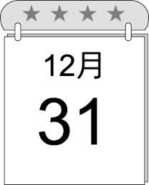  (A) | 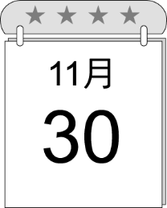  (B) | 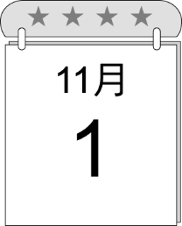  (C)
( )2. | 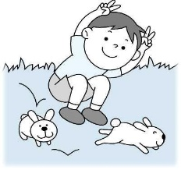  (A) | 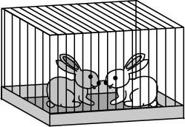  (B) | 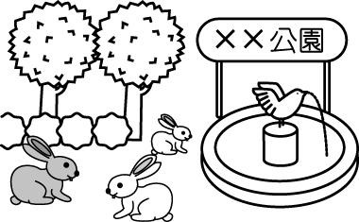  (C)
( )3. | 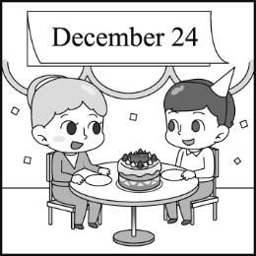  (A) | 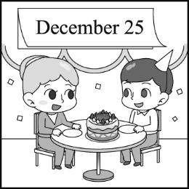  (B) | 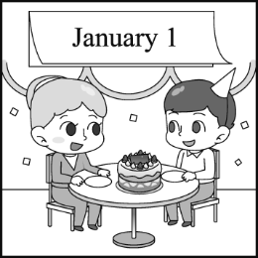  (C)
( )4. | 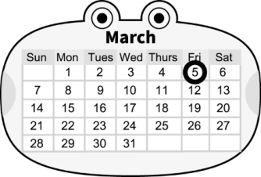  (A) | 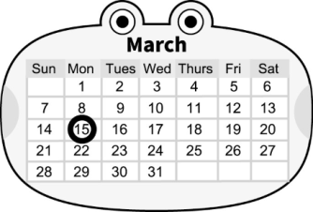  (B) | 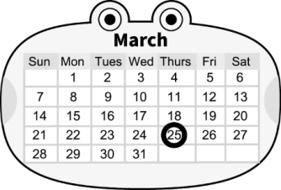  (C)
- 基本問答：根據聽到的內容，選出一個最適合的回應或最適合的問句。 （每題2分，共12分）
( )5. | (A)Yes, there is a desk.  (B)Yes, there is a pencil on your desk.  (C)No. Is it in your school bag?
( )6. | (A) You’re a big help. | (B) Yes, there are some bags. | (C) Let’s clean up the room now.
( )7. | - Great! I want to buy a beautiful notebook for her!  - Happy birthday to Mom!  - No, she doesn’t work in the gift shop.
( )8. | - Rabbits are cute animals.  - I’m not sure. Maybe pigs and cows.  - Yes, I’m on my aunt’s farm.
( )9. | (A)No, it is Mother’s Day. | (B) No, it is the fifth of May. | (C) Yes, it is May 5.
( )10. | - You can eat in the living room.  - How about bananas?  - Let’s have dinner at seven.

- 言談理解：根據聽到的內容，選出一個最適合的答案。 （每題2分，共14分）
( )11. | (A) In the girl’s room. | (B) In the boy’s room. | (C) At the living room.
( )12. | (A) Give the dog some food.  (B) Take it to an animal doctor.  (C) Take it to their parents for help.
( )13. | (A) A zoo next to a school. | (B) A free afternoon. | (C) Special colors of animals.
( )14. | (A) Studying and playing. | (B) Making a cake. | (C) Writing a letter.
( )15. | (A) The boy and the girl’s good friend.  (B) The boy and the girl’s new classmate.  (C) The boy and the girl’s new teacher.
( )16. | (A) It is next to a school.  (B) It is a house for animals.  (C) It is not big enough for five people to live.
( )17. | - Tiffany and her teacher are making dolls.  - Tiffany’s birthday is on December 3.  - Tiffany is studying in a small class.

第二部分：閱讀理解
四、單題：每題2分，共40分
( )18. | Thanksgiving is a(n) _____ holiday in the USA, and people there give thanks on that day.
 | (A)healthy | (B)magic | (C)lucky | (D)important
( )19. | _____ is between March and May.
 | - January | (B)October | (C)April | (D)July
( )20. | He put his jacket on the _____ of his chair.
 | (A)hand | (B)lab | (C)sofa | (D)back
( )21. | A:What’s your favorite _____? B:Dogs for sure.
 | (A)animal | (B)month | (C)person | (D)notebook
( )22. | Today, this store is open _____ for VIPs. We can’t go in.
 | (A)never | (B)also | (C)only | (D)behind
( )23. | The girl is _____ English in her room.
 | (A)reading | (B)studying | (C)seeing | (D)looking at
( )24. | Amy’s birthday party is _____ 6 p.m. _____ 9 p.m.
 | (A)from ; to | (B)on ; at | (C)in ; on | (D)at ; at
( )25. | Twice’s concert is _____ next weekend. I can’t wait.
 | (A)on | (B)in | (C)of | (D)X
( )26. | Father’s Day in the USA is _____ the third Sunday _____ June.
 | (A)on ; in | (B)on ; on | (C)on ; of | (D)X ; of
( )27. | A:_____ B:It’s on January twentieth.
 | (A)What date is it? |  | (B)What day is today?
 | (C)When is your birthday? |  | (D)What time is it?
( )28. | Look! _____ two monkeys playing in the tree.
 | (A)There are | (B)Are | (C)They are | (D)The
( )29. | A:Are there _____ tigers in Africa? B:No, there _____.
 | (A)some ; isn’t | (B)any ; are | (C)any ; aren’t | (D)some ; aren’t
( )30. | There are no _____ in my pencil case.
 | (A)brush | (B)a red pen | (C)any erasers | (D)rulers
( )31. | Today is December _____.
 | (A)twenty-one | (B)twenty-third | (C)twentieth-fourth | (D)twentieth-two
( )32. | A:What time is it? Are we late? B:Yes, we are. _____ We have no time.
 | (A)Hurry up! | (B)How great! | (C)Good Luck! | (D)Six o’clock.
( )33. | A:What’s there in the picture? B:_____
 | (A)Here is your picture. |  | (B)They’re in the picture.
 | (C)There are polar bears. |  | (D)They’re elephants
( )34. | There _____ some food on the table. You can eat it.
 | - is | (B)are | (C)X | (D)aren’t
( )35. | A:_____ is the basketball game? B:On Saturday afternoon.
 | (A)What date | (B)When | (C)What time | (D)What
( )36. | _____ your help, I can come here on time.
 | (A)Thanks to | (B)For example | (C)How about | (D)Take a look at
( )37. | There are _____ and _____ over there.
 | (A)tiger ; bear | (B)zebras ; horse | (C)rat ; a fox | (D)an elephant; a lion

五、閱讀測驗及克漏字測驗：每題2分，共30分
I.
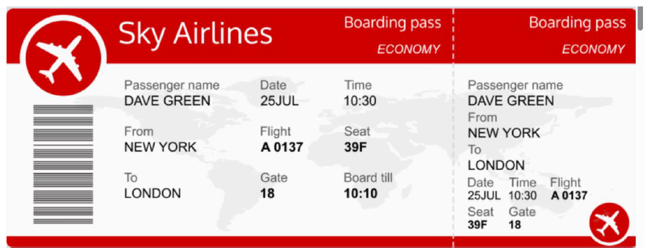
Dave Green is at the airport. Look at his boarding pass and answer the questions.
✉airport機場; boarding pass登機證; passenger乘客; gate登機門
( )38. | Where is Dave going?
 | (A)New York. | (B)London. | (C)Sky Airlines. | (D)25 JUL.
( )39. | What is Dave’s flight number?
 | (A)10:30 | (B)39F | (C)18 | (D)A0137
( )40. | On the ticket, "Board till 10:10" means the LAST time to get on the plane. If Dave get to the gate at 10:15, can Dave get on the plane? ✉ last最後的; plane飛機
 | (A) Yes, because the time is 10:30. |  | (B) Yes, because he is Dave Green.
 | (C) No, because the gate is 18. |  | (D) No, because the "Board till" time is 10:10.
II.
Mr. Collins wants his students to compare “Halloween” and “Christmas.” Here is Yuna’s report.
Halloween(October 31)  ＊To honor the dead  ＊Color: black and orange  ＊Go trick-or-treating  ＊Make jack-o’-lanterns  ＊Join costume parties and parades  ＊Watch horror movies | Christmas(December 25)  ＊To celebrate Christ’s birth  ＊Color: red and green  ＊Get gifts(candy or toys) from Santa Claus  ＊Hang Christmas stockings, decorate Christmas trees, and send Christmas cards  ＊Write a letter to Santa Claus  ＊Get together with family  ＊Join Christmas parties
✉honor尊敬; costume戲服; parade遊行; horror恐怖的；celebrate慶祝; Christ耶穌; Santa Claus聖誕老人；decorate裝飾
( )41. | Which activity(活動) is for Christmas?
(A) Writing a letter to Jack.
(B) Join a costume parade.
(C) Writing some cards to families and friends.
(D) Knocking on others’ doors and asking for candy.
( )42. | What can Yuna put in Both on her report?  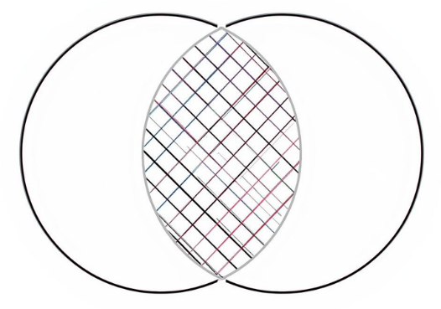  Both  Christmas  Halloween
(A) Black and orange.
(B) Watch horror movies.
(C) Get candy and have a party.
(D) Write a letter to families.
( )43. | Which is true?
(A) Christmas is on October 31.
(B) Kids go trick-or-treating on Halloween.
(C) Kids write letters to Santa Claus on Halloween.
(D) We can see kids make jack-o’-lanterns and join a parade on Christmas.

III.
In 1620, some people left England. They go to America on a big ship. The ship is the Mayflower. They want a new home.
The first winter is very cold. They do not have enough food. Many people are sick and die. It is a very sad time. Then, spring comes. They meet the Native Americans. There is one man and his name is Squanto. He is very kind. He helps them. He teaches them how to grow corn. He also shows them how to catch fish.
In the fall of 1621, they have a lot of good food. They are safe and happy. To say "thank you," they have a big dinner with their new friends. They eat and play for three days. This is the first Thanksgiving.
Today, Thanksgiving is in November. Families have a big dinner together. They eat turkey and pie. Everyone says "thank you" for their happy life.

✉ left離開; ship大船; winter冬天；sick生病的；spring春天; Native Americans美國原住民；grow corn種玉米; fall秋天
( )44. | What does Squanto do to help the people from England after the first winter?
(A) He teaches them how to grow corn and catch fish.
(B) He gives them a big ship, the Mayflower.
(C) He takes them back to their old home in England.
(D) He cooks a big turkey dinner for them in the spring.
( )45. | According to the reading, why do the people from England celebrate(慶祝) the first Thanksgiving in the fall of 1621?
(A) Because they want to find a safe way to go back to England.
(B) Because they are sad and have no food to eat.
(C) Because they are thankful for their new friends.
(D) Because they want to show Squanto how to use a big ship.
( )46. | What is the main idea of this reading?
(A) The story of how the first Thanksgiving starts and why it is celebrated.
(B) Why the Mayflower is the fast ship in 1620.
(C) Teach people to cook a big dinner with turkey and pie.
(D) A story about how Native Americans go to England in the winter.

IV.
Sandy: | What’s the ____ today?
Vivian: | It’s July thirty-first. The last day of July.
Sandy: | Tomorrow is the first day of August. _____ only one month for our summer vacation.
Vivian: | You’re right. How about _____ to Taipei Zoo on August 8th. It’s also Father’s Day.
Sandy: | Great idea! _____ We can see elephants, zebras, lions, tigers, monkeys, horses, and bears.
Vivian: | Wow! Lions are my favorite animals. A lion is the _____ of the animals.
Sandy: | But I like elephants. They are so cute. By the way, father elephants are never in the herd with their family.
Vivian: | Really? It’s my _____ time to know this.  ✉ summer vacation暑假

( )47. | (A)day | (B)date | (C)holiday | (D)month
( )48. | (A)There is | (B)There are | (C)They have | (D)There
( )49. | (A)going | (B)go | (C)to go | (D)goes
( )50. | (A)Let’s buy a gift for Dad.  (C)We can have a party. |  | (B)There are so many animals there.  (D)Don’t feed the animals.
( )51. | (A)bug | (B)food | (C)world | (D)king
( )52. | (A)one | (B)third | (C)last | (D)first

試題結束

