桃園市立大有國民中學114學年度第二學期第一次評量試卷
年 級 | 七 | 考 試  科 目 | 英 語 |  | 命 題  範 圍 | Unit 1 ~ Review 1 |  | 作 答  時 間 | 45分
班 級 |  | 姓 名 |  | 座 號 |  | 分 數
- 辨識句意：請依據所聽到的句子，選出符合描述的圖片。（每題2分，共10分。）
- （ ） (Ａ) 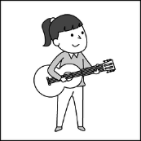 (Ｂ)  (Ｃ) 
- （ ） (Ａ) 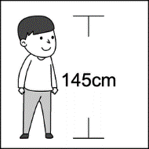 (Ｂ) 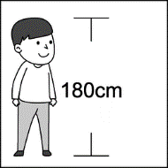 (Ｃ) 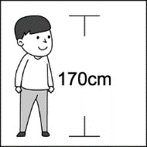
- （ ） (Ａ) 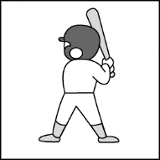 (Ｂ)  (Ｃ) 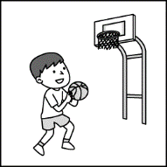
- （ ） (Ａ) 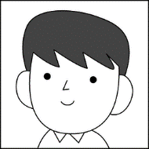 (Ｂ)  (Ｃ) 
5. （ ） (Ａ) 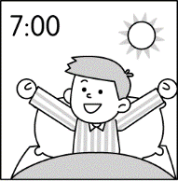 (Ｂ) 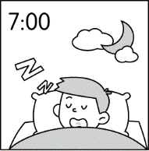 (Ｃ) 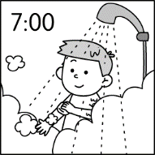
- 基本問答：請依據所聽到的內容，選出一個最適合的回應。（每題2分，共10分。）
6.（ ）(Ａ) She listens to music and washes her car.
(Ｂ) Yes, she does a lot of work.
(Ｃ) She is hungry.
7. （ ）(Ａ) Yes, she has a pretty face.
(Ｂ) Yes, she loves basketball.
(Ｃ) Yes, she has hundreds of kites.
8.（ ）(Ａ) She can fly a kite.
(Ｂ) She plays the guitar.
(Ｃ) Basketball. She plays it every morning.
9.（ ）(Ａ) Jason and I like cats.
(Ｂ) I don’t have music classes.
(Ｃ) Yes, he exercises after school.
10.（ ）(Ａ) I can do that in the morning.
(Ｂ) You are an early bird.
(Ｃ) You can eat a good breakfast and get good sleep at night.
- 言談理解：請依據聽到的對話或短文內容，選出一個最適合的答案。（每題2分，共10分。）
11. （ ）(Ａ) She has a new car.
(Ｂ) She has a big mouth.
(Ｃ) She knows everyone.
12.（ ）(Ａ) In the evening.
(Ｂ) In the morning.
(Ｃ) In the afternoon.
13.（ ）(Ａ) Every day.
(Ｂ) Once a week.
(Ｃ) They never play basketball.
14.（ ）(Ａ) Go to cram school.
(Ｂ) Play sports with her friends.
(Ｃ) Study for the tests.
15.（ ）(Ａ) Jack does his homework for three hours.
(Ｂ) Jack exercises on Mondays.
(Ｃ) Jack exercises on weekends.
四、綜合測驗（每題2分，共40分）
A.文意字彙:
16.（ ）The giraffe is four hundred and thirty tall. (A) cms (B) short (C) height
(D) centimeters
17.（ ）I usually eat sandwiches(三明治) for every morning. (A) drink (B) breakfast
(C) lunch (D) dinner
18.（ ）Helen is a good student. She never makes _________. (A) sport (B) trouble (C) cake (D) exercise
19.（ ）Batman fights bad guys, he _________ a hero to me. (A) be (B) like (C) is like (D) don't like
20.（ ）Many people don’t _________ K-pop young singers in Taiwan. (A) know (B) see (C) hear
(D) check out
21.（ ）Snoopy has a good _________ for food. It's a great beagle(獵犬). (A) lips (B) arm (C) nose
(D) hand
22.（ ）Nancy plays the __________ for an hour after school. (A) piano (B) baseball (C) basketball
(D) table tennis
23.（ ）Don't say anything to Jacky. He has a big _________. (A) tooth (B) foot (C) head (D) mouth
24.（ ）The camel(駱駝) has a strong ________. (A) eyes (B) body (C) feet (D) hair
25.（ ）Elephants’ ears are __________. (A) small (B) large (C) short (D) long
B.文法選擇:
26.（ ）A: Do you wash your hair every day? B: Yes, I __________. (A) can (B) do (C) don’t (D) can’t
27.（ ）We ___________ go out for dinner. (A) some times (B) some time (C) sometimes (D) twice
28.（ ）A: Is he often late? B: No, he _________. (A) never is (B) never do (C) am never (D) do never
29.（ ）A:_________ do your classmates play basketball after lunch? B: Every day. (A) How long
(B) How often (C) How many (D) How old
30.（ ）A: How often do you study English at school? B: ___________________.
(A) Four times a week. (B) In the morning. (C) For two hours. (D) In two weeks.
31.（ ）Wendy usually gets up ___________ six a.m. She is a morning person.
(A) in (B) on (C) to (D) at
32.（ ）A: Does your brother often clean his bedroom? B: No. He ___________ does.
(A) often (B) seldom (C) usually (D) always
33.（ ）Willian and Joe are my cousins. (A) two (B) all (C) not all (D) both
34.（ ）Cindy and her sister often books from the library with her parents.
(A) check in (B) get out (C) check out (D) check into
35.（ ）A: Who ____________ in your English song contest(比賽)? B: John and Sam do.
(A) dances (B) dance (C) is dancing (D) are dancing
五、克漏字（每題2分，共10分）
A Meet-and-Greet
Today is the day before "The Best Place Concert Tour(巡迴演唱會)". This is Mimi Wang, and I am ___36.___ from the meet-and-greet of the popular singer Alexander Leehom Wang. Let’s __37.__ a look.
Now they are celebrating(慶祝) the 30-year milestone(里程碑) this year. Look! There are many robots dancing on the stage. They are __38.__ cute. Where is Leehom Wang? Wow, he is hiding(躲藏) in a doll, and gives everyone a surprise(驚喜). “Music is his life.” He thanks to all his fans and taking pictures __39.__ them. Everyone __40.__ a good time.
Cheers(歡呼) to the next 30 years. So what is his next stop? How about a world tour? We can’t wait for it.
That’s it for today’s report. You’re watching Music Party with Mimi. Good night.
36.（ ） (Ａ) report (B) reports (C) reporter (D) reporting
37.（ ） (Ａ) take (B) go (C) use (D) at
38.（ ） (Ａ) a lot (B) so (C) lots of (D) much
39.（ ） (Ａ) but (B) and (C) with (D) together
40.（ ） (Ａ) have (B) has (C) play (D) enjoy
六、閱讀測驗: 請依圖表回答下列問題（每題2分，共10分）
Emily’s Family Routine on Saturdays
41.（ ）Who can play chess in Emily’s family? (A) Emily’s grandma. (B) Emily’s dad. (C) Emily.
(D) Emily’s mom.
42.（ ）Does Emily paint on weekends? (A) Yes, she sometimes does. (B) No, she seldom does.
(C) Yes, she usually does. (D) No, she never does.
43.（ ）What time does Emily walk her dog? (Ａ) At eight thirty. (Ｂ) From nine to eleven.
(Ｃ) After one p.m. (Ｄ) From eleven to twelve.
44.（ ）What do Emily’s parents do together on Saturday afternoons? (A) Swim. (B) Watch TV.
(C) Dance at the park. (D) Read the newspaper.
45.（ ）Which is right? (Ａ) Emily’s dad washes the car. (Ｂ) Emily can use the computer.
(Ｃ) Emily’s family plays music. (Ｄ) Emily’s grandpa cooks.

