桃園市立大有國民中學114學年度第二學期第三次評量試卷
年 級 | 七年級 | 考 試  科 目 | 英語 |  |  | 命 題  範 圍 | Unit 5, Unit 6, Review 3 | 作 答  時 間 | 45分
班 級 |  | 姓 名 |  | 座 號 |  | 分 數

- 辨識句意：每題均有三張圖片，請依據所聽到的句子，選出符合描述的圖片 （每題2分，共10分）

1. （ ）
(Ａ) 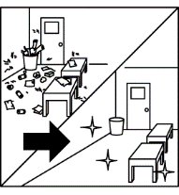(Ｂ) 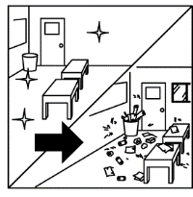(Ｃ) 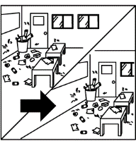

2.（ ）
(Ａ) 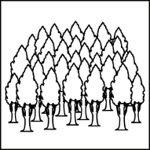(Ｂ) 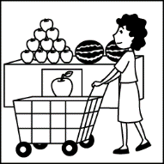(Ｃ) 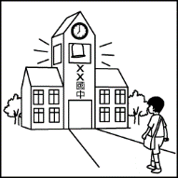

3.（ ）
(Ａ) 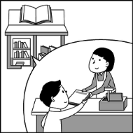(Ｂ) 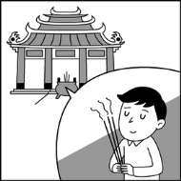(Ｃ) 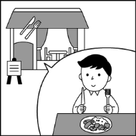

4.（ ）
(Ａ) 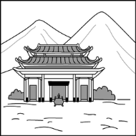(Ｂ) 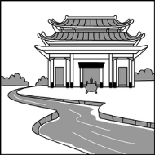(Ｃ) 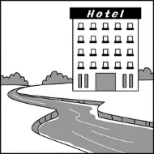

5.（ ）
(Ａ) 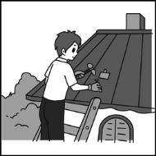(Ｂ) 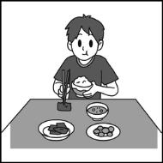(Ｃ) 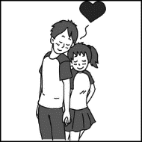

- 基本問答：每題均有三個選項，請依據所聽到的內容，選出一個最適合的回應 （每題2分，共10分）
6.（ ）
(Ａ) No, they are quite busy.
(Ｂ) Yes, they are delicious.
(Ｃ) No, they weren’t.

7.（ ）
(Ａ) They planted a lot of flowers there.
(Ｂ) I really miss the good old days.
(Ｃ) They can’t play with us now.

8.（ ）
(Ａ) I like to do some activities, like rowing a boat
and going hiking.
(Ｂ) I was free yesterday afternoon.
(Ｃ) It was a bad week.

9.（ ）
(Ａ) He sold fish at a market.
(Ｂ) He loved money very much.
(Ｃ) He made much money before.

10.（ ）
(Ａ) Yes, she went to the party.
(Ｂ) She danced with me at the party.
(Ｃ) She went home because she didn’t feel good.
- 言談理解：每題均有三個選項，請依據所聽到的對話或短文內容，選出一個最適合的答案 （每題2分，共10分）
11.（ ）
(Ａ) There was a lot of trash.
(Ｂ) There were palm trees.
(Ｃ) There were a lot of animals.

12.（ ）
(Ａ) There was a lot of trash two years ago.
(Ｂ) There are a lot of people at the beach now.
(Ｃ) The water there was not very clean.

13.（ ）
(Ａ) They are going to sleep.
(Ｂ) They are going to see the sights.
(Ｃ) They are going to cook dinner together.

14.（ ）
(Ａ) He went camping with his kids.
(Ｂ) He stayed at home.
(Ｃ) He played video games all day long.
15.（ ）
(Ａ) Tom is always late for school.
(Ｂ) Tom had a math test.
(Ｃ) Tom went to bed after twelve o’clock.

※聽力測驗結束

四 、 字彙選擇 (每題 1 分，共 10 分)
16.( ) Amy: Look! There is a new______ near the river.
Leo: Cool! No wonder (難怪) so many students exercise and play games there after school.
(A) airport (B) bookstore
(C) playground (D) theater

17.( )The Great Wall (萬里長城) is a very____ place in China. Many people around the world visit it every year to see its beauty.
(A) famous (B) cold
(C) dead (D) yummy

18.( )My father is an office worker at the___. He helps many travelers there, so he sees many planes every day.
(A) island (B) airport
(C) hotel (D) office

19.( )My sisters went to the_____to buy some new dresses for the party. There were so many nice clothes there.
(A) rainforest (B) bookstore
(C) mountain (D) department store

20.( )Many people visit this ____ for good luck(運氣) and its beautiful building every day.
(A) theater (B) fire station
(C) temple (D) hotel.

21.( )The young man went to the beach_____. He took a walk there and met an old friend.
(A) next Friday (B) the day after tomorrow
(C) the other day (D) every day

22.( )Stella: Please don't use your phone during the movie. It is not nice to other people in the ______.
Evelyn: I am sorry. I will put it away now.
(A) restaurant (B) building
(C) department store (D) theater

23.( )_____a cat, we also got a dog from the farm last month. Now we have two pets in our house.
(A) During (B) Besides (C) Between (D) Under

24.( )Helen tells her brother everything. She never____ anything from him.
(A) says (B) takes
(C) hides (D) believes

25.( ) Tim:Where should I put the notebooks?
Mom: ____ put them on the table.
(A) Only (B) Just
(C) Then (D) Before

五、 文法選擇 (每題 2 分，共 30 分)
26.( )Today is June 8, so the day before yesterday ___June 6. I remember it____a very hot day.
(A) is, was (B) was, was
(C) is, is (D) did, does

27.( )Willy___ a police officer three years ago. Now, he____ in a computer company.
(A) was ; was (B) is; is
(C) was; is (D) were; is

28.( )There____ a lot of fish in the sea here ten years ago, but now there is only trash in the water.
(A) was (B) were
(C) is (D) are

29.( )Little Tom____ use a computer before but he is very good at it now.
(A) could (B) couldn't
(C) can (D) can't

30.( )Jason didn't like fruit salad before, but he _____now.
(A) is (B) did
(C) does (D) do

31.( )The cook was busy cleaning the kitchen all day, so he____ any cookies yesterday.
(A) is making (B) made
(C) doesn't make (D) didn't make

32.( ) Jack: Did you ____ English yesterday?
Samuel: No, but I _____ Chinese.
(A)study ; study
(B) studied; studied
(C) studied : study
(D) study; studied

33.( ) My grandfather's cat was his best friend, but it ____ last winter. He still feels very sad and misses it every day.
(A) died (B) dead
(C) dying (D) death

34.( )Roy: Who___the apple trees in front of our house ten years ago? Tim: My father did. He worked very hard in the garden at that time.
(A) plant (B) plants
(C) planted (D) planting

35.( )The students _____ under the big trees in the mountains last Saturday. They shared (分享)their food and enjoyed the fresh air.
(A) picniced
(B) picnicked
(C) picnicking
(D) are picnicking

36.( )The old man____ his small boat to a traveler two days ago because he needed some money.
(A) sell (B) sells
(C) selling (D) sold

37.( )The little girl is crying loudly because she ______ her favorite water bottle in the park. She can't find it anywhere.
(A) lose
(B) loses
(C) lost
(D) is losing

38.( )James: What____? How come you are shouting(喊 叫) at each other ?
(A) happen (B) happened (C) happens (D) happening

39. ( ) Victor : Uncle John died at a young age.
Ted: When did he___his life?
Victor : At the age of 33.
Ted: What a sad piece of news (消息) !
(A) losing (B) loses
(C) lose (D)lost

40. ( ) Tommy: ____ did you like the trip?
Bob: It was great. We had a great time.
- What (B) Where
(C) How (D) When

六、克漏字與閱讀測驗選擇題 (每題 2 分，共 30 分)
請根據短文內容，選出最適合的答案。
Last weekend, my family and I (41) to a famous riverside park. We had a great time there. My brother (42) a boat on the river, and my parents took a walk along the water. However, I was angry because there was a lot of (43) on the ground. People didn't take it away. I decided to help. I picked up the bottles and cans (44). At the end of the day, the park was clean and beautiful again. My mom said, "That's sweet of you!" and she (45) me a special gift.
41. ( ) (A) travel (B) traveled (C) travels (D) are traveling
42. ( ) (A) rowed (B) flew (C) built (D) climbed
43. ( ) (A) oil (B) plants (C) trash (D) sheep
44. ( ) (A) by the way (B) little by little (C) for example (D) here you are
45. ( ) (A) buy (B) buys (C) is buying (D) bought
riverside park河濱公園 decide (決定)
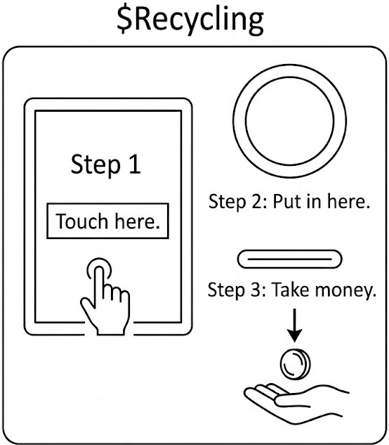
(A)The Amazing $ Recycling(回收) Machine
Do you have many plastic bottles or cans at home? Don't throw them away! Now, we have $Recycling. It is a smart machine near the shopping malls. It is easy to use:

Step1, touch the screen.
Step2, put your bottles or cans in.
Step3, take your money!

$Recycling is open 24 hours a day, seven days a week. It is very fast. It only takes 3 seconds for one bottle. If you put in 5 bottles or cans, you can get 2 NT dollar. Many people like $Recycling because they can help the Earth and get some money at the same time!
<下一頁尚有試題>
46.( )What is $Recycling for?
(A) To buy drinks with your bottle.
(B) To put in trash and get money.
(C) To clean your house.
(D) To open cans for you.

47.( )How long does it take for the machine to process(處理) one bottle?
(A) 1 minute. (B) 5 seconds.
(C) 3 seconds. (D) 24hours.

48.( )Eva has 10 plastic bottles and 15 cans. How much money can she get from $Recycling ?
(A) 5 NT dollars. (B) 1 NT dollar. (C) 25 NT dollars.
(D) 10 NT dollars.

49.( )Where can you find $Recycling?
(A) In the river.
(B) At the airport.
(C) Near the shopping malls.
(D) Under the trees.

50.( )Which is TRUE about $Recycing?
(A) It is only open on weekends.
(B) It is slow.
(C) We can put glass bottles in it.
(D) It is open every day.

(B)
Last week, Amy took a trip to Japan with her friends. They went there in the morning and had breakfast at the airport. After that, they went to an old town. Amy saw many traditional houses there and took a lot of pictures. In the afternoon, they visited an island. Many people go to the island because it was in a popular TV show a few years ago. Amy and her friends hiked around the island. They enjoyed the beautiful trees and flowers there very much.

The next morning, Amy and her friends went to an amusement park. The park was just next to their hotel, and it was very big. They played in the park all day and saw a short movie at the theater there. They really had a good time.

On the last day, they visited a famous temple in the morning. After that, they bought some snacks at a market near the train station. Amy bought cakes, cookies, and lollipops. In the evening, they went to the airport and then went home. They had a great holiday!
old town 老街區 traditional傳統的
village村落 amusement park 遊樂園
snack零食 lollipops棒棒糖

51.( ) Why do many people visit the island?
(A) Because there are old houses.
(B) Because there is a small village.
(C) Because there are many trees and flowers.
(D) Because the island was in a popular TV show
before.

52.( ) What did Amy and her friends do in the amusement
park?
(A) They saw a movie.
(B) They got some rest.
(C) They visited a temple.
(D) They bought some snacks.

53.( ) Which is true about Amy and her friends?
(A) Their trip to Japan lasted two days.
(B) They visited four places on the first day.
(C) They had snacks at a market on the second day.
(D)They were in the amusement park all day on the
second day.

54.( ) What did Amy buy at the market?
(A) Flowers and fruit.
(B) cakes, cookies, and lollipops .
(C) Books and postcards.
(D) Drinks and sandwiches.

55.( ) Which place did Amy visit on the last day?
(A) A village and an island.
(B) An amusement park.
(C) A famous temple.
(D) A theater.

<試題結束>

