桃園市立大有國民中學114學年度第一學期第一次評量試卷
年 級 | 八 | 考 試  科 目 | 英語科 |  |  | 命 題  範 圍 | U1~Review 1 | 作 答  時 間 | 45分
班 級 |  | 姓 名 |  | 座 號 |  | 分 數
Part A. 聽力測驗，共24分。
一、辨識句意：根據聽到的內容，選出符合描述的圖片或符合圖片的描述，每題1分，共4分。
- (A) 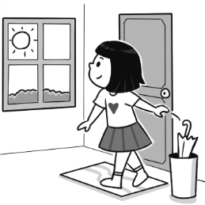 (B) 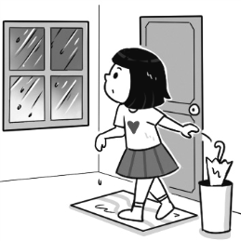 (C) 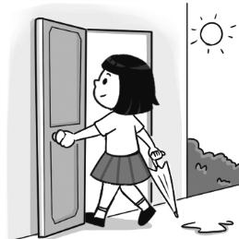
- (A) 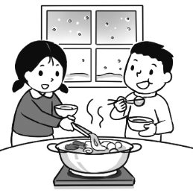 (B) 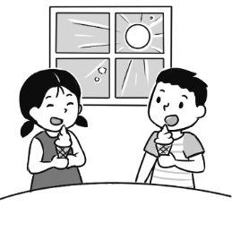 (C) 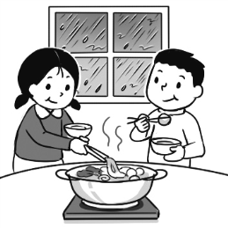
- (A) 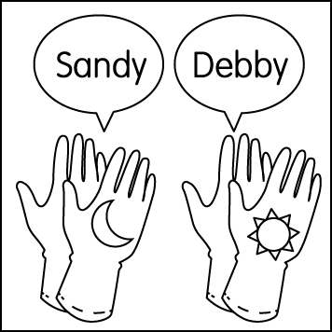 (B) 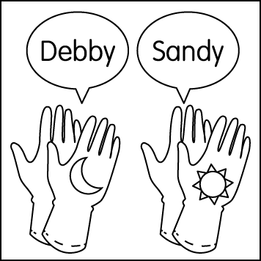 (C) 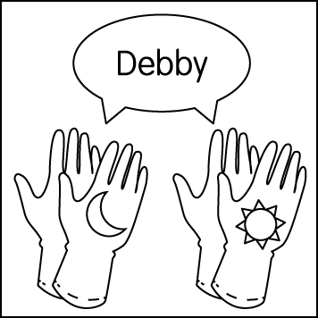
4. (A) 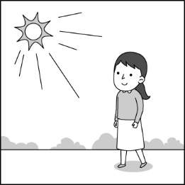 (B) 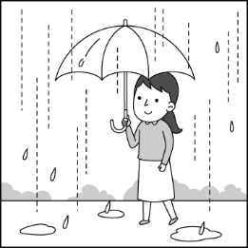 (C) 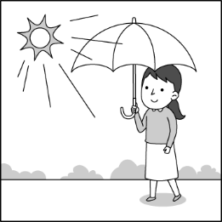
二、基本問答：根據聽到的內容，選出一個最適合的回應或最適合的問句，每題2分，共10分。
- (A) Andy’s uncle sent it. (B) The card is Andy’s. (C) Three days ago.
- (A) I want to take a trip to Toronto. (B) It is snowy and cold. (C) I don’t like the weather here.
- (A) Good. Thanks. How about you?
(B) I am writing a card to my best friend.
(C) I am doing my history report.
- (A) I was tired last night. (B) I didn’t visit my uncle last night. (C) I was in the bathroom when you came.
- (A) It is a very interesting club. (B) I like to listen to music. (C) I learn how to play the violin.
三、言談理解：根據聽到的內容，選出一個最適合的答案，每題2分，共10分。
- (A) History. (B) English. (C) Science.
- (A) The watch doesn’t look good. (B) The man can’t buy the watch. (C) The man has a lot of money.
- (A) He brushes his teeth. (B) He uses his cellphone. (C) He watches TV.
- (A) It was sunny. (B) It was rainy. (C) It was snowy.
- (A) The man’s. (B) Terry’s. (C) Their dad’s.
Part B. 綜合測驗，共56分。
四、單字及文法選擇，第15-20題，每題1分；第21-32題，每題2分，共30分

15. Mom likes the _______ very much because it can do lots of housework.
- road | - round | - rabbit | - robot

16. The sky was clear, but the ______ was strong. We all needed to hold our hats.
(A) sun | (B) rain | (C) wind | (D) snow
17. After school, many students join a sports ______ to play badminton or basketball.
(A) class | (B) club | (C) part | (D) team
18. Sandy felt _____ because she forgot to bring her homework.
(A) wrong | (B) interesting | (C) free | (D) cold
19. A: _____ shoes are these by the door? B: Nobody knows.
(A) Whose | (B) Who | (C) How | (D) What
20. Cats are clean, quiet and cute. ______, they can be friends with people.
(A) That’s fun | (B) In fact | (C) At the end | (D) Not at all
21. This box is too _____. Can we put it down for a minute?
(A) difficult | (B) same | (C) strong | (D) heavy
22. Every _____ has its beauty-flowers in spring, sun in summer, leaves in fall, and snow in winter.
(A) person | (B) lesson | (C) season | (D) listen
23. A: What did you make _____ your classmates? B: I made _____ them some cards.
(A) X/ to | (B) for/ X | (C) for/ for | (D) to/ X
24. Hey, students! When you finish your drawings, please ______.
(A) make them to me | (B) gave me it | (C) show them to me | (D) buy it for me
25. When I opened the door, I _____ a big cat catching a mouse.
(A) see | (B) saw | (C) seed | (D) seeing
26. Mom is an early bird. She gets up at five thirty, and makes breakfast for us _____ she goes to work.
(A) before | (B) after | (C) when | (D) ,so
27. The blue bags are theirs; _____ are orange.
(A) we | (B) ours | (C) they | (D) their
28. The movie, Superdog, was long, and _____. I didn’t enjoy it.
(A) I thought of you | (B) that was kind | (C) it was sunny | (D) it wasn’t fun at all
29. A: _____ on your birthday?
B: It was rainy, but we still had a good time.
(A) Did you have fun | (B) How’s the party | (C) What was the weather like | (D) How’s the rain
30. A: Guess what! I just met a movie star at the supermarket this morning.
B: What? Really? _____
A: No, I’m serious! He was buying fruit!
B: Wow, that’s unbelievable.
(A) Oh, I can’t wait. | (B) Is he a kind man? | (C) I had a good time. | (D) Are you pulling my leg?
31. A: ______
B: It was amazing! The weather was hot and sunny most of the time.
A: Did you enjoy the food?
B: Yes, the food was delicious, but sometimes too spicy for me!
(A) What was the weather like? | (B) Please call me back.
(C) How was your trip to Tailand? | (D) Where did you sent the food?
32. Tom: Hello, may I speak to Meg, please?
Meg: _____
Tom: Hi Meg, this is Tom. Are you free to talk now?
(A) It’s me. | (B) This is she. | (C) She’s not in. | (D) Call back in 5 minutes.

五、克漏字及閱讀測驗，第33-45題，每題2分，共26分。
A.
Last month, our class went on a camping trip. Everyone was excited because it was our first time camping together. The sky was clear, and the morning air was cool and fresh.
We arrived at the campsite in the morning. Some students quickly set up their tents, and others helped with the food. Anna smiled and said, “This is my sleeping bag, but you can use it if you forgot __33.__.”
We cooked noodles and grilled vegetables. We ate lunch together __34.__. The food tasted even better outdoors!
__35.__ dinner, dark clouds started to cover the sky. Luckily, __36.__, so we could tell stories and sing songs by the fire. Everyone laughed a lot. At the dinner time, we enjoyed a super huge hot pot together. How special!

The stars came out, and the night air turned cool again __37.__. At the end of the day, we all felt happy because the great memories were truly __38.__.
*＊tent(n.)帳篷 grill(v.)燒烤 memory(n.)回憶 truly(adv.)真實地

33. (A) Anna’s | (B) hers | (C) his | (D) yours
34. (A) after we finished cooking |  | (B) before we started cooking
(C) when we bought food from a store |  | (D) because we liked to eat
35. (A) Then | (B) After | (C) Before | (D) Because
36. (A) we had much rain | (B) there was little rain | (C) it rained a lot | (D) it isn’t raining
37. (A) but we had a nice day |  | (B) before it was cloudy
(C) when it was time to sleep |  | (D) because we were tired
38. (A) ours | (B) mine | (C) his | (D) yours
B.
Many people think running must be fast and hard. But in fact, there is a new way of running called slow jogging. It is popular in Japan and is becoming famous in other countries, too. Slow jogging means you run very slowly, almost like walking, but you still move both feet off the ground for a short time.

Why do people like slow jogging? First, it is easy. You don’t need to run fast or push yourself too much. This makes it good for beginners and for older people. Second, it is healthy. Studies show that slow jogging can help the heart, improve breathing, and give people more energy. It also helps people keep a good weight. Third, it is fun. You can talk with friends while jogging, look at the sky, or enjoy the city streets.
How can you start? You only need a pair of comfortable shoes, wear something easy, and bring a bottle of water, and then begin by jogging slowly for ten or fifteen minutes. If you feel good, you can jog a little longer. Remember, the goal is not to run fast, but to enjoy moving.
Slow jogging teaches us that exercise does not always need to be hard. Sometimes, moving slowly can bring us more health and happiness.
** heart(n.)心臟 improve(v.)改善 breathe(v.)呼吸 energy(n.)能量 weight(n.)重量 comfortable(adj.)舒適的
39. Slow jogging is ______
(A) running very fast. |  | (B) walking quickly.
(C) running slowly, like walking. |  | (D) moving and jumping high.
40. Which is NOT a good part of slow jogging?
(A) It helps the body. |  | (B) It gives people more energy.
(C) It helps people keep a good weight. |  | (D) It makes people run faster.
41. According to the reading, which don’t you need for this exercise?
(A)  | (B)  | (C) | (D)
42. Which is true about the reading?
(A) Slow jogging is an easy and healthy way to exercise.
(B) Running fast is the best way to get strong.
(C) Only young people can enjoy jogging.
(D) Slow jogging needs special sports shoes.

C.

Toys’ New Lives
A teddy bear once lost its way,  In a dark box it had to stay.  But one kind child gave it with care,  And soon someone held the bear.  An old toy car, its wheels not there,  It could not run from here to there.  But parts were used to make a chair,  And many kids sat down right there. |  | Puzzle pieces, small and round,  No full game could then be found.  But someone put them in a line,  To make a frame that looked so fine.  So if a toy looks old to you,  Remember what good hands can do.  __45.__  Think of the new life it might begin.
43. What did a kind hand do for the teddy bear?
(A) Lost it forever. | (B) Put it in the trash. |  | (C) Made it into a chair. | (D) Gave it a new life.
44. What happened to the old toy car at the end?
(A) It ran fast again. | (B) It was lost forever. |  | (C) It stayed in the box. | (D) It turned into a chair.
45. (A) Before you throw it in the can(垃圾桶), |  |  | (B) Don’t forget to put it in the can,
(C) Please put it in the can, |  |  | (D) After you put it in the can,

------------------------------------------------------------------------------
桃園市立大有國民中學114學年度第一學期第一次評量學生作答卷
年 級 | 八 | 考 試  科 目 | 英語科 |  |  | 命 題  範 圍 | U1~Review 1 | 作 答  時 間 | 45分
班 級 |  | 姓 名 |  | 座 號 |  | 分 數 | /20
**請將答案以黑筆直接填寫在此卷上**

六、文意字彙，請依句意填入適當單字，每字1分，共10分
46. English is my favorite _______________, and _______________ is my favorite, too.
(英文是我最喜歡的科目，科學也是。)
47. Her _______________ was to buy a new ________________ for baseball practice.
(為了棒球練習，她的選擇是買一支新手套。)
48. We ________________ a lot about _______________ on the news these days.
(我們最近聽到許多關於健康的新聞。)
49. May I change ______________ cup of tea? Because the taste is so _______________.
(我可以換另一杯茶嗎？因為這杯的味道很奇怪。)
50. She ________________ a _________________ dress from her sister for the party.
(她向姊姊借了一件可愛的洋裝出席派對。)

七、段落翻譯，共10分。
51. 我從澳洲寄了一張明信片給你。(3%) p.4
____________________________________________________Australia.
52. Shin在加入社團之前很不會游泳。(4%) p.22
Shin __________ a poor swimmer _____________________________________________.
53. 我可以考慮一下，再回電話給你嗎？(3%) p.21
_______________________________________________ and call you back?

