桃園市立大有國民中學114學年度第一學期第二次評量試卷
年 級 | 八 | 考 試  科 目 | 英語科 |  |  | 命 題  範 圍 | Unit 3 – Review 2 | 作 答  時 間 | 45分
班 級 |  | 姓 名 |  | 座 號 |  | 分 數

聽力測驗，每題播放兩次，請依題意選出最好的答案，共20分。
- 辨識句意：根據聽到的內容，選出符合描述的圖片或符合圖片的描述，每題2分，共6分。
1. (A) 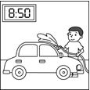 (B) 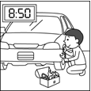 (C) 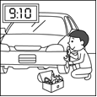
2. (A) 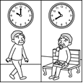 (B) 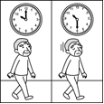 (C) 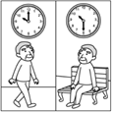
3. (A) 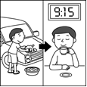 (B) 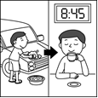 (C) 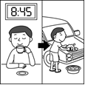
二、基本問答：根據聽到的內容，選出一個最適合的回應或最適合的問句，每題2分，共6分。
4. (A) Sure. Not at all. (B) Really? I enjoy learning history. (C) Take it easy. Teachers can help us.
5. (A) Was everything fine at that time? (B) I enjoyed making dinner for my son. (C) Pumpkin is a healthy choice for a meal.
6. (A) It is difficult for me to play basketball. (B) My brothers like Stephen Curry, too. (C) I want to be a reporter.
- 言談理解：根據聽到的內容，選出一個最適合的答案，每題2分，共8分。
7. (A) A secretary. (B) A reporter. (C) A salesman.
8. (A) She was going out with her family. (B) She was driving. (C) She was calling the man.
9. (A) She was a YouTuber when she was a kid. (B) She is a factory worker now. (C) She became a successful lawyer after she grew up.
10. (A) Mike ate the girl’s cookies. (B) Lucky didn’t have dinner last night. (C) The girl put the cookies in the kitchen at a quarter to ten last night.

綜合測驗
四、請依題意選出最好的答案，第11-27題，每題2分，共34分。
11. She __________ the cookie into halves.
(A) breaks (B) fixes (C) hangs (D) acts
12. A: ________________________B: I wanted to be a Youtuber when I was young.
(A) What do you want to be? (B) What do you do?
(C) Are you a singer? (D) What did you want to be?
13. What _____ he _____ at 9:30 last night?
(A) was; doing (B) did; do (C) are; doing (D) does; do
14. Don’t do exercise right after you finish _____ meals.
(A) to eat (B) eating (C) to eating (D) ate
15. Mother’s Day is coming. Let’s write a card to thank our mom for cooking delicious dinner and _____ us to school every day.
(A) drives (B) drove (C) to drive (D) driving
16. Using social media and playing video games _____ popular with teenagers.
(A) is (B) are (C) to be (D) being
17. IU’s relatives didn’t believe in her and _________________her dream.
(A) made fun of (B) make fun of (C) making fun of (D) were making fun of
18. Playing video games __________interesting for me when I was a kid.
(A) is (B) are (C) was (D) were
19. _____ a famous YouTuber is not easy. We need ______hard from now on.
(A) Be; to work (B) To be; working (C) Being; to work (D) Be; working
20. A: I usually get up at eight fifteen from Monday to Friday.
B: Do you get up at ______ on weekends, too?
A: No, I usually get up at ______ on weekends.
(A) a quarter past eight ; eight after a quarter
(B) a quarter to eight; a quarter to nine
(C) a quarter after eight ; a quarter to nine
(D) a quarter before eight ; eight forty-five
21. Gracie ________ to write some good stories and wants to be a writer in the future.
(A) hates (B) loves (C) enjoys (D) keeps
22. Yesterday when I got home from work, my brother _____ for dinner, so he invited me to join him.
(A) goes out (B) went out (C) is going out (D) was going out
23. I wanted to join the trip. ______, I had to stay home and study.
(A) Finally (B) In fact (C) Besides (D) However
24. It ____ important for Justin ______his homework quickly because he had to (必須)help his parents take out the trash.
(A) is; finish (B) is; finishes (C) was; to finish (D) was; finished
25. Sia and Tyla like ________the piano.
(A) play (B) to play (C) to playing (D) plays
26. Elsa has to get up early because she’s afraid of _______ late for school.
(A) going (B) be (C) to be (D) being
27. Gary: Reading English comic books _______ you learn English. Stefani: Same here. I learn a lot from these comic books.
(A) helping (B) helps (C) help (D) helped
五、克漏字及閱讀測驗，第28-40題。
A. 每題2分，共8分。
Do you have many shoes at home, but you seldom wear them? Do you want to throw them away? Please don’t do that. Here is a good idea for you. __28.__ Take the people in Kenya（肯亞）for example. Many people there have little money __29.__. They have to walk with their bare feet, and many of them get sick from jiggers. Jiggers may get into people’s feet and cause parts of people’s bodies to rot. Sick people cannot work, and they may lose their lives. Wearing shoes __30.__ a good way to keep them safe. So, your old shoes can make things different. __31.__, and let’s work together to change their lives.
 bare 赤裸的 jigger 砂蚤 cause 造成 rot 腐爛
28. (A) You can give your old shoes to others. (B) Why not give your old clothes to others?
(C) You can go there to cook for others. (D) Why not act in a show for others?
29. (A) ,but they all live a happy life (B) because the weather there is very hot
(C) ,so they can stay at home and do nothing (D) ,so they don’t have shoes to wear
30. (A) are (B) be (C) is (D) can
31. (A) I lost my shoes before (B) It is easy to buy shoes there (C) Please show some love (D) Buy new shoes from us

B. 每題2分，共18分。
I had a horrendous experience last Saturday.
That day, my family went camping near a big lake. My parents were making dinner, and my brother and I were playing by the lake. A dirty man walked to us and asked for some water.
I gave him water. His bag dropped, and things inside fell out on the grass. I saw a rope, a knife, and a baseball bat. There were also women's clothes, and I'm sure they were not his. The man put all his things back in the bag and looked at us madly. At that time, the picture of a man the police was looking for came to my mind. He was the bad guy! I was so scared; I could not move at all.
At that time, my dad came to us from behind, and the man hurried off into the dark.
dirty骯髒的 experience經驗 grass草地 knife小刀 bat 球棒 hurry off匆忙離開
32. What happened in the story?
(A) The police caught a killer. (B) The writer's family invited (邀請)the dirty man to dinner.
(C) The writer's brother ran to their parents for help. (D) A man ran away after he saw the writer's father.
33. What can we learn about the writer and the man with a bag?
(A) The man hurt the writer. (B) The writer followed the man into the dark.
(C) The writer and the man were friends before. (D) The man did not want the writer to see things in his bag.
34. Sam experienced something horrendous yesterday. How did he feel then?
(A) Mad. (B) Sad. (C) Scared. (D) Tired.

Who is your favorite singer? Do you often follow stars? If you're interested in Korean music, then you must know G-Dragon!
G-Dragon’s real name is Kwon Ji-yong. He came from Itaewon-dong, Yongsan-gu, in Seoul, and he was born in 1988. He can do many things. He can sing, write songs, and lead fashion.
G-Dragon leads BIGBANG. This group is very popular in South Korea. Fans love their songs, like “Bae Bae,” “If You,” and “Loser.” The group sells music in many countries, and their fans around the world enjoy their albums.
Besides singing, G-Dragon also leads fashion trends. Many fans and young people follow his clothing style. For example, he loves chrysanthemums, and you can often see them on his clothes. His sneakers are special because artists paint each pair by hand. He uses many kinds of hats, changes his hair color often, and always carries a bag when he goes out.
G-Dragon’s fashion ideas change how people dress in South Korea. He wears pearls and jewelry, and he sometimes wears pink or other special colors. With his bold choices, he tells people they can wear any style they like.
G-Dragon is a music star and also a fashion icon. He is a superstar in both music and fashion.
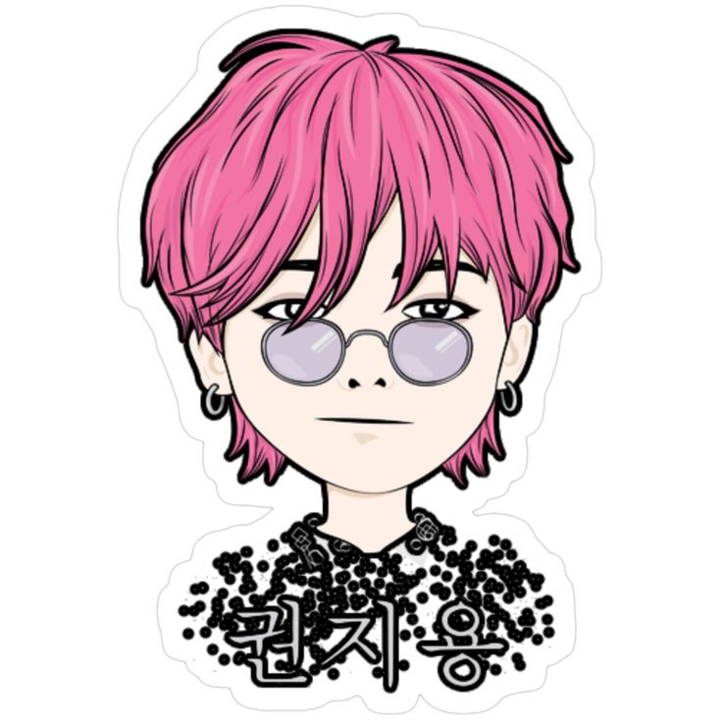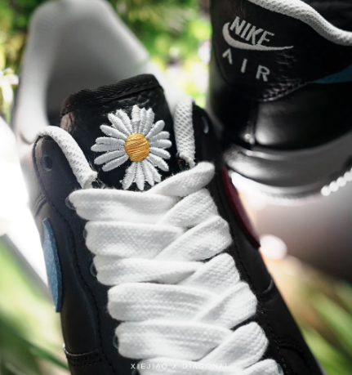
lead帶領 fashion時尚 chrysanthemums雛菊 sneakers運動鞋 bold大膽的 pearls珍珠 jewelry珠寶 icon指標
trend趨勢 album專輯
35. What is the best title(標題)for the reading?
(A) Fashion in Korea Today (B) Songs from BIGBANG
(C) Korean Singers and Music Groups (D) A Korean Singer with New Fashion Ideas
36. What CAN’T we know from the reading?
(A) The reason for the name “G-Dragon”. (B) BIGBANG and its success.
(C) The place of G-Dragon’s birth. (出生) (D) Special points (特點) in his fashion style.
37. Which one is true?
(A) We can see chrysanthemums on all of G-Dragon’s clothes. (B) He only uses clothes or bags with high prices (價錢)
(C) His style shows his ideas and his mind. (D) He cares too much about other people’s ideas.

(Jenny is giving a report in front of the class.)
Good morning everyone. Here is our report. “Do you have your dream job?” We asked all of our classmates this question first. After that, we also asked the students from “yes” group, “What do you want to do in the future?”
Please look at the graphs. According to our study, 85% of our classmates have their dream jobs (see Graph 1). As for the kind of jobs (see Graph 2), eleven of our classmates want to be YouTubers, and nine want to be singers or actors. Eight of them want to become public servants. Six choose other kinds, like cooks, writers, or reporters.
As a result of our research, we found half of the class want to work in the entertainment business. They like those jobs because they are interesting. That was a big surprise to us.
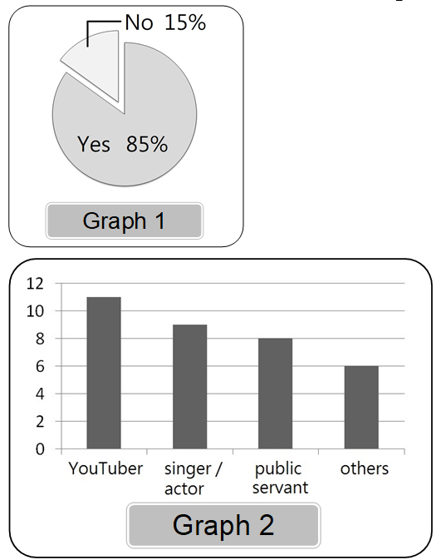
graph圖表 according to根據 public servant公務員 result結果 research研究 entertainment娛樂 surprise使人驚訝的事
38. What is the main idea of the first paragraph(段落)?
(A) The number of students in Jenny’s class.
(B) The research questions of Jenny’s report.
(C) The most popular dream job for teenagers.
(D) Different kinds of entertainment business jobs.
39. What does “That” mean in this report?
(A) In Jenny’s class, six students had no idea about their future.
(B) Many students want to get into the entertainment business.
(C) Jenny’s group asked their classmates, “Do you have your dream job?”
(D) The school can do more to help students prepare (準備) for the world of work.
40. What can we learn from the reading?
(A) No one wants to be a writer.
(B) Being a public servant is the second popular choice for the students.
(C) There are 40 students in the class.
(D) 85% of Jenny’s classmates want to be YouTubers in the future.

<<尚有手寫題，請仔細作答 >>

