桃園市立大有國民中學114學年度第一學期第三次評量試卷
年 級 | 八 | 考 試  科 目 | 英文 |  |  | 命 題  範 圍 | L5~Review III | 作 答  時 間 | 45分
班 級 |  | 姓 名 |  | 座 號 |  | 分 數

一、辨識句意：根據聽到的內容，選出符合描述的圖片或符合圖片的描述。
- (Ａ) 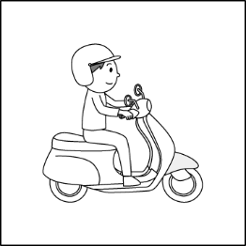 (Ｂ) 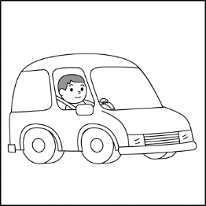 (Ｃ) 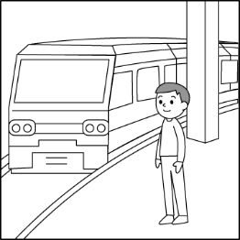
- (Ａ) 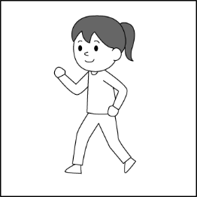 (Ｂ) 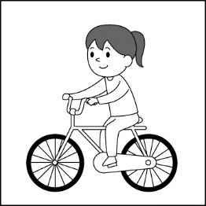 (Ｃ) 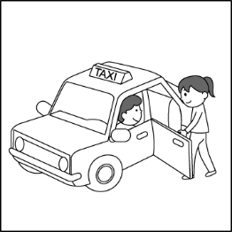
- (Ａ) 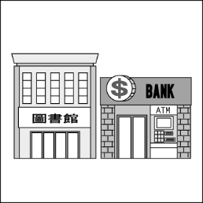 (Ｂ) 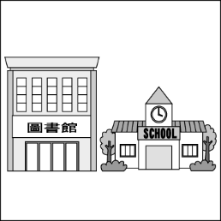 (Ｃ) 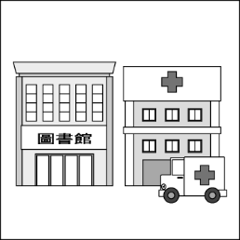
- (Ａ) 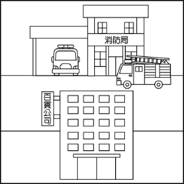 (Ｂ) 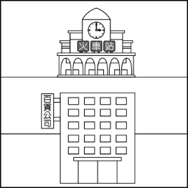 (Ｃ) 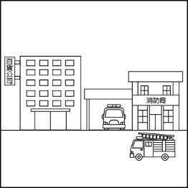
- (Ａ) 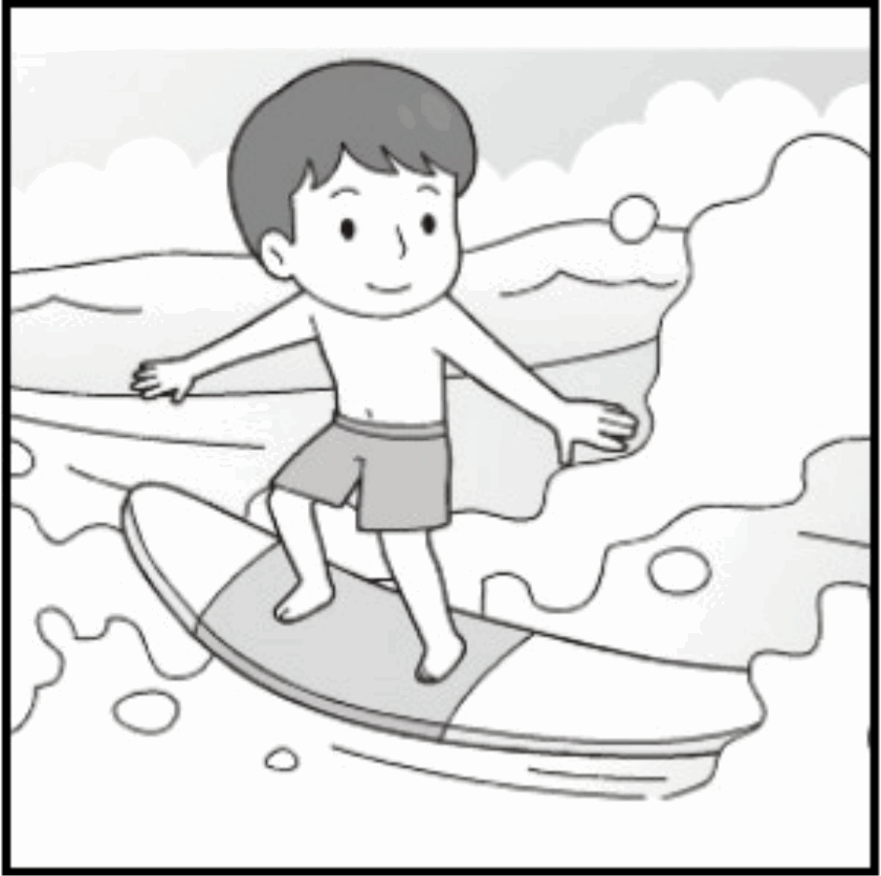 (Ｂ) 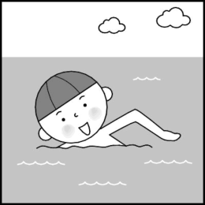 (Ｃ) 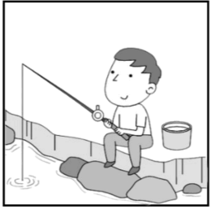

二、基本問答：根據聽到的內容，選出一個最適合的回應或最適合的問句。
- (Ａ) Me too. The stories behind them are terrible.
(Ｂ) Their clothes are cheap and good.
(Ｃ) Let’s fight for the workers in the companies.
- (Ａ) There is not much work.
(Ｂ) It is very easy to take the MRT in Taipei.
(Ｃ) I want to save some money.
- (Ａ) Lanyu is a wonderful place.
(Ｂ) It was not very expensive because I took a boat there.
(Ｃ) It is only 30 minutes.
- (Ａ) Can you send it to me?
(Ｂ) Of course not. It’s cold today.
(Ｃ) Sure. It’s my favorite color, and it’s on sale today.
- (Ａ) I don’t have anything to do next Tuesday.
(Ｂ) I went shopping with Jerry last Tuesday.
(Ｃ) She is going to watch NBA games with her boyfriend.

三、言談理解：根據聽到的內容，選出一個最適合的答案。
- (Ａ) 200 NT dollars.
(Ｂ) 500 NT dollars.
(Ｃ) 1000 NT dollars.
- (Ａ) 5 minutes.
(Ｂ) 10 minutes.
(Ｃ) 15 minutes.
- (Ａ) They take the metro.
(Ｂ) They drive a car.
(Ｃ) They get there on foot.
- (Ａ) Buy a new scooter.
(Ｂ) Go picnicking at the park.
(Ｃ) Go shopping in the department store.
- (Ａ) They’ll have dinner tonight.
(Ｂ) Mike is new to the city.
(Ｃ) They’re going to the post office by car.
四 、文意測驗 ( 一題2分)
- People like to play in the _____ on hot summer days.
(A) pool (B) map (C) taxi (D) ground
- We took a walk along the ______ and saw some fish in the river yesterday.
(A) toy (B) bank (C) supermarket (D) post office
- A: Do you hear the ______ ?
B: Yes. It’s coming from the kitchen. Let’s check it out.
(A) pool (B) play (C) corner (D) sound
- I can’t read the book. I need to wear my .
(A) pants (B) glasses (C) caps (D) shorts
- The _______ is too small. My finger (手指) hurts.
(A) belt (B) shirt (C) tie (D) ring
- Let’s scooter to the zoo.
(A) by (B) go by riding (C) ride the (D) ride
- Susan and Amy always go to Taipei .
(A) take bus (B) on taxi (C) take the train (D) by train
- Is the park the corner First Street and Apple Road?
(A) in ﹔of (B) on ﹔on (C) at ﹔on (D) on ﹔of
- Go down this road ______ three blocks, and you’ll find McDonald’s _____ the right.
(A) for ﹔in (B) for ﹔on (C) at ﹔to (D) at ﹔for
- Jim: Why did you come to the party so late?
Roy: . I couldn’t find my way home.
(A) I hated to come early (B) Let’s not talk about it again (C) I was lost (D) I get here on foot
- Rita likes to _________ with friends, so she is seldom home on weekends.
(A) go camping (B) going camping (C) camping (D) camps
- A: ______ did the Wang family get to the island?
B: They took a boat.
(A) Where (B) What (C) When (D) How
- Ten minutes ago, we went to the hotel. Now we’re back Second Street again.
(A) at (B) over (C) on (D) for
- Man: Excuse me. Is there a bookstore near here?
Jim: Yes. ______________________.
(A) Isn’t it across from your house?
(B) You can ask the old woman over there.
(C) It’s one block away, right across from the bank.
(D) Can’t you go there by taxi?
- Eddy a movie with his friends tomorrow evening.
(A) sees (B) see (C) saw (D) is going to see
- By _______ the piano for ten hours a day, Mike got first place (第一名) in the piano contest.
(A) play (B) playing (C) to play (D) played
- A: How much time did you on your science report last night?
B: It me an hour to do it. (A) spend ﹔spent (B) take ﹔took (C) take﹔spent (D) spend ﹔took
- A: Are there a lot of people coming to the party tomorrow?
B: Yes. There _________ about twenty people.
(A) will (B) is (C) will be (D) were
- A: My son spent three hours _________ his English homework yesterday.
B: How come? Isn’t he good at English?
(A) doing (B) do (C) to do (D) does
- It was sweet of Meg to pay the drinks.
(A) on (B) at (C) for (D) to
- It cost Jolin five hundred dollars the dress.
(A) buy (B) buys (C) bought (D) to buy
- How long to fly from Taipei to Tokyo?
(A) do you spend (B) is there (C) does it cost (D) does it take
- Clerk: , in cash or by card?
Jane: In cash. Here is one thousand NT dollars.
Clerk: OK. Here’s your change, NT$ 100.
(A) How do you often pay
(B) How would you like to pay
(C) Would you like to pay right now
(D) How did you pay for it
- The polyester comes off the clothes little by little when you wash them. In the end, .
(A) it goes into the sea and hurts the environment
(B) you can stop thinking about it for a second
(C) you don’t need to buy anything to wear
(D) it climbs up the mountains and is good for the environment
- Max: Why do you keep practicing riding a bike in your free time?
Zoe:
(A) I wont’ have anything fun to do.
(B) Won’t you go sightseeing with me?
(C) My plan is to go biking around the island.
(D) It’s funny. Won’t you give it a try?
五、 克漏字 (一題2分)
(Judy is moving into the dormitory today.)
Judy: Excuse me. I’m lost. My room is Room 102. 41
Emily: It’s on the first floor. This is the ground floor, so you need to go 42. the stairs to the first floor. Room 102 is 43.
Room 101 and Room 103.
(Later that day)
Emily: Hey, do you want to go 44 with me? I’m going to get some food from the supermarket nearby. It will only 45.
ten minutes to get there by bike.
Judy: Sure. That would be great!
- dormitory 宿舍 nearby附近
- (A) How can I get there?
(B) Which is my room?
(C) Where is my mail?
(D) How long will it take to get there?
- (A) along (B) straight (C) up (D) down
- (A) between (B) on the corner (C) next to (D) across
- (A) jogging (B) hiking (C) shopping (D) surfing
- (A) pay (B) take (C) spend (D) cost
六、閱讀測驗(一題2分)
ChatGPT was out in 2022. It’s helpful to lots of people. They use it to do homework, do reports, look up things, and so on. It’s great, but can we really believe in everything from ChatGPT?
To find out the answer, a mother and her son often ask ChatGPT to do different things. For example, they ask ChatGPT to write a composition about a trip to Yangmingshan(陽明山) National Park. In it, ChatGPT says, “The lake, Zhuzihu(竹子湖) is so beautiful! I can see many fish in the clear water. What’s more, I read lots of books at Yangming Bookstore(陽明書屋) — a bookstore next to green trees …”
The composition is full of mistakes: Zhuzihu isn’t a lake, and Yangming Bookstore is an old guesthouse, not a bookstore by the trees.
The mother and her son’s experiments tell us: ChatGPT is convenient, but we still have to be careful with it and never believe in everything it says.
★composition 作文 guesthouse 招待會館 experiment 實驗

- What is the main idea of the reading?
(A) We should never use ChatGPT to do anything.
(B) We can plan special trips with the help of ChatGPT.
(C) The present(現在) and the future of ChatGPT.
(D) We have to be careful when we ask ChatGPT for help.
- Why does the writer show us a composition from ChatGPT?
(A) To show us: ChatGPT might(可能) make mistakes.
(B) To show us: ChatGPT is good at writing compositions.
(C) To show us: The mother and her son’s experiments are wrong.
(D) To show us: Everyone needs to learn more about ChatGPT.

Here is a fun test about the way to spend your pocket money
Q1: Your mom gives you some snacks. What will you do?
□ A. Eat them all right away.
□ B. Share them with your friends.
□ C. Eat them some time later.
Q2: You oversleep and can’t catch the school bus. What will you do?
□ A. Ask your mom to drive you.
□ B. Take a day off.
□ C. Take a taxi to school.
Q3: You feel sick on the school bus. What will you do?
□ A. Look outside the window.
□ B. Close your eyes and take a rest.
□ C. Ask the driver to let you get off.
Q4. You go to the department store with your friend and find something great. But you don’t have enough money for it. What will
you do?
□ A. Give up things.
□ B. Ask for a big discount.
□ C. Ask your friend for money.
■ Scores: A. → 2 B. → 1 C. → 3
Scores 4-6: You are not a smart pocket money user. It’s better to ask your mom to keep it for you.
Scores 7-9 : You are usually smart when you use your pocket money. But when you really love something, you’ll lose your mind.
Scores 10-12: You are a smart pocket money user. You always spend it wisely.
★oversleep 睡過頭 right away 馬上 take off 休假 outside 外面 discount 折扣

- What does you’ll lose your mind mean here?
(A) You’ll be careful about something.
(B) You’ll give up something.
(C) You’ll change your mind and not buy anything.
(D) You’ll spend a lot of money on something.
- Joyce keeps snacks for some time, takes a rest when feeling sick, goes to school by taxi, and asks for a lower price when she doesn’t have enough money for something. What kind of pocket money user is she?
(A) She often uses her pocket money well.
(B) She has no pocket money.
(C) She sometimes uses her pocket money well.
(D) She uses her pocket money poorly.
- What can we know about the test?
(A) One can get a score of ten when finishing the first two questions.
(B) The test is to teach us to make good use of time.
(C) One can never get a score more than twelve.
(D) The four questions are all about food.

