桃園市立大有國民中學114學年度第二學期第一次評量試卷
年 級 | 八 | 考 試  科 目 | 英語科 |  |  | 命 題  範 圍 | Unit 1 – Review 1 | 作 答  時 間 | 45分
班 級 |  | 姓 名 |  | 座 號 |  | 分 數

聽力測驗，每題播放兩次，請依題意選出最好的答案，共20分。
- 辨識句意：根據聽到的內容，選出符合描述的圖片或符合圖片的描述，每題2分，共6分。
1. (A) 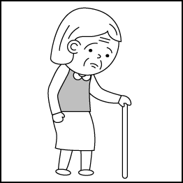 (B) 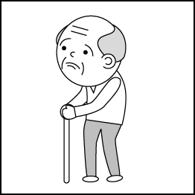 (C) 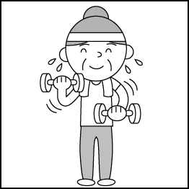
2. (A) 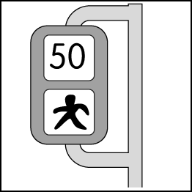 (B) 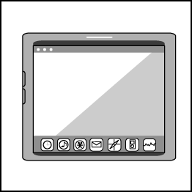 (C) 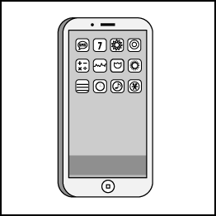
3. (A) 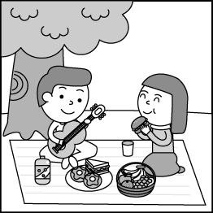 (B) 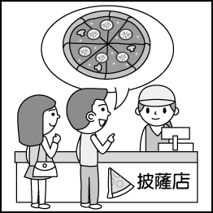 (C) 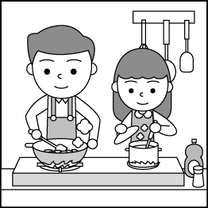
二、基本問答：根據聽到的內容，選出一個最適合的回應或最適合的問句，每題2分，共6分。
4. (A) They tasted delicious and great. (B) Learning to use chopsticks is not easy. (C) I had a fork with me.
5. (A) Fine. The jacket looks cool on me. (B) OK. I don’t want to catch a cold. (C) Sorry. I forgot to wear the jacket from you.
6. (A) Most people like tennis. (B) I enjoy playing table tennis. (C) We spend much time playing sports.
- 言談理解：根據聽到的內容，選出一個最適合的答案，每題2分，共8分。
7. (A) It is more expensive. (B) It looks good on her dad. (C) It is bigger than the pink one.
8. (A) Leo’s mom is angry because he didn’t do well on the English test again.
(B) Leo studied hard in the library, but he still didn’t do well on the English test.
(C) Leo can’t go to the movies tonight because of the bad grades on two English tests.
9. (A) Jack (B) Judy (C) Penny
10. (A) One road safety design in Iceland. (B) More and more car accidents around the world. (C) The clean air in the mountains.

綜合測驗
四、請依題意選出最好的答案，第11-27題，每題2分，共34分。
11. Is it ________ for you to get some milk on your way home?
(A) best (B) delicious (C) deep (D) convenient
12. A: Did you drink as ______coffee as Martin yesterday? B: No, I drank more than he did.
(A) many (B) much (C) more (D) most
13. We will _______ in Auckland at 6:00. It’s 5:45 now. Ready to get off the plane.
(A) take (B) bring (C) kick (D) land
14. Did the story _______interesting to you?
(A) sound (B) listen (C) sound like (D) listen like
15. Do your kids go to school by _________?
(A) themself (B) them (C) themselves (D) theirselves
16. English is the________ interesting subject to me.
(A) most (B) more (C) better (D) last
17. Everyone in the class _______ with Chihhsi's idea.
(A) agree (B) agrees (C) happy (D) are happy
18. A: Let’s have chicken dishes for dinner. B:___________. I’ll go shopping and bring some chicken home.
(A) People here like pork.
(B) How would you like your chicken?
(C) Sounds like a good idea.
(D) How do you like the food here?
19. My phone is _________ cheaper than Ariana’s.
(A) more (B) very (C) so (D) much
20. Rora: The gold chopsticks must be _______than any other ones in your kitchen.
Dad: Yes, I bought at a high price.
(A) less expensive (B) the most expensive (C) very expensive (D) more expensive
21. By wearing fashionable leather (皮革) jacket, the girl can be _____ a rock star.
(A) cooler (B) as cool as (C) cool (D) the coolest
22. The price is _______ important thing when Pharita buys clothes. She cares even more about the style and the color.
(A) the most (B) the more (C) the less (D) the least
23. The game is more ________ than that one. I love it so much!
(A) better (B) good (C) interesting (D) cheaper
24. I’d like a ________milk tea. The small one is not enough for me.
(A) convenient (B) medium (C) delicious (D) warm
25. A: _______does it taste like? B: It tastes like _______.
(A) What; a chocolate cake (B) How; sweet (C) What; sweet (D) How; a chocolate cake
26. Mom: Did you save a copy of your homework on your computer and the cloud (雲端)?
Leo: I already saved it on my notebook, but I'll upload it to the cloud too. ________.
(A) I don’t think so. (B) I am as smart as a bear. (C) It’s better to be safe than sorry. (D) Practice makes perfect.
27. A: Ruka’s grades are getting ___________. B: Maybe it is because she plays video games every day and doesn’t study at all.
(A) better and better (B) more and more (C) worst and worst (D) worse and worse
五、克漏字及閱讀測驗，第28-40題。
A. 每題2分，共12分。
(In a restaurant)
: Good evening, sir. ______(28.)_______?
: Well, I would like to have some meat.
: Sure. Which one do you want?
: The steak looks (29.) than the fish. What does it come with?
: Buns.
: I see. How about the drink? May I also have a cup of coffee?
: No problem! (30.)
: Without milk and sugar. Thanks!
28. (A) Are you ready to pay?
(B) Would you like something else?
(C) May I take your order?
(D) Would you want some ham with that?
29. (A) worse (B) yummier (C) delicious (D) good
30. (A) How does the coffee taste?
(B) Which coffee do you want, warm or iced?
(C) How would you like your coffee?
(D) How much sugar do you need?

James visited Taipei 101 with a friend of his last Saturday. It’s (31.) building in Taiwan. They tried and bought some snacks at the supermarket there. James’ favorite ones are Oyster Omelet Chips. To him, they are the most (32.) chips of all. Next weekend, James will go around Taichung by bus. Taking a bus is (33.) way to him because the bus routes are very clear and the price is low. No one can imagine what he wants to do in Taichung the most. He wants to try some famous snacks there, like Suncakes (without suns in them). Sounds interesting, right?
Oyster Omelet Chips 蚵仔煎洋芋片 route路線 imagine想像 Suncake太陽餅
31. (A) tall (B) taller (C) the tallest (D) the most tall
32. (A) special (B) nice (C) best (D) healthy
33. (A) the most easy (B) the easier (C) the least easy (D) the easiest

B. 每題2分，共14分。
North Korea may be one of the most mysterious countries in the world. Because of this, many people would like to go there to experience this special country. However, visiting North Korea is not as easy as you think. You must follow a lot of rules, or you may be in trouble. Here are some of the rules.
To start with, you must call the country the Democratic People’s Republic of Korea (DPRK) instead of North Korea to stay out of trouble. Another rule is that you should never go anywhere alone. You must not leave your hotel. You should not even be a few feet away from your group to take a closer look at something. Next, don’t say bad things about the country. Praise every stop during your trip, and remember the rule, “If you have nothing good to say, don’t say it at all.”. Finally, be careful with your photos because you can only take them in some places. If you want to take a photo of a statue, the full body of the statue must be in the frame. No funny faces when you take a photo with statues.
If you want to have a safe trip, follow the rules when you visit North Korea.
anywhere 任何地方 praise 讚美 statue 雕像 frame 相框
34. When something is “mysterious”,＿＿＿_.
(A) it has a very rich and long history (B) it is very popular around the world
(C) it is not easy to know about it (D) it is not a secret at all secret 秘密
35. Which is the right picture when you take a photo of statues in North Korea?
(A) (B)
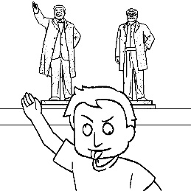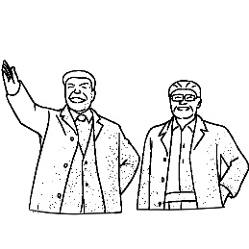
(C) (D)
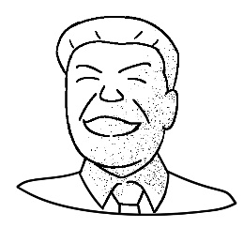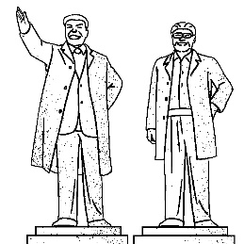
36. Which is true when you go on a trip to North Korea?
(A) You can leave your hotel to visit anywhere alone.
(B) Calling it the Democratic People’s Republic of Korea is wrong.
(C) Try to say something good when you see the sights during the trip.
(D) People can’t use their cameras or cellphones when they visit North Korea.

<<背面尚有試題 >>

Karina loves to shop for new clothes. When she was a child, her mother often took her to the department store on weekends. Her mother would let her pick out the clothes she liked and try them on. Sometimes, her mother didn’t like them because those clothes were too big for her. She didn’t want Karina to wear clothes in the wrong sizes. For her, the better the clothes fit, the better the person looked in them. Karina keeps what her mother said in mind to this day.
Today, when Karina goes shopping for clothes, she follows the rules her mother told her. If she tries on a skirt and it is too loose, she’ll get the clerk to bring her a smaller one. If the pair of jeans that she is trying on is really long and baggy, she’ll ask her friend to help her find a shorter and tighter pair. For Karina, finding clothes in the perfect size is important, so she doesn’t mind taking a long time to get everything right.
This is the reason why Karina never buys any clothes on the Internet. She wants to be able to see, feel, and try on the clothes before she buys them. If technology ever allows her to do that from her comfortable home, she may give it a try. Until then, she’s more than happy to go shopping for clothes at physical stores.

fit合身 loose鬆垮的 baggy寬鬆的 tight緊的 technology科技 allow允許 physical 實體的
37. What is the second paragraph about? paragraph 段落
(A) Maria’s favorite fashion style.
(B) The best clothes shops for Karina.
(C) Karina’s way of getting new clothes.
(D) Karina’s best shopping time of the week.
38. Karina is trying on a pair of shorts. What will she do if they keep falling down?
(A) She will buy them right away.
(B) She will ask for a smaller pair.
(C) She will get a bigger size.
(D) She will find them in a different color.
39. According to the reading, what did Karina learn from her mother? according to 根據
(A) The way of using new technology.
(B) The way of taking off clothes.
(C) The way of shopping with friends.
(D) The way of shopping for clothes.
40. Why does Karina like physical stores better than shopping on the Internet?
(A) Because Internet clothes are usually too expensive for her.
(B) Because she enjoys talking to the clerks in the physical stores.
(C) Because she wants to make sure the clothes fit well by trying them on.
(D) Because her mother told her that shopping online is not safe.

<<尚有手寫題，請仔細作答 >>

