桃園市立大有國民中學114學年度第二學期第二次評量試卷
年 級 | 八 | 考 試  科 目 | 英文 |  |  | 命 題  範 圍 | L3~Review II | 作 答  時 間 | 45分
班 級 |  | 姓 名 |  | 座 號 |  | 分 數

一、辨識句意：每題均有三張圖片，請依據所聽到的句子，選出符合描述的圖片 (一題兩分)
- (Ａ) 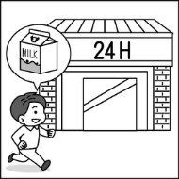 (Ｂ) 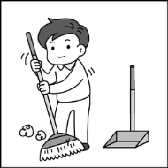 (Ｃ) 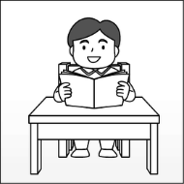
- (Ａ) 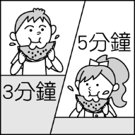 (Ｂ) 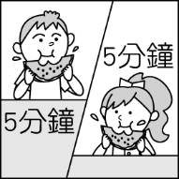 (Ｃ) 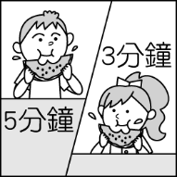
- (Ａ) 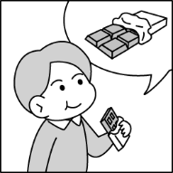 (Ｂ) 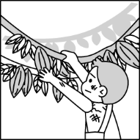 (Ｃ) 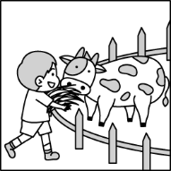
- (Ａ) 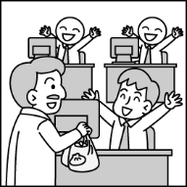 (Ｂ) 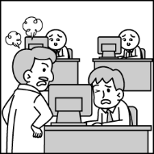 (Ｃ) 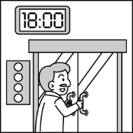
- (Ａ) 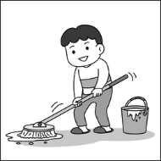 (Ｂ) 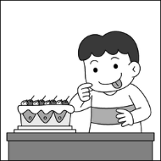 (Ｃ) 

二、基本問答：每題均有三個選項，請依據所聽到的內容，選出一個最適合的回應 (一題兩分)
- (Ａ) I didn’t hear your voice.
(Ｂ) I need to park the car first.
(Ｃ) I saw some old men jogging.
- (Ａ) Yes, I feel the house moving up and down.
(Ｂ) Yes, someone was asking for help then.
(Ｃ) Yes, I feel a little bit cold in winter.
- (Ａ) We should prepare some food, a flashlight and stay at home.
(Ｂ) The light went out an hour ago.
(Ｃ) No, we should train ourselves to face the problem.
- (Ａ) Sorry. I won’t do that again.
(Ｂ) But it is a great picture.
(Ｃ) I love this picture very much.
- (Ａ) No, I won’t. It is too dangerous.
(Ｂ) Yes, it is raining.
(Ｃ) No, let’s meet at three in front of my house.
三、言談理解：每題均有三個選項，請依據所聽到的對話或短文內容，選出一個最適合的答案 (一題兩分)
- (Ａ) Finish the homework.
(Ｂ) Buy some food in the supermarket.
(Ｃ) Do some housework.
- (Ａ) Don’t let her parents feel sad again.
(Ｂ) She has to spend more time studying.
(Ｃ) He can provide help and they can study together.
- (Ａ) Wendy enjoyed the science class today.
(Ｂ) Wendy loves insects very much.
(Ｃ) Mr. Wang’s class was boring to Wendy.
- (Ａ) Finish the fish.
(Ｂ) Order too much food.
(Ｃ) Take food home.
- (Ａ) They have to walk through rubble and sharp glass.
(Ｂ) They will have to make a sound if they find something wrong.
(Ｃ) They have to eat a lot before they start working.
四、文意選擇 (一題兩分)
- Mr. Brown his son go jogging with him every weekend.
(A) told (B) wanted (C) made (D) asked
- My brothers are reading comic books in the library.
(A) quietly (B) quite (C) quiet (D) quieter
- Jane danced _________ than all the other dancers in her school.
(A) more beautiful (B) more beautifully (C) most beautiful (D) most beautifully
- The yellow bird flew of all.
(A) high (B) higher (C) the higher (D) the highest
- Tim shouted (喊叫) because his brother broke his favorite robot.
(A) mad (B) madly (C) maddest (D) madder
- A: well can you see? B: I can see the signs from a mile away.
(A) How ﹔clear (B) What ﹔clear (C) How ﹔clearly (D) What ﹔clearly
- Brandon spent his afternoon at the park watching his dog .
(A) play (B) plays (C) played (D) to play
- To save money, we choose clothes when we don’t need them.
(A) buying (B) to buy (C) not to buy (D) don’t buy
- I them to give me one more chance.
(A) asked (B) made (C) let (D) had
- It’s getting dark. Take a flashlight you.
(A) on (B) at (C) to (D) with
- _____ her you to do the math problem.
(A) Ask ﹔help (B) Let ﹔help (C) Help ﹔let (D) Tell ﹔help
- A: Can you somebody singing?
B: Yes, and it terrible. `
(A) hear ﹔hears (B) hear ﹔sounds (C) sound ﹔hears (D) sound ﹔sound
- If Peter today, please give the box to him.
(A) come (B) came (C) coming (D) comes
- A: Did Sarah eat all the vegetables by herself?
B: Yeah. I saw her ______ some water, too.
(A) finish (B) finishes (C) finished (D) to finish
- We need to leave in five minutes, we will be late for the concert.
(A) so (B) and (C) or (D) if
五、克漏字 (一題兩分)
Amber: Where are you going, Benson?
Benson: My sister wanted me to buy some things at the bookstore for her.
Amber: I see. Do you have any plans after shopping? I am going to play basketball at the park. 31. you like to come?
Benson: I’d like to, but I 32. help Ella do her math homework today. 33. I play basketball with you, Ella won’t be
able to (能夠) finish her homework by herself.
Amber: What about tomorrow afternoon? We are going hiking.
Benson: I’m sorry. But I can’t. I need to teach Ian to ride a bike.
Amber: 34. .
Benson: I know, but I’m scared to turn them down (拒絕).
Amber: That’s easy. Just look into their eyes and say no 35. .
- (A) Should (B) Would (C) Might (D) Must
- (A) shouldn’t (B) could (C) mustn’t (D) have to
- (A) When (B) If (C) Before (D) But
- (A) You are as busy as a bee.
(B) I don’t like biking under the sun.
(C) You should help her become smarter.
(D) You should exercise more.
- (A) bravely (B) weakly (C) luckily (D) hungrily
六、閱讀測驗 (一題兩分)
“Should we learn classical Chinese (文言文)?” is a hot topic. From teachers, parents, to students, everyone may have different answers to the questions. To me, it’s great to learn classical Chinese in the past, but here are some prerequisites(先決條件): First of all, the work needs to have a great influence (影響力) on history (歷史).
Second, it needs to be able to help us understand the history of that year.
Third, it is able to show us people’s values (價值觀) and opinions (意見) in the past.
The third point is interesting because some of the values and opinions might be wrong in today’s world. However, in my eyes, people in different times surely(當然) share different ideas. Even our parents and we can fight over many things, right? Studying classical Chinese is not about asking people to follow those ideas. It’s about learning and understanding those ideas and their backgrounds.
- What does the writer think about classical Chinese?
(A) Most classical Chinese fail to meet the three prerequisites.
(B) Students should spend time on other subjects like science.
(C) Students must try hard to read classical Chinese.
(D) It is still helpful for us to read classical Chinese.

The writer recommended(推薦) a classical Chinese book to his friend, David.
After reading, David said: “Only men could learn to read and write, but women couldn’t? That was stupid. There’s no need to read this book.”
What might the writer say to David after hearing this?
(A) You can say that again.
(B) I’m sorry. No one will agree with that today. Put the book down.
(C) Don’t just look at those ideas. You should also learn about the backgrounds.
(D) Don’t be so serious. Just read it for fun to kill time.
I went to my grandmother’s home last weekend. It was my first time going there by myself. Our family hired (雇用) a foreign caregiver (提供照顧者) for her. Her name is Sabrina. Grandmother always says Sabrina is her partner. However, my relatives don’t like her. I didn’t know why, so I wanted to learn more about Sabrina.
When I arrived at my grandmother’s house, Sabrina came to open the door, and she looked nicer than I thought. She always smiled. During lunchtime, I talked with her. She shared her story with me. She was a teacher in her country. However, the salary(薪資) is very low. Other jobs are even worse. Her country doesn’t do anything to make it better. She wants to make more money for her children to study. Building a new house is also one of her dreams. So, she chose to come to Taiwan. The work is hard, but the salary is higher.
After lunch, Sabrina talked with her children on the phone. She must miss them so much. However, they can’t stay together. I feel sad about that.
Why do my relatives not like Sabrina? Did they try to talk with her? Did they know her story? If not, how could they say something wrong about her? Before we learn more about other people, we should not have a bias(偏見).

- Why do the author(作者)’s relatives NOT like Sabrina?
(A) she talks with her children on the phone.
(B) She can’t speak Taiwanese.
(C) She doesn’t smile.
(D) We don’t’ know.
- What is the main idea of this article?
(A) Some countries are not friendly to their people.
(B) The author likes Sabrina.
(C) If we don’t know others, we should not say something wrong about them.
(D) A caregiver can make a lot of money.
- What does it mean?
(A) salary
(B) house
(C) Taiwan
(D) teacher
-----------------------------------------------------------------------------------------------------------------------------------------------------------------
非選題 用黑色原子筆在答案卷上作答
七、單字 (一格1分)
- We can’t watch a movie w t buying a movie ticket (票) first.
- W ns are my favorite fruit in summer.
- They are planning to have a party to c e Christmas.
- Emma enjoys watching the sunset(日落) from the b y of his room.
- Be careful of the s p knife. Don’t cut your fingers (手指).
- After the rain stopped, we saw a beautiful r w with seven colors in the sky.
- My kid is six years old, so I need to put six c es on her birthday cake.
八、填入正確形容詞或副詞形式 (一格不限一字) (一格1分)
She is a 8. (quick) player. She plays basketball 9. (good).
James went to bed 10. (early) than Jeremy yesterday.
Ann works ten hours a day. She works as 11. (hard) as a dog.
Bill didn’t paint 12. (bad) of all the students.
Mark sings 13 (happy) than Linda.
九、寫出正確動詞形式 (一格不限一字) (一格1分)
Tina and her brother felt the house 14. (shake) at 8:00 last night.
Tony 15. (become) healthy if he exercises every day.
A: Must I 16. (wear) a face mask? B: Yes, the air is terrible.
十、依提示作答 (一題2分)
- Justin prepares dinner every day. (加入 have to 改寫)

- Judy called the lawyer this morning. (用 Judy’s mom had …..改寫)

