桃園市立大有國民中學114學年度第一學期第三次評量試卷
年 級 | 九 | 考 試  科 目 | 英語科 |  |  | 命 題  範 圍 | Lesson 5~  Review 3 | 作 答  時 間 | 45分
班 級 |  | 姓 名 |  | 座 號 |  | 分 數

綜合測驗 每題2分，共40題
- Mark wanted to know when the museum is open, so he looked for the ___________ on the Internet.
( A ) chance ( B ) mistakes ( C ) pleasure ( D ) information
- The police asked the boy what was wrong, but he just couldn’t say anything. It _________ that something terrible happened to him.
( A ) appeared ( B ) surprised ( C ) expected ( D ) scared
- It’s not easy to hike in the mountains because the air at that __________ is too thin for people to live.
( A ) middle ( B ) building ( C ) height ( D ) weight
- This restaurant mainly sells traditional Taiwanese dishes, but it also has a few _______ choices, like burgers and fries.
( A ) present ( B ) foreign ( C ) natural ( D ) sample
- The student was caught while he was trying to _______ on the test. He kept looking at the answers he wrote on his hand.
( A ) cheat ( B ) deal ( C ) tip ( D ) repeat
- A: Excuse me. I’m not sure whether you are the _______. B: Yes, I run the bakery by myself.
( A ) marker ( B ) customer ( C ) shopkeeper ( D ) engineer
- David didn’t do well on the test and ________ it. He was very sad.
( A ) allowed ( B ) failed ( C ) boiled ( D ) dropped
- He has explained the reason to me several times, however, I still can’t _________ it.
( A ) collect ( B ) develop ( C ) waste ( D ) understand
- Fred ate three _________ of peaches in the morning, and he was too full to eat anything.
( A ) cents ( B ) meters ( C ) inches ( D ) kilograms
- Luka got poor grades on the test, so this time he was really at the __________ of his class.
( A ) bottom ( B ) top ( C ) end ( D ) last
- Lollipops come in many colors, like pink and yellow, _______ they are very healthy.
( A ) or ( B ) so ( C ) but ( D ) because
- If you say you can help your friend, you should do your best to _______ your promise.
( A ) fulfill ( B ) raise ( C ) deal with ( D ) define
- The candy _______ no sugar is really popular with people who care about health.
( A ) has ( B ) with ( C ) which ( D ) without
- A: Do you know where my wallet is? B: Your wallet? You mean the one ______ you bought in Japan.
( A ) who ( B ) with ( C ) that ( D ) whose
- Take a look at the man ______ a black jacket. He is my uncle, and he is very nice.
( A ) with ( B ) at ( C ) of ( D ) in
- The woman ________ a smile on her face is my boss. She is so kind that we all like to work with her.
( A ) in ( B ) with ( C ) of ( D ) at
- The bookstore with many windows ___________ by Jonathan’s grandpa.
( A ) belongs to ( B ) were built ( C ) is owned ( D ) which was sold
- The woman ______ hair is brown is my dentist. She is also Jack’s wife.
( A ) whose ( B ) with ( C ) which ( D ) who
- I like the sweater _______ was made by my mom. This is the best birthday present _____ I have ever had.
( A ) who; which ( B ) x ; x ( C ) that; who ( D ) which; x
- The sentences you wrote ________ me think of my mom’s love for me. I couldn’t stop myself from crying.
( A ) makes ( B ) which make ( C ) made ( D ) to make
- Mike has read the novel Mr. Lin gave him twice and ______ it with his friends. He wants more people to know this wonderful book.
( A ) share ( B ) shared ( C ) to share ( D ) that shared
- A: _____ the gloves which have many red dots made by you? They’re so cute! B: You bet!
( A ) Have ( B ) Did ( C ) Were ( D ) Don’t
- A: Do you know _______ the dolls with big eyes are sold? B: Yes, I bought one in Jelly Department Store.
( A ) which ( B ) that ( C ) who ( D ) where
- Do you know the singer ____________________?
( A ) which has a beautiful voice ( B ) often wears a black dress
( C ) who come from Japan ( D ) whose songs are really popular
- Laura wants to buy the special house ______________.
( A ) which is next to mine ( B ) that her father is talking
( C ) who has three rooms ( D ) which were painted in yellow

Yellowknife (黃刀鎮) is a small city in northern Canada and is one of the best places in the world to see the northern lights. It is far away from large cities, so there is very little light pollution. Because of this, the night sky is dark and clear, which gives visitors a better chance to see the lights clearly.
The best time to watch the northern lights in Yellowknife is from late fall to early spring, especially from November to March. During this time, the nights are long and dark. Winter temperatures are very low and can drop below minus twenty degrees. Visitors should wear thick coats, gloves, hats, and warm shoes to stay safe and comfortable while waiting outside.
Many visitors choose to watch the northern lights outside the city. Tour companies often take people to open areas such as frozen lakes or wide fields. These places have fewer buildings and street lights, so the view of the sky is better. Some tours also give visitors hot drinks and take them to a warm place because they may need to wait for a long time before the lights appear.
The northern lights usually look like green lines or waves moving slowly across the sky. Sometimes, colors such as purple or pink can also be seen. The lights do not appear at the same time every night, so patience is important. Clear weather and a dark sky can make the chance of seeing them higher.
Yellowknife also has other winter activities, such as ice fishing, but watching the northern lights is the main reason many people visit the city. With good planning and proper clothing, travelers can enjoy a safe and great experience while learning more about nature and the night sky.
*pollution汙染*temperature溫度 *minus負 *patience 耐心 *proper適當的
26. What is the main idea of the reading?
( A ) To share a wonderful travel experience
( B ) To explain how the northern lights are formed
( C ) To give information about watching the northern lights in Yellowknife
( D ) To show what visitors can do in summer in Yellowknife
27. According to the reading, what makes Yellowknife a good place to watch the northern lights?
( A ) You can see the northern lights from the tall bulidings.
( B ) It has little air pollutions.
( C ) There are many tour companies in the city.
( D ) The weather is warm there in winter.
28. What can we know from the reading?
( A ) Patience is important when watching the northern lights.
( B ) Visitiors can only watch the northern lights while traveling in Yellowknife.
( C ) The northern lights in Yellowknife appear at around 1 a.m. every day.
( D ) The northern lights come in only one color.

There are people jumping, rolling, or swinging their way across the cities. These people are doing parkour, a sport that has turns the city into a fun place to move.
The idea of parkour is simple. You move from one place to another as fast as you can. You use things around you to help you move. If there is a wall, you climb over it. If there is a gap, you jump over it. You can run, walk, or jump on different surfaces. In parkour, you always move forward. You can never go backward.
Parkour started in France in the late 1980s. It came from military training. People learned how to use both their body and mind to pass obstacles. One important move in parkour is jumping and landing on the right spot. Being precise is even more important than being fast.
Parkour looks very exciting, but it can also be dangerous. Without training, people easily get hurt badly. To practice parkour safely, you need training to become balanced.
Today, there are parkour groups around the world. They help beginners learn the sport. Beginners practice basic moves again and again. They also warm up by running and doing some exercises. After that, they go outside and practice parkour in the city. If you want to try parkour, there are groups in Taiwan. With training, you can do parkour more successfully. You can also enjoy the happiness of running and jumping in the city.

*parkour跑酷 *gap空隙*surfaces表面 *military 軍事的 *precise準確的 *obstacles障礙 *balanced平衡的
29. Which is true about parkour?
( A ) It is a new sport that started in Taiwan.
( B ) It can only be done by grown-ups because it is very dangerous.
( C ) It is a sport that needs a lot of training.
( D ) In parkour, being fast is the most important thing.
30. Which of the following best explains why the writer mentions military training?
( A ) To show parkour is a better sport for soldiers
( B ) To explain the history of parkour training
( C ) To ask readers not to waste time on parkour
( D ) To expect parkour can be taught in every country
31. The following sentences are the main ideas of the reading. Put them in the correct order.
(a) Parkour began in France and developed from military training.
(b) Parkour needs training to make it safer.
(c) Parkour is a sport that people jump and move across the city for fun.
(d) The main rule of parkour is just to go forward.
( A ) c dab
( B ) dcab
( C ) cadb
( D ) acdb

Japan has had many bear attacks this year. Since April, more than 200 people have been killed or hurt by bears. Many bears are now coming into places where people live. They are looking for food, and they are getting closer to people’s homes.
There are several reasons why bears attack people more often. One reason is that there are not enough nuts in the mountains this year. Because bears cannot find enough food, they leave the forest to look for more. Another reason is that the line between towns and wildlife areas is less clear now. As people and bears live closer to each other, bears enter human areas more often.
In 2025, the most dangerous areas are in the north and northeast of Japan, especially Hokkaido(北海道). These places report the most bear sightings and attacks. The south of Japan is much safer because there are fewer bears living there.
Bears can now be found not only in the mountains but also in tourist areas, villages, and near homes. When people are in these areas, they should watch out for signs such as tracks, broken branches, or claw marks. These signs show that bears may be nearby.
If a person meets a bear, it is important to stay calm. People should not run or shout, as this may make the bear attack. They should slowly move back while facing the bear and try to look bigger by raising their arms. Speaking in a low, calm voice may also help. People should never try to feed or take photos of bears. Playing dead is not safe because bears may still attack. By learning these safety steps and being careful, people can lower the danger and protect themselves when bears appear near human areas.
*attack 攻擊*nuts 堅果*wildlife野生動物*sighting目擊*tracks足跡*branches樹枝*claw (動物的)爪
32. What problem in Japan is the reading talking about?
( A ) Tourists can't find safe places to stay.
( B ) Towns in Japan are becoming too busy.
( C ) Many people are getting lost in the mountains.
( D ) Bears are coming close to people and can be dangerous.
33. What does the word “signs” in the sentence most likely mean?
( A ) the lights along the roads
( B ) shouts from other people
( C ) the number of bears
( D ) marks left by bears

Dada junior high school is holding a speech contest. These are the pictures that every student gets when it’s their turn. Please look carefully at the pictures and answer the following questions.
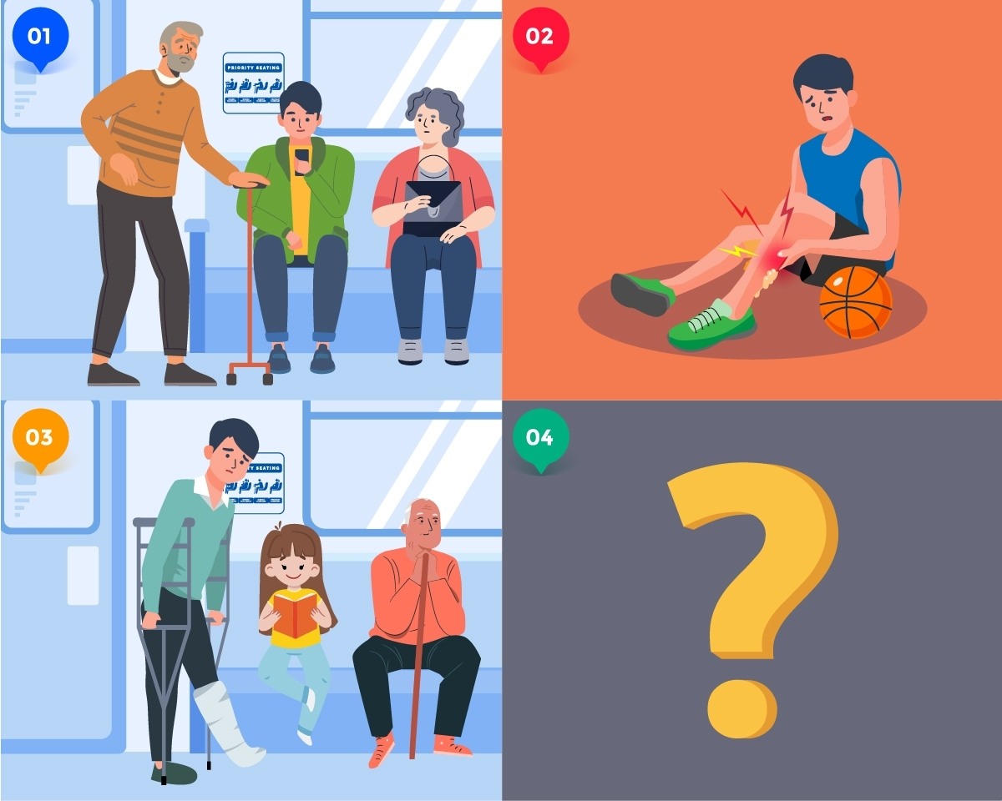

34. Which of the followings may not be in the speech contest?
(A) ……… I had a great time playing basketball with my teammates today! But I broke my leg. It hurts a lot! And I have to spend more than thirty minutes on the MRT home……….
(B) ……… There is a boy who sits on the priority seat playing games with his cellphone. Although I think he is busy studying, maybe it’s better for him to give it up because there is an old man waiting for the seat?.........
(C) ……… I’m so old and weak that I need a seat when taking the metro. The young next to me doesn’t stand up, although I’ve told him. ………
(D) ……… I broke my arms this morning in PE class. My classmate was so nice that she took me to the hospital by taxi. Her dad even drove me home. However, tomorrow I still have to take the bus to school. I hope I will have a seat. ………
35. This is Mark’s story which got the first place of the speech contest. What is the correct order of his story?
① One morning, when Anthony was on the MRT, he sat on a priority seat and played with his phone without noticing the old man in front of him. Everyone in the car was angrily looking at Anthony.
② One day, Anthony hurt his leg and needed to take the metro to school. He was looking for a seat on the metro and failed to find one. He could only stand in front of the little girl and felt terrible.
③ Anthony was a high school student who only cared about himself. He never wanted to give a hand to people around him.
④ A few days passed, Anthony found the same old man on the metro. He walked to the old one and said sorry to him. The old man said, “I guess that my granddaughter really taught you a lesson!”
(A) ③→④→②→①
(B) ③→①→②→④
(C) ②→③→①→④
(D) ②→①→③→④

Ted: Who is the tall girl?
Jenny: Which one?
Ted: (36) She looks beautiful.
Jenny: She is Cathy. She is Steve’s sister. She is the singer in the school band.
Ted: (37)
Jenny: Yes, once. When I visited Steve last time, Cathy was practicing singing. Her voice is really beautiful. She sings better than some of the singers on TV.
Ted: Doesn’t she want to join the singing contest on TV? Maybe (38) .
Jenny: In fact, she does want to join the contest, but she’s afraid that her parents won’t agree. For her parents, (39) .
Ted: I know. I remember Steve wanted to choose the badminton club last semester, but he couldn’t. That was because (40) . They hoped him to practice speaking English in the club. Those days, Steve always looked down. By the way, will the school band have a show next week?
Jenny: Yes. You can come to enjoy the show. I guess you will also love her voice.

36. ( A ) I know who you’re talking about. ( B ) It is at the door.
( C ) The boy who is playing basketball there. ( D ) The one in a purple skirt.
37. ( A ) Does she like singing? ( B ) Has she won many prizes?
( C ) Have you ever heard her sing? ( D ) Isn’t she in the badmintion club, too?
38. ( A ) I’ll like the movie ( B ) she fools us with her beautiful voice
( C ) she can become a famous star ( D ) she asked me to join her
39. ( A ) joining singing contests is the best ( B ) studying hard is the most important thing for her
( C ) Caroline will be a famous singer ( D ) singing shouldn’t cost her a lot
40. ( A ) his parents asked him to join the English club ( B ) he gave up easily
( C ) his parents told him to do his best ( D ) he was interested in singing

