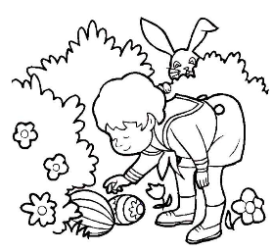
桃園市立大有國民中學114學年度第二學期第一次評量試卷
年 級 | 九 | 考 試  科 目 | 英語科 |  |  | 命 題  範 圍 | Lesson 1~ Lesson2 | 作 答  時 間 | 45分
班 級 |  | 姓 名 |  | 座 號 |  | 分 數
- 單題，第1~25題，每題2分，共50分。
1. | Look at the picture, John did the Easter egg _____ when he was six.
 | - coloring | - painting | - copying | - hunting
2. | When I read the newspaper, the first ______ caught my eye. It was about a big fire in the city.
 | - driver | (B)uniform | (C) website | (D) headline
3. | After cleaning the classroom, the students put everything back in the right place to keep it ______, so the teacher would not be angry the next day.
 | - empty | - quiet | - tidy | - well
4. | Playing the violin, which she started learning at the age of six, has been her favorite ______.
 | - hobby | - sport | - music | - dream
5. | The watch costs one million dollars, but it’s actually ______.
 | - stupid | - fake | - least | - serious
6. | Mr. Chen is a very ______ teacher, so all the students ask him for help when they have problems.
 | - strong | - funny | - trusted | - widely
7. | The dark clouds and strong wind are a clear ______ that a storm is coming.
 | - sign | - roll | - rule | - line
8. | The teacher asked the students to find the ______ of the information before writing the report.
 | - turns | - tips | - joys | - sources
9. | Emily asked her classmate if she could ______ a pencil because she forgot to bring one to class.
 | - lend | - borrow | - sell | - write
10. | Sarah is a new ______ of the school basketball team, so she will join the practice every Wednesday.
 | - fan | - leader | - catcher | - member
11. | To a small child, Mr. Hulk must look like a ______. He’s about 201 cm tall.
 | - giant | - shy | - sharp | - wide
12. | The mountain village is very ______ the city, so it takes more than three hours to drive there.
 | - different from | - far from | - close to | - full of
<<背面尚有試題，加油>>
13. | How can you say you don’t like something ______ you’ve never even tried it?
 | - since | - until | - when | - through
14. | ______ Mr. Liu was making dinner in the kitchen, his wife was setting the table.
 | - If | - Because | - Until | - While
15. | The train just left _______ I got to the train station. That’s why I was late for the meeting.
 | - as soon as | - as long as | - though | - then
16. | We can _____ buy a new car _____ go on a 15-day holiday, but we can’t do both.
 | - either…or… | - neither…nor… | - both…and… | - so…that…
17. | The weather during the Chinese New Year was ______ hot for my family ______ believe because it was winter vacation.
 | - enough…to… | - too…to… | - so…that.. | - neither…nor…
18. | Neither Hank nor Doris ______ to clean their room because they have a helper at home.
 | - need | - wanted | - has | - have
19. | The dog ______ is Susan’s. How cute it is.
 | - can roll the ball | - that can roll the ball | - which it can roll the ball | - that the ball rolled
20. | I really enjoyed the movie ______. It was so touching.
 | - that I’ve never met for years |  | - which I watched it last weekend
 | - I watched last night |  | - that I didn’t make fun of
21. | Mia: Can I borrow your notebook for the weekend?  John: Sure, you can, ______ you promise to take good care of it.
 | - as long as | - as soon as | - as well as | - as busy as
22. | Kevin ______ play video games for hours every night when he was in elementary school. Now, he always finishes his homework ______ turning on his computer.
 | - was used to/ when |  | - used to/ before
 | - used to/ when |  | - was used to/ before
23. | ______ many students were tired after hiking for hours, they were still excited about ______ wild animals in the forest.
 | - As long as/ spotted | - When/ spotting | - Though/ spotting | - Because/ spotted
24. | Kevin: Ms. Lin, I’ve finished my science project. May I start my report now?  Ms. Lin: Yes, the class is ready. Please ______.
 | - carry on | - move on | - cool down | - go ahead
25. | Tina: How was the school camping trip? I heard it might rain all weekend.  Jason: Yeah, we were worried at first, but it ______ a wonderful experience. The weather was perfect!
 | - found out | - turned out to be | - looked out for | - brought joy to

<<尚有試題，加油>>
二、閱讀測驗，第25~40題，每題2分，共30分。
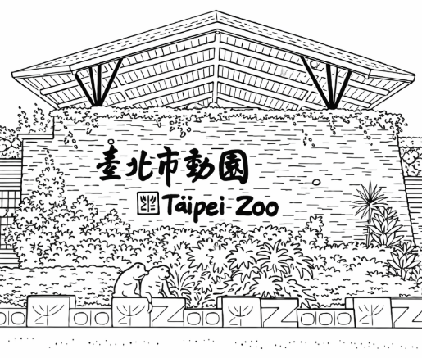
The Taipei Zoo has been an important place for people in Taiwan for many years. It was first built in a busy area of the city, Yuanshan, but later it was moved to Muzha. The reason for the move was that the first place had limited space, noise, and pollution, which made it difficult for the animals to live comfortably. The new place gave more space and a better natural area, which changed the animals’ lives and made it easier for visitors to learn about taking care of wildlife.
One of the most famous animals in the zoo was Lin Wang, an Asian elephant who lived there for many years. Before coming to Taiwan, he helped soldiers carry heavy things during wartime. Because of his kindness and long life, he became a sign of history and friendship. When he died, many people felt sad and remembered him as an old friend.
The zoo is not only a place to see animals but also a spot that tells people to care about nature. This idea is also shared in the song “Happy Paradise,” which helps people in taking care of the Earth so that animals and people can live peacefully together.
Today, the zoo keeps teaching visitors about caring for nature and being kind to life. Through stories like Lin Wang’s and messages from songs like “Happy Paradise,” people learn that taking care of the world around us is everyone’s “job”.
26. The zoo was moved to Muzha because _____.
(A) too many visitors came (B) it was easier to sell tickets
(C) the animals wanted a new home (D) the first place was too small and noisy
27. In the last paragraph, what does the word “job” mean?
(A) Something people must do. (B) A song people need to sing.
(C) A work at the zoo. (D) A kind of animal.
28. What is the main idea of the passage?
(A) The history of Taipei City. (B) How to take care of elephants.
(C) The importance of Taipei Zoo and caring for nature. (D) Why people like to visit zoos.
------------------------------------------------------------------------------------------------------------------
Hexing Station is a small railway station in Hsinchu, Taiwan. Many years ago, it was still in use, and trains stopped there every day. One day, a high school student named Mr. Tseng met a girl he liked on the train near the station.
On an important exam day, he missed the train by mistake. He was very worried he would not arrive on time, so he ran about 2.1 kilometers to catch up at the next station. Because of his strong will, he not only made it to the exam but also won the heart of the girl. They later got married.
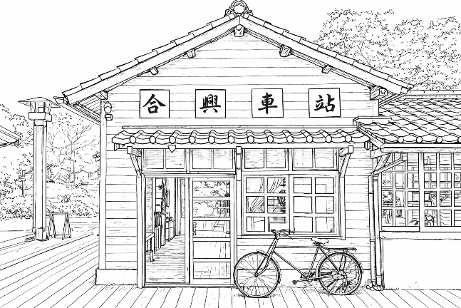
Many years later, Hexing Station faced closing. Mr. Tseng and his wife decided to take care of and save the station. They cleaned the area and added many things to make it look warm and lovely.
Today, Hexing Station is famous as a “Love Station.” Visitors come to see the wooden station building and take photos with the art about love. The story of Mr. Tseng and his wife shows that love and effort can bring new life to even an unused station.
- How did Mr. and Mrs. Tseng help the station?
(A) They took care of and saved it. (B) They got married at the station.
(C) They sold it to a company. (D) They cleaned and bought it.
- In the second paragraph, “Because of his strong will,…”, that means he used his strong _____.
(A) head (B) mind (C) body (D) eyes
- Which of the following shows the correct order of events in the story?
① Hexing Station became a “Love Station” ② He ran 2.1 km
③ Mr. Tseng met a girl ④ The station became unused

- ③ →② → ① → ④ (B) ② →③ → ① → ④
- ③ →② → ④ → ① (D) ④ →② → ③ → ①
- Peter faced a big problem in his life. In the end, he decided not to give up and tried his best because he thought of this story. What did he finally learn from the story?
(A) Love is the most important thing in life. (B) Old places should always be saved.
(C) Trains can change people’s lives. (D) Nothing is stronger than your will.
------------------------------------------------------------------------------------------------------------------

In recent years, many cities in Taiwan have built special playgrounds called inclusive parks. An inclusive park is designed for everyone. Children of different ages and abilities can play together in the same space.
Unlike traditional playgrounds, inclusive parks give play items that are safe and easy to use for children with special needs. For example, there are wide paths for wheelchairs, low slides, and swings with back support. Some parks also include a sandbox that helps children to look around and play. These things make sure that no child feels left out.
One good example is Dayou Terraced Eco Park(大有梯田公園) in Taoyuan. The park has large open spaces and creative things to play with. It is designed so that children can climb, run, and explore safely. Families often visit the park on weekends to relax and enjoy time together.
Inclusive parks are important because they teach children to respect differences while playing together. They also provide a safe and welcoming environment for families. By building more inclusive parks, Taiwan is creating a friendlier society for everyone.
✐ inclusive parks共融公園 society社會
- According to the passage, why are inclusive parks more common in Taiwan?
(A) Because they change traditional schools into fun parks.
(B) Because they provide larger and friendlier places.
(C) Because they make parks more crowded.
(D) Because they are cheaper to build.
- Which of the following playground item CANNOT be found in an inclusive park?
(A) | 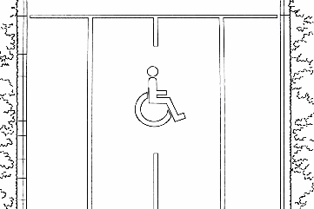 | (B) | 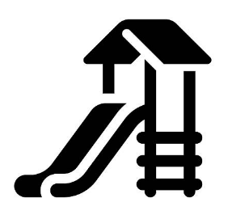
(C) | 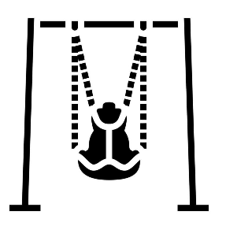 | (D) | 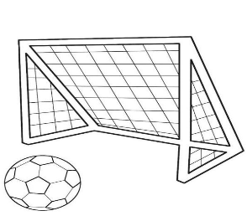

------------------------------------------------------------------------------------------------------------------
Lily: Hi Tom! You look really calm today. Have you been doing something special?
Tom: Yes! I started doing yoga every morning. It helps me feel better.
Lily: Yoga? I think it’s a bit too difficult for me.
Tom: Really! Yoga is easy enough for beginners, and it also helps you feel happy. You just need to practice a little each day.
Lily: I see. So you feel happier now?
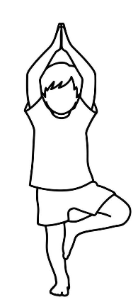
Tom: Yes! Yoga is 35. relaxing 35. I forget about my stress while doing it.
Lily: That sounds nice. But I usually like running.
Tom: You don’t have to choose. You can do 36. , or even try both.
Lily: Maybe I’ll try it. But what if I’m too tired after work?
Tom: That’s okay. Some yoga poses are 37. them. For example, the Tree Pose is a yoga pose that helps you keep your balance and feel calm. While practicing the Tree Pose, you just need to stand on one leg and stay focused. Yoga is 38. relaxing 38. helpful for keeping a good pose.
Lily: I’m often tired in the evening.
tree pose
Tom: So am I! That’s why I do short yoga practice times at home while my family watches TV.
Lily: I don’t really like stretching.
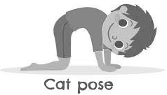
Tom: 39. at first, but people who practice every day soon get used to it.
Lily: Wow! I didn’t know that.
Tom: 40. well as long as you practice every day.
Lily: Thanks, Tom! I think I’ll start tomorrow.
Tom: Great! Remember, doing a little every day is better than doing too much at once.
✐ stretch (v.)伸展

- (A) both…and… (B) too…to… (C) so…that… (D) either…or…
- (A) either yoga or running (B) neither yoga nor running
(C) both yoga and running (D) that yoga and running
- (A) too simple for everyone to do (B) so simple that anyone can do
(C) not simple enough for anyone to do (D) neither simple nor friendly for everyone to get
- (A) both…and… (B) not only…but… (C) so…that… (D) either…or…
- (A) I do, too. (B) So am I. (C) I’m not, either. (D) Neither do I.
- (A) It’ll work (B) It worked (C) It has worked (D) It is working

<<試題結束，請仔細檢查!!!>>

