桃園市立大有國民中學109學年度第一學期第三次評量試卷
年 級 | 七 | 考 試  科 目 | 英語 |  |  | 命 題  範 圍 | Unit5~Review3 | 作 答  時 間 | 45分
班 級 |  | 姓 名 |  | 座 號 |  | 分 數
- 辨識句意：根據聽到的內容，選出符合描述的圖片或符合圖片的描述。2%
1.(A) 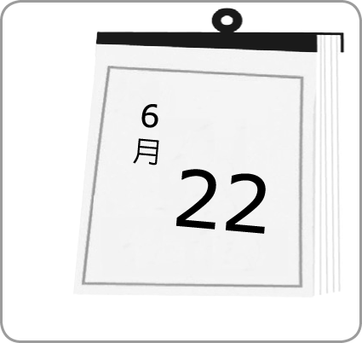(B) 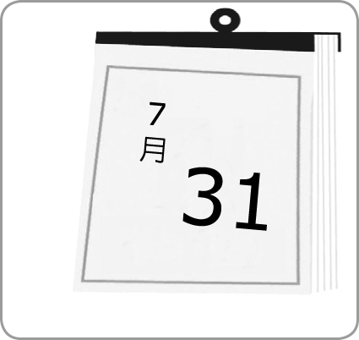(C) 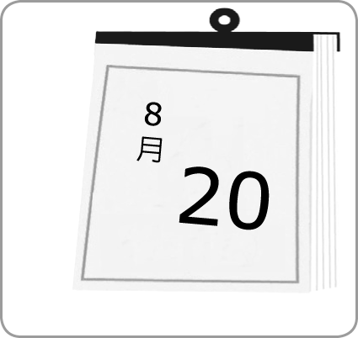
2.(A) 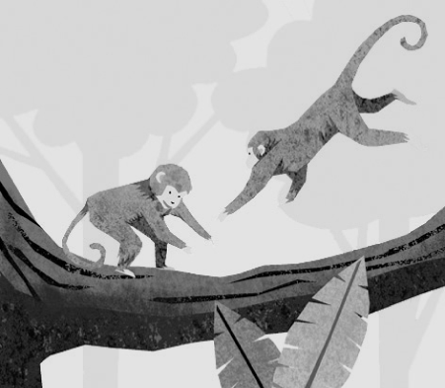(B) 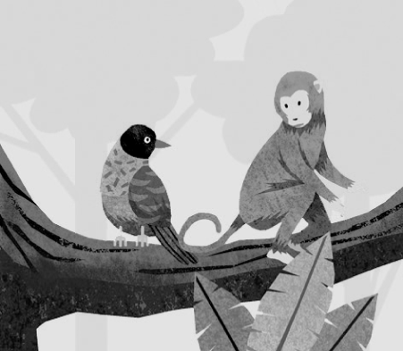(C) 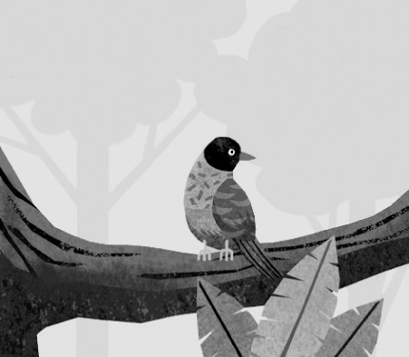
3.(A) 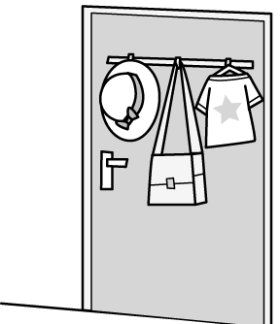(B) 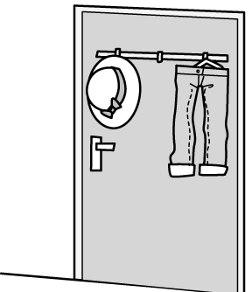(C) 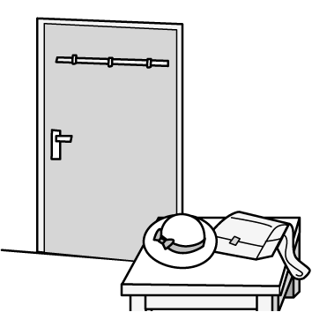
4.(A) 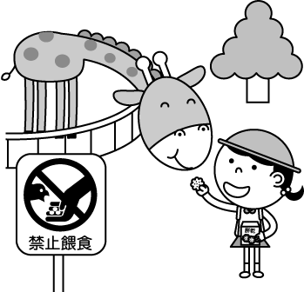(B) 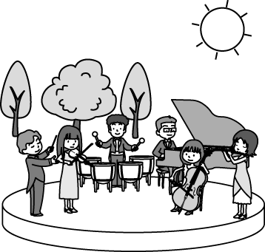(C) 
5.(A) 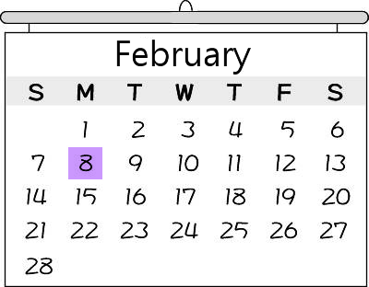(B) 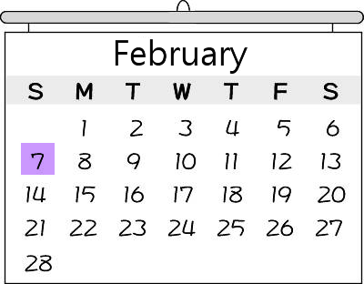(C) 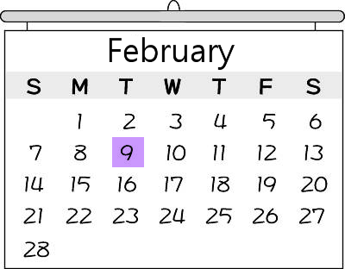
- 基本問答：根據聽到的內容，選出一個最適合的回應或最適合的問句。2%
6. (A) It’s on May 12.
(B) It’s a nice holiday.
(C) She is a good nurse.
7. (A) Yes, tigers are big cats.
(B) Yes, but there is only one.
(C) Yes, there are only cute small animals.
8. (A) It’s from Africa.
(B) It’s the king of animals.
(C) It’s with the baby lions.
9. (A) What’s your gift for Mom?
(B) You’re right. It’s this month!
(C) What day is today?
10. (A) Yes, it is. Do you have anything for Mom?
(B) No, Father’s Day is on August 8.
(C) Yes, it is my mother’s birthday.

- 言談理解：根據聽到的內容，選出一個最適合的答案。2%
11. (A) Christmas.
(B) Thanksgiving.
(C) Teacher’s Day.
12. (A) Sleeping.
(B) Eating turkey.
(C) Hiding under the table.
13. (A) At a zoo.
(B) On a farm.
(C) In a museum.
14. (A) The pig.
(B) The cow.
(C) The horse.
15. (A) The love coupons are for the man’s wife.
(B) The man’s wife is forty years old.
(C) The man doesn’t have any gifts for his wife.
四、文法選擇2%
16.My grandfather is so old, but he is really __________.
(A) full (B) lovely (C) healthy (D) yummy
17.Judy is _________ about her final exam and can’t sleep well every night.
(A) ready (B) sure (C) quiet (D) nervous
18.Abby’s birthday is in December, _________ month of the year.
(A) twelfth (B) twentieth (C) the twelfth (D) the twentieth
19.Today is very _________ to Alex. It’s his first day to go to junior high school.
(A) important (B) hungry (C) beautiful (D) welcome
20. Oscar is not scary(可怕的). He is only a paper_________.
(A) fox (B) elephant (C) tiger (D) lion
21.It’s raining now. _________, I have my umbrella with me.
(A) Lovely (B) Luckily (C) Thanks to (D) Really
22.Selena’s piano concert is_______ month. Do you want to go?
(A) next (B) last (C) in this (D) on every
23.Chinese New Year’s Day is coming. Jacky, it’s time to ________ your bedroom.
(A) hide (B) help (C) cry out (D) clean up
24.Ryan: When is your birthday?
Brian: My birthday is______ January, and it’s______ January sixth.
(A) in; in (B) on; in (C) on; on (D) in ; on
25.Nelson: What’s the date today?
Timmy:_________
(A) It’s Thursday. (B) It’s February. (C) It’s January nineteenth. (D) It’s Chinese New Year’s Eve.
26.Chinese New Year’s Day is_______ the second Friday of February this year.
(A) x (B) on (C) at (D) in
27.Linus: ________ two balls under the chair?
Julian: No, _________ only one.
(A) Are; it’s (B) Have; it’s (C) Have; it has (D) Are there; there is
28.Edwerd: Are there _______ markers on the desk?
Marcia: Yes, there are.
(A) a (B) some (C) much (D) any
29. ______ is a museum near the park. ______ big and new.
(A) It’s ; It’s (B) There is ; It’s (C) It’s ; There is (D) There is ; There is
30.Listen! There are three birds __________ in the tree.
(A) sing (B) is singing (C) singing (D) to sing
31.We have a party on _________. Can you come?
(A) this Friday night (B) December (C) 7 o’clock at night (D) the night of December thirty-first
32.Sandy:________
Melody: There are tigers and monkeys at the show.
(A)What’s there at the show?
(B) Are there any tigers and monkeys at the show?
(C) Aren’t there tigers or monkeys at the show?
(D) Can we see tigers and monkeys at the show?
33.Jean: Are you full?
Mina: ____________ Can I eat more (更多的)?
(A) Good to know. (B) No, thanks. (C) Not really. (D) That’s right.
34.Wayne: Are there any tigers in Africa?
Wally: No, tigers are from Asia.
Wayne: ______.
(A) I’m not sure. (B) Good to know. (C) Don’t fight with me. (D) Maybe next time.
35.Angel: Mom, hurry up! I’m late for school! Let’s go!
Mom: School? Why? It’s Saturday today.
Angel: Is it? _________ I can go back to sleep again.
(A) I don’t think so. (B) I’m ready for school. (C) How about Sunday? (D) Thank goodness!
36.Dora: The small zebras are so cute!
Yuna: _____________________
Dora: Let me see... Ten...No, twelve. There are two behind the tree.
(A) Are there nine zebras? (B) Where are they from? (C) That’s new to me. (D) What are they doing?
五、克漏字2%
Willie: 37 is bus 1314 coming?
Nick: At 13:15 p.m.
Willie: But it’s 13:25 now.
Nick: I know. It’s late. Wait! 38 is it today?
Willie: It’s Saturday. Why?
Nick: Oh, no! There is no bus 1314 39 weekends.
Willie: What?! What can we do now? How can we go back home?
Nick: 40 take a taxi. Cassi and Keisha will study together in the library this afternoon.
Do you want to study with us? There is an exam coming next week.
Willie: 41 is today?
Nick: Today is January 16.
Willie: Oh, no! I have to (必須) teach my sister English at two thirty p.m. today. Let’s hurry.
37.(A) What day (B) What date (C) What time (D) Where
38.(A) What day (B) What date (C) What time (D) When
39.(A) at (B) on (C) in (D) of
40.(A) How about (B) Let’s (C) Where to (D) When to
41.(A) What day (B) What date (C) What time (D) When
六、閱讀測驗2%
(一)January’s Movies at Dayou
Black Room  Soul  13:30  15:00  20:30  Jan. 7-Jan. 22 | Green Room  Wonder Woman  14:30  16:30  19:30  Jan.1-Jan.18 | Red Room  Monster Hunter  8:00  16:00  22:00  Jan. 8-Jan. 25 | White Room  Little Big Women  14:00  18:00  20:00  Jan. 15-Jan.31
We are not open on the second Wednesday of every month.
2021 January
Sun. | Mon. | Tue. | Wed. | Thu. | Fri. | Sat.
 |  |  |  |  | 1 | 2
3 | 4 | 5 | 6 | 7 | 8 | 9
10 | 11 | 12 | 13 | 14 | 15 | 16
17 | 18 | 19 | 20 | 21 | 22 | 23
24 | 25 | 26 | 27 | 28 | 29 | 30
31
42.Today is January 26. This Friday, Elaine is going to a movie. Which movie can she go?
(A) Soul. (B) Wonder Woman. (C) Monster Hunter. (D) Little Big Women.
43.It’s Wednesday morning, and Jeremy is going to a movie at Dayou. What’s the date today?
(A) January 6. (B) January 13. (C) January 20. (D) January 27.
44.Today is the first Sunday of January. George and Danny are going to a movie. Which movie room is open?
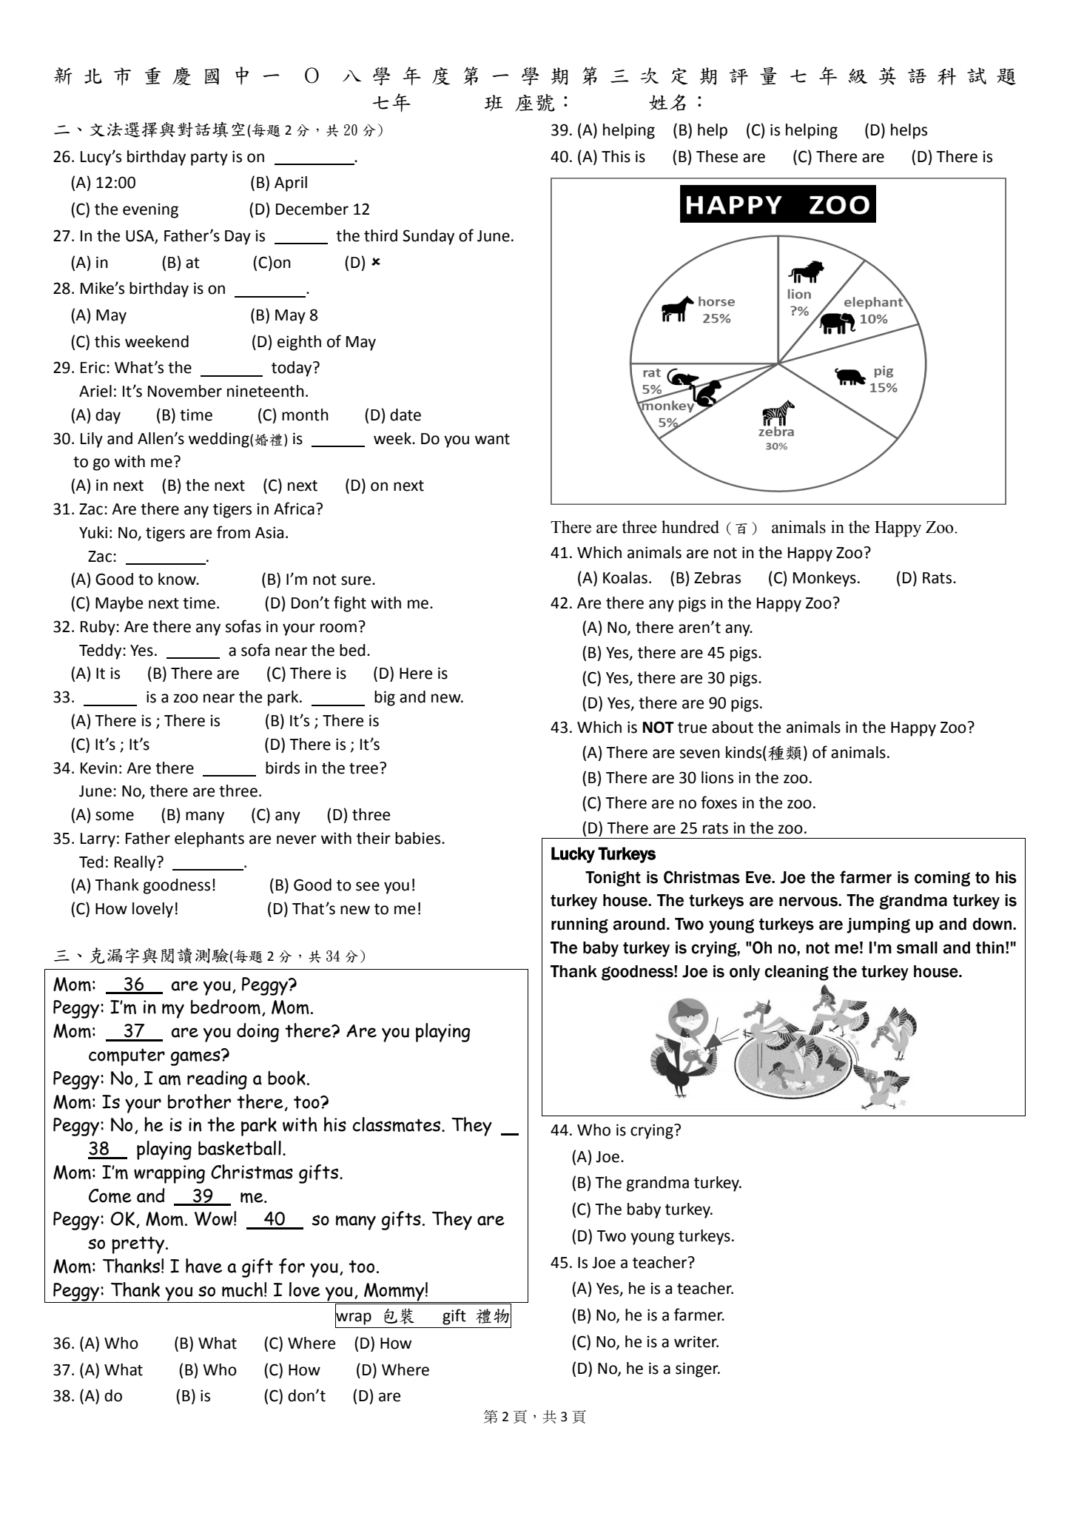
(A) Black Room. (B) Green Room. (C) Red Room. (D) White Room.

(二)
There are three hundred (百) animals in the Happy Zoo.
45. Which animals are not in the Happy Zoo?
(A) Zebras (B) Monkeys. (C) Koalas. (D) Rats.
46. Are there any elephants in the Happy Zoo?
(A) No, there aren’t any. (B) Yes, there are 10 elephants.
(C) Yes, there are 30 elephants. (D) Yes, there are 90 elephants.
47. Which is NOT true about the animals in the Happy Zoo?
(A) There are 25 rats in the zoo. (B) There are no foxes in the zoo.
(C) There are seven kinds (種類) of animals. (D) There are 30 lions in the zoo.
(三)
Shortly before Chinese New Year, all Chinese clean up their houses. It means cleaning away all bad luck. Many people put red couplets on their front doors. Some people put the word “Fu” upside-down on the wall. “Fu” means luck. The upside-down “Fu” means “luck is coming.” Many people go home to have a big dinner with their family. There are a lot of foods, like hotpot and fish. At the end of the big dinner, parents give their children lucky money in red envelopes. The money means good luck. Many families don’t sleep all night to welcome the New Year. On New Year’s Day, people set off firecrackers. People also wear new clothes and hats for the New Year. People can see lion and dragon dances on the street. On the second day of the New Year, daughters-in-law go back to their own mother’s house for a family reunion. They can be with their family on that day. On the fifth day of Chinese New Year, many people open their stores again for business. People make wishes during the first few days of the New Year. Now that you know a lot about Chinese New Year, you are ready for the next great Chinese New Year!
couplets對聯envelope信封set off 使爆炸firecracker鞭炮
lion and dragon dance 舞龍舞獅daughter-in-law媳婦business生意

48. What is the best title (標題) of this reading?
(A) Chinese New Year Is Coming
(B) All about Chinese New Year
(C) People Have a Big Dinner on Chinese New Year’s Eve
(D) Children Get Lucky Money on Chinese New Year’s Eve
49.What is the meaning of reunion?
(A) Giving thanks (B) Watching lion and dragon dances (C) Getting good luck (D) Coming together again
50. According to(根據) the reading, what DON’T people do during the Chinese New Year?
(A) People eat hotpot and fish.
(B) People open the stores for a big dinner.
(C) Parents give their children lucky money.
(D) People put the word ”Fu” upside-down on the wall.

