桃園市立大有國民中學109學年度第一學期第三次評量試卷
年 級 | 八 | 考 試  科 目 | English |  |  | 命 題  範 圍 | Lesson5 ~ Review3 | 作 答  時 間 | 45分
班 級 |  | 姓 名 |  | 座 號 |  | 分 數
第一大題到第三大題為聽力測驗，請仔細聆聽！

一、辨識句意：每題均有三張圖片，請依據所聽到的句子，
選出符合描述的圖片(6%)
- (A) (B) (C)
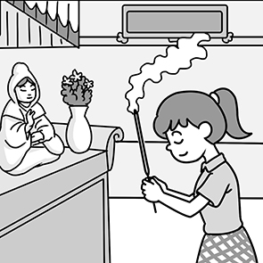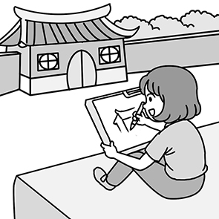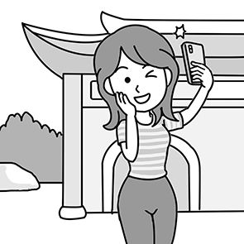

- (A) (B) (C)
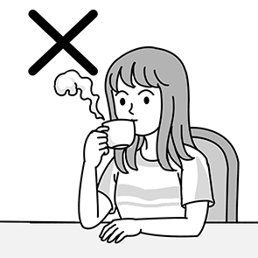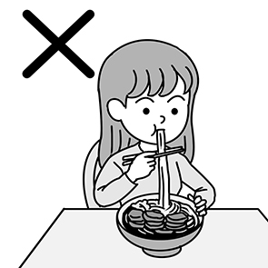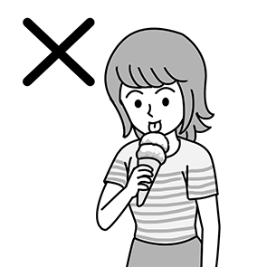

- (A) (B) (C)
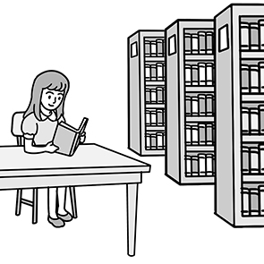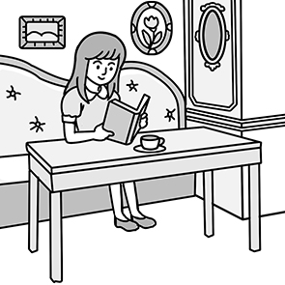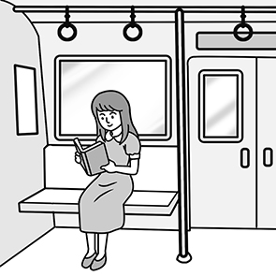

- (A) (B) (C)
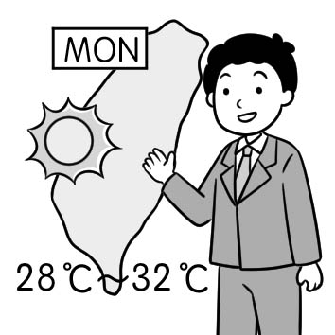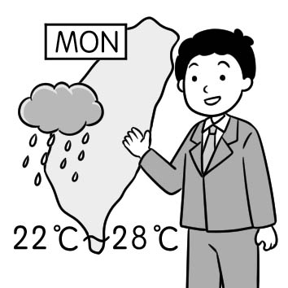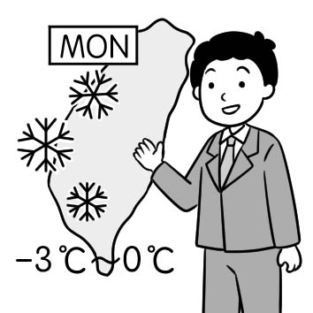
- (A) (B) (C)
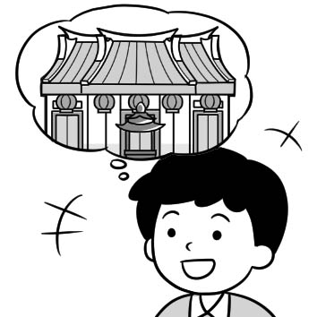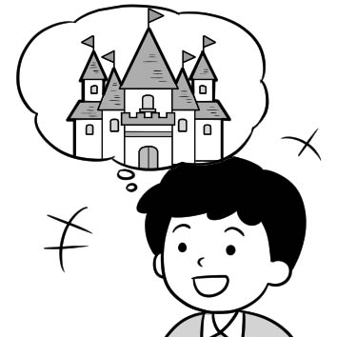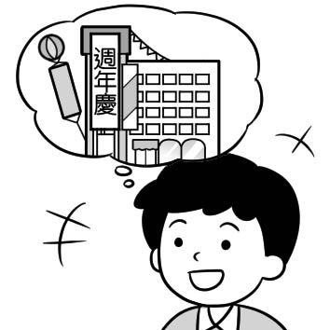

- (A) (B) (C)
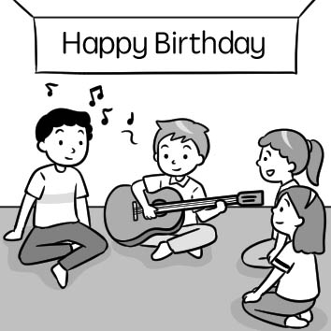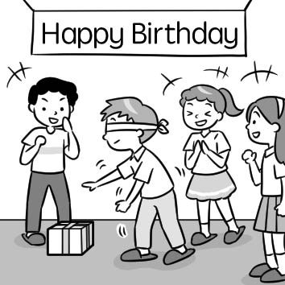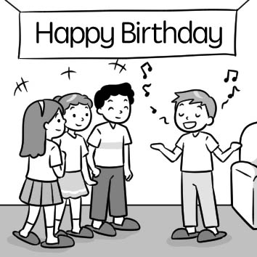

二、基本問答：每題均有三個選項，請依據所聽到的內容，
選出一個最適合的回應(10%)
- (A) Just in time.
(B) Maybe later.
(C) Half an hour.

- (A) It is delicious.
(B) I like to drink milk tea.
(C) It’s not good for my health.

- (A) It’s simple!.
(B) Oh, I am free.
(C) It didn’t cost much.

10.(A) It’ll be rainy after work.
(B) Sure. That should be fun.
(C) Yes, everything will be fine.

11.(A) No. That will take a lot of time.
(B) Yes. And it won’t cost much money.
(C) Yes, it will take me three hours to get there.

三、言談理解：每題均有三個選項，請依據所聽到的對話
與問題，選出一個最適當的答案(10%)
12.(A) Ten years.
(B) Ten weeks.
(C) Ten months.

13.(A) He loves to help people.
(B) He is a foreigner in Taiwan.
(C) He doesn’t enjoy the food in Taiwan.

14.(A) She will get married in May.
(B) She goes to Tainan every day.
(C) She will get married with Fred.

15.(A) Everyone could get one at the store.
(B) The watch was the girl’s birthday gift.
(C) The girl didn’t spend any money on the watch.

16.(A) There will be a typhoon.
(B) The woman will go outside.
(C) Jerry and Ted won’t play basketball anymore.

四、綜合測驗 (48%)

17. | Mom spent five hundred and fifty-five dollars _________ the fruits and vegetables.
 | - with |  | - on | - at |  | - for
18. | I answered the question in three seconds(秒) because it’s very ___________ .
 | - hard |  | - simple | - different |  | - sample
19. | You should keep quiet in the _____________. Many people read books there.
 | - restroom |  | - library | - department store |  | - Net
20. | What do you ____________ when you see pizza?.
 | - worry |  | - think of | - proud of |  | - take care of
21. | Peter is a new student in our class. We know very ____________ about him.  (A) something (B) much (C) little (D) few
22. | After the _____________ hit Taiwan, the old building fell down.
 | - earthquake |  | - information | - scenery |  | - design
23. | Lee: What a cool jacket! Is it expensive?  Tom: Nope. I bought it ___________ a low price.
 | - with |  | - for | - at |  | - on
24. | Rosa _________ two hours and forty minutes____________ the delicious meal for her family.
 | - took; to cook |  | - took; cooking | - spent; to cook |  | - spent; cooking
25. | Nancy: Father’s birthday is coming. Any ____________ for the gift?  Linda: How about the watch that we saw yesterday?
 | - ideas |  | - visitors | - dreams |  | - cases
26. | I ________________________ next weekend. My final exam is coming.  - will studying English  - am not going to play the basketball  - won’t play computer games  - had to prepare for it
27. | Eddy: ___________ does it take to finish your homework on weekends?  Pete: About thirty minutes.
 | - How soon |  | - How much | - How often |  | - How long
28. | Riding a bike to school _____________ me save some time on weekdays.
 | - helps | - make |  | - take | - draw
29. | Before I got to the ______________, the train left.
 | - apartment |  | - convenient store | - station |  | - temple
30. | The cellphone ____________ David twenty thousand dollars.
 | - paid (B) took (C) spent (D) cost
31. | Jane is making snacks for her classmates because there ___________ a party at school this evening.
 | - will be |  | - will have | - is going to have |  | - will be have
32. | The coffee is ____________. It doesn’t cost a cent.
 | - cheap |  | - expensive | - hot |  | - free
33. | Mia: Look over there! We can take a break in the dining area.  John: ____________________  - Really? There’s a museum.  - That’s amazing! You can’t go there by train.  - Lucky you! It’ s easy to buy a ticket.  - Ok. Let’s have some hot tea there.
34. | The new ______________ looks modern. Besides, I feel comfortable when I’m sitting on it.  - coach (B) printer (C) cent (D) couch
35. | Lisa has many good friends because she is ______________ to everyone.
 | (A) friendly (B) comfortable (C) mean (D) foreign
36. | Is __________ difficult for Mary to sing a song in front of other people?  - that (B) anything (C) it (D) doing
37. | Mandy isn’t happy about her work. She’s ___________ about giving up her job.  - order (B) serious (C) material (D) own
38. | Alex: Where’s the 3D printer? Didn’t you bring it?  Sue:________________________  (A) That’s cool. My dad bought it for me.  (B) Nope. Let me show you.  (C) Sorry, I forgot.  (D) Great! I used it to make my glasses.
39. | Mike: Are you going to eat a hamburger for dinner tonight?  Lisa : Yes, ___________________. How about you?  - I will (B) you are (C) I am (D) you will
40. | Jerry: Simon, do you want to play basketball with us?  Simon: I’m afraid not. _____________________  - Have fun and be careful. (B) You bet!  (C) Like what? (D) What a surprise!

五 克漏字、閱讀測驗(26%)
41~43
We happen to visit Denganmal in India for several days. There are only about 500 people in this small town. We are visiting Bhagat and his family. Although his house is made of mud, it’s one of the biggest houses in the neighborhood and Bhagat’s family is one of the largest around the place.
A woman about forty years old comes out to welcome us happily, telling us she is Tuki. At the same time, two other women come from inside the house to see us, too. Tuki is Bhagat’s first wife. She has been married for tens of years. Saakhri and Bhaggi join the family later. They are Bhagat’s second and third wives. A man in India can only have one wife, but why can Bhagat have three wives? They face a serious problem. There is no water in the summer months. Because wells run dry, they have to walk to a far well or to a river to get water. It takes twelve hours to go there and come back home. Tuki can’t leave her six children alone for so long to get water. That’s why Bhagat get married three times. Saakhri and Bhaggi can now go and collect water while Tuki does housework at home and takes care of kids when her husband works in the fields.
Saakhri and Bhaggi are now known as “water wives.” They do the same thing for years. Although life in India is difficult, the family eat and live together happily.

* neighborhood 鄰近地區 far 遠的 well 井 field 田地

41. What do we know about Bhagat?
(A) He lives in a big city in India.
(B) He’s poor and doesn’t have a chance to work.
(C) He’s probably richer than most of the people in his place. * richer 較富有 than 比
(D) There aren’t many people in his family.
42. If they go to get water at 6:00 a.m. when do they get home?
(A) At 6:00 p.m. (B) At 8:00 p.m. (C) At 9:00 p.m. (D) At 12:00 p.m.
43. What does Bhagat’s first wife always do for the family?
(A) Get water from the well every morning.
(B) Work on the farm.
(C) Help her husband work on the farm.
(D) Do housework and take care of her children.

44~46
Dear Annie,
I’m really worried about our daughter, Sophia, these days. I just can’t understand why she always thinks she is too heavy. She refuses to eat food like pork and beef. She eats very little rice. She has only fruit and vegetables. In fact, I feel that she is too skinny. I once took her to see a doctor, and the doctor said she should eat in a balanced way. She also needs to exercise more to stay healthy, but she still insists on doing it in her own way. Maybe you can talk to her after you come back from Japan.
Love,
John 4/14/2020

*refuse拒絕 skinny 骨瘦如柴的 balanced 均衡的 insist 堅持

44. What is the relationship between John and Sophia? * relationship 關係
(A) Brother and sister. (B) Father and daughter.
(C) Son and mother. (D) Husband and wife.
45. What is Sophia’s problem?
(A) She thinks she is too heavy.
(B) She misses her mother a lot.
(C) She doesn’t like fruit or vegetables.
(D) She always worries about her father.
46. What did Sophia do after seeing a doctor?
(A) She did a lot of exercise with her father.
(B) She ate some meat every day.
(C) She ate only rice.
(D) She still wouldn’t exercise more.

47~49
Look at the bulletin board at Josh’s school. * bulletin board 布告欄
Some English storybooks for sale

About thirty books. Fifty dollars for each one. If you want to learn English, buy them.

Ariel 0981-325-904
Soda Green is coming!

Do you like their songs? Here they are! They will bring the best songs for us. Let’ s join the greatest music party tomorrow!
Time: 7:30 p.m. Friday February 5th
Place: At our school gym

Where is my dog?

Her name is Spot. I lost her at the playground yesterday. She is white and cute. Please call Gini at 0935-9090119
We need you!

Want to play on the school basketball team? You have the chance to make your dreams come true. Come to the basketball tryout at the gym after school today. You might be a star.
2021/2/4

47. What does “one” mean?
(A) A dog. (B) A song. (C) A book. (D) A basketball team.
48. Michael enjoys reading books. What can he do?
(A) Find the dog at the playground. (B) Call Ariel for the books.
(C) Go to the music party. (D) Join the basketball tryout at the gym.
49. Which is true?
(A) There is a music party this Friday morning.
(B) Gini lost her cat at the playground yesterday.
(C) Ariel’s cellphone number is 0935-909-119.
(D) The basketball tryout is on Thursday.

50~53
When you grow old enough, sharing housework at home or doing things for yourself is quite important for you. It makes your parents’ life easier. Besides, it also helps you finish something on your own and learn skills in living. 50 you should be doing on your own when you are a teenager.
- Learn how to use you money
Making money isn’t easy. When your parents give you pocket money, you 51 . You should also be able to fill out a deposit form in the post office or a bank to deposit your money.
- Prepare meals by yourself
Learning preparing a snack, or even cooking a simple meal for the family is quite important. You should
know your way around the kitchen. And 52 when your parents are away from home for some time.
- Finish your school work
You should be able to finish your homework by yourself without your parents’ telling you again and again. It’s your business, not your parents’.
4. 53
For your parents, they have been really troubled to get you up on early morning since you started junior
high school. Make a good habit of waking up yourself and go to school on time.
- Clean the house
You need to clean your house with your parents and you are able to help keep your house clean at any time.

＊ deposit form 存款單 since 自從

50. (A) We can do what (B) Here are five things
(C) Check everything (D) I worry about
51. (A) buy some important things (B) put it in your wallet
(C) should know how to use it (D) shouldn’t go food shopping
52. (A) you can buy some food in the supermarket
(B) you can clean the kitchen by yourself
(C) you can make a meal for yourself
(D) you can study on your own
53. (A) Going to school on time is important (B) Be sure to have good study habits
(C) Getting up early is troubling (D) Wake yourself up in the morning

試題結束
請確認答案卡的座號

