桃園市立大有國民中學108學年度第二學期第三次評量試卷
年 級 | 8 | 考 試  科 目 | 英語 |  |  | 命 題  範 圍 | L7 --- Review 3 | 作 答  時 間 | 45分
班 級 |  | 姓 名 |  | 座 號 |  | 分 數

A: 聽力測驗 30%
- 辨識句意：根據聽到的內容，選出符合描述的圖片或符合圖片的描述。
- （ ）
(Ａ) 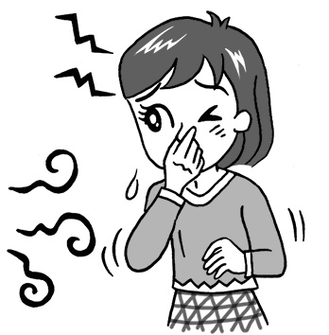 (Ｂ) 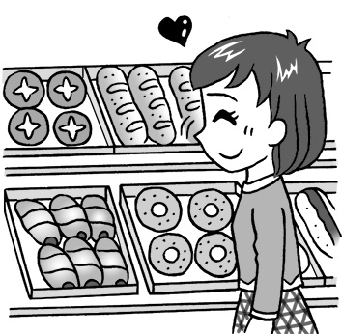 (Ｃ) 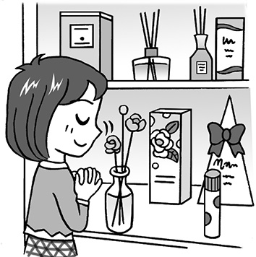

- （ ）
(Ａ) 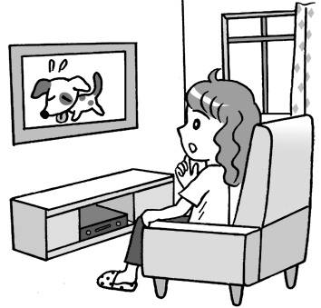 (Ｂ) 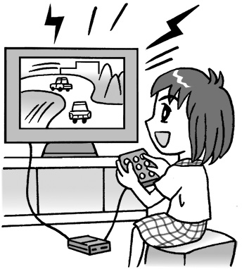 (Ｃ) 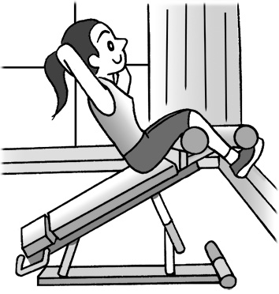

- （ ）
(Ａ) 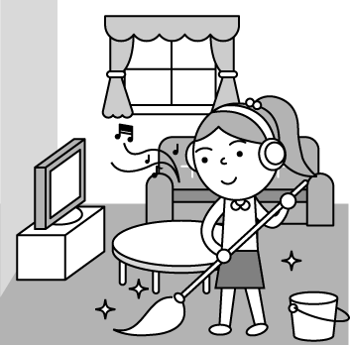 (Ｂ) 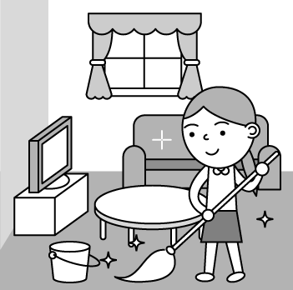 (Ｃ) 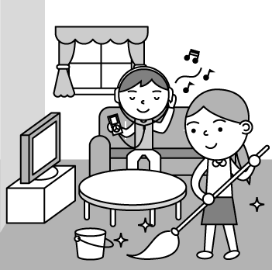

- （ ）
(Ａ) 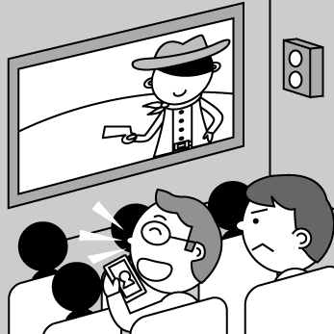 (Ｂ) 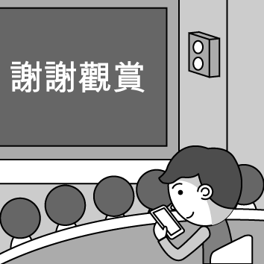 (Ｃ) 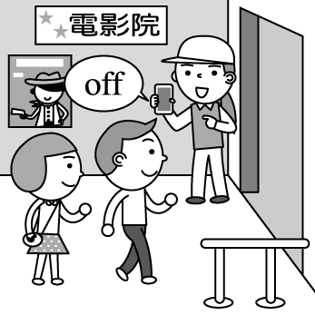

- （ ）
(Ａ) 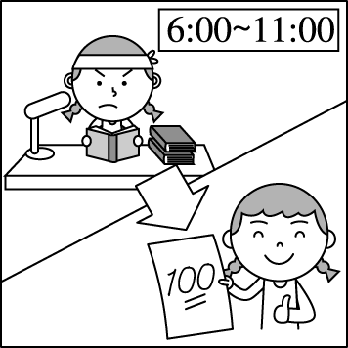 (Ｂ) 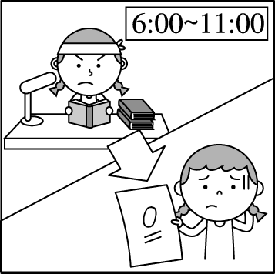 (Ｃ) 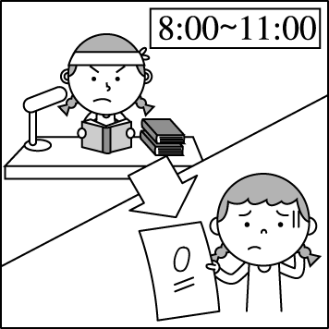

- 基本問答：根據聽到的內容，選出一個最適合的回應或最適合的問句。

- （ ）
(Ａ) I didn’t order this.
(Ｂ) Can you bring me a fork?
(Ｃ) We need a little more time to think about it.
- （ ）
(Ａ) Going camping is really interesting to me.
(Ｂ) When you go camping, I’ll watch the door for you.
(Ｃ) I need to do housework and take care of my brother.
- （ ）
(Ａ) You’re right. I have the same feeling like you.
(Ｂ) Maybe we can share something with him.
(Ｃ) Let’s watch his most famous play now.
- （ ）
(Ａ) I see. I’ll give it a try.
(Ｂ) You’re a very nice husband.
(Ｃ) That’s not a problem. It doesn’t take time.
- （ ）
(Ａ) There’s no fruit on the farm.
(Ｂ) I don’t think picking fruit will be free.
(Ｃ) Of course. Let’s be a one-day happy farmer!

- 言談理解：根據聽到的內容，選出一個最適合的答案。

- （ ）
(Ａ) People tip service workers in the USA.
(Ｂ) The woman is going to France next month.
(Ｃ) Service workers in the USA don’t care about tips.
- （ ）
(Ａ) They are talking about the new library nearby.
(Ｂ) The woman told the boy to study in a library.
(Ｃ) The boy and the woman are both junior high school students.
- （ ）
(Ａ) Turn on the lights.
(Ｂ) Eat more meat.
(Ｃ) Sort the trash.
- （ ）
(Ａ) He has to listen carefully and take notes in class.
(Ｂ) He has to go to cram school.
(Ｃ) He has to spend more time studying.
- （ ）
(Ａ) They are talking about movies and music.
(Ｂ) They are talking about tips for learning English well.
(Ｃ) They are talking about the latest computer games on the Net.

B: 綜合測驗 70%
- Kenting ________ Park is famous for its unique（獨特的）sceneries, and tropical climate （熱帶氣候）with sunshine
throughout the year.
(A) Nation (B) International (C) Country (D) National

17. My parents always tell me not to make the same ________ again.
(A) respect (B) mistake (C) prince (D) queen

18. Bubble milk tea is very popular in Taiwan, and you can find it in every ________ of Taiwan.
(A) part (B) gate (C) castle (D) stage

19. Half of the children ________ late this morning because the school bus broke down.
(A) is (B) was (C) are (D) were

20. If you ________ thirsty, ________ a glass of water.
(A) are；have (B) will be；has (C) are；will have (D)will be；have

21. ________ of my parents is a doctor. They ________ work in the hospital.
(A) One；all (B) Both；both (C) Each；both (D) Each；all

22. Natalie, the princess of the country, didn’t feel tired at all ________ she slept only for three hours last night.
(A) but (B) because (C) when (D) although

23. It makes me feel comfortable to have some cold drinks ________ the weather is hot.
(A) but (B) when (C) before (D) X

24. My brother always spends ________ of his time playing online games. He enjoys playing them very much.
(A) several (B) a few (C) most (D) many

25. Yesterday was my birthday, and I got three books from my dad. ________ of them are about computer games.
(A) One (B) Any (C) Both (D) Two

26. If the weather ________ fine tomorrow, we ________ a picnic.
(A) is ; will have (B) will be ; have (C) is ; have (D) will be ; will have

27. Sean is not Jolin’s big fan, ________ he plans to go to her concert with his wife.
(A) although (B) so (C) but (D) before

28. ________ ________ the English singing contest, everyone practiced a lot every day last month.
(A) After ; joinning (B) After ; join (C) Before ; joins (D)Before ; joining

29. No one thought Mary would show up at John’s wedding. So when she ________, everyone was surprised and could not
believe their eyes.
(A) was (B) did (C) does (D) is

30. Teacher Victor ________ coffee in the office when his student called him.
(A) was drink (B) drinks (C) is drinking (D)was drinking

You carried me on your shoulders when I was little
You put a smile on my face
With your silly joke
I grew stronger but you became weaker
You tried to catch up with me
When I sailed out into the sea
But your body did not listen to you
It pulled you under
You never stopped working
Until the day I saw you falling
I tried to catch you when you were falling
It was too late. God was calling
You gave me wings, so I could fly on my own
But I have to see you lying in the cold box alone
Someday, maybe, when I see you again
You will smile at me, with your healthy body

31. What does you refer to (與…相關) in the poem?
(A) The writer’s father. (B) The writer’s pet dog. (C) The writer’s younger brother. (D) The writer’s wife.
32. What can we know from the sentence But I have to see you lying in the cold box alone ?
(A) The writer’s father was sleeping. (B) The writer’s father was playing a zombie in a paly.
(C) The writer’s father was dead. (D) The writer’s father was flying in the sky alone.
33. What is true about the poem?
(A) The writer is a bird because he can fly. (B) The writer died at the young age.
(C) The writer is very happy because he has wings. (D) The writer misses a person a lot.

A long time ago, there was an elf (精靈) named Frez who was 34. of the best toymakers at the North Pole.
Every year, he 35. Santa make 36. of toys for kids. Santa was very happy with his work. However, Frez
got nervous during Christmas, so he ate more than he usually 37. . This worried Santa a lot, 38. Santa did
not know how to help him. One Christmas, Frez was too nervous to make toys. He kept 39. mistakes because he
wanted to make perfect toys. 40. Santa learned what was troubling Frez, he told Frez that every toy was good
enough when he made it with love. Frez became a happy elf after that.

34. (A) two (B) one (C) many (D) all
35. (A) help (B) is helping (C) helped (D) was helping
36. (A) two thousands (B) two thousand (C) thousand (D) thousands
37. (A) did (B) does (C) was (D) is
38. (A) if (B) before (C) but (D) so
39. (A) made (B) make (C) to make (D) making
40. (A) Before (B) Although (C) If (D) When
Germany is one of the countries famous for its traditional culture. Foreign visitors should be careful about the customs
(習俗) or manners（舉止）in Germany, especially the unspoken rules（潛規則）of behavior (行為).
Here is a list of the dos and don’ts in Germany
- Do not ask about people’s age.
- Do not ask about how much money people make.
- Bring a gift for the host when you pay a visit.
- During a meal, finish the food on your plate.
- Always be on time. That can make you win their favor.
- Always leave a tip for the waiters in the restaurant.
- When you greet people, do not hug them. Just shake hands and keep eye contact (接觸).
As the saying goes, when in Rome, do as the Romans do. Learning about German culture and customs before
visiting is important. It’s not polite to offend (冒犯) German people or hurt their feelings. So, remember the dos and don’ts
above when you have the chance to take a trip to Germany. It will make you a considerate person and bring you a lot of fun
during your stay in Germany.

41. Which behavior is polite in Germany?
(A) Just leave the food on the plate if you can’t finish it. (B) Being late is fine when visiting friends.
(C) Don’t give any tips to waiters or waitresses in the restaurant. (D) Keep eye contact when talking to someone.
42. What does when in Rome, do as the Romans do mean in this article?
(A) The customs in Germany are the same in Rome.
(B) Learning other countries’ culture and customs isn’t important.
(C) People in Germany are very polite.
(D) You should follow the customs of the people in that place when visiting another country.
43. What is the meaning of the word considerate?
(A) Nice. (B) Careful. (C) Correct. (D) Ugly.
BOARDING GATE CLOSES 10 MINUTES BEFORE DEPARTURE (出發), AND THE DEPARTURE TIME IS 04:00 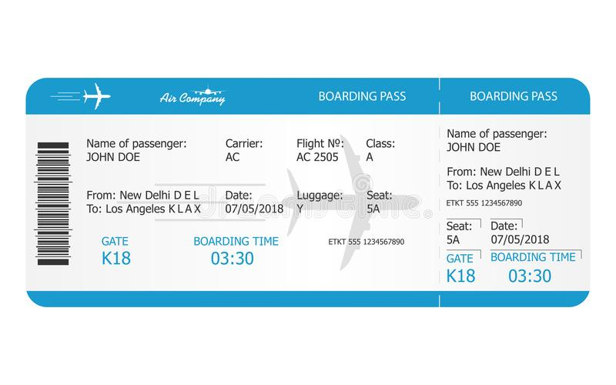

44. Which city is John’s flight leaving for?
(A) New Delhi. (B) Los Angeles. (C) Taipei. (D) Hong Kong.
45. What time does the boarding gate close?
(A) At 03:00. (B) At 03:30. (C) At 03:50. (D) At 04:00.

After the Lunar New Year holiday in 2020, people around the world have been worried about the COVID-19 (新型冠
狀病毒). Since then, more people have gotten the virus as it has spread from a market in Wuhan across China and to
several countries globally, including Taiwan. While a certain number of fear and anxiety (焦慮) is understandable（可理解
的）, the World Health Organization (WHO) and governments (政府) globally are working to control the spread of the
virus. More importantly, you need to know how to protect（保護）yourself and others.

- Wash your hands or use an alcohol-based hand rub often, especially 49. using the bathroom or handling（處理） animals or animal waste.
- Cover your nose and mouth when coughing or sneezing with your arm or tissue.
- Avoid (避免) close contact with others if you feel sick and wear a mask if you go out.

Besides the above, simply take care of yourselves: eat well, drink enough water, and get enough rest. The healthier you are the better off you will be anyway!

46. What is this article about?
(A) Mask. (B) China. (C) Virus. (D) Bathroom.
47. In which city did the COVID-19 start?
(A) Wuhan. (B) Taipei. (C) New York. (D) London.
48. Which is the most important way to protect yourself and others from the COVID-19?
(A) Stay up all night. (B) Wear a mask.
(C) Get together with friends and family. (D) Call the police.
49. (A) after (B) before (C) although (D) because
50. What should you NOT do if you feel sick?
(A) Stay home and take a rest. (B) See a doctor. (C) Wear a mask. (D) Go shopping with friends.

~ END ~
祝大家有一個愉快的暑假！

