桃園市立大有國民中學109學年度第二學期第一次評量試卷
年 級 | 八 | 考 試  科 目 | 英語 |  |  | 命 題  範 圍 | L 1 – L 2 | 作 答  時 間 | 45分
班 級 |  | 姓 名 |  | 座 號 |  | 分 數
選擇題含聽力測驗共37題 70%
聽力測驗:
一、辨識句意-根據聽到的內容，選出正確的圖片代碼：每題1分
- (A) (B) (C)
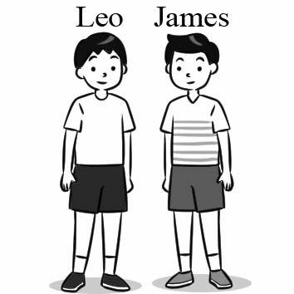 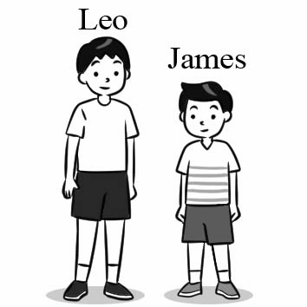 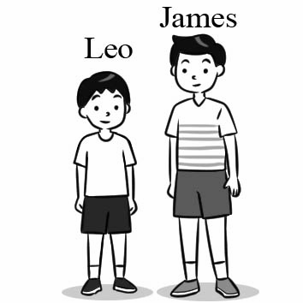
- (A) (B) (C)
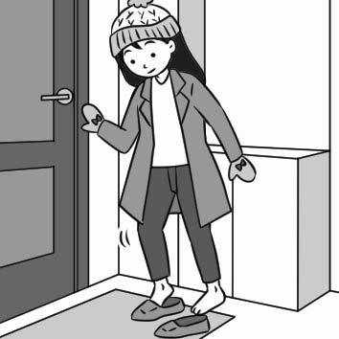 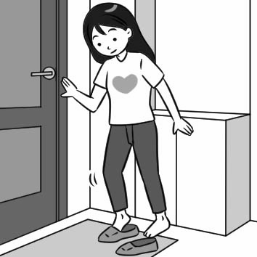 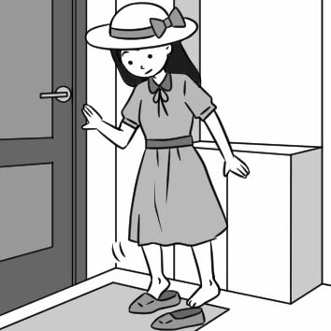
- (A) (B) (C)
  
- (A) (B) (C)
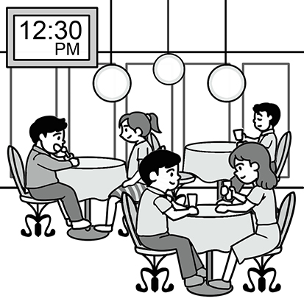 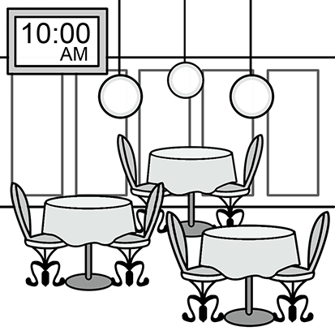 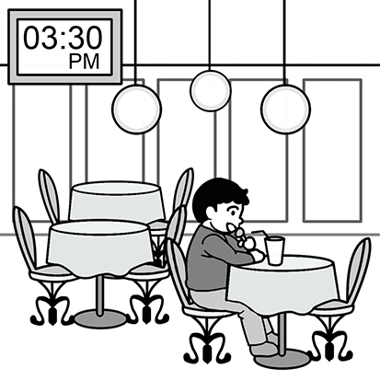

二、基本問答-根據聽到的內容，選出合適的回應：每題2分

- (A) Really? Can I try some?
(B) Chicken is cheaper than rice.
(C) Mom loves chicken very much.
- (A) No problem.
(B) It takes a long time.
(C) That belt is cheaper.
- (A) It’s not in India.
(B) That sounds wonderful!
(C) I will visit you next month.
- (A) I agree.
(B) I feel better.
(C) It sounds great.
- (A) No, the blue dress is yours.
(B) Right. It’s prettier and less expensive.
(C) You’re right. This dress is not very nice.

三、言談理解-根據聽到的對話內容與問題，選出正確的答案：每題2分
- (A) The girl’s mom can make soup.
(B) The girl ate at a pizza shop yesterday.
(C) The girl worked at a pizza shop before.
- (A) Salad from Uncle Jam.
(B) Bread from a supermarket.
(C) Sandwiches from Mama Bakery.
- (A) She doesn’t buy a sofa.
(B) She agrees to buy a sofa for NT$20,000.
(C) She is happy to pay NT$25,800 for the first sofa.
- (A) They are talking about lunch.
(B) The man will cook beef noodles.
(C) The woman still wants to have steak.
- (A) The weather looks nice.
(B) It’s safer to go outside now.
(C) Going out is more dangerous than staying home.

四、綜合測驗: 每題2分
( )15. Lucy: My friends are nice. How about ________?
Mina: Hers are nice, too.
- Dora’s (B) mine (C) her (D) your
( )16. Mary couldn’t find ________ pencil, so she used ________.
- her; my (B) her; mine (C) hers; me (D) she; mine
( ) 17. A: Helen, is this book ________?
B: No. It’s ________.
- his; her (B) Eric; mine (C) your; Eric (D) yours; Eric’s
( ) 18. Bella: What’s wrong with Andy? He ________ sad last night.
Alice: He lost his bike yesterday.
- tasted (B) smelled (C) looked (D) touched
( ) 19. Beth: How does the strawberry cake ________?
Kris: It’s so delicious. I can’t stop eating it.
- taste (B) sound (C) look (D) feel
( )20. James: Your house smells like ________.
Harry: Oh, I bought some flowers. They are on the table.
- sweet (B) big (C) a garden (D) a bun
( )21. A-mei’s voice sounds ________. We all like her song very much.
- terribly (B) terrible (C) beautifully (D) beautiful
( )22. Summer is coming. It becomes ________ in Taiwan.
- colder (B) hotter and hotter (C) colder and colder (D) hot and cool
( )23. Anita is ________ of the two girls.
- most beautiful (B) the most beautiful (C) more beautiful (D) the more beautiful
( )24. Haagen Dazs may be ________ ice cream in the world.
(A) the most famous (B) famous (C) famousest (D) more famous

五、克漏字測驗: 每題2分
Gorillas, chimpanzees and orangutans are all members of the same family: the primates. The gorilla is the ____(25)____ of the three and can be as tall as 1.75m. The orangutan is smaller. A male orangutan reaches about 1.4m, but the chimpanzee is the smallest of the three. Chimpanzees are not usually taller than about 1.2m. Gorillas have very long arms, which are ____(26)____ than their legs, but they have a short, heavy body. Orangutans are similar but their bodies are not as ____(27)____ as gorillas’. Again, the chimpanzee is the littlest. They only weigh between 50kg and 70kg. As gorillas are the ____(28)____ ape of the three, they have to eat the ____(29)____ food. They eat about 23kg of food each day. Besides, people think that gorillas, chimpanzees and orangutans are very smart because all three apes can communicate with their own species. For example, an orangutan can be heard by other orangutans up to 1km away. But chimpanzees have a much louder call. Their danger signal can be heard up to 3km away! Sadly, all three apes are in danger because their worst enemy takes over their home. Do you know who their enemy is? It’s us – human beings!
gorilla ( 大猩猩) chimpanzee ( 黑猩猩) orangutan ( 紅毛猩猩) ape (猿) enemy (敵人)
primates (靈長類動物 ) species (物種 ) signal (信號 ) take over （佔領）human beings （人類）
( )25. (A) larger (B) largest (C) most large (D)large
( )26. (A) long (B) longest (C) the longer (D)longer
( )27. (A) heavy (B) heaviest (C) more heavy (D)heavier
( )28. (A) even bigger (B) biggest (C) bigger (D)big
( )29. (A) many (B) much (C) more (D)most

六、閱讀測驗: 每題2分
Daoyou Daily News from India
Not many people heard of IR8 before, but in India most of the people eat it for meal. There is a great story behind
it. More than 50 years ago, with the second-largest people on land, India had big trouble keeping its people from getting
hungry. In 1966, people in Philippines, a country near India, tested a new kind of rice, and the result was wonderful.
One year later, a 29-year-old man, Nekkanti Subba Rao, successfully grew the new kind of rice in India. The new kind
of rice was shorter than the other kinds of rice plants, but it could grow a lot of rice. Nekkanti Subba Rao tried hard to
help and teach other farmers to grow the new rice, so he got the name of “Mr. IR8.”
When Nekkanti first successfully grew IR8 in India, he had no idea that it would start the Green Revolution. The
Green Revolution led to a big change in rice farming. Farmers grew the new kind of rice and got more than three times
rice. Farmers lived better lives, and hungry people got enough food to eat. Before long, IR8 came to other countries
near India. It saved millions of people from dying of not having enough food.
This November is the fiftieth birthday of IR8. It is now the most common kind on the farm. It just needs 130 days
to grow while others take around 160 to 170 days, but some people don’t think it tastes as ____42____ as the other
kind. However, with it, many countries are able to deal with the food problem successfully. Science brings IR8 to the
world and it saves a lot of people. Science truly can change the world.

( )30. From the reading, what may IR8 be?
- A big trouble. (B) A famous farmer from India.
(C) A kind of rice. (D) A man from Philippines.
( )31. Which one of the followings is correct?
(A) Science made people’s life better. (B) More and more people became hungry.
(C) The Green Revolution was bad for people. (D) IR8 needs much longer time to grow.
( )32. What is true about the reading?
(A) IR8 is shorter and tastes better than other kinds.
(B) India is the first country to grow IR8.
(C) 1967 was a great turning point in the history of rice farming.
(D) Nekkanti successfully grew the new kind of rice in India in 1966.
( )33. What does it mean in the reading?
(A) Farmer (B) Nekkanti (C) Green Revolution (D) IR8
( )34. (A) much better (B) best (C) better (D) good

Here is a list of four students’ school performance.
 | Allan | Ricky | Mary | Sophia
Chinese | 85 | 65 | 100 | 95
English | 60 | 100 | 95 | 85
Math | 75 | 75 | 65 | 100
History | 90 | 85 | 100 | 100
Science | 60 | 95 | 90 | 100
PE | 50 | 60 | 85 | 50
performance (表現)
( )35. According to the list, which is true?
(A) Allan’s math is better than Ricky’s. (B) Mary’s English is the worst of all.
(C) Sophia’s history is as good as Mary’s. (D) Ricky’s English is worse than Allen’s.
( )36. Whose grade in science is worse than the other students’?
- Ricky’s (B) Mary’s (C) Sophia’s (D) Allan’s
( )37. Here is a message from the teacher to the student’s parents. Who is the student?

Although your child is great at many subjects, her health worries me. She
failed every test in PE class and always looks tired. She doesn’t look as healthy as
other students.
- Ricky (B) Mary (C) Sophia (D) Allan

非選擇題，請同學們用黑色原子筆作答 30%
七、根據句意填入字詞，並做適當變化: 每題2分

quiet / touch / free / square / bath / snow / together /
popcorn / traditional / knock / clap / stand

- It ________ a lot in New York in winter last weekend. The whole city became a white world.
- After finishing practicing swimming, we can go to the movie ________.
- My dad and I always play basketball in our ________ time.
- Allan was taking a ________ when his teacher called last night.
- My children and I always have ________ when we see a movie in the theater.
- We Taiwanese always eat rice cake during Chinese New Year. It is a ________ snack in Taiwan.
- Don’t ________ the knife. It’s really dangerous.
- There are many people dancing in the ________ every evening.
- Listen! There is someone ________ on the door. Let’s check it out.
- Everyone ________ and shouted when our team got a point.
- You must keep ________ when you are in the museum.
- There are more than one hundred food ________ at the night market.

八、依提示作答: 每題2分
- The rabbit meat tastes like chicken. （依畫線部分造原問句）
- Hank is 15 years old.
Roy is 20 years old.
Jerry is 30 years old. (以Hank起首， 用最高級合併句子)
3. Your car is newer than my car, but Tim’s car is the most expensive. (畫線部分用所有格代名詞改寫)

~ End ~

