桃園市立大有國民中學110學年度第一學期第二次評量試卷
年 級 | 九 | 考 試  科 目 | English |  |  | 命 題  範 圍 | Unit3 ~ Review2 | 作 答  時 間 | 45分
班 級 |  | 姓 名 |  | 座 號 |  | 分 數

一、綜合測驗 (46%)

1. | The weather said there will be a typhoon in two days. We have to prepare for it.
 | - news |  | - interview | - report | - list
2. | Jenny cut her when she cooked dinner. She can’t do many things with her hand now.
 | - toe |  | - finger | - head |  |  | - shoulder
3. | It’s a good study for a student to preview lessons before taking classes.
 | - habit |  | - hobby | - keyword |  |  | - tool
4. | Kevin his new glasses and broke them. Now he has trouble seeing things clearly.
 | - rolled |  | - dropped | - dug |  |  | - interested
5. | It’s not to take someone’s things without asking. People might think you’re a thief.  (A) correct (B) fake (C) crazy (D) real
6. | Most students are the coming trip because they can have fun with their classmates.
 | - boring |  | - expecting | - interesting |  |  | - excited
7. | The tree grew to a of 20 feet. No one can reach the top of it.
 | - height |  | - land | - kilogram |  |  | - sight
8 | Teenagers under 18 aren’t allowed to ride a . They must pass the road test.
 | - taxi |  | - motorcycle | - bicycle |  |  | - ship
9. | My favorite singer,Jolin, is going to show on the TV . I can’t wait to listen to her singing.
 | - meeting |  | - club | - group |  |  | - program
10. | Don’t make any about Peggy’s new hairstyle. She can’t stand it.
 | - commons |  | - mistakes | - comments |  |  | - reports
11. | Tony is afraid he will fail the final exam, so he has studied hard for weeks.
 | - of | (B) that |  | (C) if |  | (D)why
12. | The basketball game was to me. The player made a 3-point shot at the last second.
 | - exciting |  | - excited | - excite |  |  | - bored
13. | Grace is the lower price of the pretty dress. She thought it would be very expensive.
 | - surprising at |  | - surprised at | - surprising to | - surprised with
14. | Mark is a person, so everyone feels with him. He has few friends.
 | - bored ; boring |  | - boring ; boring | - boring ; bored |  |  | - bored ; bored
15. | Pauline forgot it was Amy’s birthday yesterday, so she didn’t prepare any gifts for Amy.
 | - X |  | - when | - whether |  |  | - if
16 | Jane will marry Tim is true. I feel happy for them.
 | - That |  | - X | - How |  |  | - Whether
17. | Everyone wants to know Helen crossed the river without a boat.  (A)that (B) what (C) how (D) can
18. | Tommy is wondering his best friend will come to his wedding or not.
 | - that |  | - when | - if |  |  | - what
19. | Did you tell Judy ? She felt so angry at the party.  (A) why didn’t you come the party  (B) why you didn’t come to the party  (C) whether you didn’t to the party  (D) if didn’t you come to the party
20 | Many people like to share their experience on on the internet.  (A) how can they take care of their pets  (B) how they do take care of their pets  (C) how to take care of their pets  (D) how their pets to take care of
21. | I have nothing in mind about our report . Could you tell me ?
 | - what to do it |  | - how to do | - what to do |  |  | - how I do it
22. | Karen looks upset. Do you know ?  (A) what the matter with her  (B) what wrong with her does  (C) what happened to her  (D) how was she
23. | I forget to wear a watch to school today. I am not sure  (A) what time is it ?  (B) what time is it.  (C) what time it is ?  (D) what time it is.
二、 克漏字、閱讀測驗(34%)
24~28
I know that everyone should have a hobby. I tried a few different activities, but I wasn’t really satisfied with them. First, I started playing basketball with my friends. However, it was really (24) because we ran around in the hot sun. I never had any energy the next day. So, (25) .
I thought painting would be easier. I painted at home, and I joined an art club at school. I also did some face-painting. That part was OK, but I was (26) painting on paper. I knew I’d never become a painter, so I stopped after a few weeks.
Next I tried music. I thought that it would be cool to play the guitar. However, I found it really (27) . I tried the piano and the flute as well, but they were even harder!
At the moment, I’m learning to cook. My mom is teaching me to make some American dishes. I don’t know (28) , but so far, so good. I think that cooking is interesting. Maybe I’ll become a cook and work in a restaurant one day!

24. (Ａ) tiring (Ｂ) tired (Ｃ) interesting (Ｄ) interested
25. (A) I joined a basketball team with my friends
(B) I gave up playing basketball as my hobby
(C) my friends invited me to play with them more often
(D) I made up my mind to play it well
26. (Ａ) exciting to (Ｂ) excited about (Ｃ) boring to (Ｄ) bored with
27. (Ａ) helpful (Ｂ) comfortable (Ｃ) difficult (Ｄ) easy
28. (Ａ) that I am tired of cooking
(Ｂ) what I like American dishes
(Ｃ) how I make it a hobby
(Ｄ) whether this will be my hobby

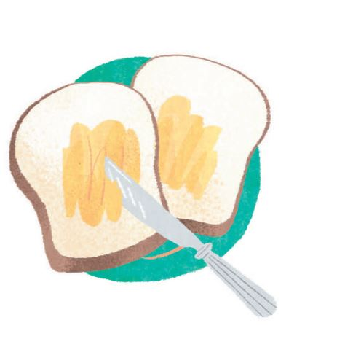
29~31
Murphy's Law
It's breakfast time. You are going to take a bite of a nice, warm piece of toast. Then you drop it and it falls. You pray for it to land on the side without butter on. However, it lands butter-side down! This is a perfect example of Murphy's Law.
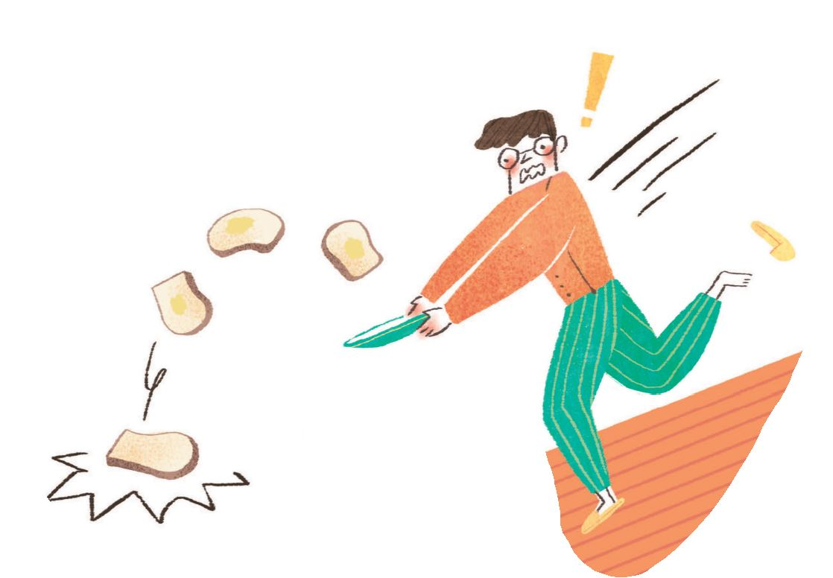
Have you noticed that it always rains when you least expect it? Or when you stand in line at a checkout, why does the line next to yours always seem to move faster? And why does your teacher always call on you when you don't know the answer to a question? If it is possible for something to go wrong, it will go wrong. This is Murphy's Law.
The lesson behind Murphy's Law is to be prepared for the worst. So, if you aren't ready for tomorrow's test, don't even think about cheating because you will get caught. Study hard!
 law 定律 butter-side 有塗奶油的那面checkout 付款櫃台

29. Which is NOT an example of Murphy's Law?
(Ａ) It always rains when you forget to bring an umbrella to school.
(Ｂ) You don’t want to meet somone, but they are usually around you.
(Ｃ) When you forget your wallet, someone pays for you.
(Ｄ) You just finished washing your car, and it starts to rain.
30. Which of the following is NOT the lesson from Murphy's Law?
(Ａ) Anything can happen, so we always need to be prepared.
(Ｂ) Hope for the best, prepare for the worst.
(Ｃ) Everything will go wrong, so we don't need to try hard.
(Ｄ) Always have more than one plan ready.
31. What is the definition of Murphy's Law?
definition 定義
(Ａ) A bad beginning makes a bad ending.
(Ｂ) Anything that can go wrong will go wrong.
(Ｃ) God helps those who help themslves.
(Ｄ) Actions speak louder than words.

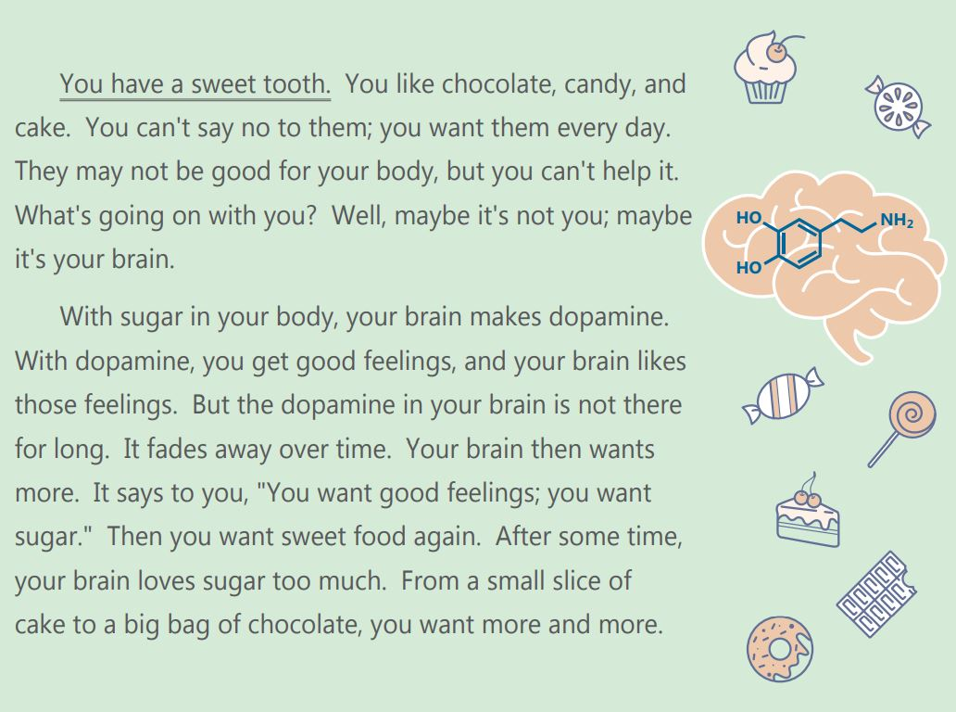
32~34
 brain 大腦 dopamine 多巴胺 fade away 逐漸消失 over time 隨著時間
32. You have a sweet tooth means .
(A) you like to bake sweet desserts
(B) you have terrible toothache
(C) you can't eat chocolate or candy
(D) you like sweet food very much
33. Which may be the title of the reading?
(A) Does Your Body Need Sugar?
(B) How Much Do You Like Sugar?
(C) What Does Sugar Do to Your Brain?
(D) Is Sugar Good or Bad?
34. Which picture explains the reading?
(A)
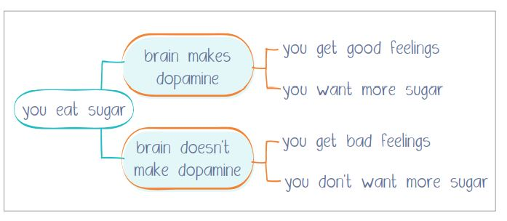

(B)
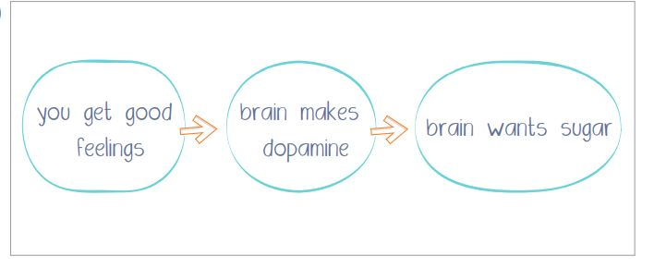

(C)
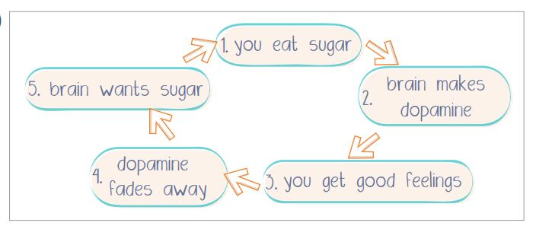

(D)
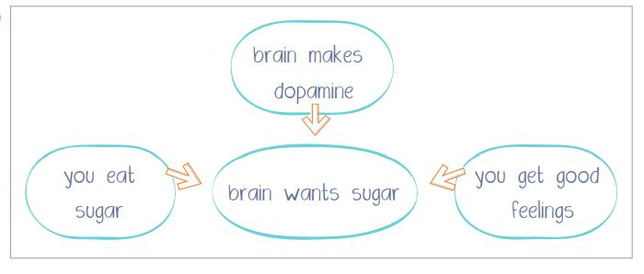

35~37
Vampires and Garlic
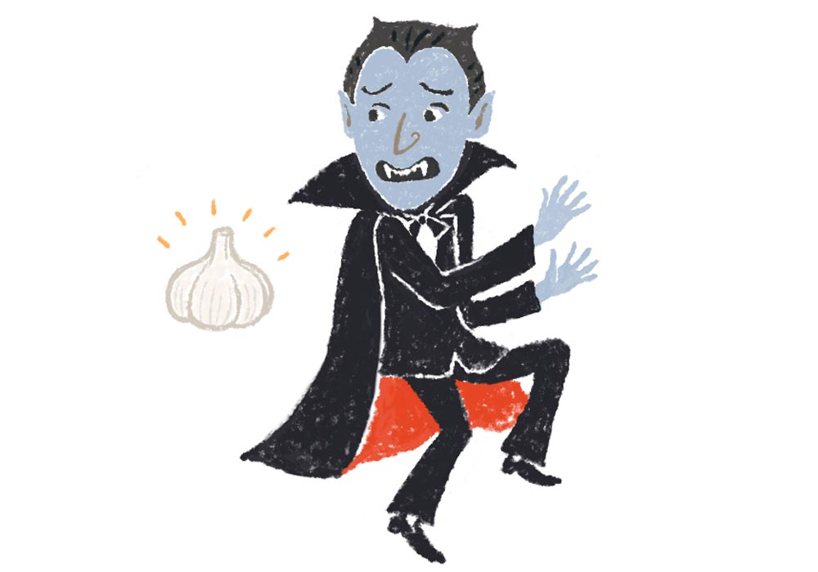
There is some interesting "information" about fighting vampires. One of the best ways is using garlic. But why is garlic a vampire's worst fear? Well, here are the reasons.
1. It just smells bad.
Many people love the taste of garlic, so its strong smell doesn't really keep them from eating it. But vampires are different. They hate the smell of garlic because they have a better sense of smell than we do.
2. It kills infection.
In all vampire stories, when a vampire bites you, you get an infection and then become a vampire. Here's good news for you. Garlic is a very strong antibiotic from nature, and it can fight off and kill most infections. So, if becoming a vampire starts from getting an infection, then garlic would probably be the best choice to finish off all vampires.
3. It can keep evil spirits away.
In many cultures around the world, people believe in the magic of garlic: It can protect them from evil spirits. Vampires are evil spirits, so they run away when they see garlic.Still not a fan of garlic? You should be! Although you may not like it, eating it may help you keep those scary vampires away!
 vampire 吸血鬼 infection 感染 antibiotic 抗生素 choice選擇 evil spirit 惡靈

35. According to the reading, vampires .
(A) have a better sense of smell than we do
(B) are the scariest evil spirits
(C) enjoy the taste of garlic but not its smell
(D) are scared of the dark
36. What does "finish off" mean in this reading?
(A) Save.
(B) Kill.
(C) Protect.
(D) Treat.
37. What is the main idea of the reading?
(A) To explain vampires’ fear of garlic.
(B) To give more information about vampires.
(C) To tell people to eat more garlic.
(D) To show people the right way to eat garlic.

38~40
Dear John,
It is not easy to tell you this, but I still need to say it. I'm leaving you. We have a sweet time, but I'm afraid it's over.
Leaving you really breaks my heart. When you're around, I am never bored. There is always something to do. I can ask you anything and you will probably help me find the answer. You let me experience so many interesting things through the Interest, such as new music, new games, new knowledge, new friends, and more.
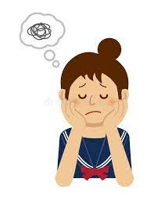
In fact, things have been totally different since you came into my life. When I wake up, you are there to go through my friends updates on Facebook and Instagram with me. Also, I check my LINE app again and again all the time. And when it doesn't show any new messages, I still refresh the screen, just in case I miss something. It is difficult for me to focus on school, and my grades are getting worse!
Besides, having you around is really hurting my relationships with my friends and family. When my friends and I hang out, I turn to you for Instagram updates and ignore everyone else. My friends try to talk to me, but I don't even answer because I am too busy paying attention to you. I'm worried that they won’t invite me out again! I love doing many things with you, but it means I seldom speak to my family! My parents are both unhappy and angry with me.
Althogh you’re not a real person, you're really wonderful and I'll miss you so much. But right now, I really need to focus on my studies, spend more time with my friends, and become a real part of my family again.
I hope you understand. For the last time, goodbye....

Best wishes,
Sally

 go through 經歷 refresh 刷新 just in case 以防萬一 focus on 專注於 hang out 出去玩
Relationship關係 update 更新 pay attention 注意

38. What is the meaning of the word “ignore “ in the reading?
(A) Don’t listen to someone’s talking .
(B) Be angry with someone .
(C) Feel interested in something.
(D) Want to be on the same page with someone.
39. Why does Sally want to leave John?
(A) John loves someone else.
(B) Sally's parents ask her to break up with John.
(C) She has changed for the worse.
(D) John seldom pays attention to her.
40. What is the real reason that Sally wants to write the letter?
(A) She wants to break up with her boyfriend.
(B) She wants to make a new boyfriend.
(C) She wants to quit using a cellphone.
(D) She wants to hang out with her friends.

共40 題，請在答案卡上作答，並於考後繳交答案卡。

