桃園市立大有國民中學110學年度第一學期第一次評量試卷(聽力)
年 級 | 九 | 考 試  科 目 | English |  |  | 命 題  範 圍 | Unit3 ~ Review2 | 作 答  時 間 | 45分
班 級 |  | 姓 名 |  | 座 號 |  | 分 數

聽力試卷共二面20 題，請於答案卡上作答，違者不予計分!

一、辨識句意：根據聽到的內容，選出正確的圖片代碼(4%)

- (A) (B) (C)
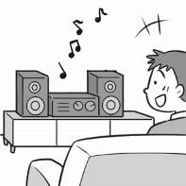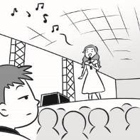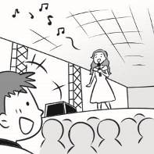

- (A) (B) (C)
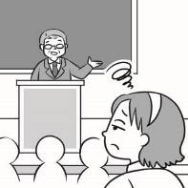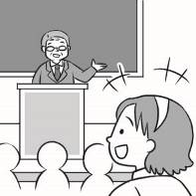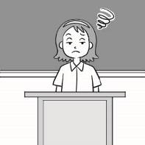

- (A) (B) (C)


- (A) (B) (C)
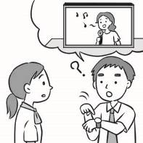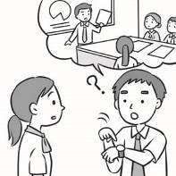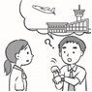

二、基本問答：根據聽到的內容，選出合適的回應 (8%)
- (A) I learned a lesson.
(B) I have a sore throat.
(C) The news interests me.
- (A) It’s tiring to Jack.
(B) He’s bored with it.
(C) I am excited about it, too.
- (A) I love the news.
(B) I fact-checked it.
(C) I’m bored with it.
- (A) I believe you.
(B) Check it before you share it.
(C) Search with some key words.
- (A) By scooter.
(B) From the airport.
(C) Just next to the pond.
- (A) He’s not on the list.
(B) He will drive to the airport.
(C) He’s a famous director from Taiwan.
- (A) I have no idea where to start.
(B) I think Judy would be good for the job.
(C) I’m wondering if you are interested in it.
- (A) We now understand how hard it is.
(B) We didn’t expect such a terrible sight.
(C) Well, we’re still not on the same page.

三、言談理解-根據聽到的對話內容與問題，選出正確的答案 (8%)
- (A) He feels bored.
(B) He feels excited.
(C) He feels worried.
- (A) She will be honest with her friends.
(B) She should not go to the hospital so often.
(C) She will not buy medicine online in the future.
- (A) A train driver.
(B) A tennis player.
(C) A news reporter.
- (A) They will cook for themselves.
(B) They’re interested in the same book.
(C) They will have dinner at the night market.
- (A) She bought a bag.
(B) She is tired of picking presents.
(C) She is excited about giving Amy a surprise.
- (A) In a hospital.
(B) In a shoe shop.
(C) In a convenient store.
- (A) A Delicious Dish.
(B) A Famous Camera.
(C) My Favorite Video.
- (A) Who the taxi driver was.
(B) Whether Danny is alive or not.
(C) Which hospital Danny is staying in.

