桃園市立大有國民中學110學年度第一學期第三次評量試卷
年 級 | 九 | 考 試  科 目 | English (Listening) |  |  | 命 題  範 圍 | Lesson5 ~ Review3 | 作 答  時 間 | 20分
班 級 |  | 姓 名 |  | 座 號 |  | 分 數
第一大題到第三大題為聽力測驗，請仔細聆聽！

一、辨識句意：每題均有三張圖片，請依據所聽到的句子，
選出符合描述的圖片(6%)
- (A) (B) (C)
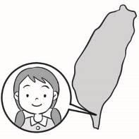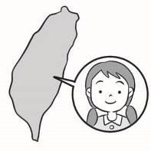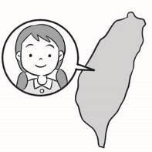

- (A) (B) (C)
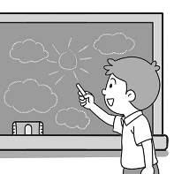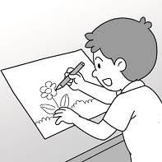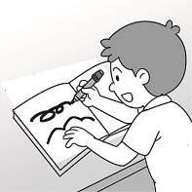

- (A) (B) (C)
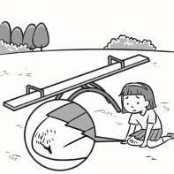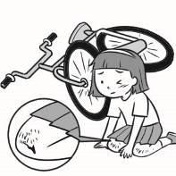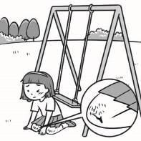

- (A) (B) (C)
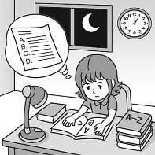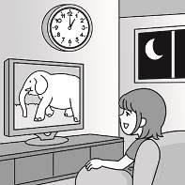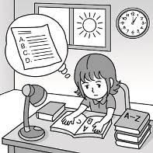
- (A) (B) (C)
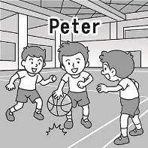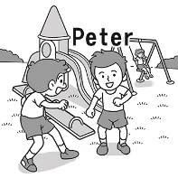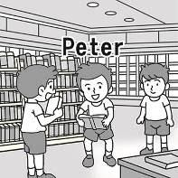

- (A) (B) (C)
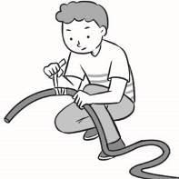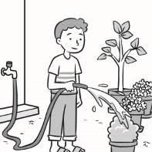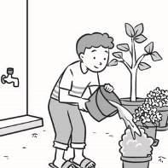

二、基本問答：每題均有三個選項，請依據所聽到的內容，
選出一個最適合的回應(7%)
- (A) I borrowed a workbook from her.
(B) The girl who works in the bakery is cute.
(C) She’s an exchange student from the USA.

- (A) You are a big fan of soccer.
(B) She always kicks the ball very hard.
(C) Don’t worry. I’ll show you how to do it.

- (A) As quickly as possible.
(B) Since junior high school.
(C) Every day except Sunday.

10.(A) I’ll use it to keep a diary.
(B) It sounds like a stupid idea.
(C) It was found in an envelope.

11.(A) I need three rooms, please.
(B) I don’t know who is in the room.
(C) I want a room with a beautiful lake view.

12.(A) We are going on a trip next week.
(B) Oh, no! I haven’t started packing yet.
(C) You should answer all the emails by tomorrow.

13.(A) Do you speak English?
(B) Then you should not talk now.
(C) I will go to the library tomorrow.

三、言談理解：每題均有三個選項，請依據所聽到的對話
與問題，選出一個最適當的答案(7%)
14.(A) A dictionary.
(B) An envelope.
(C) Glue and tape.

15.(A) He called 119.
(B) He started a fire.
(C) He shared some news.

16.(A) The copy machine is broken.
(B) She doesn’t know how to use a computer.
(C) There is something wrong with her computer.

17.(A) In a park.
(B) In a library.
(C) In a toy shop.

18.(A) A statue that looks like a tree.
(B) Something they moved to a tree.
(C) A person who didn’t move for a long time.

19.(A) They’ve got a new neighbor.
(B) They made a cake this morning.
(C) They bought some cakes from a bakery.

20.(A) The boy has some eye problems.
(B) The girl didn’t want to go to a doctor.
(C) Their science teacher didn’t write clearly.

試題結束
請確認答案卡的座號

