桃園市立大有國民中學110學年度第一學期第三次評量試卷
年 級 | 八 | 考 試  科 目 | 英語 |  |  | 命 題  範 圍 | Unit5~Review3 | 作 答  時 間 | 45分
班 級 |  | 姓 名 |  | 座 號 |  | 分 數
- 辨識句意：根據聽到的內容，選出符合描述的圖片或符合圖片的描述。(10%)
- (Ａ) 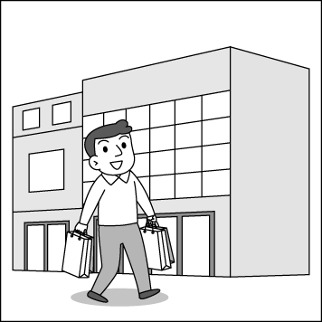(Ｂ) 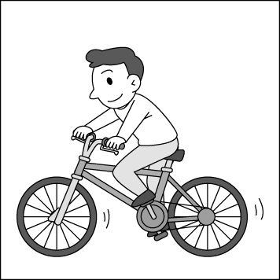(Ｃ) 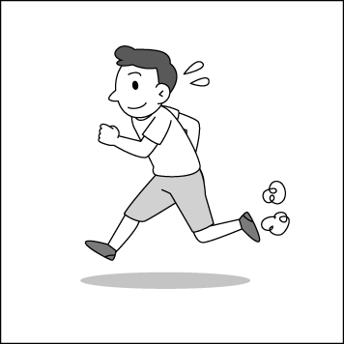
- (Ａ) 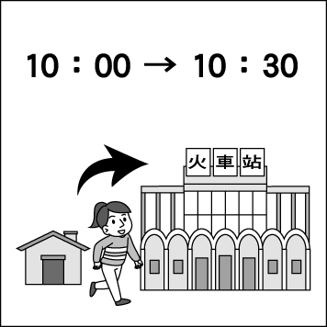(Ｂ) 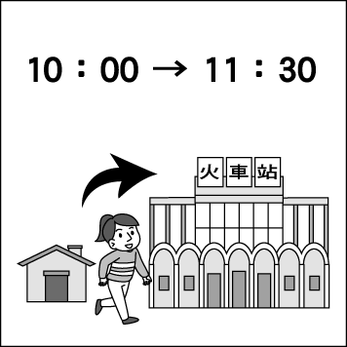(Ｃ) 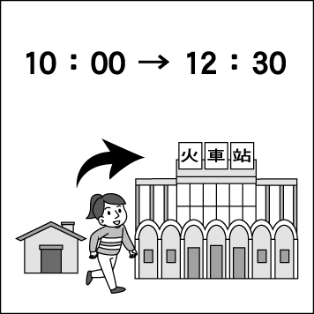
- (Ａ) 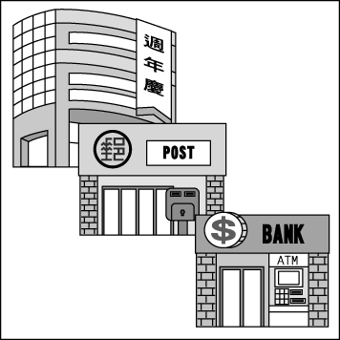(Ｂ) (Ｃ) 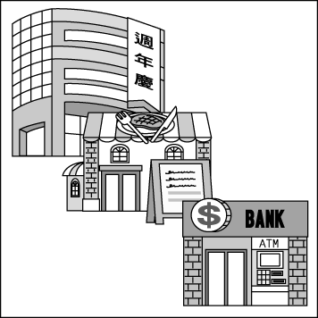
- (Ａ) 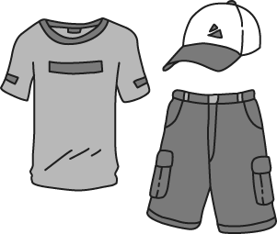(Ｂ) 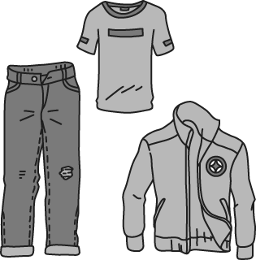(Ｃ) 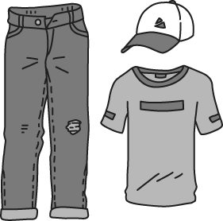
- (Ａ) 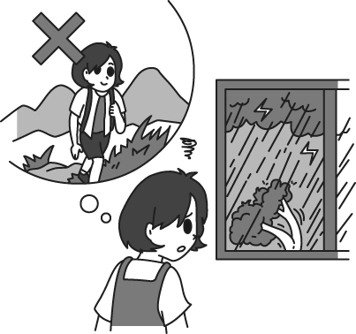(Ｂ) 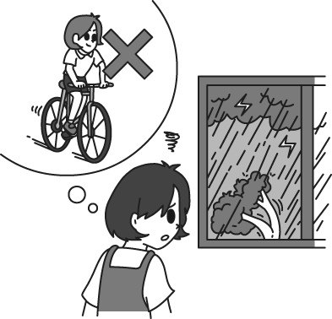(Ｃ) 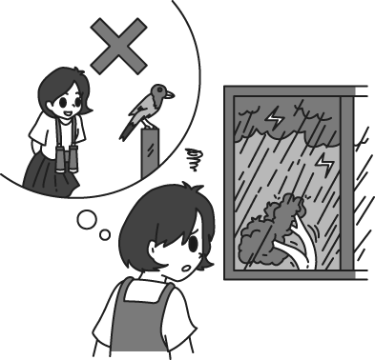
- 基本問答：根據聽到的內容，選出一個最適合的回應或最適合的問句。(10%)
- (Ａ) They go well with the shirt.
(Ｂ) They are four thousand in total.
(Ｃ) They are on a big sale now.
- (Ａ) I need to pay now.
(Ｂ) In cash, please.
(Ｃ) Sorry, I forgot to bring my credit card.
- (Ａ) No, he is coming soon.
(Ｂ) Yes, I will be free this Friday.
(Ｃ) No, he will be busy with his English report.
- (Ａ) I like to go window shopping.
(Ｂ) Only 15 minutes. I still have to pick up my son later.
(Ｃ) You can buy almost everything in the supermarket.
- (Ａ) Go straight and turn right. Walk about 5 minutes and you can see it.
(Ｂ) You can ask for help.
(Ｃ) There are many people in the hospital today.

- 言談理解：根據聽到的內容，選出一個最適合的答案。(10%)
- (Ａ) She doesn’t know much about Taichung.
(Ｂ) She doesn’t know the way to the train station.
(Ｃ) She doesn’t really like her job.
- (Ａ) She goes to the night market on foot.
(Ｂ) She goes to the night market by MRT.
(Ｃ) She goes to the night market by bus.
- (Ａ) The man and the woman are on the bus.
(Ｂ) The woman is going to the hospital.
(Ｃ) The man and the woman are at a bus stop.
- (Ａ) She is going to pay 300 dollars.
(Ｂ) She is going to pay 600 dollars.
(Ｃ) She is going to pay 1,000 dollars.
- (Ａ) On April 8.
(Ｂ) On March 3.
(Ｃ) On March 15.
四、文法選擇(46%)
（ ）16. The movie theater is ________ Love Road and Park Street.
(A) next to (B) between (C) across from (D) on the corner of
（ ）17. The of the cellphone is too high. I don’t have enough money to buy it.
(A) cost (B) pay (C) price (D) age
（ ）18. To earn(賺) money for living, David can do ________.
(A) something (B) anything (C) nothing (D) most
（ ）19. Taylor Swift, Gordon’s favorite singer, ________ Taipei to have a concert next month. He just
can’t wait to see her.
(A) are visiting (B) is going to visit (C) visited (D) will visits
（ ）20. Will Mia go shopping ________ ?
(A) just now (B) last night (C) later (D) every Saturday
（ ）21. Sally: What a clean house! How much time did you just spend ________ it up today?
Timmy: It took me the whole afternoon ________ it up.
(A) to clean; to clean (B) to clean; cleaning (C) cleaning; to clean (D) cleaning; cleaning
（ ）22. Amy: You are too heavy, and it may harm(傷害) your health. You can go jogging with me in the park every day. Doing exercise will _______ you nothing.
Jack: I’m really busy. _____________ do you spend on jogging every day?
Amy: Only about half an hour.
Jack: All right. I will try it in my free time.
(A) spend; How much (B) pay; How much (C) take; How long (D) cost; How long
（ ）23. The weather is fine and the sky is so clear. It’s a perfect time to .
(A) go stars watching (B) go star watching (C) go watching star (D) go watching stars
（ ）24. Alex: I NT$8000 for the bag.
Fanny: I can’t believe you so much money on it.
(A) spent ; cost (B) spent ; paid (C) paid ; spent (D) cost ; spent
（ ）25. Sam: _____ does it take _____ from here to Korea?
Brian: About four hours.
(A) How long; to fly (B) How much; flying (C) How long; fly (D) How much; flies
（ ）26. I _____ busy next month, but you _____.
(A) become ; don’t (B) will be ; won’t (C) was ; weren’t (D) am ; aren’t
（ ）27. The sound of the piano was beautiful, so everyone stopped _____.
(A) to listen (B) listening (C) to listening (D) listen
（ ）28. With eReaders like iPad and Kindle Fire, some people believe _____ no need for paper books in the near future.
(A) it will be (B) there is going to have (C) there will be (D) there is
（ ）29. Go straight _____ three blocks, and you’ll find the restaurant _____ your left.
(A) for ; on (B) for ; at (C) on ; on (D) to ; in
（ ）30. Which is NOT correct ?
(A) Will you drive or walk to the train station?
(B) Lily is going to take the boat to the island tomorrow.
(C) It took them only five minutes to walk to the library yesterday.
(D) Taking out the trash won’t cost you too much time.
（ ）31. Peter: Are you going to watch World Cup on TV tonight?
Hebe : .
(A) Yes, I am. (B) Yes, I do. (C) No, I will. (D) No, we aren’t.
（ ）32. The little girl is crying because she can’t find her parents. Let’s take her to the .
(A) supermarket (B) train station (C) police station (D) library
（ ）33. cheap workers, those factories can make more money.
(A) By use (B) In use (C) In using (D) By using
（ ）34. Clerk: ________
Rose: Thank you very much.
(A) Here your change is.
(B) Here is your change.
(C) Your change here is.
(D) Here is it.
（ ）35. Clerk: ________
Daisy: In cash.
(A) How much will you spend on it?
(B) Is there anything else?
(C) How would you like to pay?
(D) How much did you pay?
（ ）36. Jane: How do I get to the fire station?
Man: ________
(A) Turn right on Dayou Road and go straight. It’s next to the department store.
(B) Sorry. Can you help me, too?
(C) Aren’t they across from your school?
(D) It’s on Second Road.
（ ）37. Tim: When will Dad be back from Japan?
Emily: ________
(A) Why not ask her in person?
(B) He will be very busy in Japan.
(C) He won’t be back from Japan until Friday.
(D) He won’t be back to Japan today.
（ ）38. Jay: Excuse me. I’m new here. Where is Taiwan Bank, please?
Eva: ________
(A) Oh, Taiwan Bank is very big. (B) Yes, the bank is behind the post office.
(C) You can take a taxi to Taiwan Bank. (D) It’s between the bookstore and the hospital.
五、克漏字選擇(10%)
When Vivian and Jack went to the USA on vacation last week, a thief broke into their house. After they came back home, they found their family ring was missing. They 39. the police. Then, a police officer came and asked their neighbors some questions. One of the neighbors said, “When I heard a strange noise outside, I was surfing the Net. I thought there might be a cat running after a mouse again. So I didn’t mind it.” Another neighbor said, “I came back at 9:30. When I walked into the building, I heard a big sound outside. But I was busy 40. on the phone, so I didn’t go out and check. Mr. Lee 41. at the gate at that time. He must have heard that sound, too.” Mr. Lee said, “Yes, I heard the sound, too. I looked up and saw something moving in the dark. I thought a pot plant might be falling to the ground, so I asked the janitor to deal with it. Then I went out to buy a drink. I didn’t come back until 11:10.” The officer 42. asking the janitor. The janitor helped the officer to check what would be monitored on the closed-circuit TV. They found that a man in black was breaking the window with a hammer. That must be the thief. They also found some clear screenshots of the thief in the elevator. The officer said to Vivian and Jack, “It 43. easy for us to catch the thief with the screenshots in a few weeks. Please don’t worry.” After hearing what the officer said, Vivian and Jack were happy that they would get their family ring back soon.

＊break into闖入 janitor 大樓管理員 monitor 監視 closed-circuit TV 閉路電視
hammer鐵鎚 screenshot螢幕影像 elevator電梯

( )39. (A) call (B) called (C) are calling (D) will call
( )40. (A) talk (B) talked (C) talking (D) talks
( )41. (A) is smoking (B) was smoking (C) will smoke (D) smokes
( )42. (A) goes on (B) is going on (C) will go on (D) went on
( )43. (A) is going (B) will be (C) be (D) was

六、閱讀測驗(14%)
(一)
My father told me at dinner
With putting his hand on my shoulder.
On my birthday he’ll give me a pet gift,
And he wanted me to give him a list.

Maybe I could get a mouse,
And keep it in the house.
But will it play with the rats?
That would make us very sad.

Could I keep a white goose?
We could swim in the swimming pool.
My brother said its poop is stinky,
And makes our house dirty.

How about keeping a rabbit?
In the garden it had grass to eat.
Where could it live? I thought.
Let it free outside, of course.

It’d be fun to have a spider.
I’d hide it in my drawer.
Then I would prepare
To let my sister scared.

I listed all these animals on the paper.
With a smile I gave it to my father.
He talked to me keeping them was hard,
And said a puppy would be a good start.
poop 糞便 stinky 臭的

( )44. What gift would the writer get from his father on his birthday?
(A) A mouse. (B) A rabbit. (C) A cat. (D) A dog.
( )45. What is the writer’s plan for his sister?
(A) To prepare a gift for her. (B) To play a trick on her. (C) To make fun of her.
(D) To make a drawer for her.
( )46. What do we know from the poem?
(A) The writer had kept some mice in the house. (B) The writer lived in a house with a garden.
(C) The writer knew his sister did like pets. (D) The writer’s brother would swim with the goose.
(二)
Dear Allan,
I am excited that you’ll come to Taiwan for the first time next week. In order to help you have much fun, I put a lot of time into planning a wonderful trip for you. When you get to the airport, my father will drive his car to pick you up and then take you to our home. After your stay at our home for your first night in Taiwan, we’ll start our trip. We’ll set foot in some interesting places near my home. And because these places are not far away from my home, we can ride a bike to all of them. For another, all of them are special and popular, so I guess that you must be into them. Below is the itinerary along with the map I’ve prepared for you. I am sure you’ll love my hometown, where I’ve been living since I was born, and want to come again soon after you go back to the USA.

Itinerary for Lulu’s Trip
 | Day 1 | Day 2 | Day 3 | Day 4
Morning | City Zoo | Large Tree Park | Art Museum | Free time
Afternoon | The Great Bridge | Father Charlie’s Church | Robert’s Bookstore | Going to the airport
Evening | Duncan’s Department Store | Yummy Night Market | Party at Hank’s home | Going back home
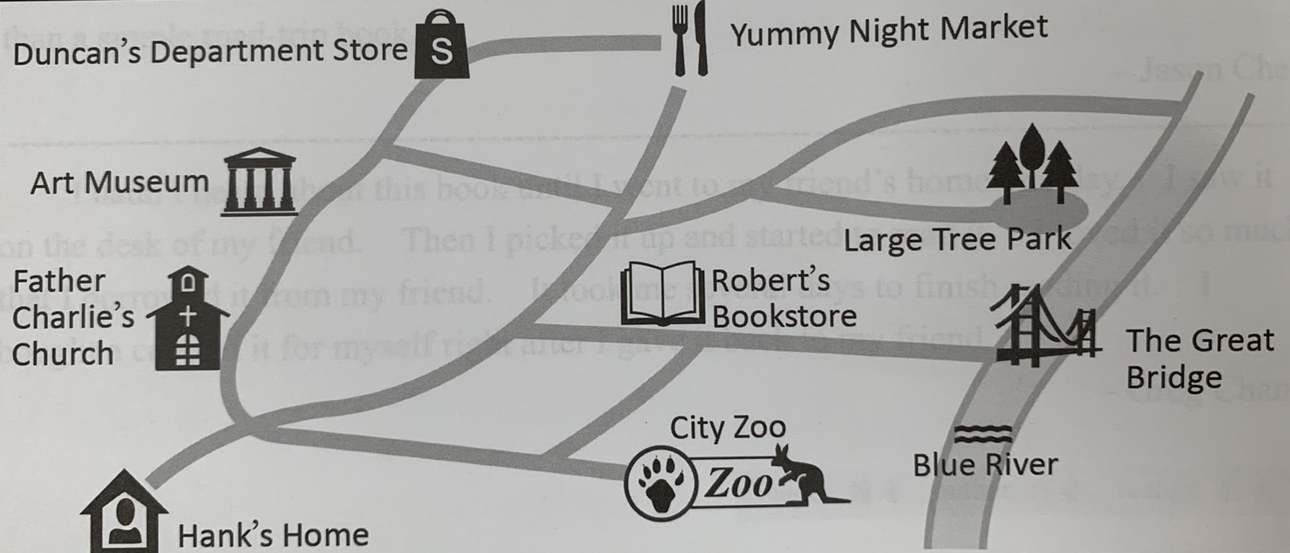

set foot in 到達 be into sth. 非常喜歡itinerary 旅遊行程 hometown 家鄉

( )47. How will Hank and Allan go to those places?
(A) By taking an airport. (B) By driving a car. (C) By riding a bicycle. (D) On foot.
( )48. Which is on the same street as Father Charlie’s Church?
(A) Robert’s Bookstore. (B) Art Museum. (C) Large Tree Park. (D) City Zoo.
( )49. What can we learn from this letter?
(A) It’s Allan’s first time to come to Taiwan.
(B) Allan made the itinerary all by himself.
(C) Hank’s mother will pick up Allan at the airport.
(D) Hank is an American, and he is going to move to Taiwan.
( )50. After reading Hank’s letter, Allan is also very excited. He tells how he feels to his parents.
Hank has really prepared a wonderful itinerary for me! I can’t wait to go to Taiwan and go to all those interesting places with him. I especially like the day when I can take a walk in a beautiful park in the morning and then eat many delicious Taiwanese snacks in the evening. I think I’ll have a great time in Taiwan!

Which day is Hank talking about?
(A) Day 4. (B) Day 3. (C) Day 2. (D) Day 1.

