桃園市立大有國民中學110學年度第一學期第一次評量試卷
年 級 | 七 | 考 試  科 目 | 英語 |  |  | 命 題  範 圍 | Starter~Review1 | 作 答  時 間 | 45分
班 級 |  | 姓 名 |  | 座 號 |  | 分 數

A. 聽力測驗，每題2分，共30分。

一、辨識句意：根據聽到的內容，選出符合描述的圖片或符合圖片的描述。

1. (A) 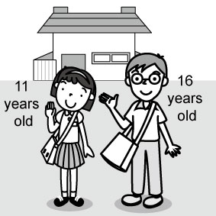 | (B) 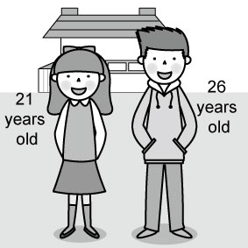 | (C) 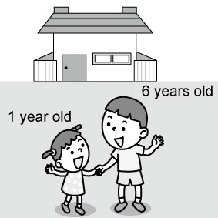
2. (A) 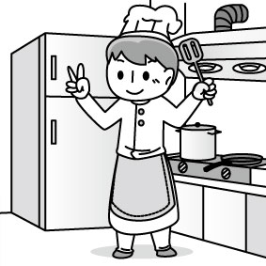 | (B) 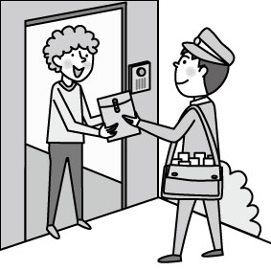 | (C) 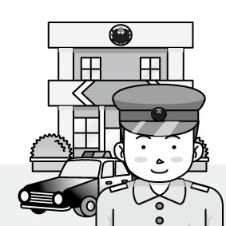
3. (A) 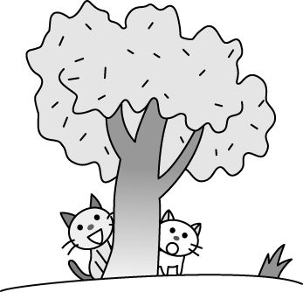 | (B) 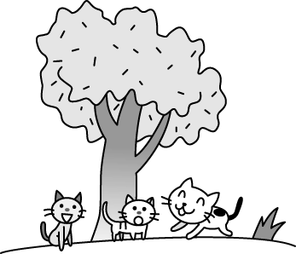 | (C) 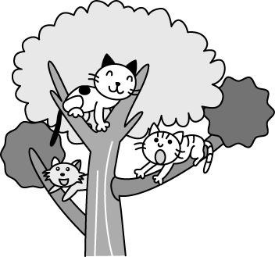
4. (A) 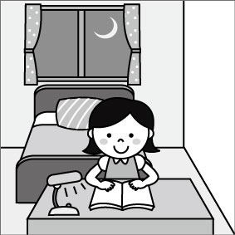 | (B) 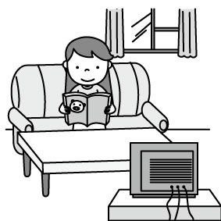 | (C) 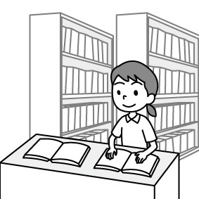
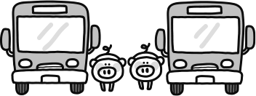  5. (A) | 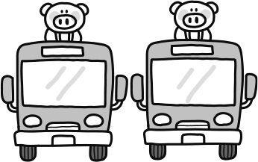  (B) | 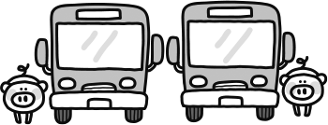  (C)

二、基本問答：根據聽到的內容，選出一個最適合的回應或最適合的問句。
6. (A) He is short. | (B) He is not a teacher. | (C) He is Ms. Johnson’s student.
7. (A) Yes, it’s a comic book. | (B) Yes, he is a good writer. | (C) No, he is a junior high school student.
8. (A) This is a pink watch, not blue. | (B) They are watches from my uncle. | (C) These watches are not from my classmates.
9. (A) It is a pink ruler and it is for  you. | (B) No, it is on the table. | (C) No, it is under the table.
10.(A) It’s my brother’s pencil case. | (B) It’s on the table. | (C) It’s from Paul.

三、言談理解：根據聽到的內容，選出一個最適合的答案。
11. (A) John. | (B) Ted | (C) Billy.
12. (A) He is the boy’s father. | (B) He is the girl’s father. | (C) He is a good police officer.
13. (A) A nurse. | (B) A doctor. | (C) A cook.
14. (A) It’s on the sofa. | (B) It’s under the chair. | (C) It’s on the cookie.
15. (A) Purple. | (B) Brown. | (C) Gray.

B. 綜合測驗，共50分。
四、單字及文法測驗 (16~19題，每題3分；20~28題，每題2分，共30分)
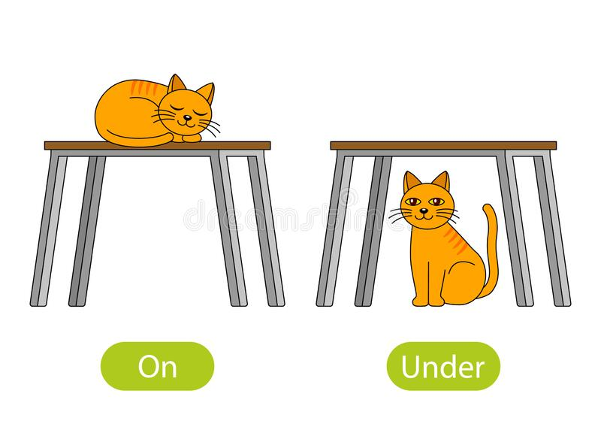
16. Look at the picture. Where is the cat?
(A) Above the table. | (B) Next to the table.
(C) Under the table. | (D) On the table.

17. A: B: They’re notebooks.
(A) Where are they? (B) How old are they? (C) What are those? (D) Who is she?

18. Amy and Patty are classmates. class is 714.
(A) Her (B) Their (C) We (D) They

19. The beautiful women my aunts.
(A) is (B) isn’t (C) are (D) am

20. A: Isn’t that your cousin? B: _________
(A) No. She is my cousin. | (B) No. She is a police officer.
(C) Yes. She is my sister. | (D) Yes. Her name is Annie Banker.

21. A: _____ is the boy? B: He’s my friend.
(A) Where (B) How (C) Who (D) What

22. Jolin Tsai is a ________. Her songs are very popular (受歡迎的) .
(A) teacher (B) singer (C) writer (D) student

23. A: Where is my dog, Lucky? B: He’s playing on the ________.
(A) bathroom (B) kitchen (C) bedroom (D) sofa

24. A: Is that your dog? B: Yes, is. name is Dora.
(A) that ; It (B) it ; Its (C) this ; Her (D) it ; She

25. A: Are your dad and your mom doctors? B: No, my are teachers.
(A) parents (B) cousins (C) classmates (D) uncles

26. My son, Ben, a junior high school student.
(A) are (B) is (C) be (D) am

27. Look! My house is big and beautiful. It’s the two trees.
(A) next (B) in front (C) above (D) between
28.A: B: He’s in the kitchen.
(A) Who’s Mark? | (B) Is Mark there?
(C) How’ Mark? | (D) Where’s Mark?

五、克漏字 (第29-33題，每題2分，共10分)

Miya: Sandy, welcome to my room.
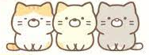
Sandy: Thank you. Wow! What are 29 ?
Miya: 30 are my 31 , Nekos.
Sandy: Are they bears?
Miya: No, 32 . They are cats from Sumikko Gurashi.
Sandy: 33 . They are so cute.
 Sumikko Gurashi 角落生物
29. (A) it |  | (B) this | (C) that | (D) those
30. (A) We |  | (B) They | (C) You | (D) It
31. (A) toys |  | (B) toy | (C) toies | (D) toyes
32. (A) they are |  | (B) they aren’t | (C) those are | (D) their aren’t
33. (A) And you |  | (B) Nice to meet you | (C) I see | (D) Too bad

六、閱讀測驗 (第34-38題，每題2分，共10分)
A.
Hi, there. This is my family tree. I am forty. My wife is beautiful and we have two sons. They are students at Da You junior high school. My parents are teachers, and my sister is a teacher, too. Her husband is a cook. They have a son and two daughters. Ken is a doctor. Lucy is a nurse. Cindy is a singer. We are a big and happy family.

34. Look at the family tree. Who is I?
(A) Ben. (B) Lois. (C) Ann. (D) Bill.

35. Who is Allen’s cousin?
(A) Tom. (B) Dick. (C)Lucy. (D) Helen.

36 .Which is NOT true?
(A) Allen and Dick are forty years old.
(B) Lucy’s sister is a singer.
(C) Ken’s father is a cook.
(D) Helen is a teacher.

B.
The Upside Down House
Hello, my name is Frank. My dad and I are in Germany now. Look! We are in front of a very cool house. Its name is “The Upside Down House”. It is upside down outside. Go inside the house, and you can see a bedroom, a bathroom, a living room, a dining room and a kitchen. All the things in these rooms are upside down, too. Tables, beds, and chairs are all above your head. You can take pictures in this house, but you can’t touch those things. Wow! Look at me! I am standing on the ceiling, but I am not upside down.
  - thing 東西 touch 觸碰 ceiling 天花板

37. Which is true?
(A) The upside down house is in a crack between two houses.
(B) This upside down house is in Poland.
(C) There are six rooms in this house.
(D) You can’t touch the tables or chairs in the Upside Down House.

38. Which is the Upside Down House?
(A) | (B) | (C) | 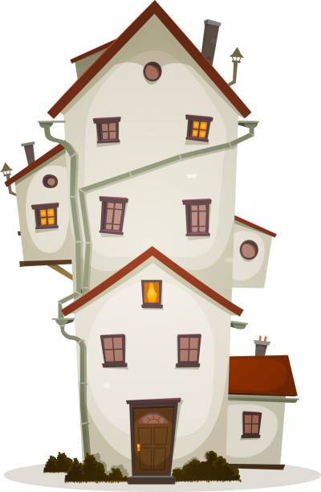  (D)

=============================================================================

