桃園市立大有國民中學110學年度第一學期第三次評量試卷
年 級 | 七 | 考 試  科 目 | English |  |  | 命 題  範 圍 | U5-6  Review3 | 作 答  時 間 | 45分
班 級 |  | 姓 名 |  | 座 號 |  | 分 數

試題卷3張5面共50題，請細心作答！ 電腦卡請寫上班級、座號、姓名，班級及座號務必劃記正確！

【第一部分、聽力測驗】
- 辨識句意：根據聽到的內容，選出符合描述的圖片或符合圖片的描述。 (每題2分)
1.( ) (A) 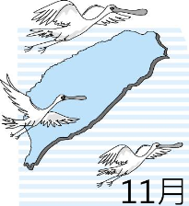 | (B) 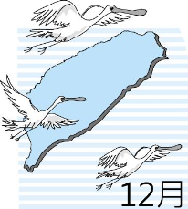 | (C) 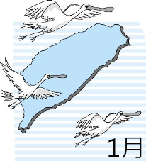
2.( ) (A) 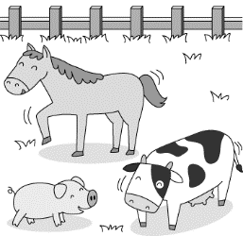 | (B) 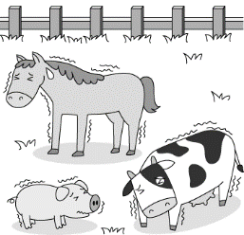 | (C) 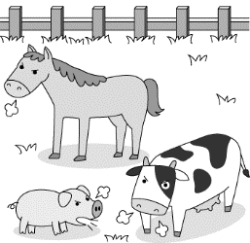
3.( ) (A) 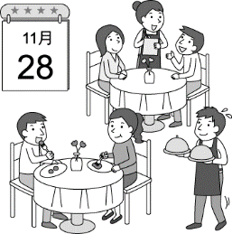 | (B) 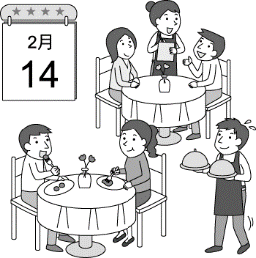 | (C) 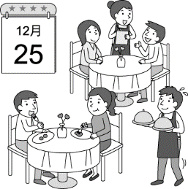
4.( ) (A) 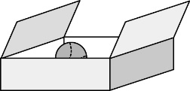 | (B) 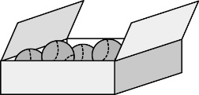 | (C) 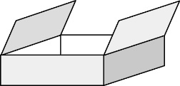
5.( ) (A) 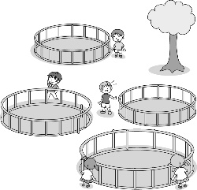 | (B) 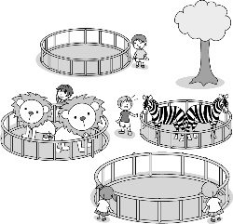 | (C) 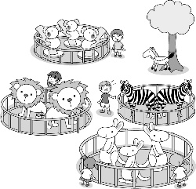
6.( ) (A) 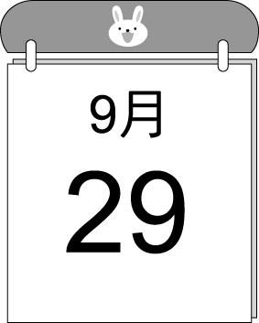 | (B) 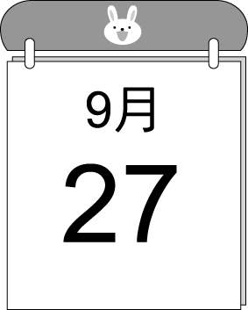 | (C) 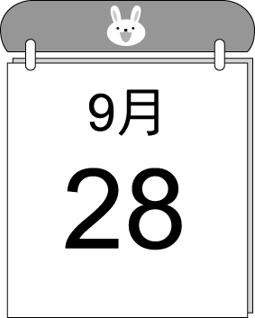

- 基本問答：根據聽到的內容，選出一個最適合的回應或最適合的問句。 (每題2分)
7.( ) (A) It’s a great doll. | (B) It’s for you. Happy birthday! | (C) It’s a gift from Janet.
8.( ) (A) Yes, it is. It’s an important holiday in the USA.
(B) No, it’s a day about thanks.
(C) Yes, there is a Christmas tree in my house.
9. ( ) (A) My favorite book is Time Machine.
(B) Let’s go to our favorite park next time!
(C) April. It is not too hot and not too cold.
10.( ) (A) Sure. How about the black one?
(B) They are my mother’s horses.
(C) There are seven horses on my farm.
11.( ) (A) Yes, there are five. | (B) No, there are two red pens. | (C) These red pens are special.

- 言談理解：根據聽到的內容，選出一個最適合的答案。 (每題2分)
12.( ) (A) Birds. | (B) Monkeys. | (C) Pigs.
13.( ) (A) It’s from Mark’s aunt.
(B) It’s from George’s wife.
(C) It’s from Mark’s grandma and grandpa.
14.( ) (A) It’s in January. | (B) His gift is a notebook. | (C) It’s on December 23.
15.( ) (A) The boy and the girl’s good friend.
(B) The boy and the girl’s new classmate.
(C) The boy and the girl’s new teacher.
16.( ) (A) Give the dog some food.
(B) Take it to an animal doctor.
(C) Take it to their parents for help.

【第二部分、閱讀理解】
四、綜合測驗 (每題2分)
17. The month between October and December is .
(A) July | (B) November | (C) January | (D) August
18. There are many black and white lines on the back of a/an .
(A) elephant | (B) horse | (C) lion | (D) zebra
19. Linda: , Mia? Mia: It’s January 20th.
(A) What day is it? | (B) What’s the date? | (C) What time is it? | (D) When is it?
20. July fourth is very to the people in the USA. It’s the birthday of the USA.
(A) important | (B) lucky | (C) magic | (D) safe
21. A: Here are some cookies for you. B: Thank you, but I am .
(A) full | (B) hungry | (C) nervous | (D) ready
22. A: I am too short. I can’t touch that box. Can you me? B: Sure.
(A) know | (B) follow | (C) provide | (D) help
23. this kind old lady, Mimi’s cat, Fifi, is healthy again.
(A) Luckily | (B) Thanks to | (C) Look at | (D) With
24. In the long line, Pete is person. He is waiting to buy the ticket of Mayday’s concert.
(A) first | (B) my first | (C) the first | (D) the one
25. A: can I talk to Teacher Emily? B: You can talk to her now.
(A) What | (B) When | (C) Where | (D) How
26. A: When is Teacher’s Day in Taiwan? B: It’s .
(A) twenty-eighth of the September | (B) on twenty- eight of September
(C) on the twenty- eighth of September | (D) the twenty-eight of September
27. There is a basketball game in our school gym seven this Saturday.
(A) at ; of | (B) on ; of | (C) in ; on | (D) at ; X
28. A: B: No, there isn’t.
(A) Is there a bird in the tree? | (B) What’s that over there?
(C) What is there on the table? | (D) Is it the turkey on the farm?
29. There are no after 11 p.m.
(A) buses | (B) any buses | (C) bus | (D) a bus
30. Every year, my family and I have a big dinner and go around the table the night of Chinese New Year’s Eve.
(A) on | (B) in | (C) at | (D) X
31. A: Are any rats in this restaurant? B: No. It’s very clean.
(A) it | (B) these | (C) they | (D) there
32. A: There any red dolls in your room. B: Not really. There are .
(A) aren’t ; any | (B) aren’t ; some | (C) are ; some | (D) is ; any
33. A: Are there any Father elephants in the herd with their family? B: No, . are never with their family.
(A) there aren’t ; They | (B) they aren’t ; There | (C) there isn’t ; There | (D) there aren’t ; There
34. Your room is so dirty. Can’t you right now?
(A) look it up | (B) wake it up | (C) clean it up | (D) fight with it
35. A: Welcome to birthday party. B: Happy birthday ! This gift is for you.
(A) the eighteen | (B) my eighteen | (C) the eighteenth | (D) my eighteenth
36. A: Guys, a concert in the park. Let’s go take a look. B: I can’t wait.
(A) it is | (B) there is | (C) it can be | (D) there have
37. A: What’s that around the chair? B:
(A) Look over there. It’s a rat. | (B) Good to know that.
(C) You really are an expert. | (D) Thank goodness.
38. A: Where is Mom? B: She is reading a book in the living room. By the way, Dad is
there.
(A) too | (B) also | (C) only | (D) in

五、克漏字測驗 (每題2分)
Eddie: Look at those horses. They are healthy and strong.
Sandy: Yes, they are 39. . So beautiful, right? I am very happy to stand here and watch 40. .
Eddie: See? There are two birds standing on that horse’s back.
Sandy: Oh! I know them. They’re horses’ good friends.
Eddie: 41. What are they?
Sandy: Brown-headed cowbirds. 42. Horses provide food for brown-headed cowbirds, and they can clean up the bugs for horses. It’s called mutualism.
Eddie: That’s new to me. 43.
Sandy: I know I am.
mutualism 互利共生

39. (A) hiding in the mud | (B) jumping up and down
(C) my favorite animals | (D) new to me
40. (A) ones | (B) them
(C) they | (D) their
41. (A) Really? | (B) Not really!
(C) They are thankful for horses. | (D) That’s a big help to horses.
42. (A) Horses and brown-headed cowbirds help each other.
(B) Brown-headed cowbirds are big fans of horses.
(C) They clean each other up and become healthy again.
(D) Brown-headed cowbirds are food for horses.
43. (A) It’s good to know that.
(B) This is such a good example of mutualism.
(C) I am so lucky.
(D) You are really an animal expert to me.

六、閱讀測驗 (每題2分)
Welcome to the Gloria Museum. This month we are having a special doll display from many countries. In our American Room, you can see a large collection of Barbie dolls dating back to the 1980s. You will be surprised to know that Barbie has so many clothes and shoes. In the German Room, you can see that Germans used wood to make their dolls. In China, people made dolls out of china. It’s very interesting, right? What clothes do the Japanese dolls wear? Find the answer by yourselves.
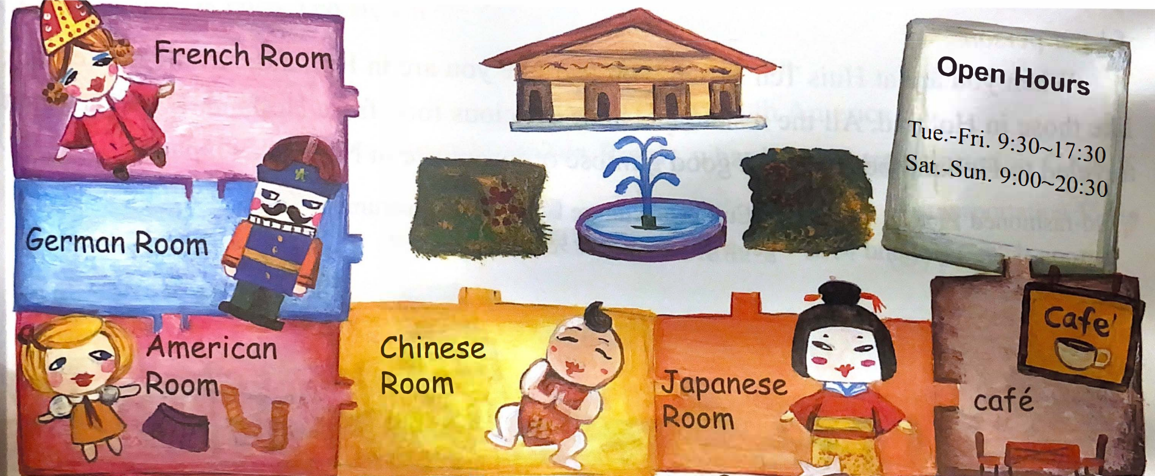 If you feel a little hungry during the visiting, you can have hot coffee, ice cream, cheese cake or some cookies at our Gloria’s Café. It is at the corner of the first floor. You can’t miss it.
display展示, countries國家, collection收藏, surprised感到驚訝的, wood木頭, china瓷器, by yourselves靠自己,
corner角落

44. The Wang family go to the Gloria Museum this morning, but it is not open. What day is today?
- Sunday. | - Monday. | - Saturday. | - Friday.
45. What does “It” refer to(指) in the reading?
- The museum. | - Ice cream. | - Cheese cake. | - The coffee shop.
46. What is the best (最好的) name for this special display at the museum?
- Japanese Dolls. |  | - Barbie’s Fashion Show.
- Dolls Around The World. |  | - The Best Coffee In The Museum.

The economy is bad right now. Many people are out of work. They want to work, but few companies are looking for new workers.
Because people makes less money, they have to buy less. They are buying only what they need. They are not buying new cars; they have to drive their old ones. They are not buying new houses and have to live in their old ones. They are not buying new clothes. They are not having vacations. Many people just stay home and watch TV.
Many poor people can’t eat at a restaurant. They eat simple food and some even beg for their food. Many people are only doing things for free. For example, they go to the library, not buying new books. Life is so hard that everyone hopes the economy will be better soon.
economy經濟, few很少, looking for尋找, less比較少, vacation假期, poor貧窮, beg for乞討, hard困難, better比較好,
soon很快地

47. What does “out of work” mean in line one?
- Go out to work. | - No jobs (工作). | - Work everyday. | - Don’t want to work.
48. According to(根據) the reading, why is life so hard?
- Because people can’t buy new things. |  | - Because people only stay home and watch TV.
- Because people buy things for free. |  | - Because people have less money.
49. What do we learn from this reading?
- Many people work hard(努力) because economy is bad.
- Some people don’t want to work.
- Many people can’t buy new things because the economy is bad.
- A bad economy is not good or bad to poor people.
50. Which is NOT true?
- Borrowing (借) books from libraries can save money.
- People have to buy less because they make less money.
- People don’t want to work, so the economy is bad.
- Many people just stay home and watch TV because they have less money.

