桃園市立大有國民中學110學年度第二學期第二次評量試卷
年 級 | 八年級 | 考 試  科 目 | 英語科 |  |  | 命 題  範 圍 | Unit3~ Review2 | 作 答  時 間 | 45分
班 級 |  | 姓 名 |  | 座 號 |  | 分 數
第一部份，聽力測驗，1-15題，每題2分，共30分
一、Choose the correct picture. 辨識句意：根據聽到的內容，選出符合描述的圖片或符合圖片的描述。
1.
(A) | 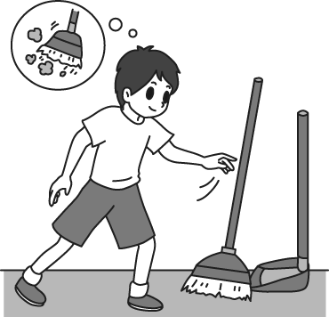 | (B) | 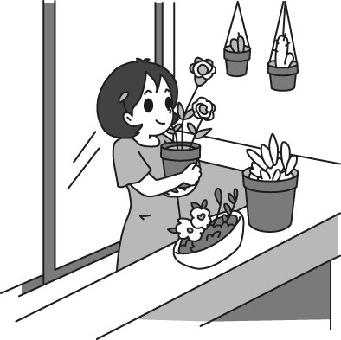 | (C) | 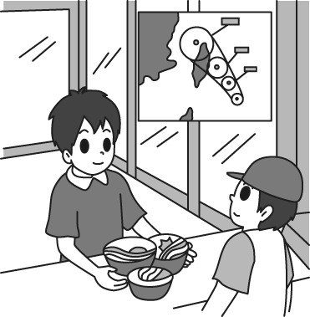
2.
(A) | 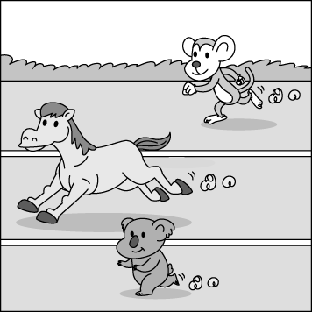 | (B) | 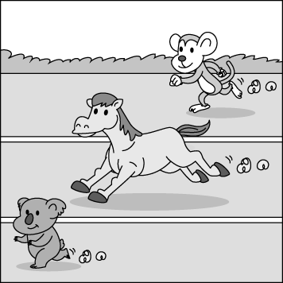 | (C) | 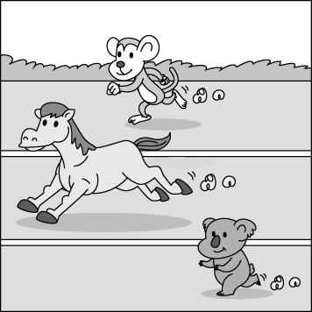
3.
(A) | 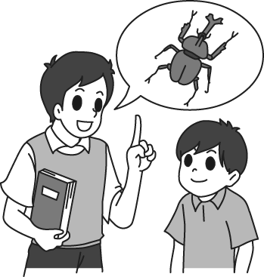 | (B) | 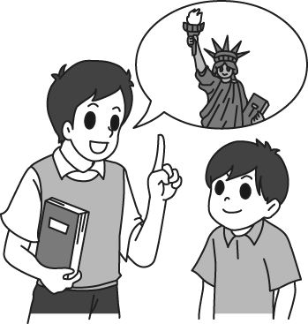 | (C) | 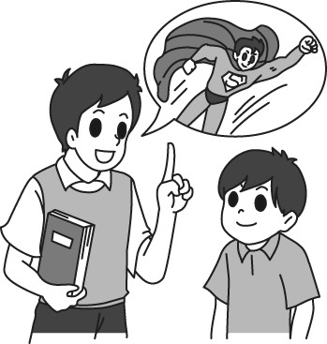
4.
(A) |  | (B) |  | (C) | 
5.
(A) | 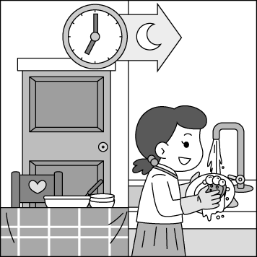 | (B) |  | (C) | 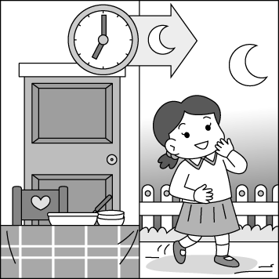

二、Choose the best response. 基本問答：根據聽到的內容，選出一個最適合的回應或最適合的問句。
6.(A) Because I was weak this morning. | (B) Because I had to catch the school bus. | (C) Because I didn’t take a break.
7.(A) No, let’s meet at three. | (B) Yes, it is on the balcony. | (C) No, I won’t. It is too dangerous.
8.(A) I love this picture very much. | (B) Wow, it is a great picture. | (C) Sorry. I won’t do that again.
9.(A) The rainbow was very beautiful. | (B) Ben did it by himself. | (C) It was in the bedroom.
10.(A) He did his homework carefully. | (B) He did his homework at school. | (C) He didn’t do his homework yesterday.

三、Choose the best answer. 言談理解：根據聽到的內容，選出一個最適合的答案。
11.(A) He lives his life happily. | (B) He sleeps more than 10 hours a day. | (C) He doesn’t eat meat at all.
12.(A) He didn’t have enough sleep. | (B) He forgot to bring his English book. | (C) He didn’t do well on the English test.
13.(A) The man did it by himself. | (B) The man and his brother. | (C) The man and the woman.
14.(A) They are in the shopping mall. | (B) They are on the mountains. | (C) They are in a nice restaurant.
15.(A) Play with animals. | (B) Take pictures of them. | (C) Feed the animals.
第二部份，綜合測驗
四、Vocabulary and grammar. 單字及文法測驗，第16-23題，每題1分；題24-30題，每題2 分，共22分。
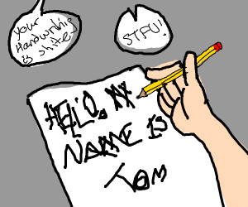
16. Tom’s handwriting is terrible. It’s really ______ to read. handwriting(n.)字跡
16.
(A) hard | (B) quick | (C) well | (D) clear

17. My grandma can’t use a cellphone, so she likes to turn on the ______ and listen to the news.
(A) light | (B) fan | (C) radio | (D) power

18. Go on the web page, you can get the ______ information about our school.
(A) brave | (B) pretty | (C) fine | (D) latest

19. Sharks usually have ______ teeth because they eat meat and keep growing new ones.
(A) mean | (B) sharp | (C) bright | (D) dark

20. Mandy always gets 100 ______ from her husband on her birthday. That’s so romantic. romantic(adj.)浪漫的
(A) rubbles | (B) balconies | (C) rainbows | (D) roses

21. Have some water, ______ you’ll get thirsty during the basketball game.
(A) or | (B) if | (C) as | (D) when

22. Ben: What’s the ______ of the window? Kate: Oh, it’s about 2 feet wide.
(A) color | (B) size | (C) price | (D) level

23. Ollie is good at sports. He can get good grades in PE the most ______.
(A) friendly | (B) clearly | (C) easily | (D) quick

24. This lesson helps the students ______ more about ______.
(A) learn / itself | (B) learn / themselves | (C) to learn / itself | (D) learns / ourselves

25. Ann didn’t get enough sleep last night because she heard someone ______ loudly outside her house.
(A) talk | (B) talks | (C) talked | (D) to talk

26. If Mr. Jones ______ to the office tonight, ask him to call the lawyer, Mrs. Sheep.
(A) will come | (B) coming | (C) came | (D) comes

27. Bus driver: Sorry, the bus is running out of oil. It won’t go any _____.
Rio: What! I’ll be late for school!
(A) faster | (B) closer | (C) longer | (D) farther

28. Leo: Wow, your new apartment is big and beautiful.
Amy: Thanks. I have some fruit and cookies for you. _______ Enjoy.
(A) Help yourself. | (B) Behave yourselves. | (C) Know yourself better. | (D) Talk to yourself.
29. Cody: I don’t know how I can finish the work. I’m so worried.
Kim: Don’t worry too much. You can ask me any questions when you need. ______ Cheer up.
(A) I have to say sorry to you. | (B) You need to do it quickly.
(C) I’m always there. | (D) You look sadder than before.

30. Pete: Could you help me move these boxes up to the 3rd floor?
Mary: ______ Let me take off my jacket first, and then do it together.
(A) Great. Let’s be ready. | (B) No problem.
(C) We should wash our hands first. | (D) I could see the dots moving.

五、Cloze and comprehension tests. 克漏字及閱讀測驗，第31-44題，每題2分，共28分
A.
Dear Mother Anita,
I feel so 31. to write this letter, but if I 32. do it, you’ll never know what your problem is.
These days, Rio and I ate too much food 33. working. You just sat there and watched us 34. . Also, you 35. Pox and Eddie stay and play on the farm. They didn’t produce eggs and milk anymore. We’re all getting fatter and lazier, but we don’t like it. We want to move. We want our happy days back and to 36. . Just tell us what to do, and we can 37. . We’ll listen to you and follow your steps. We believe we’ll work 38. than before. Would you please 39. ?
Sincerely yours,
The Animals

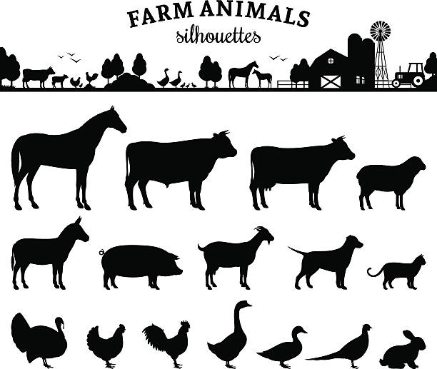

31. (A) sad | (B) sadly | (C) more sadly | (D) most sadly
32. (A) can’t | (B) didn’t | (C) don’t | (D) won’t
33. (A) besides | (B) through | (C) as | (D) without
34. (A) slept | (B) sleeping | (C) sleeps | (D) will sleep
35. (A) had | (B) took | (C) gave | (D) got
36. (A) run quickly | (B) play terribly | (C) live happily | (D) sing beautifully
37. (A) read by ourselves | (B) sleep by ourselves | (C) feed ourselves | (D) train ourselves
38. (A) careful | (B) carefully | (C) hard | (D) harder
39. (A) take us down | (B) make a change | (C) go shopping later | (D) join the game

B.
Many young people have Instagram accounts, however having an Instagram account isn’t young men’s rights now. Want Show Laundry in Taichung, run by a couple in eighties, went viral on Instagram in 2020. But what makes Want Show Laundry so popular? It’s all because of their grandson, Reef Chang.
In the beginning, Reef posted pictures of his grandparents posing in a creative outfit from the forgotten or unwanted clothes in the laundry. He started “wantshowasyoung”


Instagram account to help his grandparents deal with the boredom as they grow old. Also, he wanted to remind people to pick up their clothes. This account has 650 thousand followers around the world on Instagram. BBC, CNN, and New York Times all reported this lovely couple.
Reef and his grandparents got lots of feedback and encouragement. Now they start the “circular fashion” platform. They’ll sell the unwanted or forgotten clothes in the laundry, or donate them to people in need. They all want the “good circle” to go on and on.
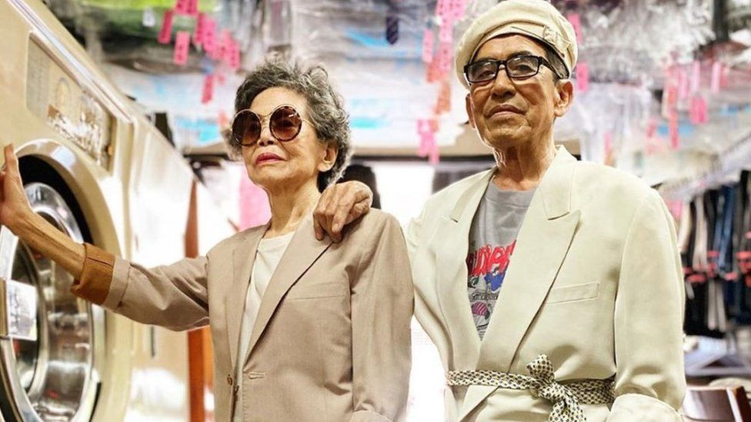

*account(n.)帳號；laundry(n.)洗衣店；go viral網路上爆紅；outfit(n.)全套服裝；deal with處理；remind(v.)提醒；boredom(n.)無聊；
couple(n.)夫妻、情侶；feedback(n.)回饋；encouragement(n.)鼓勵；circular(adj.)圓的、環形的；platform(n.)平台

40. Why did Reef Chang start the “wantshowasyoung” Instagram account?
(A) To help his grandparents to be famous. | (B) To sell the clothes.
(C) To help his grandparents deal with boredom. | (D) To buy a new laundry.

41. What clothes did the couple dress in?
(A) Clothes Reef bought. | (B) Clothes people left in the laundry.
(C) Clothes people gave them. | (D) Clothes the couple made.

42. What does the word them mean in the sentence?
(A) Clothes. | (B) Money. | (C) Pictures. | (D) The couple.

C.
--------------------------------------------------------------------------------------------
Share Toy Love
Do you have some toys you don’t need?
Your old love may be someone’s new favorite.
Bring one toy to the Wonderful Shop & get your new favorite for free!
☺When & How:
May 21 ~ May 28 Bring one toy for one Toy Love card
May 29 ~ June 5 Bring one card for one toy you like
☺What toys:
All kinds of toys, like dolls, toy cars, blocks, balls, trains Except books
(We are closed on Wednesdays)
☺Notice: 1. Your toy must be clean.
2. Your toy must be in good shape, without anything missing.
--------------------------------------------------------------------------------------------
43. What is the ad for?
(A) Selling old toys. | (B) Telling people how to buy a good toy
(C) Knowing what kinds of toys are the most popular. | (D) Inviting people to change toys with each other.

44. If Ken has a Share Toy Love card, when can he use it?
May
Sun | Mon | Tue | Wed | Thu | Fri | Sat
15 | 16 | 17 | 18 | 19 | 20 | 21
22 | 23 | 24 | 25 | 26 | 27 | 28
29 | 30
June
 |  | 1 | 2 | 3 | 4 | 5
(A) May 24. | (B) May 28.
(C) June 2. | (D) June 4.

桃園市立大有國民中學110學年度第二學期第二次評量學生作答卷
年 級 | 八年級 | 考 試  科 目 | 英語科 |  |  | 命 題  範 圍 | Unit3~ Review2 | 作 答  時 間 | 45分
班 級 |  | 姓 名 |  | 座 號 |  | 分 數
請直接書寫至作答卷上
六、字彙選填，必要時請做適當變化，每字1分，共10分：
space face typhoon American shine slowly wise choose reach giant

45. Bill made the same mistake again, but this time he ❶ to ❷ it.
46. The ❸ won’t ❹ Taiwan tomorrow if it moves ❺ .
47. Look! There is a ❻ star ❼ in the sky.
48. We found a parking ❽ close to the art museum.
49. This restaurant is so popular. It provides nice ❾______________ food.
50. It’s ❿______________ to save some money every month.

七、填入適當形容詞或副詞，必要時請做適當變化，每格1分，共6分。
51. strong
a. The wind is _______________________.
b. The wind blows _____________________________________ than yesterday.
52. good
a. The dancer danced ____________________ last night.
b. The dancer danced ______________________________________ of all the dancers last night.
53. terrible
a. He felt _________________________.
b. He cooked the dinner _________________________ tonight.

八、引導式翻譯，每題2分，共4分。
54. 如果Ela遲到，請讓我知道。
_________________________________if __________________________________
55. 我早上看到一隻老鼠跑進你的教室裡。
_____________________________________________________into your classroom this morning.

